Flexi-Vision 2 (DH495)
Thank you for purchasing from RNIB. In the unlikely event the item is unsuitable, please contact us within 14 days of receipt to obtain your returns number. To ensure your return goes smoothly, the item and all components must be in as new condition and packed in its original, undamaged packaging. For further details and guidance on returning faulty items, please see the Terms and conditions of sale and How to contact RNIB sections of this instruction manual.

Please retain these instructions for future reference.

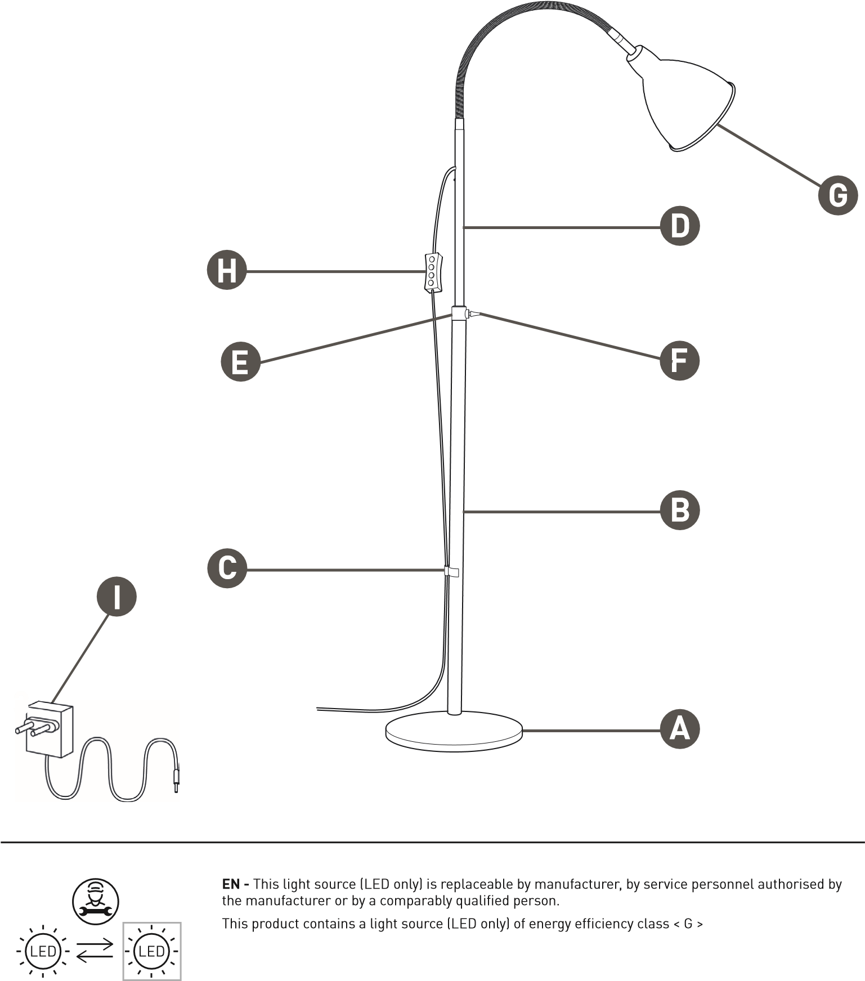

The Control gear is replaceable by the end user.

Safety Instructions
Thank you for purchasing this Daylight product. To read more information about your guarantee, please go to www.daylightcompany.com. To ensure correct and safe operation please read the following and retain for future reference.

Getting started
- Carefully unpack the lamp. You will have the following parts:
- Weighted floor base (A)
- Lower pole (B) with cable guide (C)
- Upper pole assembly (D) with height adjuster & thumbscrew (E & F), shade (G), cable & switch controller (H)
- Plug-in Adapter (I)
- Place the Base (A) on the floor
- Screw the Lower Pole (B) onto the base and tighten firmly.

Please note: do not use excessive force as this could damage the threads. If the threads become crossed, unscrew and try again.

During use, make sure the pole is kept tight to avoid damage to the threads.

- Holding the Upper Pole Assembly (D), locate the Height Adjuster (E). Loosen the Thumbscrew (F) and screw the Height Adjuster into the Lower Pole and fully tighten.
- Set the preferred height of the Upper Pole Assembly and tighten the Thumbscrew (F).
- Slide the Cable Guide (C) down the pole so that it is close to the base and insert the cable.
- Connect the Plug-in adapter (I) to the connector on the lamp and plug the adapter to a convenient electrical socket.
- Switch on using the YELLOW button on the controller
- The RED & GREEN buttons control the 5 brightness levels
- The colour of the light (Kelvin temperatures 6,000K / 4,000K / 2,700K) can be changed with the BLUE button.
- The lamp has a memory function that remembers the last settings used. If the lamp is disconnected from the power supply, the memory function is reset.

Cleaning and safety
- Before cleaning make sure the lamp is disconnected from the electrical supply by removing the power supply from the electrical socket.
- Wipe with a damp soft cloth and dry off.
- DO NOT USE spray cleaners and ensure that liquid does not enter the lamp housing as this may affect electrical safety and could damage the lamp.
- The lamp will become warm in use due to internal electronics. This is quite normal.

CAUTION: DO NOT LOOK DIRECTLY AT THE LEDs.

Do not open or tamper with the lamp other than as advised in these instructions. Only use the plug-in power supply that came with the lamp. Use of another type will invalidate your guarantee and may damage your lamp. Do not clean or polish the flexible arm with oily / greasy substances as they will affect the functionality of the arm and cause it to drop / not hold position. If the lamp cable becomes damaged it should only be replaced by a suitably qualified person in order to avoid any hazard.

INCASE OF ANY DOUBT PLEASE CONSULT A QUALIFIED ELECTRICIAN.

Daylight Guarantee and warranty
This product is guaranteed against mechanical and electrical defects. For full Daylight guarantee Terms & Conditions please refer to the Daylight website. Faulty products should be returned to the place of purchase and proof of purchase must be presented. Please quote the model number in all correspondence. Returned products damaged by poor packaging are the responsibility of the sender. During the guarantee period, Daylight will repair or replace the product free of charge provided the fault was not caused by misuse, improper handling, negligence, normal wear and tear, accidental damage, or by any modifications made by the purchaser. The guarantee does not cover consumables such as bulbs, tubes or batteries. This guarantee does not affect your statutory rights.

Terms and conditions of sale
This product is guaranteed from manufacturing faults for 24 months from the date of purchase.

For all returns and repairs contact RNIB. You can request full terms and conditions from RNIB or view them online.

How to contact RNIB
Phone: 0303 123 9999
Email: shop@rnib.org.uk
Online Shop: shop.rnib.org.uk

Products are provided by RNIB Enterprises Limited. Company number: 0887094 Registered office: The Grimaldi Building, 154a Pentonville Road, London N1 9JE. RNIB Enterprises Limited is a trading subsidiary of the Royal National Institute of Blind People, a charity registered in England and Wales (226227) and Scotland (SC039316).

Date: April 2025.

