Ikonn kitchen scale (DK208)
Thank you for purchasing from RNIB. This item has been supplied by a third party. In the unlikely event the item is unsuitable, please contact us within 14 days of receipt to obtain your returns number. To ensure your return goes smoothly, the item and all components must be in as new condition and packed in its original, undamaged packaging. For further details and guidance on returning faulty items, please see the Terms and conditions of sale and how to contact RNIB sections of this instruction manual.

Please retain these instructions for future reference.

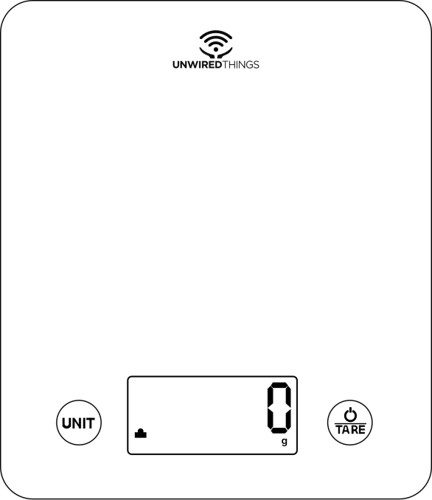

Preface
Congratulations on purchasing the IKONN SK-1 Kitchen Scale.
This kitchen scale is an IKONN-compatible product, meaning that apart from functioning as a regular scale which measures your ingredients and food items- it can also be used together, with an IKONN Accessibility system which supports audio announcement of readings in your chosen language. This manual serves as a guide to efficient and safe use of the product. Read this information thoroughly before using the product and store this document for future reference.

Warning: To avoid injury or product damage, read the chapter on handling and safety, before using the product.

Kitchen Scale features
The IKONN SK-1 is designed to adequately measure the serving sizes of ingredients and food items.
- System of high precision strain gauge sensors
- LCD display
- Capacity of 5 kg / 11 lb.
- Division of 1 g
- Measure volume of milk.
- Switch between units of weight and volume.
- Tare function
- Auto Off: After use, the scale automatically powers off to conserve battery life.
- Low battery, overload, and error indications.
- Compatibility with the IKONN Accessibility system.

Note: The kitchen scale is not a diagnostic or medical device.

While connection between the kitchen scale and IKONN Accessibility System enhances daily tasks and routines for users unable to view the screen, it is not intended to replace professional medical or mobility aids. Individuals with specific medical or mobility requirements should consult their healthcare providers for guidance.

Before use
Unpack the product with care. All packaging materials are recyclable; however, you may wish to keep the packaging until you are satisfied that the scale meets your needs.

Having taken the product out of the packaging, ensure that all the parts and components are present and in good condition. In case of any missing elements or if something does not seem right, please get in touch with the retailer from whom you purchased the product. Ensure that packaging bags are kept out of reach of children as these can cause suffocation.

Parts and components

Note: The graphics in this manual are schematic representations used for reference only and may differ from actual product appearance.

Included components:
- 1 Measuring platform
- 2 LCD display
- 3 Measurement/Unit button
- 4 Power/Tare button
- 5 High precision sensors
- 6 Battery compartment
- User manual

Operation

Insert batteries.

Open the battery compartment at the back of the scale and install 3 × AAA batteries in the correct position. The flat (negative) end of each battery must rest against the spring.
After batteries insertion, close the compartment by gently pushing the battery cover back onto it.

Replace batteries.
To replace the batteries, open the battery compartment and remove the used batteries with the aid of a flat object. Insert new, compatible alkaline/carbon batteries - rechargeable batteries do not provide enough voltage to maintain normal operation. Ensure you to correctly orient the batteries according to their positive and negative signs.

Note: Learn more about battery handling and disposal in chapter on Handling and Safety.

Weighing
Place the scale on a hard and level surface. Gently touch the Power/Tare button to activate the scale and wait until the display shows ‘0’. Place the item that you wish to weigh on the scale. The LCD display will now show the weight of the item.

Once you are done with your measurements, press the Power/Tare button to turn the scale off. Otherwise, the scale will turn off automatically after 2 minutes of inactivity to conserve the battery life.

Change units of measurement.
With the scale turned on, press the Measurement/Unit button repeatedly to select the desired unit of measurement until it is shown on the display. The scale supports switching between grams and pounds/ ounces in weight mode, and fluid ounces and milliliters in volume mode.

The order in which the units change with each button press is:
grams -> pounds/ ounces -> milliliters of milk -> fluid ounces of milk.

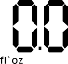

When either milliliters of milk or fluid ounces of milk is selected – there will be an ‘M’ symbol present on an LCD display.

Tare function
Tare function allows you to weigh it a second item immediately after weighing the first one, without having to remove the latter from the scale. This is useful if you wish to measure something inside a bowl or container.

If you intend to weigh something inside a bowl or container, start by placing the empty bowl or container on the scales. When you remove everything from the scale, it will display a negative number, equal to the weight of the container. To reset the scales back to zero, press the Power/button again.
Activate your scale with a Power/Tare button and wait for the display to show ‘0’. Then, place the container on the scale surface. At this point, the LCD display will show the weight of that container in a fixed manner. Once the weight of the container is displayed, press the Power/Tare button briefly to zero the scale. You can now place other items into the container, and the scale will display only their weight, excluding the weight of the container.

The ‘T’ symbol will be displayed in the upper-left corner, indicating that the Tare function is now enabled.

You can press the Power/Tare button once again to repeat the function and weigh new ingredients by placing them in the container.

When you remove all items from the scale, it will display a negative number, equal to the weight of the container. To reset the scales back to zero, press the Power/Tare button again.

Negative values
The negative values will be shown on the display when the weighted ingredients are removed from the scale in TARE mode.

To zero the scale again, press the Power/Tare button and the display will return to ‘0’ again.

Other possible indications and their corresponding symbols are listed below.



- Low battery - Battery power is running low. Please replace the batteries.

- Scale overload - Weighing subject exceeds the maximum scale capacity. Please remove excess weight to avoid damage.

- Stability error - The scale is not placed on a flat surface. Please place the scale on a flat surface.

Using kitchen scale with IKONN Controller
As with all Unwired Things products, this scale features the ability to connect with the IKONN Accessibility System which can provide audio feedback in your chosen language. The system is intended to support users unable to view the screen for any reason.

Use the IKONN Add product function on your IKONN controller to pair your new scales with the IKONN controller. Use the help function on your controller or the manual for the controller if you are unsure how to do so.

You will hear an announcement once the connection is established and IKONN will also state the name of the product that it has connected with. The kitchen scale function will subsequently be available on your main function list. To use the scales, with IKONN, you should now select the kitchen scale function. If the scale is off, you should turn it on immediately to allow it to connect with IKONN.

Note that more than one IKONN controller can be used to interact with the scales, though not at the same time.

You can find more support using the built-in IKONN controller help function or on the https://ikonn.info website.

Tips and Troubleshooting
In case you are experiencing problems with the kitchen scale, here is a list of options that you can try:
- Ensure that the scale is placed on a hard, level surface.
- Check each sensor foot on the back to make sure nothing is stuck to the bottom of it.
- Ensure that the batteries are oriented correctly inside the battery compartment, according to their positive and negative signs.
- Replace the batteries if the display is faint or the “Lo” message is displayed on the screen.

Handling and safety
Warning: Read all safety information below before using the kitchen scale and keep this manual for future reference. Failure to follow these safety instructions could result in fire, electrical shock, or other injuries, as well as damage to the product or other property.

The scale is not intended for commercial or industrial use.

General safety and handling
Handle the product with care, as it contains sensitive electronic components. Always check for visible signs of damage. If you find any, reach out to the retailer from whom you purchased the product. Do not open or attempt to repair the scale yourself, as disassembling of the product may cause injury to you or damage the scale. Do not use a damaged scale.

The kitchen scale should be used indoors, on flat and stable surfaces. Ensure that the surface is clean and dry before use, clean it with a slightly damp cloth. Do not immerse the scale in water or use chemical/abrasive cleaning agents. Do not overload the scale with anything that would result in exceeding the maximum weight capacity, stated in the technical specifications. Avoid applying excessive pressure or bending the product. Never apply excessive pressure to buttons and switches. Do not drop the scale or other objects onto it. Any modification of the product may have consequences for safety, warranty, and proper functioning.

Radio emissions from kitchen scale can negatively affect the operation of other electronic equipment.

Operate the kitchen scale only acceptable temperatures. Do not operate the scale in places that are excessively hot, humid dusty, where insects may enter, where it might be exposed to mechanical vibration.

Batteries
Batteries must be recycled or disposed of separately from household waste. Do not dispose of batteries in normal waste and check with your authority for battery recycling advice. When handling batteries or cells, wear gloves.

Do not use deformed batteries. Do not mix old with new batteries nor mix batteries of different compositions/brands. Do not burn or expose the batteries to high temperatures, as this could lead to explosions. Do not tamper with batteries or cells in any way. Avoid short-circuiting the batteries' power supply terminals and cells. If the scale will be stored for a long period, it is recommended to remove the batteries to avoid leakage. Avoid touching the liquid coming from leaking batteries or cells.
Ensure that batteries are out of the reach of children, especially if there's a risk of ingestion. If someone ingests a battery, they seek medical help immediately.

Regulatory information
Dimensions 217 × 187 × 18mm
Weight 0.376kg
Battery type 3 × AAA
Capacity 5kg/11lb
Division 1g
Temperature 0 – 38 °C
Transmission frequency range 2402 – 2480MHz
Maximum RF power output -3.34dBm

Technical specifications may change without prior notification.
to improve product quality.

Disposal of electronic appliances
The product and/or batteries should be disposed of separately from household waste. Upon reaching the end of its operational life, ensure the proper disposal of cells, batteries, or accumulators by delivering them to a collection point designated by your local authorities. Consumers are encouraged to reach out to their local authorities or the retailer for guidance on the correct disposal of old machines and their associated batteries. Adherence to these guidelines is instrumental in safeguarding the environment.

Technical support and warranty
Unwired Things assumes responsibility to the end user or consumer for any lack of conformity that may exist at the time of product delivery, in accordance with the terms, conditions, and deadlines stipulated by the relevant regulations. All Unwired Things products are covered by a two-year warranty.

We recommend that all repairs be conducted by qualified personnel.
Should you encounter any issues with your product or have any uncertainties at any point, please do not hesitate to reach out to the retailer from whom you purchased the product.

Copyright
Unwired Things retains the intellectual property rights for the content contained within this document. All rights are reserved. Unauthorized reproduction, distribution, or use of any part of this document and product may violate applicable laws and could result in civil and criminal penalties.

Terms and conditions of sale
This product is guaranteed from manufacturing faults for 24 months from the date of purchase.

For all returns and repairs contact RNIB. You can request full terms and conditions from RNIB or view them online.

How to contact RNIB
Phone: 0303 123 9999
Email: shop@rnib.org.uk
Online Shop: shop.rnib.org.uk

Products are provided by RNIB Enterprises Limited. Company number: 0887094 Registered office: The Grimaldi Building, 154a Pentonville Road, London N1 9JE.
RNIB Enterprises Limited is a trading subsidiary of the Royal National Institute of Blind People, a charity registered in England and Wales (226227) and Scotland (SC039316).

Date: May 2026.

