Compact 8 (HC135)
Thank you for purchasing from RNIB. In the unlikely event the item is unsuitable, please contact us within 14 days of receipt to obtain your returns number. To ensure your return goes smoothly, the item and all components must be in as new condition and packed in its original, undamaged packaging. For further details and guidance on returning faulty items, please see the Terms and conditions of sale and how to contact RNIB sections of this instruction manual.

Please retain these instructions for future reference. These instructions are also available in other formats.

Contents
Compact 8 (HC135) 1
Introduction 2
What’s in the box? 3
Orientation 3
Front 3
Back 3
Opening the stand 3
Closing the stand 4
Setting Up Compact 8 4
Connect the cables 5
Charge the battery 6
Continuous charging 6
Battery life 6
Battery level 6
Battery status light 6
Power on Compact 8 7
Software setup instructions 7
Using the Touch Screen 8
Easy mode and Advanced mode 8
Basic operations 10
Set time and date 10
Navigating the menus 12
Button bars 12
Main Menu structure 13
Operating the Compact 8 16
Using the desktop camera 16
Short distance viewing 16
Magnify the camera image 17
Pan to see more of the image 18
Change the colour mode 18
Taking Snapshots 19
Customizing Appearance 25
Colour 26
Available colour combinations 27
Dynamic contrast 28
Line 28
Light Sensitivity 29
Edge Effects 29
Two-colour combination 31
Smooth 32
Edge only 33
Highlight 34
Colour Blindness 35
Changing System Settings 36
Theme 39
Lights 39
Miracast 40
Standby 42
Language 42
Update 42
Restore 43
Information 44
How to contact RNIB 44
Terms and conditions of sale 44

Introduction
Congratulations on receiving your new Compact 8 from Optelec. This handheld electronic video magnifier has a stand for table reading, or it can be held for viewing nearby objects. Small enough to easily carry with you, the Compact 8 is ideal for magnification on the go. A convenient carrying case is provided to protect the unit during transport.

Featuring a built-in 8-inch LED (light-emitting diode) screen, the Compact 8 allows you to magnify images up to 30 times. You can adjust the display of live images and image captures based on your personal preferences, including magnification, brightness and colour filters, colour combinations, lines and masks, and edge effects.
You can pan images while the camera is live or after you have taken a picture. You can keep images on the Compact 8, later changing the colour mode or magnification for better viewing.
Wi-Fi can be enabled by connecting the Compact 8 to a smart television or monitor with Miracast.

What’s in the box?
The Compact 8 box includes the following:
- Compact 8 device
- Protective carry case
- Lens cloth
- AC adapter power supply
- Note: Style may vary depending on country.
- USB-C to USB-A power cable
- Information for Use (IFU) documents—Compact 8 Setup and Use and Compact 8 Safety and Care

Orientation

Front
The front of the Compact 8 is the side with the screen. Since the device has
a touch screen, no buttons other than the Power button are needed.

Back
On the back of the Compact 8 you find the cameras, lights, and built-in stand. The Power button is on top.

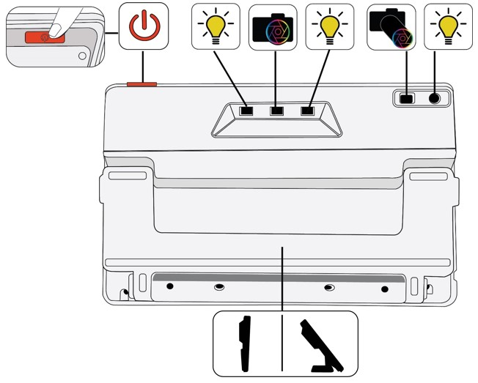
On the back of Compact 8, the components from top to bottom, left to right, are:
- Power on / standby / power off
- Light 1 for desktop camera
- Desktop camera
- Light 2 for desktop camera
- Distance camera
- Light for distance camera
- Built-in stand
- Sound is provided when you power on Compact 8, and a camera shutter sound occurs when you take a snapshot. A tapping sound can be heard when activating a feature or adjusting the volume level.
- Note: The audio port on the left side of the device does not currently have functionality.
- Compact 8 has no vibration (also called haptic feedback).

Opening the stand
The stand must be opened to use Compact 8 to read with the desktop camera.
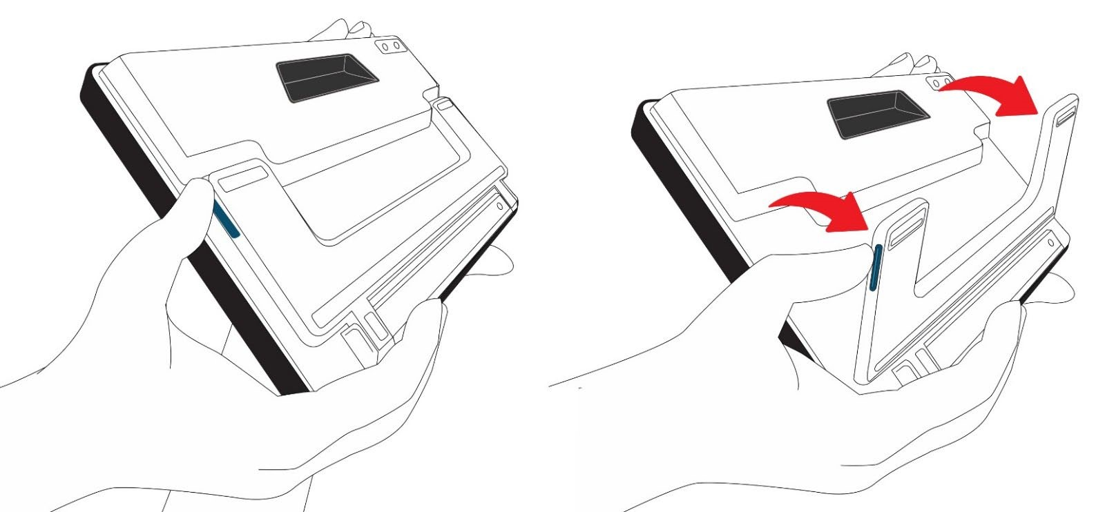
To open the stand:
- Hold up the Compact 8 on a flat surface with the display facing you.
- Use one hand to steady the device from the top.
- With the other hand, use your thumb to press the blue tab on the side of the stand while pushing out. When it is fully extended, the stand snaps open.
- Close the stand
- To use the Compact 8 to view objects at a short distance, the stand must be closed to use the distance camera. For example, you need to close the stand and hold the device to look at labels or signs.
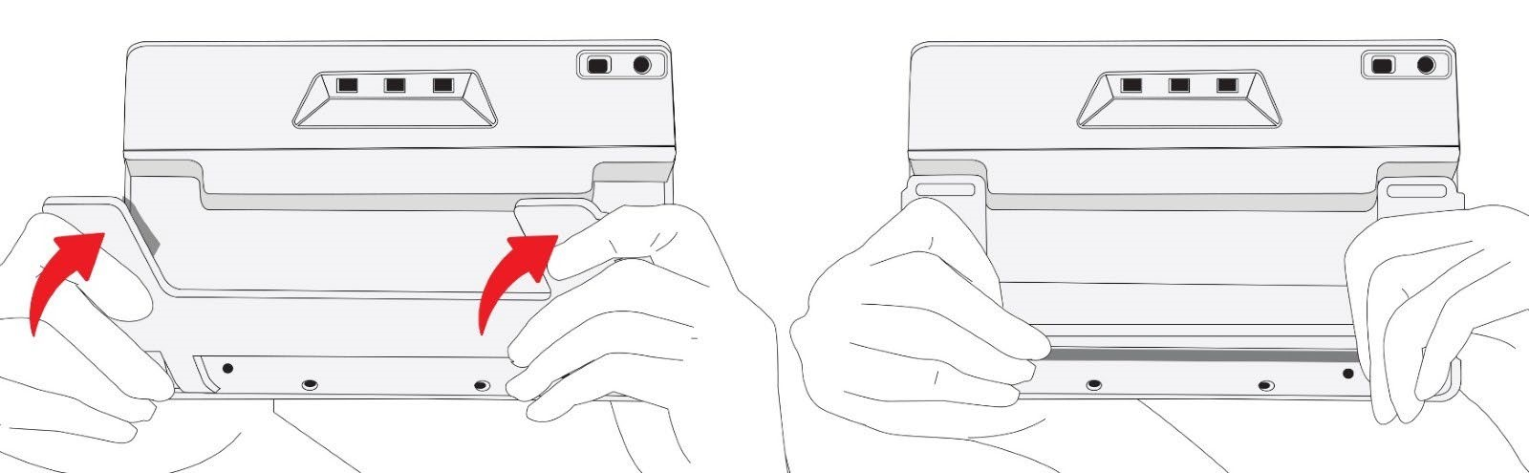

Closing the stand
Hold the Compact 8 from the bottom with the display facing you.
Firmly hold the sides of the device with your palms while pushing the backs of the legs toward the body until they snap closed.

Caution: When closing the stand, ensure your fingers are outside of the recessed area on the rear of the device to reduce the risk of your fingers getting pinched.

Setting Up Compact 8
Carefully unpack everything and familiarize yourself with the components of Compact 8. Next, follow these directions to connect the power supply and fully charge the battery before powering up.
Refer to the following drawing for an overview of the setup process.
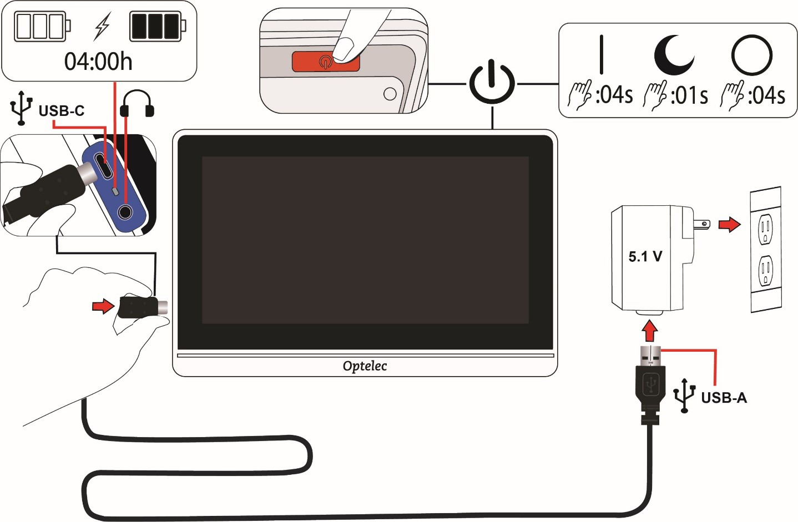

Connect the cables
To connect the Compact 8 to the AC adapter/power supply:
The Compact 8 is delivered with a power supply and four country-specific power plugs in EU, US, UK, and AU types. Slide the appropriate plug for your region onto the power supply until it clicks.

Connect the USB-C end of the included USB cable to the USB-C connector port on Compact 8.

When the Compact 8 screen is facing you, the left side of the device (left to right) has a USB-C port, a status light, and a non-functional audio jack.

Plug the USB-A end of the cable into the AC adapter/power supply.

Caution: For safety reasons, only use the power supply and USB cable that was delivered with the Compact 8 to charge the unit’s battery.

Plug the adapter/power supply into an AC wall outlet that is unobtrusive but easily accessible.
Tip: A surge protector is recommended for protection during an electrical storm or other events that may cause an electrical surge.

Charge the battery
Fully charge the battery before first use. Charging Compact 8 takes up to 4 hours. Wait until the battery charging status light on the left side of Compact 8 is solid green to power on the device.
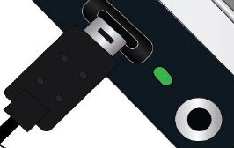

Status light

Continuous charging
The battery can be continuously charged, even while the unit is in operation. You can leave the battery connected to the power supply because the battery cannot be overcharged.

Battery life
Your Compact 8 battery life is up to 3.2 hours and is dependent on usage and product settings.

Battery level
A battery symbol is displayed while the device is powered down and charging. It is also displayed on the Main Menu, which is available by tapping the screen to display the button bars, then tapping the button on the left top of the screen.

In the following image, the left battery is fully charged, the middle battery is charging at 60%, and the right battery is nearly empty at 20%.
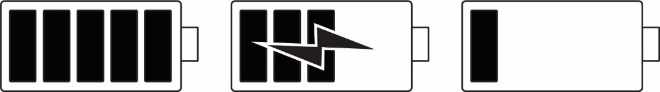
It is recommended that you charge the device when its battery charge level drops below 40%.

Battery status light
A small light next to the USB port indicates the device’s charging status.

A blinking green light means the battery is charging.

A solid green light means the battery is fully charged and the charger is connected.

A blinking yellow light indicates a depleted battery or a charging error. If this occurs, ensure you are using the charger provided with your device and that all cables are properly connected. If the light does not change to blinking green within 30 minutes, contact Optelec technical support for assistance.

Power on Compact 8
To power on your device, press and hold the orange button on the top of the device for 4 seconds. The button is on the right side behind the front edge when the screen is turned toward you.
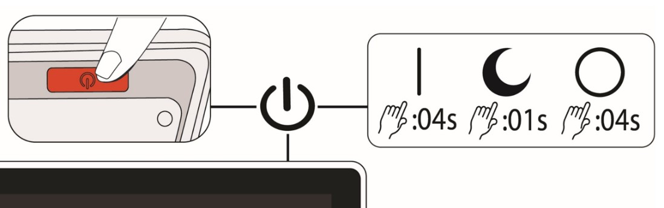
The Power button is also used to put the device on standby or turn it off. When you want to leave your device on but will not be using it for a brief time, it saves battery power to press the Power button for 1 second to put it on standby.

To turn off the device, press and hold the Power button for 4 seconds.
See the following table for a quick reference on using the Power button.
Mode | Action | Result
On | Press 1 second | Standby mode
On | Press 4 seconds | Powers off
Off | Press 1 second | Shows battery info while charging
Off | Press 4 seconds | Powers on
Standby | Press 1 second | Wakes device

Software setup instructions
The first time you power on your Compact 8, you are asked to select a language. The default is Easy mode.

Using the Touch Screen
Compact 8 has a touch screen, so all functions are available through buttons and menus displayed when you touch the screen. You can hide them by touching the screen again. The button bars are automatically hidden after about 10 seconds. The following drawing depicts each of the available buttons.
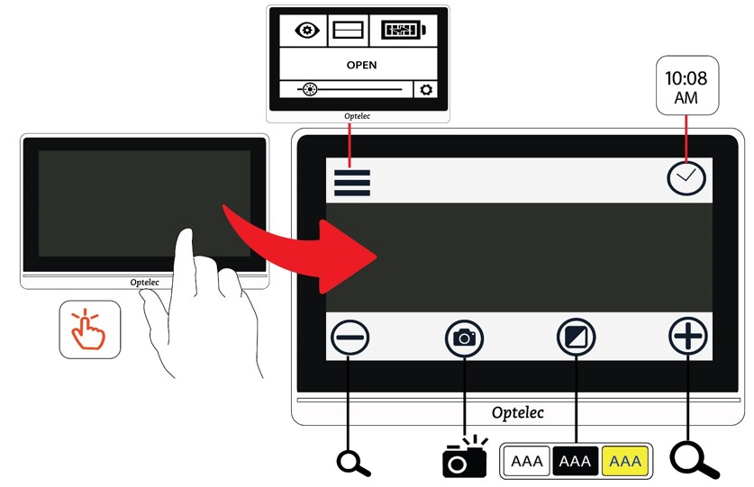
This chapter describes the basics of the touch screen in these sections:
Easy mode and Advanced mode section, which describes the differences between the two and how to change from one to the other.

Basic operations section, which identifies common elements of the screens and enables you to set the time and date.

Button bars section, which defines the buttons included on the top and bottom button bars.

Main Menu structure section, which defines the icons on the Main Menu.

Easy mode and Advanced mode
You can use Compact 8 with or without the menus. In Easy mode, the Menu button and clock are hidden when you touch the screen. Only the bottom buttons are displayed.

These buttons are used to control magnification, change the colour combination, and take a snapshot.

In the following drawing, Easy mode is shown on the left and Advanced mode is on the right.
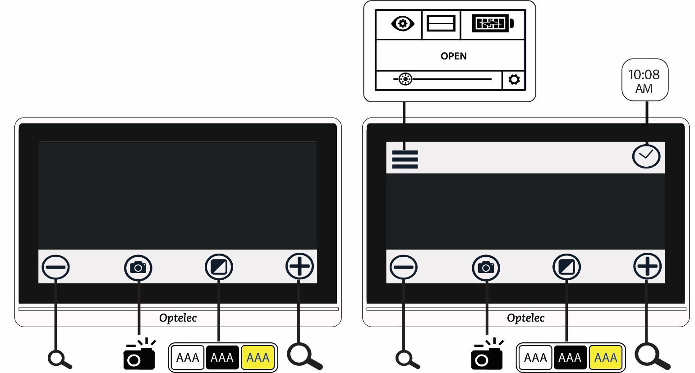

To change the mode:
- Press and hold the Colour Mode button for 5 seconds.
- On the Mode menu that is displayed, tap Easy or Advanced. Easy mode displays only the bottom button bar. Advanced mode includes a top button bar.

In Live View, tap the Menu button on the top left of the screen. The Main Menu is displayed.

The default mode is Easy (unless you changed it to Advanced mode the first time the device was powered on). To customize your settings, you must be in Advanced mode. None of the menus used to customize Compact 8 are available in Easy mode.

In the following drawing, the user is tapping the Colour Mode button while in Easy mode. After selecting Advanced on the Mode menu, the resulting screen is in Advanced mode.
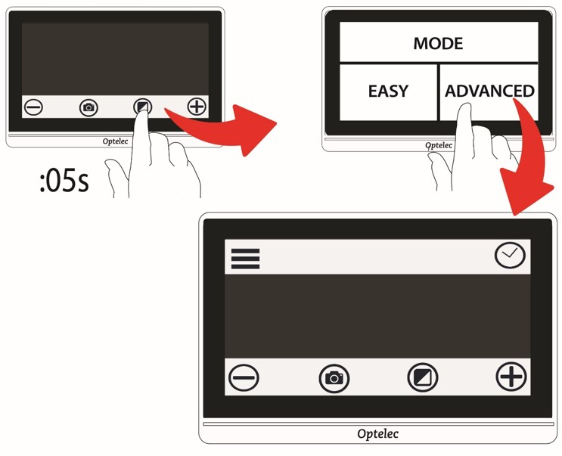

Basic operations
When you power up Compact 8, Live view is the default. You remain in Live view until you take a snapshot. You are in Snapshot view until you close the snapshot by tapping the X in the top right corner of the screen.

Tip: If you are unsure whether you are in Live view, tap the screen to display the button bars. If an X button is at the top right, you are in a snapshot. To return to live view, tap the X.

Set time and date
The following instructions demonstrate some common functionality and enable you to set the current time and date.

Tap on a live image to display the button bars.
Tap the clock in the top right to display the time and date.
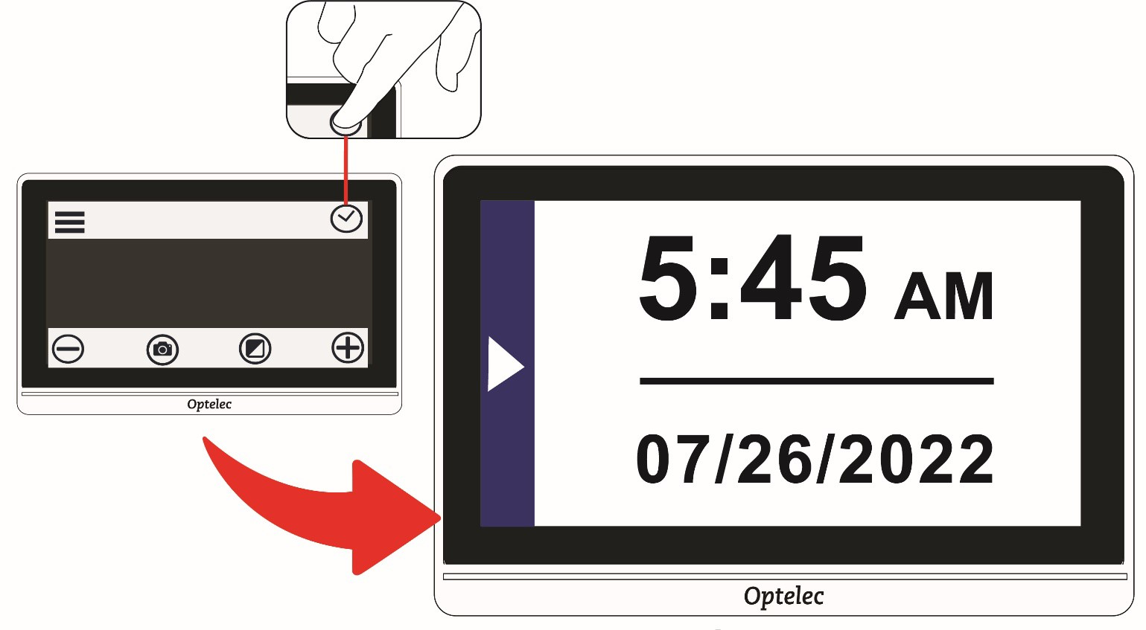
Tap anywhere in the Time and Date screen to display a screen where you choose time and date values.

Anything selected (highlighted) is active. Tap the Date box to select it and display the fields where you set the month, day, and year.
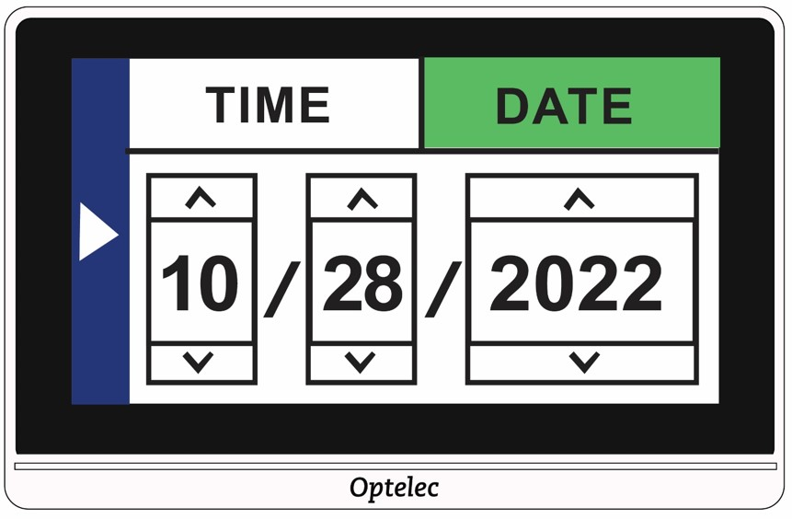

5
.
Tap the up and down arrows to change the value
between them. Tap the arrows to set the correct date.
Tap the Time box to highlight it and display the fields where you set hours and minutes.

Tap 12 or 24 to set whether you want to use a 12-hour clock with AM and PM or a 24-hour clock.

Set the correct time.

To automatically set the values and return to the previous screen, tap anywhere in the left portion of the screen with an arrow.

Repeat the previous step to return to Live view. The clock now reflects the updated time and date.

Caution: Do not rely on the time or date function in this device for any medical decisions, such as when to take your medication. The feature is for your convenience and is not set automatically.

Navigating the menus
When you tap the Menu button to display the Main Menu, you are in Menu view. As you navigate through the menu screens, you will find common elements.
On the Main Menu or any related screen, return to the previous screen by tapping the triangular left arrow on the right side of the screen. You can keep tapping the arrow until you return to Live view.
If you display a snapshot and want to close it and return to Live view, tap the X in the upper-right corner.
Some icons represent functions that can be enabled or disabled by tapping them. The icon is selected when enabled.
For example, tapping the Line icon enables it (left). Tapping it again disables it (right).

Button bars
When you touch the screen, button bars are displayed at the top and the bottom of the screen. A graphical overview and button definitions follow:
The buttons are defined in the following table.
Button | Name | Description
 | Menu button | Displays the Main Menu, where you can access functions and change how the display is rendered.
 | Time button | Displays the current time and date. Tap anywhere on this screen to display the Time and Date screen (see page 14), where you set the values.
 | Zoom out | Decreases the magnification and shows more of the image on the screen.
 | Snapshot | Takes a picture of the image currently on the screen.
 | Colour mode | Changes the colour combination used to display the current image on the screen.
 | Zoom in | Increases the magnification and shows less of the image on the screen.

Main Menu structure

You must be in Advanced mode to personalize your settings. The top button bar is displayed in Advanced mode. If only the bottom button bar is displayed, you are in Easy mode.

To display the menus:
Tap the screen to display the button bars.
Tap the Menu button in the top left corner of the screen.

The Main Menu is displayed.
Row 1
Row 2
Row 3

The structure of the Main Menu is outlined in the following table. The icons representing the menus appear in the left column. The options on the Appearance menu and the Settings menu are described in the next two chapters.

Menu Description
Appearance | Provides ways to customize the screen’s appearance so it is right for your vision—colours, line or mask, light sensitivity, edge effects, and colour blindness settings. Changes to visual properties are immediate. See Customizing Appearance on page 31.
Line on/off | Enables or disables the display of a line or mask on the screen, which can help you keep your place while reading or performing other tasks.
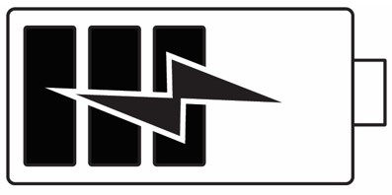  Battery | Displays the percentage of battery power currently available. See Charge the battery on page 8.
SAVE | Saves the snapshot currently displayed on the screen. Once it is saved, the same snapshot and the button bars are displayed. See Save a snapshot on page 27. Not available from Live view.  Note: This option is only available after you have taken a snapshot.
OPEN | Displays a small representation of each saved snapshot in a grid. Also enables you to open a file by tapping on its image. See Open a saved document on page 28. The Delete button at the bottom enables you to delete one or more files. See Delete snapshots on page 29.

Menu | Description
Brightness | Slide the circle right to increase the brightness of the Compact 8 screen. Slide left to decrease it. You can also tap at a lower or higher level to change it. The change is immediate, so you can check the change in brightness while on the Main Menu.
Settings | Displays options that enable you to manage essential system settings. See Changing System Settings on page 44.

Operating the Compact 8
Compact 8 can be used whenever you need to magnify an image. You can hold it to check store labels, read restaurant menus, or magnify anything nearby using the distance camera.

When you extend the stand, you can read material directly beneath Compact 8 using the desktop camera. This section provides examples of uses and describes how to open and close the stand.

Using the desktop camera
Choose a stable, level surface for reading. Extend the stand and place the device on top of your reading material.
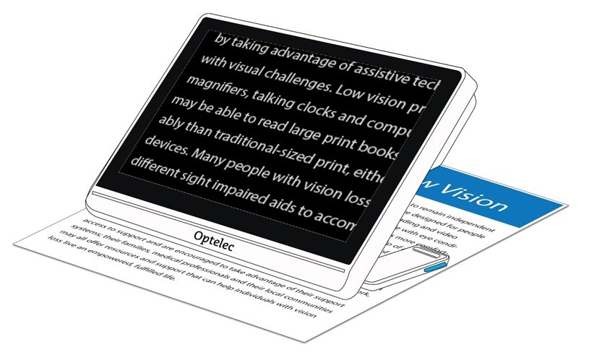
By default, an illumination LED on the back of the Compact 8 shines on the viewing area. The light can be disabled or re-enabled through the Main Menu.

You can improve the visibility of the text being displayed by changing the colour mode and level of magnification.

Short distance viewing
You can hold the Compact 8 to view objects a short distance away. The distance camera is ideal for viewing labels, price tags, or receipts. The stand must be closed to engage the distance camera.

You can also view signs in stores or on the street as you carry Compact 8 with you.
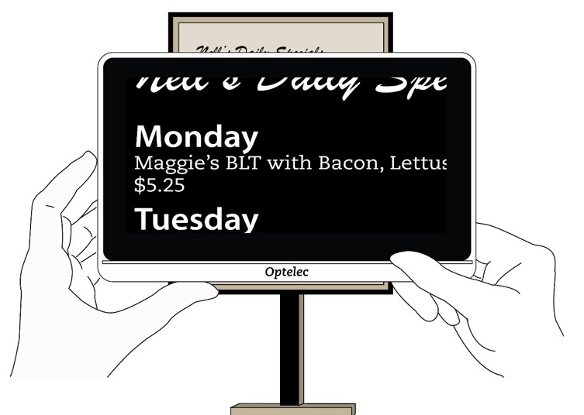

Magnify the camera image
You can change the magnification in Live view or Snapshot view. You have three ways to change it.

Tap the Zoom Out button to decrease magnification and the Zoom In button to increase magnification. Each time you tap is a minor increase or decrease in magnification.

Tap and hold the Zoom in or Zoom Out buttons to continuously adjust the magnification.

Use pinch to zoom on the touch screen.

Zoom out: Place two fingers apart and pull them together to decrease magnification and see more of the image.

Zoom in: Place two fingers together on the screen, then spread them out to increase magnification and see less of the image.
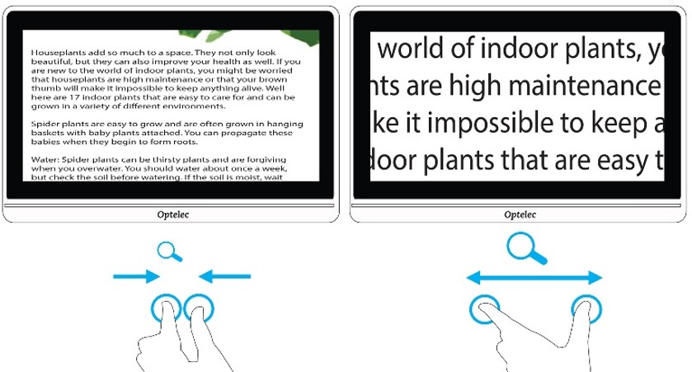

Pan to see more of the image
You can swipe the screen up, down, left, or right to view more of an image than is currently displayed on the screen.

Panning is available in Live view, Snapshot view, and when reviewing a saved image file. More of the display can be panned as the magnification increases.

Change the colour mode

Tap the Colour Mode button to cycle through true colour and four other colour combinations. True colour is always available.

The factory default colour modes are white on black, black on white, yellow on black, and yellow on blue.

The following drawing shows the default colour combinations. The first example shows the user tapping the Colour Mode to rotate through the colour combinations.
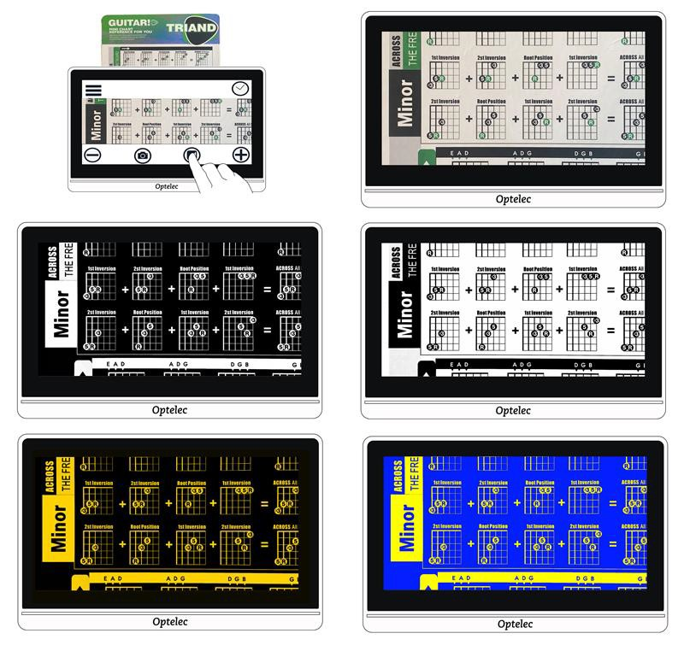

Taking Snapshots
When you power on Compact 8, Live view is the default. The screen shows wherever the Compact 8 camera is currently focused. You are in Live view until you take a snapshot, which freezes the image on the screen. Snapshots allow you to take your time studying objects in more detail.
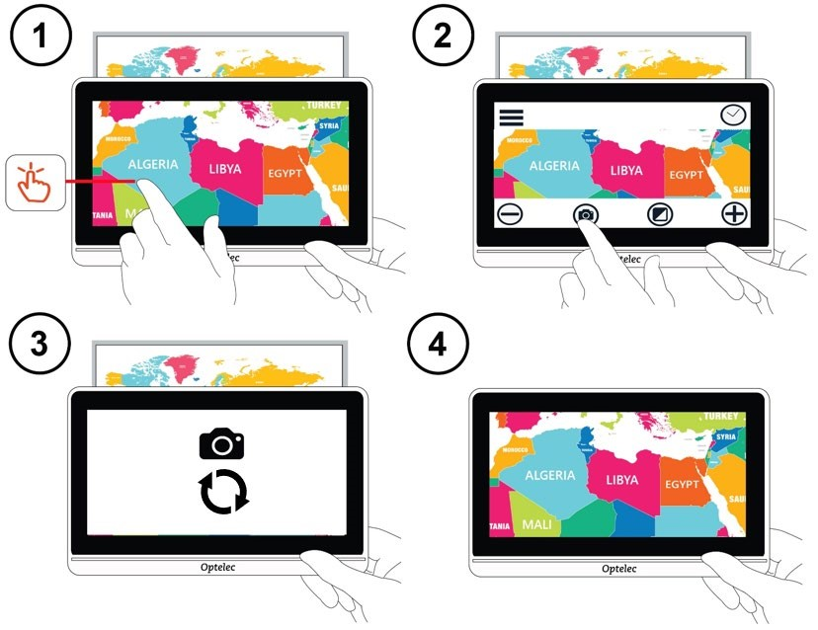

To take a snapshot
- Centre the image you want to save.
- Hold the device steady. Movement can blur the image.
- Tap the screen to display the button bars.
- Tap the Snapshot button. A camera icon and a moving circle are displayed during the capture process.
- Keep the device steady until you hear a camera shutter sound.
- The snapshot is displayed.

Close a snapshot
- In Snapshot view, an X is displayed in the top right corner when you display the button bars. The captured image is displayed until you close it by tapping the X.
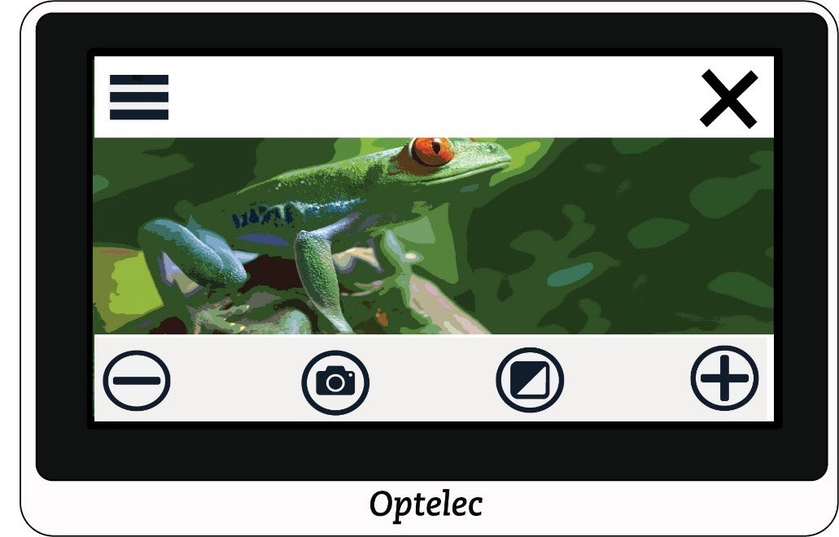
- To return to Live view, you must close the snapshot.

Modify a snapshot
You can customize snapshots the same way you customize the Live view. For example, you can change the magnification or colour mode of a snapshot.

Save a snapshot
If you want a snapshot to be available for viewing later, you can save it:

- Tap the screen to display the button bars.
- Tap the Menu button to display the Main Menu.
- Tap SAVE. This option is only available after you have taken a snapshot.
- Note: The snapshot remains open until you tap the X in the upper-right corner.
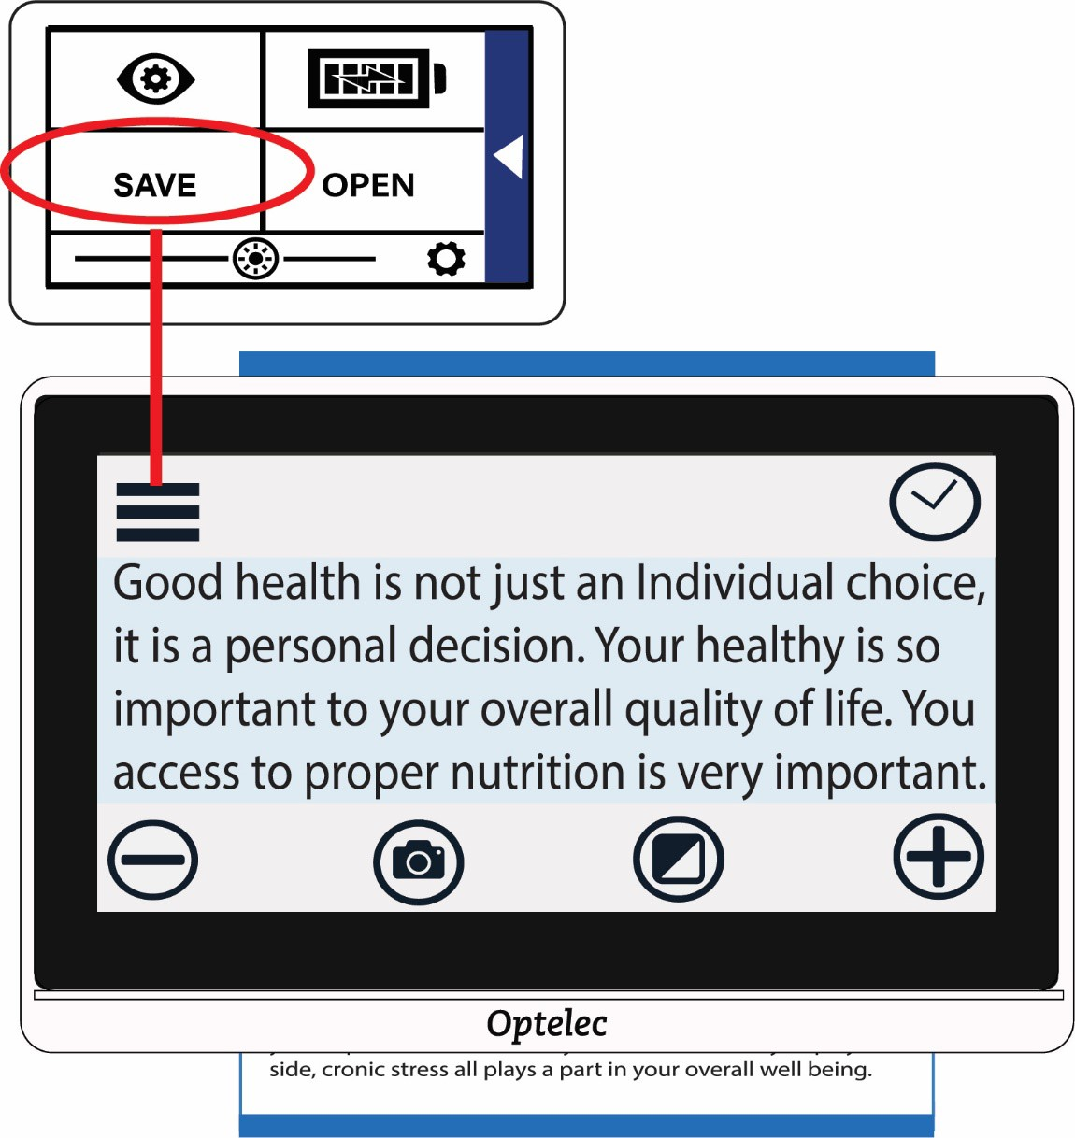

Open a saved snapshot
- To open a saved snapshot:
- Tap the screen to display the button bars.
- Tap the Menu button to display the Main Menu.
- Tap OPEN. All images you have saved will be displayed in a grid. All snapshots are saved as true colour.
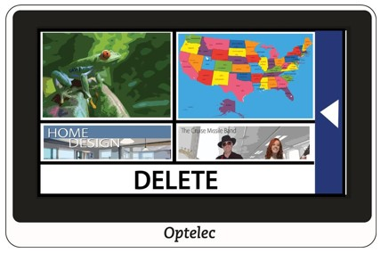
Tap the snapshot that you want to open. The message “Opening” is shown until the image is displayed.
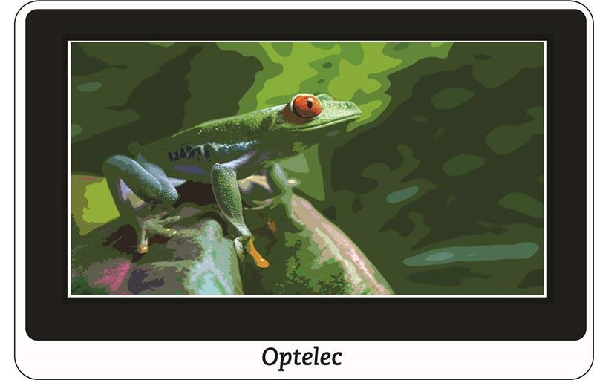
If desired, modify the magnification and colour. You also can pan magnified images just as you can live images. Modifications to a saved high-contrast image are applied only while you have the image open and viewing it. The image reverts to true colour when you close it.

To close the open snapshot, tap the screen to display the button bars and tap the X in the upper-right corner. The Live view is displayed.

Delete snapshots
To delete one or more snapshots:
- Tap the screen to display the button bars.
- Tap the Menu button to display the Main Menu.
- Tap OPEN. All images you have saved will be displayed in a grid. All snapshots are saved as true colour.
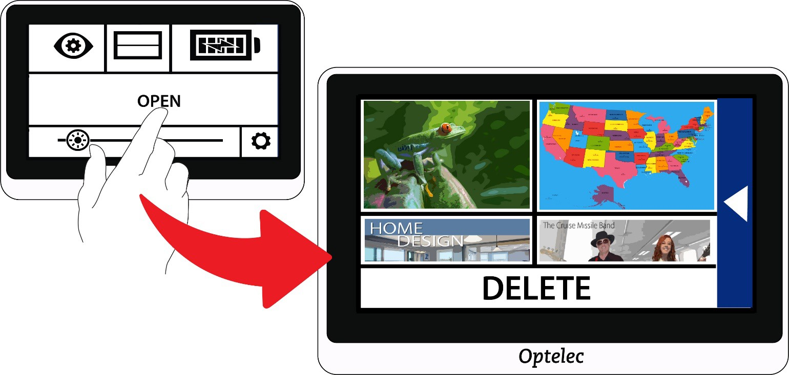
- Tap DELETE at the bottom of the screen. A checkbox is added in the upper-right corner of each snapshot.
- Tap the checkbox on each snapshot that you want to delete.
- Tip: To remove all snapshots from Compact 8, you can leave all checkboxes empty, tap DELETE, then tap YES on the confirmation screen.
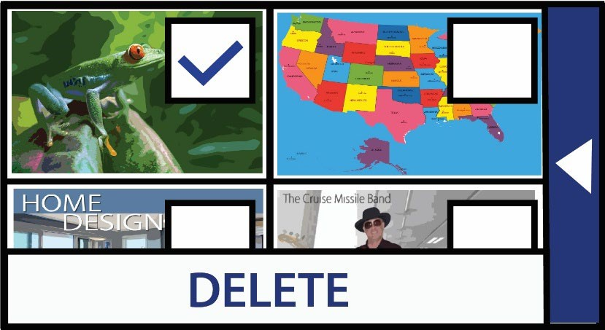
- Tap DELETE. A confirmation message is displayed.
- Tap YES. The system message “Selected documents deleted” is displayed, then you return to the Delete screen.

Customizing Appearance
- COLOR | - LINE
- LIGHT SENSITIVITY | - EDGE
- COLOR BLINDNESS

The Appearance menu displays options that enable you to customize the visual properties of the image on the Compact 8 screen.

To change the settings, you must be in Advanced mode so that the top button bar is displayed. If you tap the screen and only the bottom button bar is displayed, you are in Easy mode.

To display the Appearance menu:
- Tap the screen to display the button bars.
- Tap the Menu button in the top left corner of the screen. The Main Menu is displayed.
- Tap the Appearance icon. The Appearance menu is displayed.
- Row 1
- Row 2
- Row 3
All options on this menu are available in both Live view and Snapshot view, apart from the Line option, which is only available in Live view.
The available edge effects depend on the current colour mode.

The options that are available from the Appearance menu are described in the following table.
Option | Description
COLOR | Colour screen, where you set the four colour combinations available through the Colour Mode button.  Note: True colour, which is always available as the fifth colour mode, cannot be disabled.
LINE | Line screen, where you select the type of line or mask displayed in Live view when the Line icon is selected on the Main Menu. Tap to select a horizontal or vertical line or mask.
LIGHT  SENSITIVITY | Tap to enable (selected) or disable (not selected) light sensitivity. When enabled, wavelengths associated with pain from light sensitivity are reduced.
EDGE | Edge Effects screen, where you can enable or disable a feature that removes clutter and enhances the edges of high-contrast images.
COLOR BLINDNESS | The Colour Blindness screen, which improves colour differentiation and contrast for three types of colour blindness. If any of the boxes appear solid Gray, tap it. Otherwise, NONE is selected by default.  Note: You must scroll down to see this option.

Colour
You can set four colour combinations included in the rotation of the
Colour Mode button by going to Main Menu > Appearance Menu >
Colour.

The same colours are offered in Live view and Snapshot view.

Note: True colour, which is the fifth colour mode, cannot be disabled.
Tap the up and down arrows to select the two colours of each colour combination.
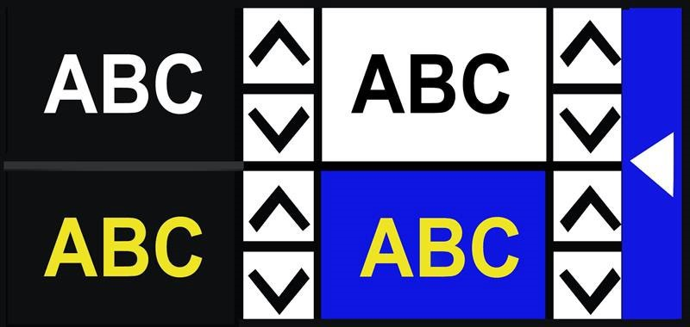
The top left colour combination is required. If you want fewer than four colour combinations in the rotation, scroll until the X is displayed in the other three boxes.

The colour combinations are set when you leave the Colours screen. Tap the right arrow to return to the previous screen.

Available colour combinations
The following two-colour combinations can be used in displaying images. When referenced, foreground is mentioned first. For example, white on black means white text on a black page.
Foreground Background
White | Black
Black | Yellow
Black | Green
Blue | Yellow
Blue | White
Black | Orange
Black | Red
Black | Blue
Yellow | Black
Green | Black
Yellow | Blue
White | Blue
Orange | Black
Red | Black
Blue | Black
Black | Enhanced colour
Black | Grayscale

Dynamic contrast
Compact 8 dynamically adjusts the contrast in distinct parts of the image to improve the viewing experience. Dynamic contrast is automatically set when using any two-colour combination or enhanced colour.

Line
The Line option on the Appearance menu is used to select the type of line or mask you want to use whenever the Line option on the Main Menu is enabled (selected). Using a line or mask in Live view can help you keep your place on the screen.

You can change the position of a line by using one finger to move a horizontal line up or down, or a vertical line left or right.
You can change the size of a mask by using one finger to move one side of a horizontal mask up or down, or a vertical mask right or left.

You have a choice of four options:
- Horizontal line (top left)
- Vertical line (top right)
- Horizontal mask (bottom left)
- Vertical mask (bottom right)
- The line or mask is displayed across the screen and continues to be displayed until the Line option is deselected.

Light Sensitivity

Compact 8 is designed to minimize discomfort from light sensitivity during long-term use of this device. This feature reduces the wavelengths of light associated with this discomfort. The goal is to increase comfort while maintaining acceptable luminance and contrast levels. Users with many types of eye conditions may benefit from this feature, but especially those having macular degeneration or retinitis pigmentosa.

To enable this feature, go to Main Menu > Appearance and tap on Light Sensitivity. When selected, the Light Sensitivity feature is enabled.

Edge Effects

The Edge Effects screen is designed to help you recognize objects by removing clutter and enhancing edges. With this feature enabled, contrast is improved to help objects stand out against the background.
For true colour or enhanced colour, two options are available: disabled (default) or enabled.

For any two-colour combination, four options are available: disabled (default), smooth, edge only, or highlight.

A description of each type of edge effect follows, along with samples.

True colour or enhanced colour:
If using true colour or enhanced colour, tap one of the following:
- Disabled
- No changes are made to images.
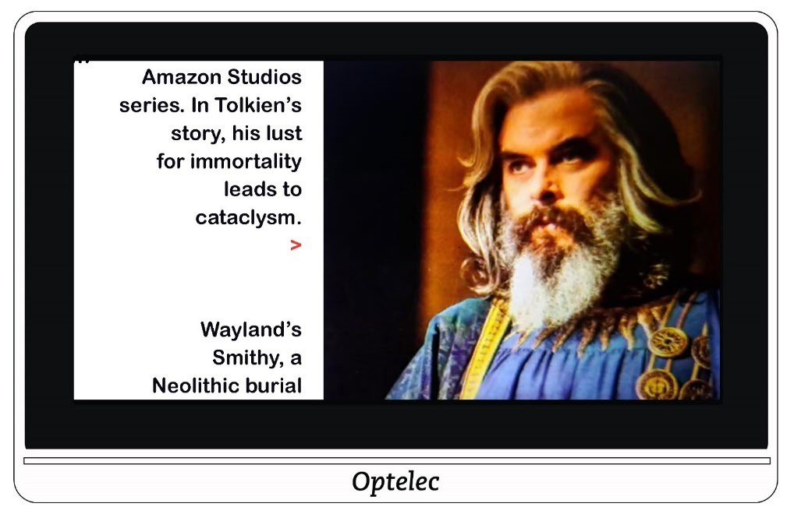

Enabled
Improves contrast in images and outlines text.
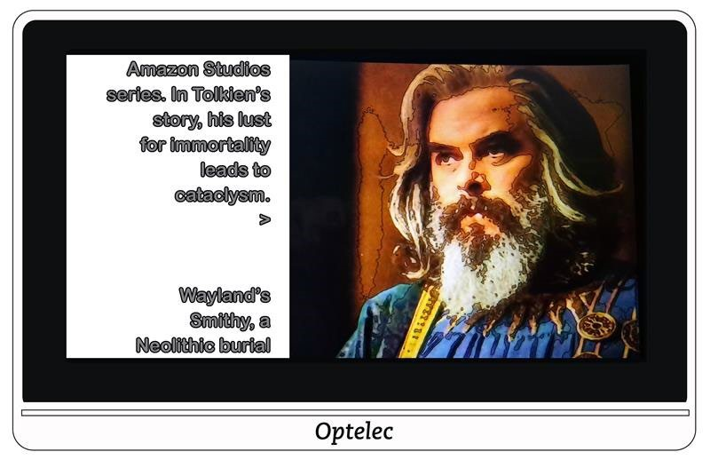

Two-colour combination
If using any two-colour background and foreground combination, tap one of the following:
- Disabled
- No changes are made to images.
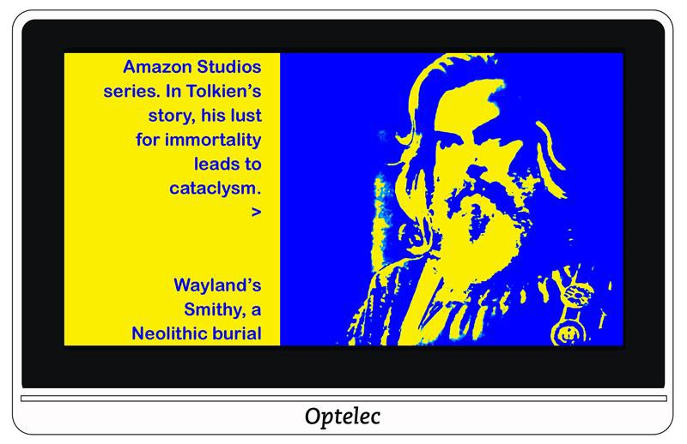

Smooth
Reduces visual noise in images.
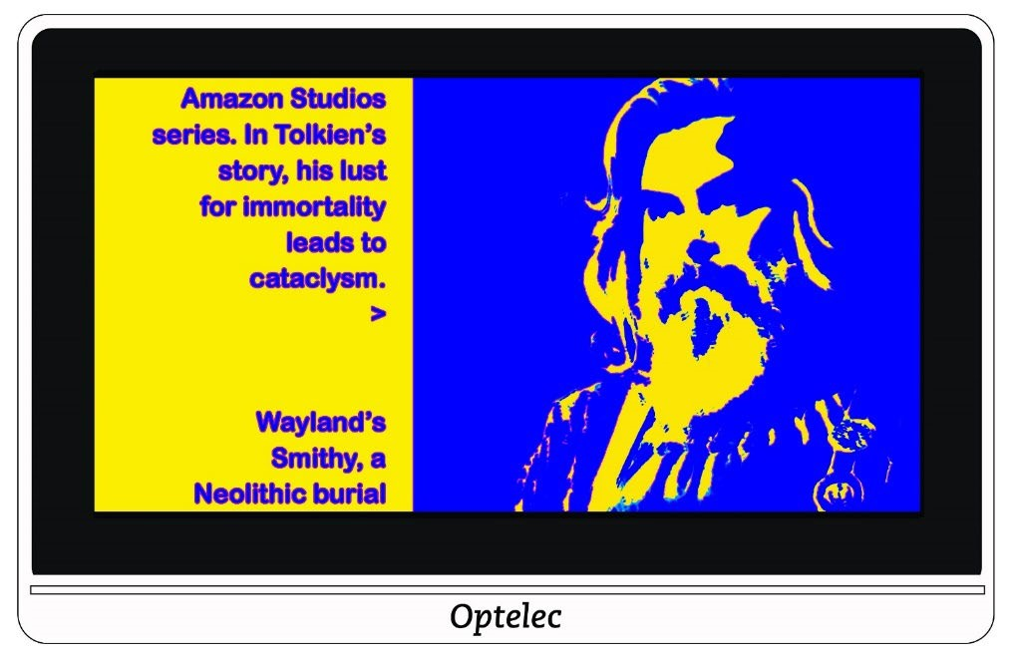

Edge only
Display only the lines and edges of objects in the image.
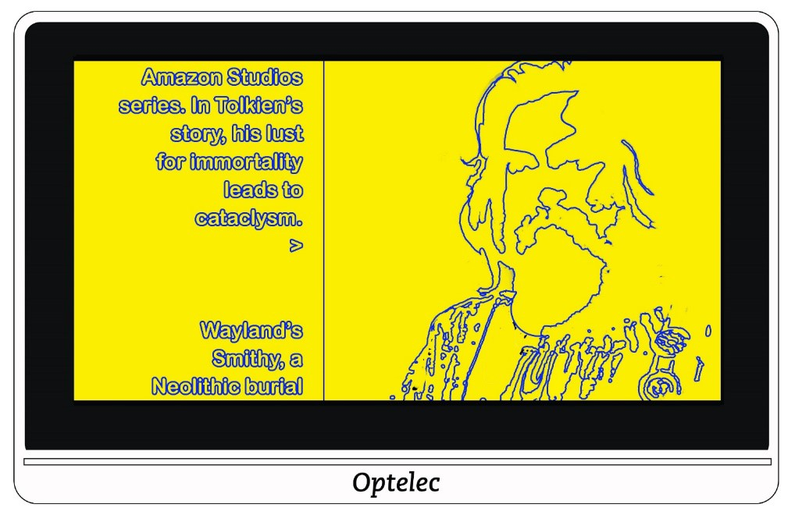

Highlight
Highlights the edges of images.

You have a choice of five colours used to highlight the outlines of text and images. When you tap the Highlight option, the Edge Highlight screen is displayed. Tap the colour used for highlighting.
Colour Blindness
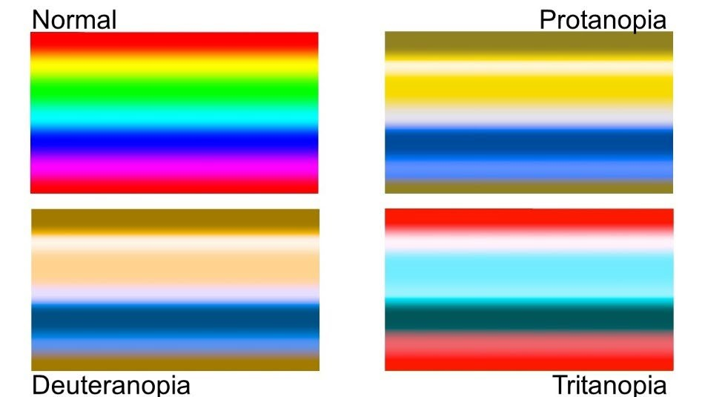

Compact 8 is designed to assist with colour differentiation that improves
contrast for users with three types of colour blindness.

To use the colour blindness feature, go to Main Menu > Appearance > COLOR BLINDNESS.

You must scroll down to see this option.

The Colour Blindness screen displays four boxes. NONE is selected by default. If one of the boxes appears solid grey, tap it.

This feature address three types of colour blindness:
- Protanopia (colour blindness to red) is detected by placing a blue box next to a grey one.
- Deuteranopia (colour blindness to green) is detected by placing a green box next to a grey one.
- Tritanopia (colour blindness to blue) is detected by placing a yellow box next to a grey one.

Changing System Settings
The Settings menu displays options that enable you to manage essential system settings.

To change the settings, you must be in Advanced mode so that the top button bar is displayed. If you tap the screen and only the bottom
buttons are displayed, you are in Easy mode.

Directions for displaying the Settings menu are found after the following graphic of the menu’s contents.
THEME | LIGHTS
SOUND | MIRACAST
STANDBY | LANGUAGE
UPDATE | RESTORE
INFORMATION

To display the Settings menu:
- Tap the screen to display the button bars.
- Tap the Menu button in the top left corner of the screen. The Main Menu is displayed.
- Tap the Settings icon in the lower right corner. The Settings menu is displayed.

Each option on the Settings menu is defined in the following table.
Details are provided in this chapter.
Option Description
THEME | Theme screen (page 46), which enables you to set a light or dark theme for the buttons and menus.
LIGHTS | Lights screen (page 47), where you control whether the lights are enabled when you use the cameras.
SOUND | Sound screen (page 47), which enables you to set the system volume.
MIRACAST | Miracast screen (page 48), where you set up Compact 8 to display on a Miracast-enabled device, such as a television or monitor.
STANDBY | Standby screen (page 50), which enables you to set the period of inactivity required before Compact 8 goes into Standby mode.
Option Description
LANGUAGE | Language screen (page 50), where you can change the language used on the buttons and menus.
UPDATE | Update screen (page 51), where you install the latest Compact 8 software and firmware.
RESTORE | Restore screen (page 52), where you can reset Compact 8 to its default settings.
INFORMATION | Information screen (page 52), which provide facts that may be helpful if you need technical support.

Theme

The Theme screen enables you to select a dark or light background for menus, screens, and buttons. For example, selecting LIGHT means black text against a white background; selecting DARK means white text against a black background.

Lights

This screen lets you enable or disable the two lights for the desktop camera (labelled MAGNIFIER on the Lights screen) and the light for the distance camera (labelled OVERVIEW on the Lights screen).

MAGNIFIER lights are used with the desktop camera, where the stand is open so that you can read material beneath the device. By default, the reading lights are enabled for optimal image quality.

The OVERVIEW light is used with the distance camera, which is used to view objects at a short distance when the stand is closed. By default, the overview light is disabled.

Tap in the square to set the lights to on or off for each camera. The square and checkmark are selected when the lights are on
Slide right to select the checkmark and enable the light(s). The screen is selected when enabled.
Slide left to select the X and disable the light(s). The screen is not selected when disabled.
7.3 Sound
The Sound screen enables you to control the volume of system sounds, such as the camera shutter sound that is emitted when an image is successfully captured. The updated volume is immediately applied.
You can change the volume in the following ways:
Slide the volume button right to increase the volume and left to decrease it. Each time you change the sound level, a soft popping sound is played as an example of the volume. When the sound is up, the MUTE section of the screen is not selected, and the field highlights the X.
Use the yes/no slider field below the Mute icon. When the sound is off, the MUTE section is highlighted.
To mute system sounds, tap right to highlight the checkmark at the bottom of the screen. When the sound is muted, the bottom of the screen’s background changes colour, and the volume indicator at the top of the screen moves to the far left.
- To activate sound, tap left to highlight the X at the bottom of the screen. If you previously set the volume at the top of the screen, the volume indicator remembers the last setting and moves to it.

Miracast

Miracast® is a standard for a wireless connection. It can be described as HDMI over Wi-Fi, where the Wi-Fi connection replaces a USB to HDMI cable from Compact 8 to a computer, TV, tablet, or cell phone.

Note: Bluetooth is not required to use Miracast.

To use Miracast on Compact 8, you must have a computer or other display device that supports Miracast and is enabled for a connection.

For directions, refer to the documentation for that device.
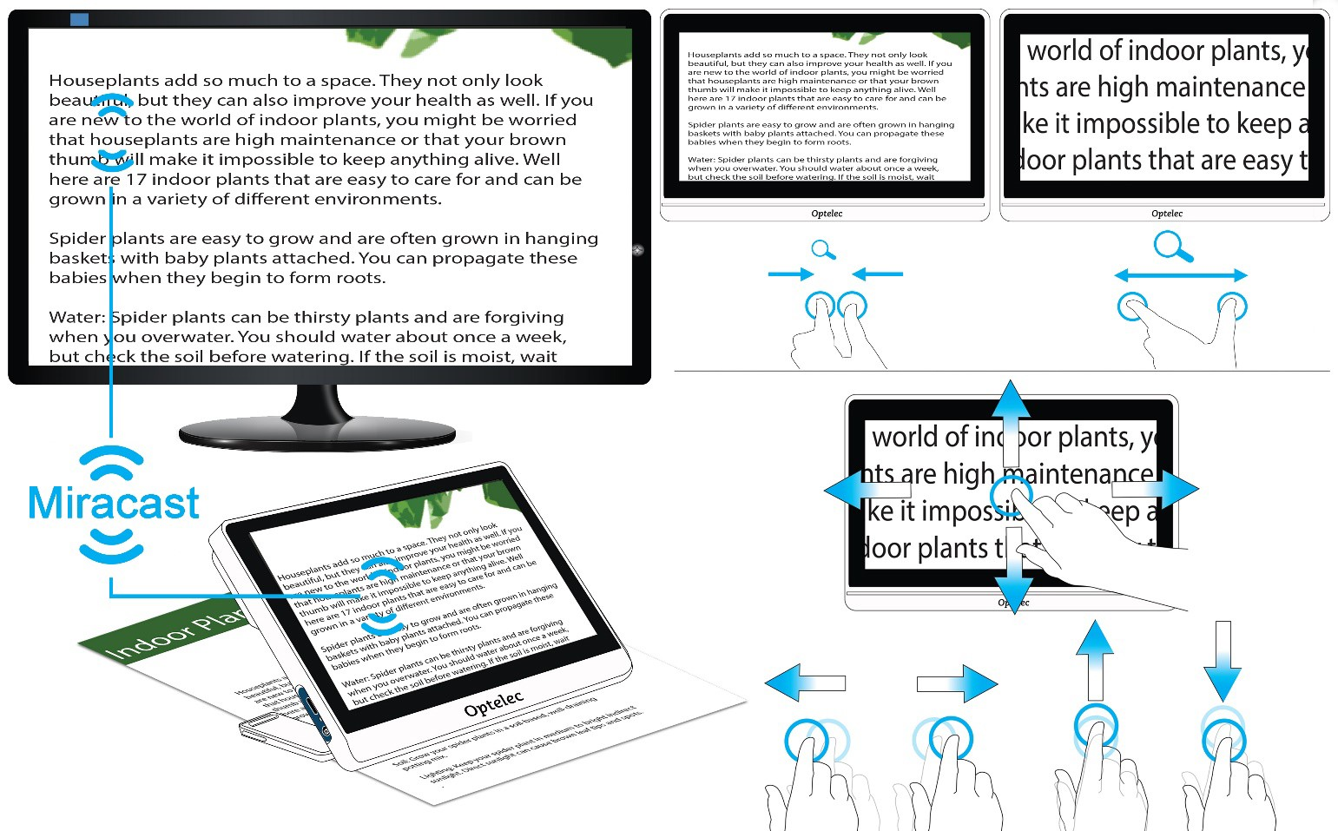
To guarantee a good connection, the Compact 8 needs to be within one meter or three feet of the TV or other device. Depending on the connection, a short delay may occur.

A duplicate of the Compact 8 screen is displayed on the connected device. You can pan an image, and the connected device will display the image as it is moved up, down, left, and right.

To enable Miracast on Compact 8 and connect it to another display device:
Go to Main Menu > Settings > Miracast.

On the top right corner of the Miracast screen, swipe the on/off button to the right to select the checkmark.

Compact 8 automatically scans for available devices and lists them on the screen. Tap on a device name to connect. In the screen that displays, tap CONNECT. (To return to the Miracast screen instead of connecting, tap FORGET.) It could take up to a minute to establish the connection. When established, the video will be streamed, and the same content will appear on the display device and the Compact 8.

To disconnect, return to the Miracast screen. In the upper right corner, swipe the button left so X is selected.

Standby

The standby time indicates what period of inactivity is required for the device to go into Standby mode. The minimum is NONE and the maximum is 30 minutes.

If you tap 15 MIN, for example, Compact 8 goes into Standby mode when no user interaction occurs for 15 minutes.

If you tap NONE, the device will never go into Standby mode despite the length of inactivity. This option is not recommended since Standby mode helps extend the battery life.

Language

On the Language screen, tap to check the language used for the buttons and menus. The change is immediate.

Caution: Be sure that the correct language is selected before exiting the screen.

The language is set when the device is powered on for the first time.
However, this screen enables you to change the language at any time.

Update

For maximum performance, you should periodically update the
Compact 8 to install the latest software release. To perform the update, you need a dual USB drive (USB-C and USB-A) or dual USB cable (USB-C and USB-A).

Note: It is recommended that you update using a USB drive. However, you can also use a dual cable. To do so, copy the update file into the main directory of the device, go to step 2, and skip step 3. If the update fails, try using a dual USB drive.

To update the device:
- Download the release software from the Optelec website onto a USB drive that can support both USB-C and USB-A. The release file, which has a VHU (Vispero Hardware Update) extension, updates the Compact 8 software and firmware.
Tip: A USB-C adapter can be used with a USB-A flash drive.
Ensure you have a minimum of 50% battery power by looking at the battery icon on the Main Menu. If necessary, charge the device.
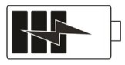
- Insert the USB-C drive with the VHU release file into the Compact 8 USB port.
- Go to Main Menu > Settings > Update.
- Tip: If “Insert USB Drive” is displayed, flip over the USB-C drive and reinsert it into the port.
- Tap UPDATE. During the update, which can take several minutes, status messages are displayed. At the end of the update, the system restarts.
Caution: Do not remove the drive until the update is finished. Doing so may result in an unresponsive device that requires service repair.
After the update, Live view is displayed.

Restore

If you are dissatisfied with the way your Compact 8 is set up, you can restore its default settings. You will be in Easy mode, and all settings will be returned to how the device arrived in the box. The colour combinations and other custom settings you may have made are cleared.

Note: No saved images are deleted when you reset the Compact 8. Only customization of the device is affected.

If you want to restore Compact 8 to its factory default values, go to Main Menu > Settings > Restore. A confirmation screen is displayed. Tapping YES restores your settings, and you are returned to Live view in Easy mode.

Information
The Information screen provides product information, including software and firmware versions, platform name, and serial number.

How to contact RNIB
Phone: 0303 123 9999
Email: shop@rnib.org.uk
Address: RNIB, Northminster House, Northminster, Peterborough PE1 1YN
Online Shop: shop.rnib.org.uk
Email for international customers: exports@rnib.org.uk

RNIB Technology Team:
Telephone 0303 123 9999
Email tfl@rnib.org.uk

Terms and conditions of sale
This product is guaranteed from manufacturing faults for 12 months from the date of purchase. If you have any issues with the product and you did not purchase directly from RNIB then please contact your retailer in the first instance.

For all returns and repairs contact RNIB first to get a returns authorisation number to help us deal efficiently with your product return.

You can request full terms and conditions from RNIB or view them online.

RNIB Enterprises Limited (with registered number 0887094) is a wholly owned trading subsidiary of the Royal National Institute of Blind People ("RNIB"), a charity registered in England and Wales (226227), Scotland (SC039316) and Isle of Man (1226). RNIB Enterprises Limited covenants all of its taxable profits to RNIB.

This product is CE marked and fully complies with all applicable EU legislation.

This product is UKCA marked and fully complies with the relevant UK legislation.

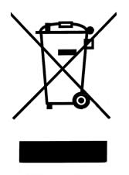

Please do not throw items marked with this symbol in your bin. Recycle your electricals and electronic devices free at your local recycling centre. Search for your nearest recycling centre by visiting www.recyclenow.com.

Why recycle?
Unwanted electrical equipment is the UK’s fastest growing type of waste.

Many electrical items can be repaired or recycled, saving natural resources and the environment. If you do not recycle, electrical equipment will end up in landfill where hazardous substances will leak out and cause soil and water contamination – harming wildlife and human health.

RNIB are proud to support your local authority in providing local recycling facilities for electrical equipment.

To remind you that old electrical equipment can be recycled, it is now marked with the crossed-out wheeled bin symbol. Please do not throw any electrical equipment (including those marked with this symbol) in your bin.

What is WEEE?
The Waste Electrical or Electronic Equipment (WEEE) Directive requires countries to maximise separate collection and environmentally friendly processing of these items.

How are we helping?
In the UK, distributors including retailers must provide a system which allows all customers buying new electrical equipment the opportunity to recycle their old items free of charge. As a responsible retailer, we have met the requirements placed on us by financially supporting the national network of WEEE recycling centres established by local authorities. This is achieved through membership of the national Distributor Take-back scheme (DTS).

Date: June 2023.

© RNIB

*HC135P* HC135P

