Ravencourt Living Talking Easy USB Music and radio Player (HD16)
Thank you for purchasing from RNIB. This item has been supplied by a third party. In the unlikely event the item is unsuitable, please contact us within 14 days of receipt to obtain your returns number. To ensure your return goes smoothly, the item and all components must be in as new condition and packed in its original, undamaged packaging. For further details and guidance on returning faulty items, please see the Terms and conditions of sale and How to contact RNIB sections of this instruction manual.

Please retain these instructions for future reference.

What is our Easy Music Player?
Our Easy Music Player is a digital radio and audio player which has been thoughtfully designed to be very simple to operate through a press of a button, once set to the correct station or media option.

Our Easy Music Player is also portable as it has a built in rechargeable battery, or it can be mains powered.

Battery life:
If you play through USB, the battery life is about 6 hours.
If you play through Bluetooth connection or Digital Radio the battery life will be about 12 hours. It takes 7 hours to fully charge your Easy Music Player.

For single button use we recommend not letting the battery run completely flat. This is so that the users settings are not lost. Pressing the top button puts the Easy Music Player into standby mode which will still drain the battery. For constant use please use the cable provided.

Product features:
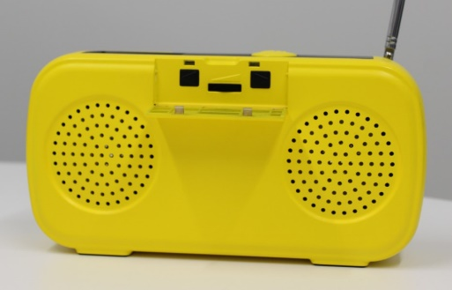
PlayButton
SelectButton
ConfirmButton
VolumeWheel

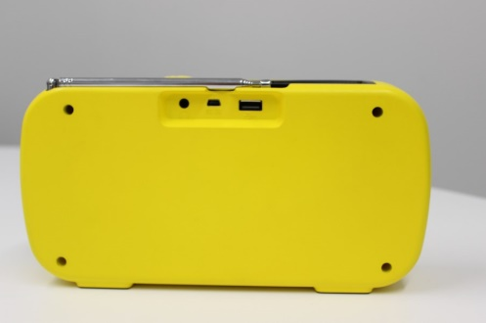
USBPort
RadioAntenna
HeadphoneJack
PowerSocket

Playing modes:
- DAB Radio
- USB Player (perfect for playlists and audio books)
- Bluetooth Speaker Listening Modes:
- Easy Music Player Speakers
- Bluetooth Headset Wired Headset

How to use your Easy Music Player
First you will need to open the front cover and turn volume wheel to the right side until it clicks. Your Easy Music Player has now been switched on. To switch off turn the volume wheel all the way to the left until it clicks.

To switch playing modes hold the top button for 5 seconds. Your Easy Music Player can be set to play your desired audio at a comfortable volume level, and by closing the control panel, the intended user can simply pause and play the Easy Music Player using the button on the top.

DAB Radio mode
DAB Radio mode allows the user to listen to their favourite radio station and use the top button to start and stop the radio.
Please use the Easy Music Player’s aerial when in radio mode.
When you select DAB radio by pressing the top button for 5 seconds, the system will start booting up DAB.
After starting up, DAB will automatically open the last listened to radio station however, if there is not a previously listened to radio station, then it will automatically enter DAB scanning after starting up.
You can enter the DAB Radio menu by pressing the [ ] button.

DAB Radio
Station List
Scan
Return Upper

Press [ ] button to scroll through the menu content, followed by pressing [ ] button to confirm.
If you have selected and confirmed STATION LIST, and it shows ‘no DAB radio station’, it will enter a DAB scan automatically.

DAB Radio ^{1/17}
Station List ^{3/17}
ABC Classic FM
ABC Country

Press [ ] button to select DAB radio station, followed by pressing [ ] button to confirm.

USB player mode
USB player mode allows you to upload a favourite playlist onto a USB stick and play through your Easy Music Player.
The user can use the One Button Operation to Pause and Play the audio.

This mode can also be used for audio books and talking newspapers. The Easy Music Player features automatic bookmarking, which saves your place on multiple audio books.
If a USB is connected you can access USB player mode by holding down the play button for 5 seconds.
  BLU Headset EXT Audio
  BLU Headset
  DAB Radio _{3/17} ABC Country

Bluetooth headset

Press [ ] and [ ] button at the same time to change to Bluetooth headset mode. Under searching mode, press [ ] button to select searched Bluetooth headsets. If there are multiple devices, press [ ] button in turn to select, followed by pressing [ ] button to confirm.

Wired Headset
To listen to your Easy Music Player through a wired headset, simple plug your headset into the headphone jack on the back.

FAQ’s
Q. My Easy Music Player is not picking up a radio signal. What should I do?
A. You can scan and select radio stations by pressing [ ] followed by [ ] buttons .If this doesn’t work please try a new location, adjust the aerial and try this again. Some areas or buildings with very thick walls do not receive good DAB Radio Signal.

Q. When playing a playlist or audio book by USB, do I need to leave the USB stick in the Easy Music Player?
A. Yes

Q. When I press the top button to stop the Easy Music Player will it still use up battery life?
A. Yes, for constant use we recommend plugging into the mains with the adaptor provided. The battery life of 6 -12 hours can be used for portability when necessary.

Terms and conditions of sale
This product is guaranteed from manufacturing faults for 12 months from the date of purchase.

For all returns and repairs contact RNIB. You can request full terms and conditions from RNIB or view them online.

How to contact RNIB
Phone: 0303 123 9999
Email: shop@rnib.org.uk
Online Shop: shop.rnib.org.uk

Products are provided by RNIB Enterprises Limited. Company number: 0887094 Registered office: The Grimaldi Building, 154a Pentonville Road, London N1 9JE. RNIB Enterprises Limited is a trading subsidiary of the Royal National Institute of Blind People, a charity registered in England and Wales (226227) and Scotland (SC039316).

Date: May 2026.

