# Logic MAC Keyboards (HK67-HK72)

Thank you for purchasing from RNIB. This item has been supplied by a third party. In the unlikely event the item is unsuitable, please contact us within 14 days of receipt to obtain your returns number. To ensure your return goes smoothly, the item and all components must be in as new condition and packed in its original, undamaged packaging. For further details and guidance on returning faulty items, please see the Terms and conditions of sale and How to contact RNIB sections of this instruction manual.

Please retain these instructions for future reference.

**Contents**

Logic MAC Keyboards (HK67-HK72) 1

What’s in the box 3

Get to know the Titan Mac Logickeyboard 4

Bluetooth connection 4

USB wired connection 5

Bluetooth pairing 6

Keyboard controls 7

System Lock 8

Keep the Titan powered 9

Cleaning your Titan 10

Protect the environment 11

Terms and conditions of sale 11

How to contact RNIB 11

Thank you for purchasing the Titan Mac Logickeyboard. It features backlit keys delivering a precise typing experience, and a dual-connectivity system enabling use as USB wired or Bluetooth wireless – selectable with a keypress.

The Titan keyboard uses a long-lasting rechargeable lithium battery for the Bluetooth system and is designed and optimized for use with Mac OS. However, it can easily be connected to an iPad or iPhone as well, or to two Macs – one corded and another wirelessly – making it ideal to control two workstations.

### What’s in the box

* Titan Mac Logickeyboard
* USB cable
* User guide

### 

### Get to know the Titan Mac Logickeyboard

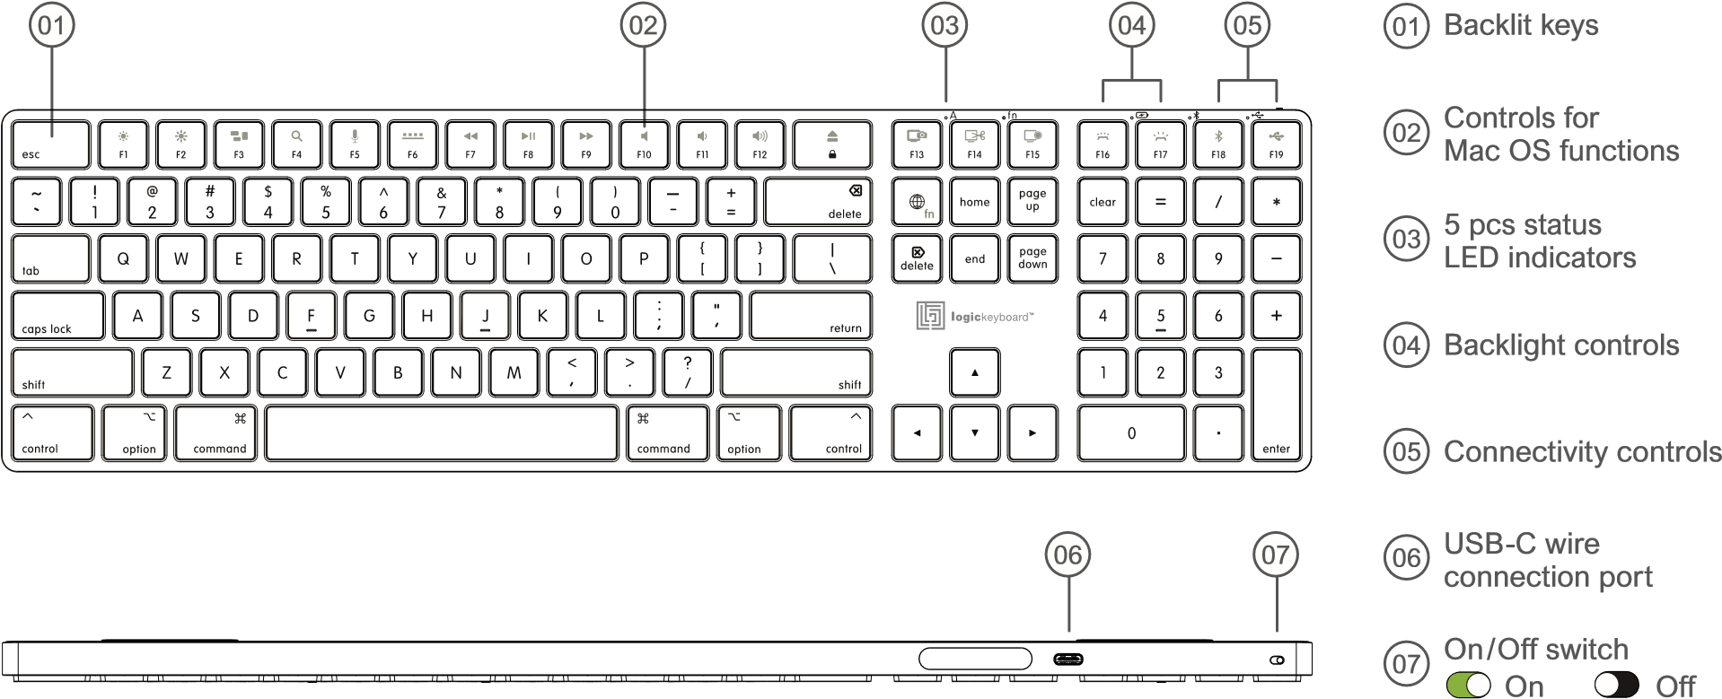

#### Status LED indicators

When the Titan keyboard’s on/off switch is in On position, the keyboard uses 5 LED status indicators. What do they mean?

Battery

Bluetooth

connection

Caps

Lock

USB wired

connection

fn Lock

**Caps Lock [A] and Fn Lock [fn]**

LED indicators illuminate in color matching the connectivity setting.

**Battery indicator**

On

= Battery being charged

* Off = Battery is fully charged, or USB cable is not connected.
* Slowly flashing (est. 1 flash/sec) = Battery power level is below <5%. Insert cable to recharge.
* Fast flashing (est. 3 flashes/sec) = Battery power is critical low <1%. Backlight turns off when battery is critically low.

### Bluetooth connection

* On = Keyboard is connected wirelessly via the Bluetooth system.
* Off = Bluetooth system is deactivated, and keyboard is connected via USB cable.
* Slowly flashing (est. 1 flash/sec) = Bluetooth system is in pairing mode, searching for a new host.
* Fast flashing (est. 3 flashes/sec) = Bluetooth connection is selected but the Bluetooth system is unable to pair with the last connected host. Make sure the device Titan keyboard is connected to is turned on and within operating distance. After 30 seconds of searching in vain for its host, the Titan keyboard will enter Power Saving Mode.

### USB wired connection

* On = Keyboard is connected via USB cable.
* Off = Keyboard is connected wirelessly via the Bluetooth system.
* Fast flashing (est. 3 flashes/sec) = USB wired connection is selected, but keyboard is unable to connect. Make sure the USB cable is properly inserted in both the Titan keyboard and your Mac or try connecting it to another USB port. To avoid battery power drainage in such unintentional situation, the keyboard will enter Power Saving Mode after 30 seconds.

**Let’s begin**

Slide the keyboard on/off switch to position On so green is visible. The three LED indicators for Battery (red) Bluetooth connection (blue) and USB connection (green) will light up for 2 seconds.

### Bluetooth pairing

When you power up the Titan keyboard for the first time, it automatically enters Bluetooth pairing mode. The Bluetooth indicator LED (blue) will flash slowly (est. 1 sec flashes). This indicates the keyboard is searching for a Bluetooth host for connection.

1. When you power up the Titan keyboard first time, it automatically enters Bluetooth pairing mode. The Bluetooth indicator LED (blue) will flash slowly (est. 1 sec flashes). This indicates the keyboard is searching for a Bluetooth host for connection.

Goto **System Preferences** on your Mac, iPad or iPhone, and choose **Bluetooth.**

2. Search for **TITAN keyboard** and click to connect.

3. When the keyboard is successfully paired, the associated blue Bluetooth indicator LED will light permanently.

4. If you later wish to pair your Titan keyboard to another Bluetooth device, you can easily enter pairing mode again with a **long key press of [Fn+F18].** Press and hold the two keys for 2 seconds. The blue LED Bluetooth indicator will flash slowly indicating

the keyboard is searching for a new host. Follow steps 1 to 3.

#### USB connection

* Connect the included USB cable to the Titan keyboard and to your Mac.
* Press **[Fn+F19]** to switch to USB wired connection.
* After the keyboard’s connectivity is changed to USB wired, the associated green USB indicator will light permanently.

#### Switch connectivity

**+**

For wireless connection press

**+**

For USB wired connection press

### Keyboard controls

The function keys (F-keys) in the top row of the Titan keyboard provide controls for several common Mac OS functions. These

controls are accessible by pressing the designated F-key in combination with the **Fn modifier key** simultaneously.

|  |  |  |
| --- | --- | --- |
| Dim screen |  | Decrease speaker volume |
| Brighten screen | Increase speaker volume |
| Mission control | Eject |
| Spotlight Search | Screenshot, entire screen |
| Dictation/Siri | Screenshot, selection of screen |
| Hide/show dock | Screenshot and recording opt |
| Rewind/Back one song | Keyboard illumination down |
| Play/Pause | Keyboard illumination up |
| Fast forward/Next song | Bluetooth connection |
| Mute speaker | USB wired connection |

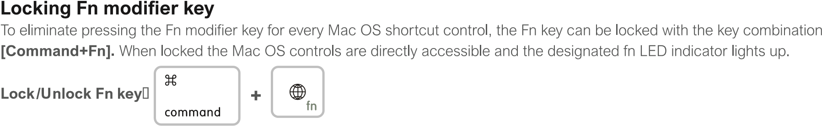

### System Lock

To avoid unintentional activation of the System Lock key it requires a long key press.

**System Lock**  Press and hold for 2 seconds (without the use of Fn key)

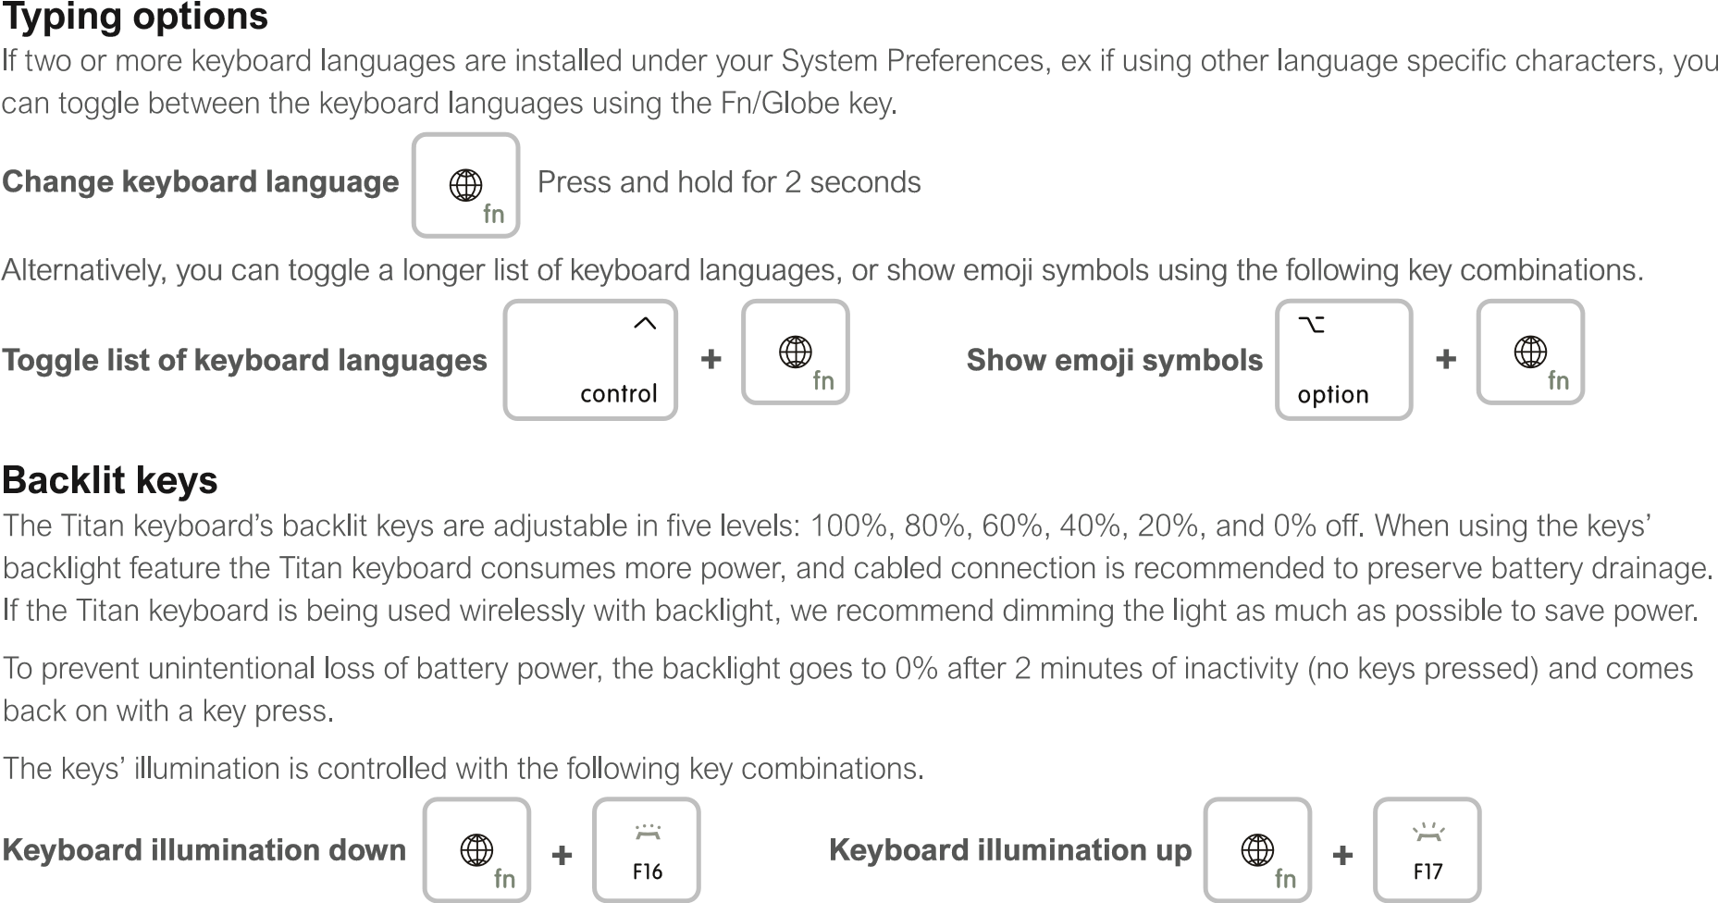

### Keep the Titan powered

We recommend never letting the Titan keyboard’s lithium battery run completely out of power. When the battery power is low and the battery LED indicator starts flashing, insert the USB cable and recharge the keyboard timely to ensure uninterrupted work.

If battery runs critically low the battery LED indicator starts flashing fast. To prevent sudden shutdown the backlight turns off.

**Note:** If the lithium battery runs completely out of power, slide the keyboard on/off switch to Offso black is visible, **before** connecting the USB cable and recharging. Once the charging cable is connected to a power source, you can slide the on/off switch back to On and start using the Titan keyboard again.

To preserve battery power when the keyboard is set to Bluetooth wireless connectivity, the Titan keyboard uses a Power Saving feature. After 2 minutes of inactivity (no keys pressed) the backlight turns off. After 15 minutes of inactivity the Titan keyboard enters Power Saving Mode and sets the Bluetooth system to stand-by. It is reactivated by pressing any key. Allow it a couple of seconds to reconnect.

**Note:** When the Titan keyboard is connected to a USB port or an 5V external power supply, the power saving features are disabled despite the keyboard is set to Bluetooth wireless connection.

### Cleaning your Titan

We recommend keeping your keyboard clean for an optimal user experience and for a healthy keyboard. Clean only the outside of the keyboard.

Before you clean it, make sure the on/off switch is set to Off

Use a lint-free cloth and clean the keys gently. Avoid using any strong chemicals such as solvents or abrasives, and be careful not to get any liquids or moisture under the keys or into any openings of the keyboard.

**System requirements**

* Mac OS X (10.10 or later version)
* USB-C port and/or Bluetooth receiver

**Keyboard specifications**

* Dual connectivity: Bluetooth wireless and USB wired connection
* Backlit low-profile keys
* Scissors switch key mechanism
* Key travel 0.075” ~ 2 mm
* 5 LED indicators for: Caps Lock, fn Lock, Battery, Bluetooth connection and USB connection
* Aluminum body
* Dimensions: 16.93” X 4.69” X 0.54” ~ 430 mm X 119 mm X 13 mm
* Net weight: 20 oz ~ 567 gr
* Certifications: FCC-ID, CE-RED, UKCA, & RoHS

**Battery**

* Capacity: 1500mAh
* Battery life without backlight: 300 hours
* Battery life with backlight: up to 40 hours (backlight at 20%)
* Charging time from 0 – 100% est. 4.5 hours

**Bluetooth system**

* Bluetooth v 5.1
* Connection distance: up to 30 ft ~ 10 m

**USB cable**

* USB-C to USB-C
* Length: 59.0” ~ 1.5 m

**Warranty information**

Your Titan Mac Logickeyboard contains no user-serviceable parts. Do not attempt to disassemble or open your Titan Mac Logickeyboard, or expose it to liquids or high temperatures.

The Titan Mac Logickeyboard has a limited warranty covering factory defects for 12 months from the date of delivery. The warranty does not cover defects caused by misuse or from spills into the keyboard.

Any claim must be made to Logickeyboard within the warranty period and must be made in writing with the proof of purchase identifying the product(s), date of purchase, purchase price, and a statement of the defect and its location at the time of claim.

Due to the nature of the products supplied, and the inability of Logickeyboard to control the use of the merchandise on site, faulty products must be sent to a Logickeyboard facility for inspection. Returns are on buyers' expense and risk.

The liability of Logickeyboard for a defective product is limited to either: (i) replacement or repair of the faulty product or (ii) the refund of the purchase price of the defective part, whichever is the smaller amount.

Logickeyboard bears no liability for defects if the product has been altered or modified in any way.

In no circumstances can Logickeyboard be liable for any consequential damage howsoever caused, or any injury, loss or damage which may be caused to any other merchandise or to any loss of business or loss of profit resulting there from.

### Protect the environment

The Titan Mac Logickeyboard contains a lithium-ion battery. At the End of Life of the keyboard, don’t try to open or crush the battery.

The Titan Mac Logickeyboard must be disposed of separately from household waste. Logickeyboard accepts receiving EOL products to ensure proper waste. However, to save unnecessary transportation of the product, we recommend disposing of it at the nearest recycling site taking electronics waste.

The gift box of the Titan Mac Logickeyboard is made from 100% recyclable cardboard. We recommend wasting it separately at the nearest recycling station taking cardboard.

WWW.LOGICKEYBOARD.COM

Disclaimer - the content of this manual is subject to changes without notice. We assume no responsibility for any errors or inaccuracies that may appear in this user guide. Nor do we assume responsibility for any damage on other products or services than supplied or provided by Logickeyboard Logickeyboard is a trademark of BSP Europe A/S. All other names, product names and trademarks in this documentation are the property of their respective holder. Copyright 2024by BSP Europe A/S - Denmark ©

## Terms and conditions of sale

This product is guaranteed from manufacturing faults for 12 months from the date of purchase.

For all returns and repairs contact RNIB. You can request full terms and conditions from RNIB or view them online.

## How to contact RNIB

Phone: 0303 123 9999

Email: shop@rnib.org.uk

Online Shop: shop.rnib.org.uk

Products are provided by RNIB Enterprises Limited. Company number: 0887094 Registered office: The Grimaldi Building, 154a Pentonville Road, London N1 9JE.  RNIB Enterprises Limited is a trading subsidiary of the Royal National Institute of Blind People, a charity registered in England and Wales (226227) and Scotland (SC039316).

Date: May 2025.