# Logic PC Keyboards (HK67-HK74)

Thank you for purchasing from RNIB. This item has been supplied by a third party. In the unlikely event the item is unsuitable, please contact us within 14 days of receipt to obtain your returns number. To ensure your return goes smoothly, the item and all components must be in as new condition and packed in its original, undamaged packaging. For further details and guidance on returning faulty items, please see the Terms and conditions of sale and how to contact RNIB sections of this instruction manual.

Please retain these instructions for future reference.

**Contents**

Logic PC Keyboards (HK67-HK74) 1

Quick setup guide 2

What’s in the box 2

System requirements 2

Product specification 3

How to set up 3

Troubleshooting 4

Technical support 4

Disclaimer 5

Terms and conditions of sale 5

How to contact RNIB 5

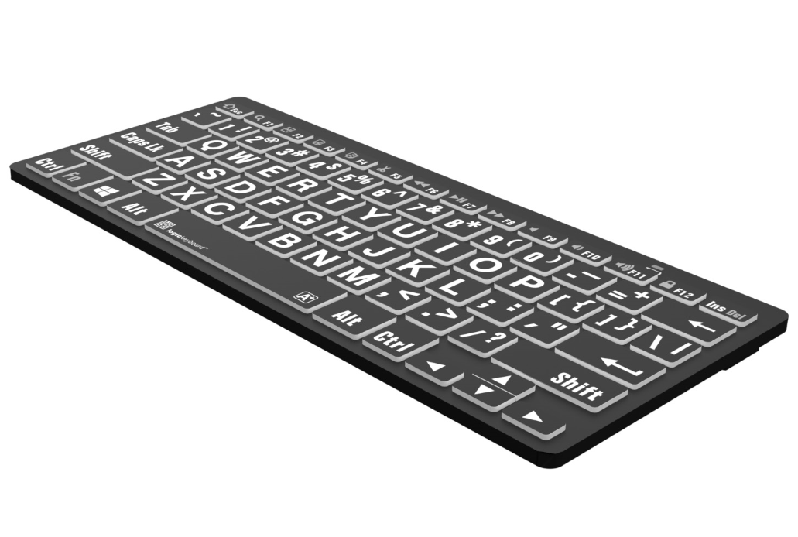

Wireless for Windows PC



### Quick setup guide

Thank you - for purchasing the LogickeyboardTM Wireless Bluetooth keyboard. This product from LogickeyboardTM is made to match the same high design and quality standards as our other keyboard lines, with low profiled keys for less hand strain, and with the same outstanding mechanism that enables a light touch and quiet key operation.

### What’s in the box

* Wireless Bluetooth keyboard
* Two AAA batteries
* Quick setup guide

### System requirements

* For use with Windows 7-11.
* Built in Bluetooth.
* Operation current: <1.2mA
* Operation voltage: 3.3V
* Sleet current: <0.2mA

### Product specification

* Length: 285mm – 11.2 inches
* Width: 120mm – 4.7 inches
* Height: 23mm – 0.9 inches
* Weight: 315g – 11.1 oz.
* Bluetooth v 3.0 Class 2
* Connect dist: up to 10 m ~ 30 ft
* Range of frequency: 16 Ghz

### How to set up

This keyboard is built for Windows PC’s with built in Bluetooth. Follow the setup instructions below to connect your new keyboard.

#### Connect with Windows PC

Install batteries in the keyboard, making sure that they are positioned according to the embedded directions in the battery cavity.

Turn the Power switch on the back of the keyboard to the “On” position.

Press and hold the “Connect” button on the back of the keyboard for 3 seconds until the LED indicator on the front of the keyboard flashes.

On your Windows PC, go to Settings > Devices > Bluetooth & other devices and select “Add Bluetooth or other device.”

1. Choose “Bluetooth” on the popup-list and select “Bluetooth 3.0 Keyboard” to connect your keyboard.
2. Your Bluetooth Windows PC keyboard is now ready for use.

#### Function keys on your keyboard

Press in combination with the En Modifier key on the keyboard.

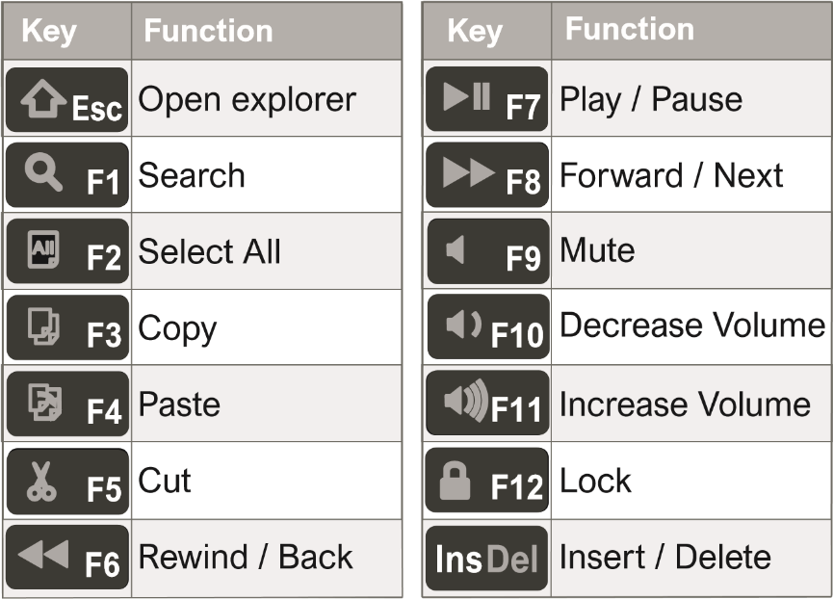

### Troubleshooting

“I don’t see “Bluetooth Logic keyboard” on my Bluetooth device list”

* Make sure Bluetooth is enabled on your device.
* Replace the batteries if they are power drained.
* Turn the power switch on the back of the keyboard to the position “On.”
* Ensure that the keyboard is within a 30 feet ~ 10 meters distance from your device.

“After being kept idle for some time, my keyboard loses keystrokes“

* The keyboard goes to power saving mode after being idle for 15 minutes. After pressing any key there is a wake-up time of 4 seconds.

### Technical support

For technical support Please go to our website [logickeyboard.com/QandA](http://logickeyboard.com/QandA) where you can find common Questions & Answers.

You can also contact us for specific support or guidance at any time. Please visit [logickeyboard.com/contact](http://logickeyboard.com/contact)

### Disclaimer

The content of this guide is subject to changes without notice. We assume no responsibility for any errors or inaccuracies that may appear in this Quick Setup Guide, nor do we assume responsibility for any damage because of using products or services provided by Logic Keyboard.

## Terms and conditions of sale

This product is guaranteed from manufacturing faults for 12 months from the date of purchase.

For all returns and repairs contact RNIB. You can request full terms and conditions from RNIB or view them online.

## How to contact RNIB

Phone: 0303 123 9999

Email: shop@rnib.org.uk

Online Shop: shop.rnib.org.uk

Products are provided by RNIB Enterprises Limited. Company number: 0887094 Registered office: The Grimaldi Building, 154a Pentonville Road, London N1 9JE. RNIB Enterprises Limited is a trading subsidiary of the Royal National Institute of Blind People, a charity registered in England and Wales (226227) and Scotland (SC039316).

Date: May 2025