VoxiVision 2 (HT436)
Thank you for purchasing from RNIB. This item has been supplied by a third party. In the unlikely event the item is unsuitable, please contact us within 14 days of receipt to obtain your returns number. To ensure your return goes smoothly, the item and all components must be in as new condition and packed in its original, undamaged packaging. For further details and guidance on returning faulty items, please see the Terms and conditions of sale and How to contact RNIB sections of this instruction manual.

Please retain these instructions for future reference.

I - First Steps

What's in the box?
- VoxiVision² (with protective case)
- Foldable stand + carry case

Accessories
- Detachable neck lanyard
- Power adapter + USB Type-C cable
- QR code labels ×50

VoxiVision2
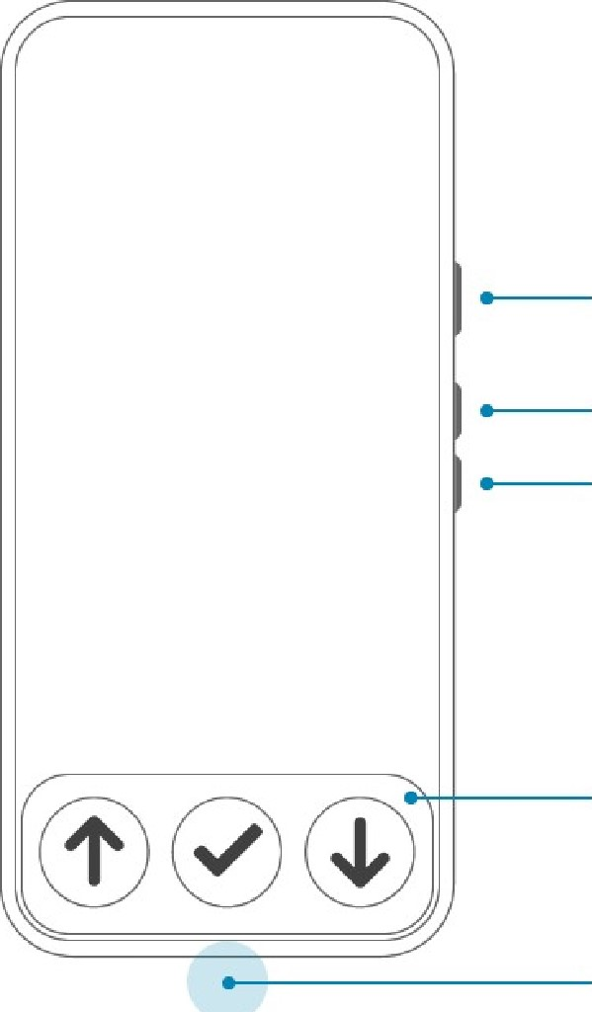
On / Off
(long press)
Speech recognition
(short press)
Sleep
(double-press)
Volume +
Volume —
Navigation bar
USB Type-C Port
Battery Audio

Foldable stand
The folding stand consists of 3 elements: the wooden stand on which the VoxiVision will be placed, the vertical stand (equipped with a rotating stop) and the metal baseplate (with a QR Code on) on which the document will be placed.
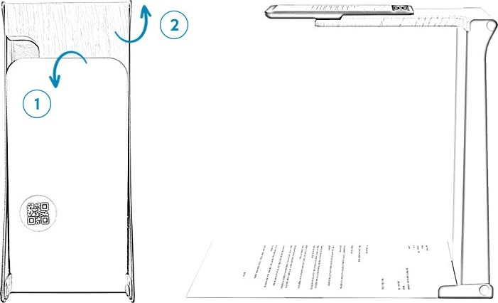
Steps to unfold the stand:
1 - Hold the metal baseplate
- Rotate it away from the wooden support: you will feel slight resistance
- Rotate it until it cannot move any more (you will feel a click)

2 - Hold the wooden stand
- Rotate it until it cannot move any more

Position the stand so that the metal baseplate and the wooden stand faces towards you.
To align an A4 document perfectly, there is a plastic arm on the right-hand side of the vertical metal section, at the bottom. Lower this down towards you until it rests on the table. Align the top right corner of an A4 document up against the vertical metal section and slide it to the right until it touches this arm.

Power on / off
To turn on your VoxiVision, press and hold the On / Off button (located on the right side) until you feel a vibration. It takes less than a minute to fully turn on the device. If the VoxiVision does not turn on, you may need to charge it.
To shut down your VoxiVision, long press the On / Off button and choose "Shut down".

Sleep Mode
To put VoxiVision to sleep, double-press the On / Off button.
By default, VoxiVision goes to sleep after 2 minutes of inactivity (this time can be changed in Advanced settings)

To exit Sleep Mode, single press the On / Off button. Alternatively, press the button on the remote control (this feature must be activated in Settings > Advanced settings).

Choice of version/mode
There are two modes available:
- Basic mode: Access to only the main functions with simplified navigation (with only the 3 buttons on the navigation bar)


Go directly to page 5

- Standard mode: Access to all functions and advanced settings


Go directly to page 11

Voice commands
You can also control your device by voice using voice commands (see Chapter 9 for Standard mode).
To activate a voice command, press the On / Off button (located on the right side of your VoxiVision). Once you hear a beep (a blinking microphone appears on the screen), you can start speaking. The speech recognition stops as soon as you stop talking
Alternatively, press the button on the VoxiVision remote (if it has been paired), then speak after the beep.

Charging
To charge your VoxiVision, plug the charger into the USB Type-C port on your VoxiVision (located on the bottom middle edge).
When the battery drops below 20%, you will get a notification on the home screen.
To check the battery level, long press the On/Off button (located on the right side of the VoxiVision) or use the voice command “battery”.

Terms and conditions of sale
This product is guaranteed for 24 months from the date of purchase. For all returns contact RNIB. You can request full terms and conditions from RNIB or view them online.

How to contact RNIB
Phone: 0303 123 9999
Email: shop@rnib.org.uk
Online Shop: shop.rnib.org.uk

Products are provided by RNIB Enterprises Limited. Company number: 0887094 Registered office: The Grimaldi Building, 154a Pentonville Road, London N1 9JE. RNIB Enterprises Limited is a trading subsidiary of the Royal National Institute of Blind People, a charity registered in England and Wales (226227) and Scotland (SC039316).

Date: February 2026.

