USB player comparison chart
11
Feature | RNIB  Communiplayer | RNIB Accord
 | 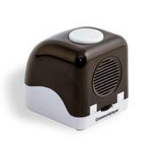 | 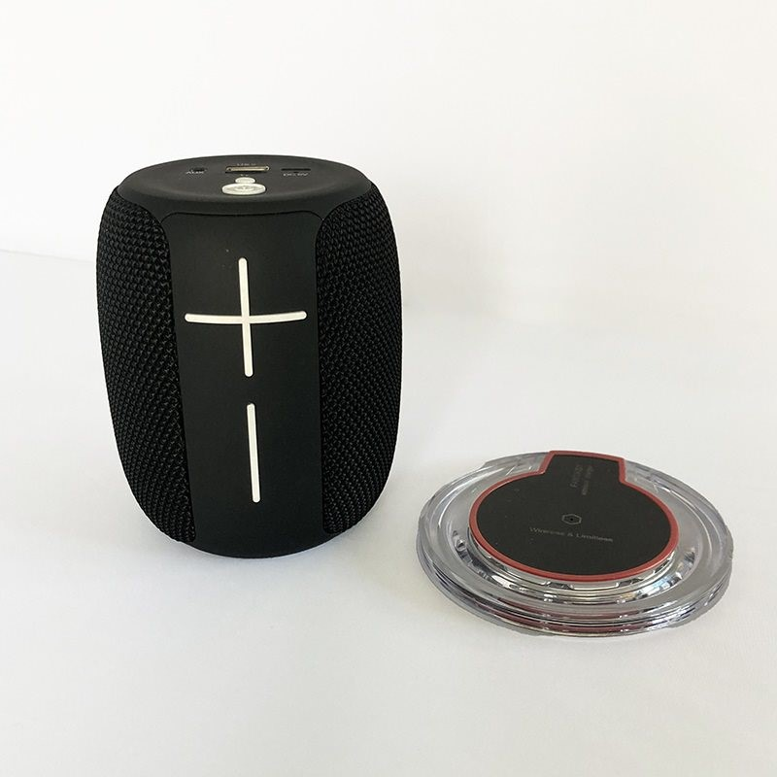
Product code | DH475 | DH472
Price ex VAT | £34.99 | £49.99
USB |  | + SD card
MP3
WAV |  | + WMA
Bluetooth |  | 10m range
Navigation | Tracks, folders | Tracks, folders
Bookmark | 20 USBs | Unlimited
Battery life | 8 hours | 5-6 hours
Charger | USB mini cable only | USB-C cable only,  Wireless pad
Headphone jack
Other |  | Low battery warning, voice prompts, two-year warranty

