Miele GuideLine washing machine (DK193)
To avoid the risk of accidents or damage to the machine, it is essential to read these instructions before it is installed and used for the first time. (en-GB / M.-Nr. 11 343 530).
Please retain these instructions for future reference. These instructions are also available in other formats.
Warning and safety instructions 6
Correct application 6
Safety with children 7
Technical safety 7
Correct use 9
Accessories 11
Note 12
Operating the washing machine 15
Control panel 15
How the control field works 18
GuideLine 19
Programme selector 19
Control field 20
Additional tools 22
Caring for the environment 23
Disposal of the packing material 23
Disposing of your old appliance 23
Before using for the first time 24
Protective foil and stickers removal 24
Remove the drain hose elbow from the drum 24
Running the first programme 25
Washing environmentally and economically 28
Energy and water consumption 28
Detergent 28
Choosing the correct extra option (Short, Soak, Pre-wash) 29
When drying with a tumble dryer 29
1. Prepare the laundry 30
Sort the laundry 30
Pre-treating stains 31
General tips 31
2. Load the washing machine 32
Open the door 32
Close the door 33
3. Select a programme 34
Programme selection 34
Selecting a temperature and spin speed 35
Selecting Extras 35
4. Add detergent 37
Detergent dispenser drawer 37
CapDosing 39
Activating CapDosing 40
Inserting a capsule 41
Switching off/changing CapDosing 42
5. Start the programme 43
To start a programme 43
6. End of programme – unload the drum 44
End of programme 44
Spinning 46
Final spin speed in wash programmes 46
Rinse and interim spin 47
To omit the final spin (Rinse hold) 47
To omit rinse and interim spin and the final spin 47
Delay start 48
Selecting Delay start 48
To begin delay start 48
To alter delay start 49
To cancel a delay start that has already started 49
Programme chart 50
Extra options 54
Short 54
Water + 55
Pre-wash 55
Soak 55
The following extras can be selected in addition to the programmes 56
Garment care label symbols 57
Programme selection examples 58
Programme sequence 61
Special features in the programme sequence 62
Changing the programme sequence 64
Changing a programme or adding/removing laundry 64
Cancelling a programme 64
Interrupting a programme 65
Garment care label symbols 66
Programme selection examples 67
Detergent 70
The correct detergent 70
The right amount to dispense will depend on the following: 70
Water softeners 70
Water hardness levels 71
Dispensing aids 71
Refill packs of detergent 71
Fabric conditioner and liquid starch 71
Adding fabric conditioner or liquid starch separately 71
Colour run and dye removers/dyes 72
Recommended Miele detergents 73
Recommended detergents in accordance with Directive (EU) Nr. 1015/2010 75
Cleaning and care 76
Cleaning the external casing and the control panel 76
Cleaning the detergent dispenser drawer 76
Hygiene info (Cleaning the drum) 79
Cleaning the water inlet filter 79
Problem solving guide 81
The programme does not start 81
The programme is cancelled and a fault indicator light lights up in the control panel 82
During the programme, a symbol appears in the time display 83
At the end of the programme, an indicator light lights up in the control panel 84
General problems with the washing machine 85
An unsatisfactory wash result 87
The door will not open 89
Opening the door in the event of a blocked drain outlet and/or power cut 90
After sales service 94
Repairs 94
Warranty: U.K. 94
Warranty: Other countries 95
Optional accessories 95
Installation 96
Front view 96
Rear view 97
Installation surface 98
Transporting the washing machine to its installation site 98
Removing the transit bars 99
Re-fitting the transit bars 102
Levelling the machine 102
The water protection system 106
Connection to the water supply 108
Water drainage 110
Electrical connection 111
Technical data 113
Data sheet household washing machines 114
Consumption data 117
Selecting test programmes 118
Programmable functions 119
Accessing the programming level 119
Choosing and selecting a programmable function 119
Editing and saving a programmable function 121
Exit programming level 122
P13 Sensor tone 122
P14 Lock code 123
P22 Control panel switch-off status 124
P24 Memory 124
P26 Longer pre-wash Cottons 124
P27 Soak duration 125
P28 Gentle action 125
P29 Reduce temperature 126
P30 Water plus 126
P31 Water plus level 126
P32 Maximum rinse level 127
P33 Suds cooling 127
P34 Anti-crease 128
P62 Backlight brightness dimmed 128
P63 Welcome tone 128
Optional accessories 129
Detergent 129
Specialist detergents 130
Fabric care 131
Additive 132
Machine care 132
How to contact RNIB 134
RNIB terms and conditions of sale 134

Warning and safety instructions
This washing machine complies with all current local and national safety requirements. However, inappropriate use can lead to personal injury and damage to property.
Read the operating instructions carefully before using the washing machine. They contain important information on safety, installation, use and maintenance. This prevents both personal injury and damage to the washing machine.
In accordance with standard IEC 60335-1, Miele expressly and strongly advises that you read and follow the instructions in the chapter on installing the washing machine as well as the safety instructions and warnings.
Miele cannot be held liable for damage caused by non-compliance with these instructions.
Keep these operating instructions in a safe place and pass them on to any future owner.

Correct application
- This washing machine is intended for use in domestic households and similar working and residential environments.
- The washing machine is not intended for outdoor use.
- It must be used only as a domestic appliance to wash items which are specified by the manufacturer as being washable on the wash care label. Miele cannot be held liable for damage resulting from incorrect or improper use or operation.
- The washing machine can only be used by people with reduced physical, sensory or mental capabilities, or lack of experience or knowledge, if they are supervised whilst using it or have been shown how to use it safely and recognise and understand the consequences of incorrect operation.

Safety with children
- Children under 8 years of age must be kept away from the washing machine unless they are constantly supervised.
- Children 8 years and older may only use the washing machine unsupervised if they have been shown how to use it safely and recognise and understand the consequences of incorrect operation.
- Children must not be allowed to clean or maintain the washing machine unsupervised.
- Please supervise children in the vicinity of the washing machine and do not let them play with it.

Technical safety
- Please observe the instructions in “Installation” and “Technical data”.
- Before setting up the washing machine, check it for any externally visible damage. Do not install or use a damaged machine.
- Before connecting the washing machine, ensure that the connection data on the data plate (fuse rating, voltage and frequency) match the mains electricity supply. If in any doubt, consult a qualified electrician.
- Reliable and safe operation of this washing machine can only be assured if it has been connected to the mains electricity supply.
- The electrical safety of this washing machine can only be guaranteed when correctly earthed.
It is essential that this standard safety requirement is met. If in any doubt, please have the wiring system of the building tested by a qualified electrician.
Miele cannot be held liable for the consequences of an inadequate earthing system (e.g. electric shock).
- Do not connect the washing machine to the mains electricity supply by a multi-socket adapter, extension lead or similar. These do not guarantee the required safety of the machine (fire hazard due to the risk of overheating).
- Faulty components must only be replaced by genuine Miele original spare parts. Only when these parts are fitted can Miele guarantee the safety standards of the machine.
- The electrical socket must be easily accessible after installation so that the machine can be disconnected from the electricity supply if necessary.
- Unauthorised repairs could result in unforeseen dangers for the user, for which the manufacturer cannot accept liability. Repairs should only be undertaken by a Miele authorised service technician, otherwise any subsequent damage will not be covered by the warranty.
- If the electrical connection cable is faulty it must only be replaced by a Miele authorised service technician to protect the user from danger.
- The machine must be isolated from the electricity supply when cleaning and maintaining the machine and in the event of a fault.
- The Miele “Water protection system” protects from water damage provided the following conditions are met:
- the machine is correctly plumbed in and connected to the electricity supply.
- if a fault or damage has been identified, the machine must be examined by a competent person before further use, and repaired if necessary.
- The water flow pressure must be at least 100 kPa and should not exceed 1000 kPa.
- In areas which may be subject to infestation by cockroaches or other vermin, pay particular attention to keeping the machine and its surroundings in a clean condition at all times. Any damage which may be caused by cockroaches or other vermin will not be covered by the warranty.
- The machine must not be used in a non-stationary location
(e.g. on a ship).
- Do not make any alterations to the machine, unless authorised to do so by Miele.

Correct use
- Do not install the washing machine in a room where there is a risk of frost. Frozen hoses may burst or split. The reliability of the electronic control unit may be impaired at temperatures below freezing point.
- Before using the machine for the first time, check that the transit bars at the rear of the machine have been removed (see “Installation – Removing the transit bars”). During spinning, a transit bar which is still in place may result in damage to both the machine and adjacent furniture or appliances.
- Turn off the stopcock if the machine is to be left for any length of time (such as holiday), especially if there is no floor drain (gully) in the immediate vicinity.
- Flooding danger.
If hooking the drain hose into a wash basin, check that the water can drain quickly enough to prevent the sink from overflowing. Make sure the drain hose is secure, so that the force of the water flowing out of the hose does not dislodge it.
- Take care to ensure that foreign objects (such as nails, pins, coins, paper clips) do not find their way into the machine with the laundry. These may damage components of the machine (such as suds container, drum), which in turn can result in damage to the laundry.
- The maximum load for this washing machine is 8kg (dry weight). See the “Programme chart” for maximum recommended loads for individual programmes.
- If the correct amount of detergent is dispensed, the machine should not need to be descaled. If, however, you do wish to descale it, only use a proprietary natural citric acid based descaling agent. Miele recommends using Miele descaling agent which is available to order online at miele.co.uk or from Miele. Strictly observe the instructions on the packaging.
- Textiles which have been pre-treated in solvent based cleaning agents must be thoroughly rinsed in clean water before being washed in the machine.
- Do not use solvent based cleaning agents, e.g. those containing benzine, in this machine, as this may result in damage to component parts and create toxic fumes. Such agents also pose a fire and explosion hazard.
- Do not use solvent based cleaning agents, e.g. those containing benzine, to clean the surfaces of the machine. They can cause damage to plastic surfaces.
- Only use dyes specified by the manufacturer as being suitable for use in a domestic washing machine. Always observe the manufacturer's instructions carefully.
- Colour run and dye removers contain sulphur compounds which can cause damage such as corrosion. Do not use these products in this machine.
- If detergent comes into contact with the eyes, rinse them thoroughly with lukewarm water immediately. If swallowed, seek medical assistance immediately and retain the packaging or label for reference. Those with skin problems or sensitive skin should avoid their skin coming into contact with detergent.

Accessories
- Accessory parts may only be fitted when expressly approved by Miele. If other parts are used, warranty, performance and product liability claims will be invalidated.
- A Miele tumble dryer can be stacked on top of a Miele washing machine using the appropriate stacking kit (available as an optional accessory). Please make sure you order the correct one for the Miele washing machine and Miele tumble dryer.
- If installing the machine on a Miele plinth, (available as an optional accessory, depending on country), please make sure you order the correct one for this washing machine.
Important: Miele cannot be held liable for damage caused by non-compliance with these Warning and Safety instructions.

Note
When icons/symbols have been used within the body of the text they have been replaced by wording, usually within square brackets. Some icons/symbols have additional text, such as the programme selector.
The following table shows the alternative text used for icons/symbols within the body text:
Icon/Symbol | Description | Alternative text
Indicator lights
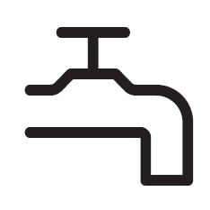 | Tap icon. | [tap]
 | Circle with bumpy line icon. | [door]
 | Cross icon. | [plus]
 | Padlock icon. | [padlock]
Capsule sensor controls
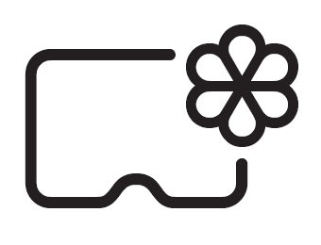 | Capsule with flower icon. | [flower capsule]
 | Capsule with triangle and water droplet icon. | [triangle capsule]
 | Capsule with water droplet icon. | [droplet capsule]
Sensory control
 | Diamond clock icon. | [diamond clock]
Programme selector
 | Blank round clock with dial pointing to 12 o'clock. | The off position [12 o’clock]
Spin speed sensor controls
 | Spiral with a diagonal line through it. | [no spin]
Not washable care label
 | Basin of water with diagonal line through it. | [not washable symbol]
Detergent drawer
 | Basin icon with one line. | [basin I]
 | Basin icon with two lines. | [basin II]
 | Flower icon. | [flower]
 | Capsule icon. | [capsule]
Capsule types
 | Flower icon. | [flower]
 | Triangle with water droplet icon. | [triangle]
 | Water droplet icon. | [droplet]
Rinse hold
 | Basin icon full of water. | [basin]

Operating the washing machine

Control panel
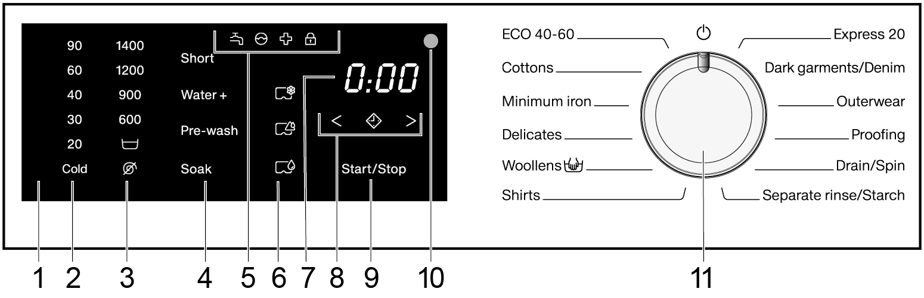
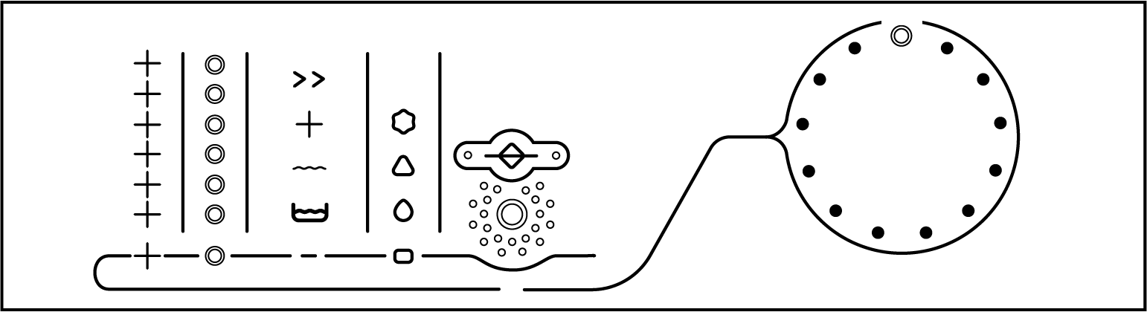
Left to right on the control panel:
- Control field
The control field consists of a time display and various sensor controls. The individual sensor controls are explained in the following sections.
- Sensor controls – temperature
For selecting the temperature.
- Sensor controls – spin speeds
For selecting the spin speed.
- Sensors for extra options
You can supplement wash programmes with extra options. If a wash programme has been selected, the sensor controls for the possible Extras light up dimly.
- Indicator lights
[tap icon] lights up if there are faults affecting the water inlet and drainage.
[circle with bumpy line icon] lights up if excess detergent was used.
[cross icon] lights up as a reminder about hygiene information.
[padlock icon] flashes for as long as it is possible to add laundry, lights up when the door of the washing machine is locked.
- Sensor controls ‒ CapDosing
[capsule with flower icon] CapDosing of fabric care products (such as fabric conditioner, proofing agent).
[capsule with triangle and water droplet icon] CapDosing of additives (such as detergent enhancer).
[capsule with water droplet icon] CapDosing of detergent (for the main wash only).
- Time display
After the programme has started, the programme duration will appear in the display in hours and minutes. When Delay start is being used, the programme duration will appear after the Delay start time has elapsed.
- Sensory controls
The Delay start time selected will appear in the time display. After the programme has started, the Delay start time will begin to count down. Once the Delay start time has elapsed, the programme begins and the estimated programme duration appears on the time display.
[diamond clock icon] After touching the [diamond clock] sensor control, a later start time for the programme (Delay start) can be selected. Once selected, [diamond clock] lights up brightly.
[greater than icon] The duration of the Delay start period is increased by touching the > sensor control.
[lesser than icon] The duration of the Delay start period is reduced by touching the < sensor control.
- Start/Stop sensor
Touching the Start/Stop sensor starts the selected programme or cancels a programme that has already been started. The sensor flashes slowly as soon as it is possible for a programme to be started and then lights up constantly after the programme has started.
- Optical interface
This is used by the Service department as a transmission point.

- Programme selector
[blank round clock with dial pointing to 12 o’clock] For selecting programmes and for switching off the appliance. The washing machine is switched on when you select a programme, and switched off by turning the programme selector to the off position [12 o’clock].

How the control field works
The 2, 3, 4, 6, 8 and 9 sensor controls react to fingertip contact. If a sensor control is illuminated, it can be selected.
If a sensor is brightly lit, this means: currently selected.
If a sensor is dimly lit, this means: it can be selected.

GuideLine
This washing machine is designed for blind and visually impaired people and is equipped with a special user interface. In addition, an acoustic signal sounds each time the sensor controls are operated.
The control panel is made up of two parts. The programme selector is located on the right and the control field is located in the centre.

Programme selector
The 12 wash programmes surround the round programme selector. The setting for switching off the washing machine is located at the 12 o’clock position. When the programme selector is turned to a wash programme, the washing machine switches on automatically and this is indicated by a corresponding melody. The individual programmes are indicated with a dot.
Clockwise, the following programmes are included on the programme selector:
- Express 20
- Dark garments/Denim
- Outerwear
- Proofing
- Drain/Spin
- Separate rinse/Starch
- Shirts
- Woollens
- Delicates
- Minimum iron
- Cottons
- ECO 40-60

Control field
The control field consists of sensor controls. The sensor controls react to touch. A confirmation signal sounds when a sensor is touched. The control field is explained from right to left below.

Start/Stop sensory control
The Start/Stop sensor control is marked with a large circle surrounded by dots. To start a wash programme, touch the middle of this circle. A brief signal sounds to confirm the programme has been started and the door can be heard locking into place.

Delay start sensor controls
These three sensor controls are located above the Start/Stop sensor control.
The middle sensor control [diamond clock], marked with dash – diamond – dash, switches Delay start on or off. A brief signal sounds to confirm Delay start has been switched on. A signal will sound twice in quick succession to indicate that Delay start has been switched off.
The sensor control on the right >, marked with a dot, increases the delay start period by one hour with every touch. Each hour is indicated with a higher pitch signal. A period of up to seven hours can be selected. The sensor control on the left <, marked with a dot, reduces the delay start period by one hour with every touch.

Capsules sensor controls
There are three sensor controls for capsules. The sensor controls are marked differently depending on the capsule. The explanation follows the order from top to bottom.
[capsule with flower icon] The fabric care products sensor control is marked with a flower.
[capsule with triangle and water droplet icon]
The additives sensor control is marked with a triangle.
[capsule with water droplet icon] The detergent sensor control is marked with a droplet.
A brief signal sounds to indicate that a capsule has been selected. The upper [flower capsule] is indicated using a higher pitch signal; the lower [droplet capsule] is indicated using a lower pitch signal. A signal will sound twice in quick succession to indicate that a capsule has been deselected.

Extra options sensor controls
There are four sensor controls for extra options. The sensor controls are marked differently depending on the extra option. The explanation follows the order from top to bottom.
- The Short sensor control is marked with a double arrow pointing to the right.
- The Water + sensor control is marked with a plus.
- The with pre-wash sensor control is marked with a wavy line.
- The Soak sensor control is marked with a washing up bowl.
A brief signal sounds to indicate than an extra option has been selected. A signal will sound twice in quick succession to indicate that an extra option has been deselected.

Spin speed sensor controls
There are six sensor controls for the spin speed. The sensor controls are marked with a small circle. The highest spin speed (1400 rpm) is at the top. The lowest spin speed (no spin) is at the bottom. A different confirmation signal sounds depending on the spin speed selected. The higher in pitch the sound is, the higher the selected spin speed.
[spiral with a diagonal line] The lowest spin speed – no spin.

Temperature sensor controls
There are six sensor controls for the temperature. The sensor controls are marked with a plus. The highest temperature (90 °C) is at the top. The lowest temperature (cold) is at the bottom. A different confirmation signal sounds depending on the temperature selected. The higher in pitch the sound is, the higher the selected temperature.

Additional tools

Audio operating instructions
The washing machine is supplied with audio operating instructions. The audio operating instructions explain the most important steps and wash programmes.

Caring for the environment

Disposal of the packing material
The packaging is designed to protect the appliance from damage during transportation. The packaging materials used are selected from materials which are environmentally friendly for disposal and should be recycled.
Recycling the packaging reduces the use of raw materials in the manufacturing process and also reduces the amount of waste in landfill sites.

Disposing of your old appliance
Electrical and electronic appliances often contain valuable materials. They also contain specific materials, compounds and components, which were essential for their correct function and safety. These could be hazardous to human health and to the environment if disposed of with your domestic waste or if handled incorrectly. Please do not, therefore, dispose of your old appliance with your household waste.
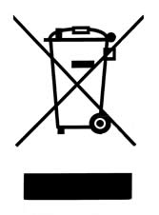
Please dispose of it at your local community waste collection / recycling centre for electrical and electronic appliances, or contact your dealer or Miele for advice. You are also responsible for deleting any personal data that may be stored on the appliance being disposed of. Please ensure that your old appliance poses no risk to children while being stored prior to disposal.

Before using for the first time
Warning: Damage resulting from incorrect installation and connection. Installing and connecting the washing machine incorrectly will cause serious property damage. See “Installation”.

Protective foil and stickers removal
- Remove:
- the protective foil from the door
- any stickers from the front and the lid.
Important: Please do not remove any labels (such as the data plate) which are visible when you open the door.

Remove the drain hose elbow from the drum
An elbow piece for the drain hose is stored in the drum.
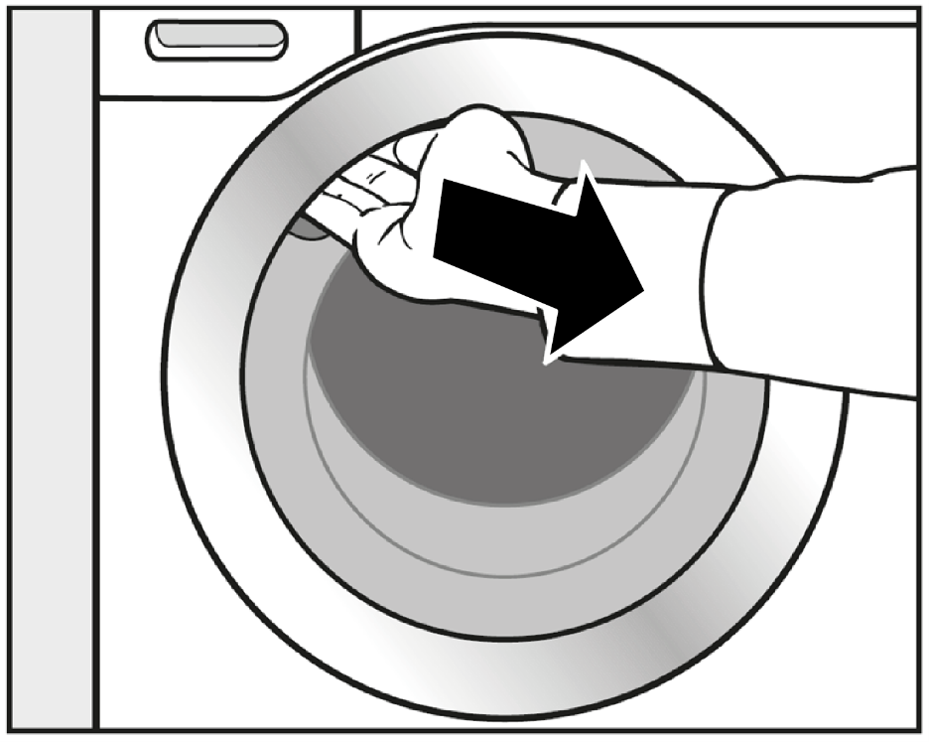

- Reach under the door grip and pull the door open.
- Remove the elbow piece.
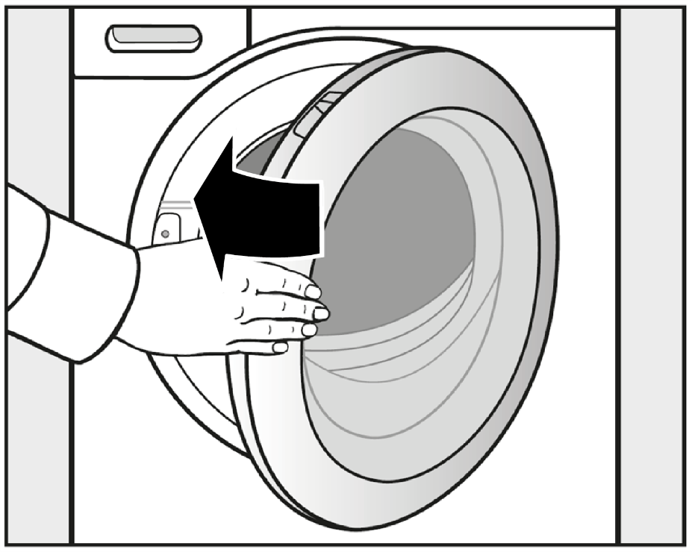
- Shut the door with a gentle swing.
Note: This washing machine has undergone a complete functional test at the factory and there will be some residual water in the drum from this process.

Running the first programme
- Open the stopcock.
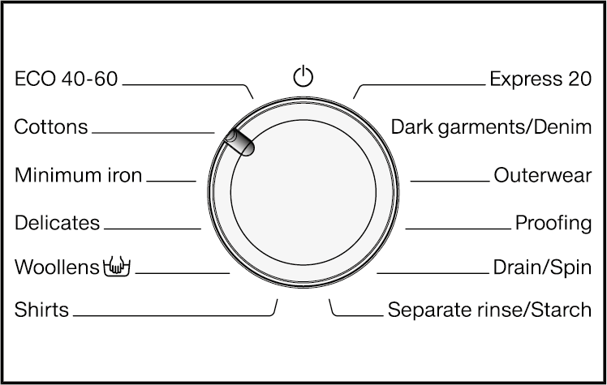
- Turn the programme selector to Cottons.
The washing machine is now switched on and in the control panel, the temperature 60 °C lights up.
- Touch the Start/Stop sensor.
The programme will start and the padlock symbol lights up in the control panel.
Note: After 10 minutes, the indicators dim and the Start/Stop sensor starts flashing.

At the end of the programme
At the end of the programme, the Anti-crease function is switched on. The [padlock] symbol lights up in the control panel; 0:00 appears in the time display and the drum occasionally rotates.
- Touch the Start/Stop sensory.
The door will unlock.
- Reach under the door grip and pull the door open.
Tip: Leave the door slightly open to allow the drum to dry.
- When the programme has ended, turn the programme selector to the off position [12 o’clock].
The washing machine is switched off and is now ready for use.

Energy savings
- Ten minutes after the beginning of the anti-crease phase, the indicators dim and the Start/Stop sensor starts flashing.
- Fifteen minutes after completion of the anti-crease phase, the washing machine is completely switched off and the door lock lifted.

Washing environmentally and economically

Energy and water consumption
- Water consumption and energy usage are determined by the size of the load.
To make the most of your machine, load the maximum dry load for the programme you are using.
- When smaller amounts of laundry are washed, the automatic load control will reduce the amount of water and energy used.
- Use the Express 20 programme for small, lightly soiled loads.
- Modern detergents make it possible to wash at lower temperatures (such as 20 °C). Washing using lower temperature settings will save energy.
- To maintain the hygiene of the machine, carry out a hot wash (above 60 °C) at regular intervals. The [plus] indicator will light to remind you to carry out a hot wash.

Detergent
- Do not exceed the amounts of detergent recommended by the manufacturer on the packaging.
- Adjust the dosage to the degree of soiling of the laundry.
- Reduce the amount of detergent with smaller loads (approx. one third less than the amount recommended can be used when washing a half load).

Choosing the correct extra option (Short, Soak, Pre-wash)
Select:
- A wash programme together with the Short extra option for light to normal soiling where there are no obvious marks.
- A wash programme without any extra options for normal to heavy soiling with visible staining.
- A wash programme together with the Soak extra option for heavily soiled laundry.
- The Pre-wash extra option for laundry with large amounts of dirt
(e.g. as dust, sand).

When drying with a tumble dryer
Selecting the highest possible spin speed for the wash programme will save energy when drying in a tumble dryer afterwards.

1. Prepare the laundry
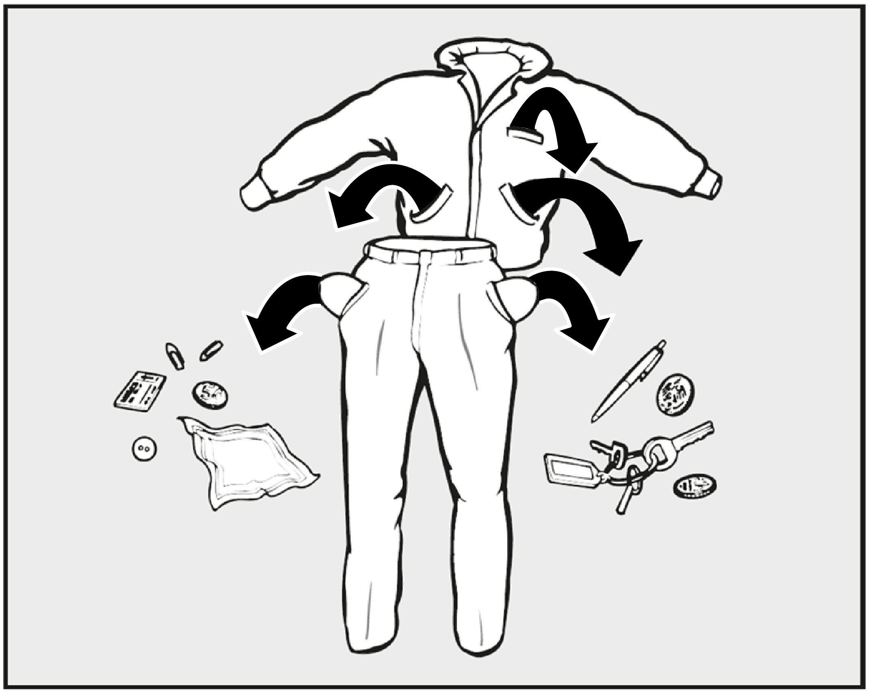
- Empty all pockets.
Warning: Damage due to foreign objects. Nails, coins, paper clips, and so on can cause damage to garments and components in the machine. Check the laundry before washing and remove any foreign objects.

Sort the laundry
- Sort the laundry by colour and by care label. Most garments have a textile care label in the collar or side seam.
Tip: Dark textiles often contain excess dye and should be washed separately several times before being included in a mixed load. Always wash whites and coloureds separately.

Pre-treating stains
- Badly soiled areas and stains should be cleaned as soon as possible, preferably whilst still fresh. Spillages should be carefully dabbed off using a soft, colourfast cloth. Do not rub.
Tip: Stains (such as blood, egg, coffee, tea) can be pre-treated using some handy tricks which can be found in the Miele guide to laundry care.
Warning: Damage due to solvent-based cleaning agents. Cleaning agents containing benzine, stain remover, etc., can damage plastic parts. When pre-treating textiles, make sure that any plastic parts (such as buttons) do not come into contact with cleaning agent.
Warning: Risk of explosion due to solvent-based cleaning agents. When using solvent-based cleaning agents, an explosive mixture may develop. Never use solvent-based cleaning agents in the washing machine.

General tips
- Curtains: Remove lead weights first or place in a laundry bag.
- Underwiring and collar stiffeners: Any loose wiring in bras, shirt collar stiffeners, etc. should be removed or sewn in.
- Close any zips, attach velcro fasteners, fasten hooks and eyes etc. before washing.
- Fasten duvet covers, pillow cases etc. to prevent small items from being rolled up inside them.
Do not wash any items in this washing machine which are specified by the manufacturer as not washable on the care label [not washable symbol].

2. Load the washing machine

Open the door
- Reach under the door grip and pull the door open.
Important: Check the drum for pets or foreign objects before loading it with laundry.
The most efficient use of energy and water is achieved when a full load is washed. However, do not overload as this reduces cleaning efficiency and causes creases.
- Unfold the laundry and load loosely into the drum.
Note: Mixing both large and small items gives better wash results and also helps distribute the load evenly during spinning.
Tip: Please note the maximum load for different wash programmes.

Close the door
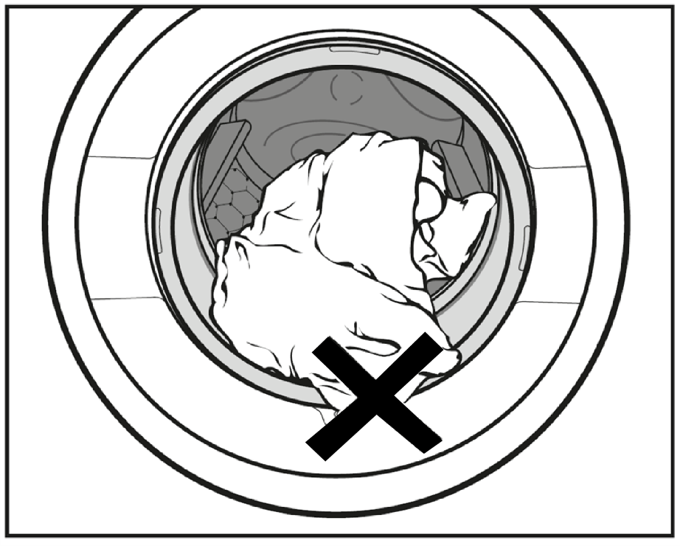
- Make sure that no items are caught between the door and the seal.
- Shut the door with a gentle swing.

3. Select a programme

Programme selection
The washing machine is switched on by turning the programme selector to a wash programme.
[Programme selector, clockwise: Express 20, Dark garments/Denim, Outerwear, Proofing, Drain/Spin, Separate rinse/Starch, Shirts, Woollens, Delicates, Minimum iron, Cottons, ECO 40-60.]
- Turn the programme selector to the required programme.
The likely wash time is shown in the time display and the pre-set temperatures and spin speed light up in the control panel.

Selecting a temperature and spin speed
Note: The wash programme’s preset temperature and spin speed light up brightly. The choice of available temperatures and spin speeds for the wash programme light up dimmed.
The temperatures reached inside the washing machine might not be the same as the temperatures selected. Perfect wash results are achieved through a combination of energy use and wash duration.
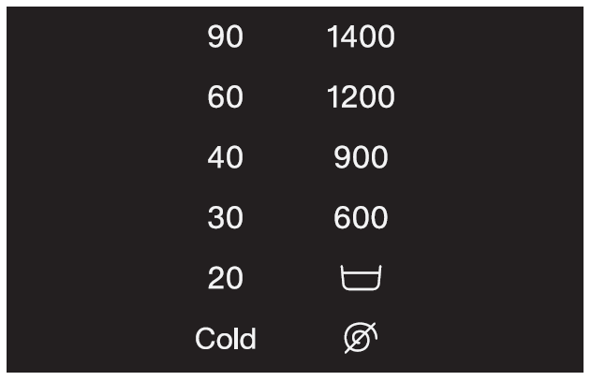
[Temperature and spin panel. Two columns, each listing six settings. Temperature on the left, top to bottom: 90, 60, 40, 30, 20, Cold. Spin on the right, top to bottom: 1400, 1200, 900, 600, basin symbol, no spin symbol.]
- Touch the sensor for the desired temperature. It will then light up brightly.
- Touch the sensor for the desired spin speed. It will then light up brightly.

Selecting Extras
Note: the selection of extras available for the wash programme lights up dimly.

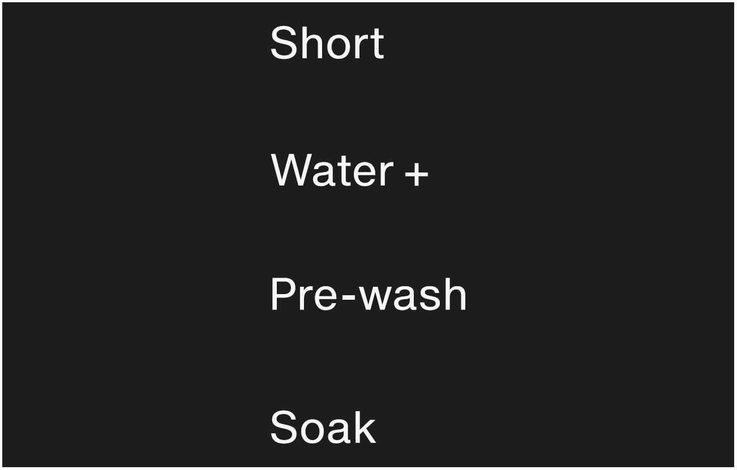
[Extras panel. One column, four options top to bottom: Short, Water +, Pre-wash, Soak.]
- Touch the sensor for the extra you want. It then lights up brightly.
Tip: You can select multiple extras for a wash programme.
Note: Please refer to “Extras” for more information.

4. Add detergent

Detergent dispenser drawer
Any detergent suitable for automatic front loading washing machines can be used. Please observe the instructions for use and dosage on the detergent packaging.

Adding detergent
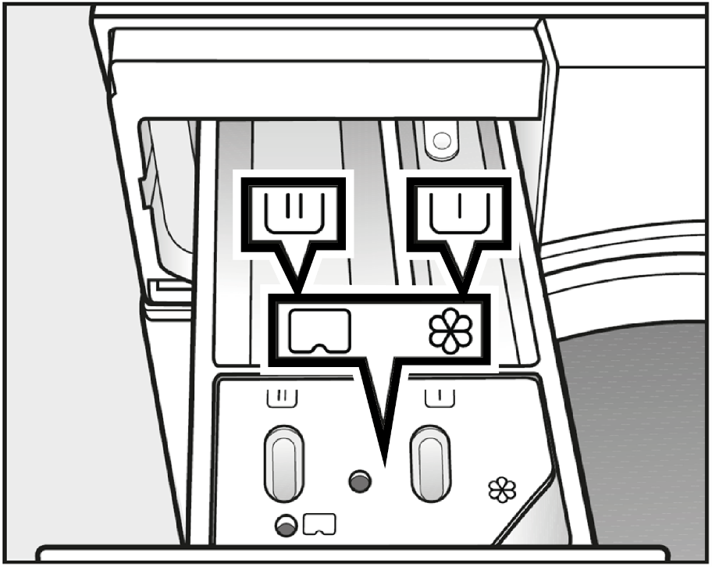
- Pull out the detergent drawer and add detergent to the compartments.
[basin icon with one line] Detergent for the pre-wash.
[basin icon with two lines] Detergent for the main wash and soaking.
[flower icon] Fabric softener, liquid starch, or
[capsule icon] capsules.

Adding fabric conditioner
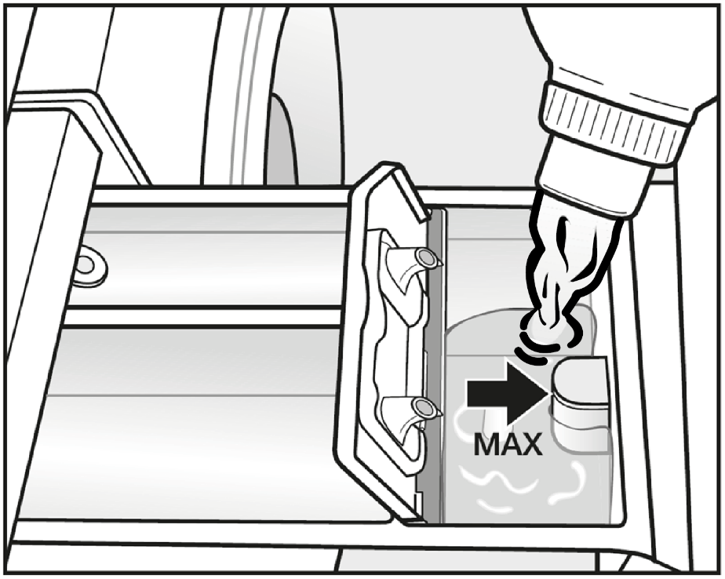
- Add fabric conditioner or liquid starch to the [flower] compartment.
Do not exceed the maximum level mark.
It will be automatically dispensed in the final rinse. At the end of the programme a small amount of water remains in the [flower] compartment.
Important: If starching frequently, thoroughly clean the dispenser compartment, especially the siphon tube, regularly.

Tips on dosing
Adjust the detergent dosage to the level of soiling of the laundry and the size of the load. Reduce the amount of detergent with smaller loads (for example, reduce the amount of detergent by one third when washing a half load).
Too little detergent:
- Results in laundry not being cleaned properly and may cause it to become grey and hard to the touch over time.
- Can lead to a build-up of mould in the washing machine.
- Results in grease not being completely removed from the laundry.
- Can lead to limescale deposits on the heater elements.
Too much detergent:
- Causes poor wash, rinse, and spin results.
- Causes higher water consumption as an extra rinse cycle is automatically activated.
- Is a greater burden on the environment.

Using liquid detergent with a prewash
Liquid detergent cannot be used for the main wash if the pre-wash has been selected.
Use powder detergent for the main wash.

Using detergent tablets or pods
Always put detergent tablets or pods directly in the drum with the laundry. They cannot be added via the detergent dispenser drawer.
See “Detergent” for further information.

CapDosing
Three different types of capsule are available:
[flower icon] = Fabric care (such as fabric conditioner, proofing agent).
[triangle with water droplet icon] = Additives (such as detergent enhancer).
[water droplet icon] = Detergent (for the main wash only).
Note: each capsule contains the correct amount for one wash cycle.
Caps are available to order from Miele or from the Miele online shop (see the end of this booklet for contact details).
Warning: Capsules pose a health risk. The ingredients of capsules can be hazardous to health if they are swallowed or come into contact with skin. Keep capsules out of the reach of children.

Activating CapDosing
- Touch the sensor for the capsule you want to use.
Sensor control |  | Capsule
[flower capsule | for |  | [flower]
[triangle capsule] | for |  | [triangle]
[droplet capsule] | for |  | [droplet]

Inserting a capsule
- Open the detergent dispenser drawer.
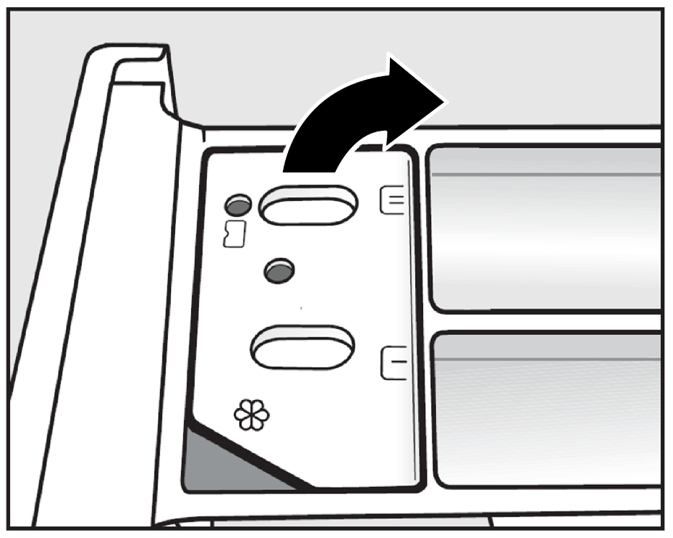
- Open the lid of the [flower/capsule] compartment.
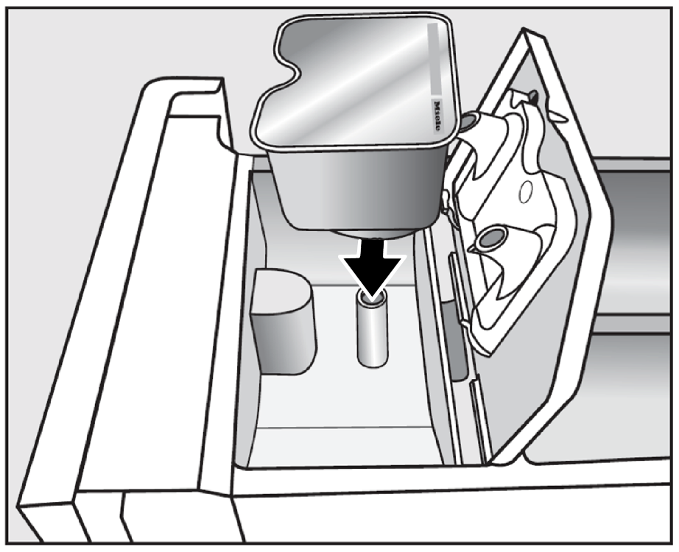
- Press the capsule in firmly.
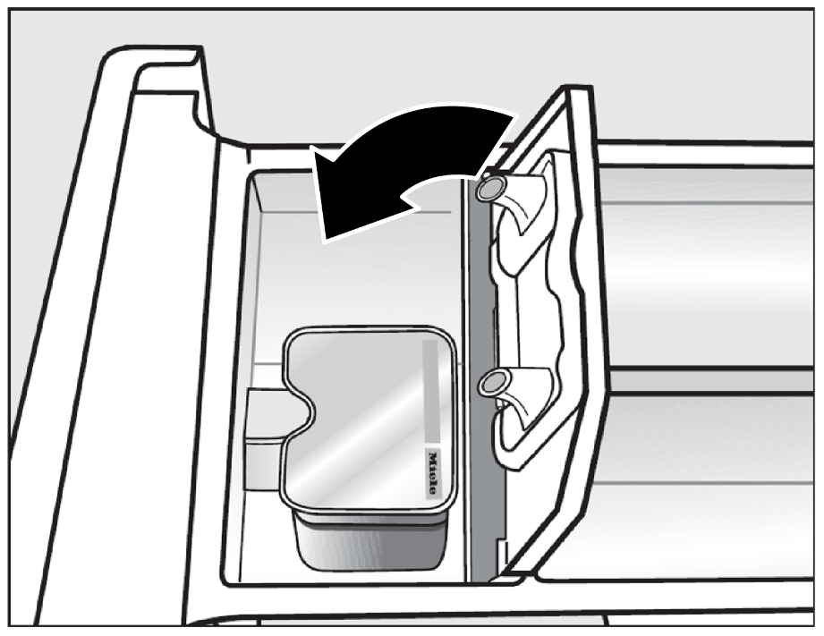
- Close the lid and press it firmly shut.
- Close the detergent dispense drawer.
Important: The capsule is opened by the act of inserting it in the detergent dispenser drawer. The contents can run out of the capsule if you then remove it from the drawer before it is used. Dispose of opened capsules.
The wash programme will dispense the contents of the capsule at the correct time.
Important: Water intake to the [flower] compartment is solely via the capsule. Do not add any additional fabric conditioner to the [flower] compartment.
- Remove the empty capsule at the end of the programme.
Note: for technical reasons a small amount of water will remain in the capsule.

Switching off/changing CapDosing
- In order to switch off CapDosing, touch the brightly lit sensor.
- In order to change CapDosing, touch one of the other capsule sensors.

5. Start the programme

To start a programme
- Touch the flashing Start/Stop sensor.
The door will lock (the padlock symbol will appear in the control panel to show this) and the programme will start.
If a delay start time has been selected, then this will count down in the time display. At the end of the delay start time or immediately after the programme has started (if no delay start time has been selected), the programme duration will appear in the time display.

Energy savings
After 10 minutes, the indicators dim and the Start/Stop sensor starts flashing.
- Touch the Start/Stop sensor to switch the indicators on again (this does not have any effect on a running programme).

6. End of programme – unload the drum

End of programme
The time display shows 0:00. The [padlock] symbol will remain lit up in the control panel. The door is locked in the anti-crease phase.
- Touch the Start/Stop sensor.
The door will unlock and the [padlock] symbol appears in the control panel.
- Pull open the door.
- Remove the laundry.

Energy savings
- Ten minutes after the beginning of the anti-crease phase, the indicators dim and the Start/Stop sensor starts flashing.
- Fifteen minutes after completion of the anti-crease phase, the washing machine is completely switched off and the door lock lifted.
Important: Items left in the drum could discolour other items in the next wash or become discoloured themselves. Remove all items from the drum.
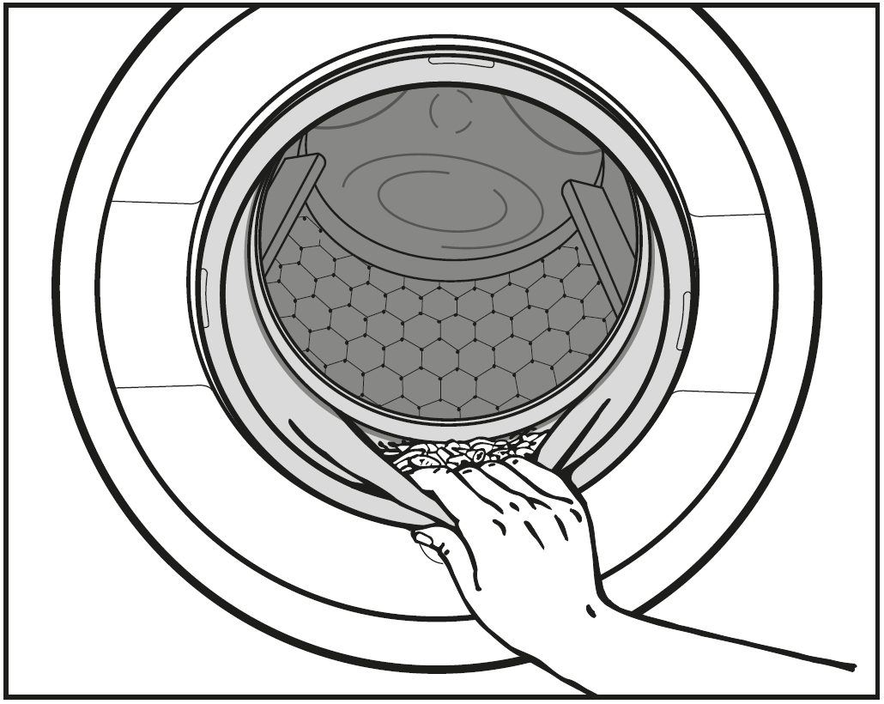
- Check the folds in the door seal for any small articles, e.g. buttons, which might be lodged there.
Tip: Leave the door slightly open to allow the drum to dry.
- Turn the programme selector to the off position [12 o’clock]. This switches the washing machine off.
- If applicable, remove the used capsule from the detergent dispensing drawer.
Tip: Leave the detergent dispenser drawer slightly open to allow it to dry.

Spinning

Final spin speed in wash programmes
When a programme is selected, the sensor control for the optimum spin speed for that programme will be brightly lit up in the control field.
A faster spin speed can be selected for certain wash programmes.
The highest selectable spin speed is indicated in the table.
Programme | rpm
ECO 40-60 | 1400
Cottons | 1400
Minimum iron | 1200
Delicates | 900
Woollens  | 1200
Shirts | 900
Express 20 | 1200
Dark garments/Denim | 1200
Outerwear | 900
Proofing | 1200
Drain/Spin | 1400
Separate rinse/Starch | 1200

Rinse and interim spin
There is a spin after the main wash and between the rinses. A reduction in the final spin speed will also reduce the interim spin speed. If a spin speed of less than 700 rpm is selected for the Cottons programme, an additional rinse is introduced.

To omit the final spin (Rinse hold)
- Touch the [basin] sensor (rinse hold).
The laundry is not spun after the final rinse and remains in the final rinse water. This helps prevent creasing if the laundry is not going to be removed from the drum immediately after the end of the programme.

After the end of a programme
Note: The sensor for the optimum spin speed lights up in the control panel. You can change the spin speed. The Start/Stop sensor lights up, flashing.
- Start the final spin: touch the flashing Start/Stop sensor once.
The final spin is carried out.
- End the programme: touch the flashing Start/Stop sensor twice.
The water will drain away.

To omit rinse and interim spin and the final spin
- Touch the [no spin] sensor.
After the last rinse, the water will be pumped away and the anti-crease phase will switch in.
In some programmes an additional rinse is introduced with this setting.

Delay start
With Delay start, you can delay the start of a programme from 1 hour up to a maximum of 7 hours. This allows you to make use of night-time economy electricity rates, for example.

Selecting Delay start
Note: Delay start is not possible in the Drain/Spin and Proofing programmes.
- Select the programme required.
- Touch the [diamond clock] sensor control.
The [diamond clock] sensor control lights up brightly.
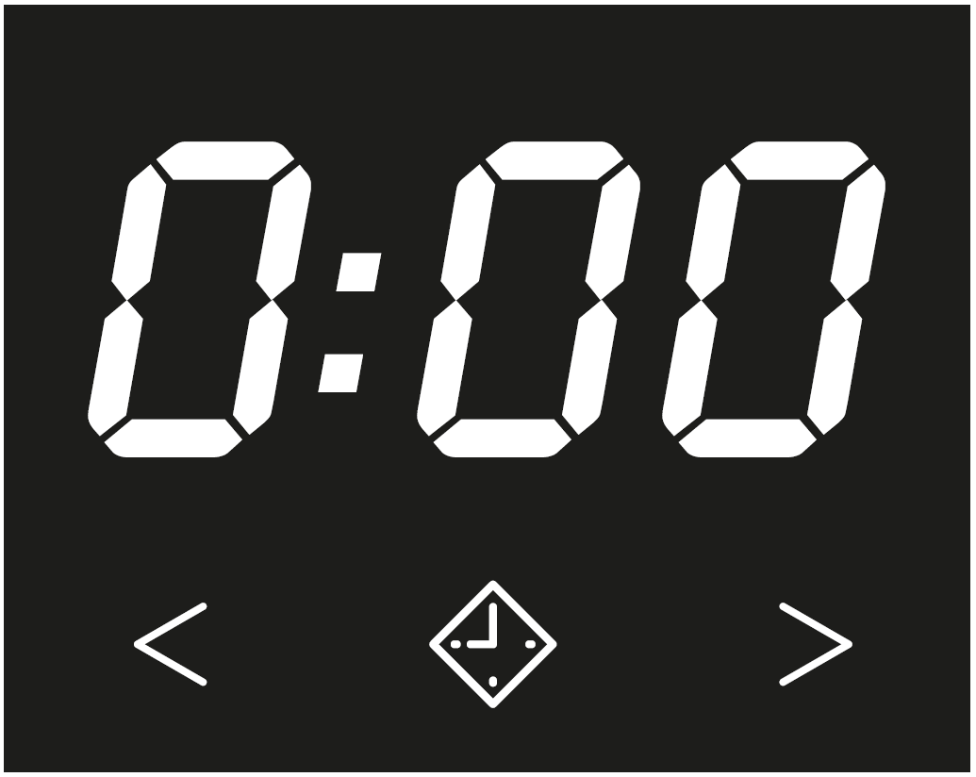
- Touch the < or > sensor control repeatedly until the required delay start time appears in the time display.
Each time the sensor control is touched, the time increases or decreases by 1 hour.

To begin delay start
- Touch the flashing Start/Stop sensor.
The delay start process starts and counts down in the time display.

To alter delay start
- Touch the Start/Stop sensor.
The delay start process stops and the [padlock] symbol lights up in the control panel.
- Touch the < or > sensor repeatedly until the required delayed start time appears in the time display.
- Touch the flashing Start/Stop sensor.

To cancel a delay start that has already started
- Touch the Start/Stop sensor.
The delay start process stops and the [padlock] symbol lights up in the control panel.
- Touch the brightly lit [diamond clock] sensor.
The delay start period is deleted and the [diamond clock] sensor switches off. The programme duration appears in the time display.
- Touch the flashing Start/Stop sensor in order to start the wash programme.

Programme chart
ECO 40-60 ‒ Max. load 8.0 kg
Items | Normally soiled cotton garments
Tip | - These settings are the most efficient in terms of energy and water consumption for washing cottons.  - With 60°C, the wash temperature reached is below  60 °C. The wash performance is the same as with the Cottons 60 °C programme.
Note for customers and test institutes:
When ECO 40–60 is selected, the label programme Cottons 60°C is selected. Indicated by the illumination of the temperature 60.
If the sensor control 40 (dimly illuminated) is touched, the label programme Cottons 40°C is activated.
Cottons ‒ 90 °C to cold ‒ Max. load 8.0 kg
Items | Cotton, linen or mixed fibre fabric, e.g. table linen, underwear, Tshirts, etc.
Tip | Where particularly high levels of hygiene are required, please select a temperature of 60 °C or higher.
Minimum iron ‒ Cold to 60 °C ‒ Max. load 3.5 kg
Items | Synthetic and mixed fibre textiles as well as easy care cotton
Tip | Reduce the spin speed for fabric that creases easily.
Delicates ‒ Cold to 40 °C ‒ Max. load 2.0 kg
Items | Delicate garments made from synthetic fibre, mixed fibre and viscose  Curtains specified as machine-washable by the manufacturer
Tip | – Dust in curtains usually means that a programme with Pre-wash is advisable.  – Deselect the spin for items which crease easily.
Woollens ‒ Cold to 40 °C ‒ Max. load 2.0 kg
Items | Wool or wool blend fabric
Tip | Reduce the spin speed for fabric that creases easily.
Shirts ‒ Cold to 60 °C ‒ Max. load 2.0 kg
Items | Shirts and blouses made of cotton and mixed fibre
Tip | – Pre-treat collars and cuffs depending on the level of soiling.  – Wash silk shirts and blouses in the Delicates programme.
Express 20 ‒ Cold to 40 °C ‒ Max. load 3.5 kg
Items | Cotton garments that have hardly been worn or are only very lightly soiled
Tip | The Short extra option is activated automatically.
Dark garments/Denim ‒ Cold to 60 °C ‒ Max. load 3.0 kg
Items | Black and dark items made of cotton, mixed fibre or denim
Tip | – Wash inside out.  – Denim often contains excess dye and may run during the first few washes. Therefore, wash light and coloured items separately.
Outerwear ‒ Cold to 40 °C ‒ Max. load 2.5 kg
Items | Performance outerwear (e.g. jackets and trousers) made from membrane fabric such as Gore-Tex®, SYMPATEX®, WINDSTOPPER®, etc.
Tip | – Zip up or close any jackets with Velcro before washing.  – Do not use fabric conditioner.  – If required, these items can also be re-proofed using the Proofing programme. Proofing after each wash cycle is not recommended.
Proofing ‒ 40 °C ‒ Max. load 2.5 kg
Items | Treating microfibre fabric, ski wear or table linen made from mainly synthetic fibres to provide a finish which is resistant to water and dirt
Tip | – The items must be freshly laundered and spun or dried before proofing.  – For best results, the items should be heat-treated afterwards. This can be achieved by drying them in the tumble dryer or ironing them.
Drain/Spin –
Tip | - Drain only: Set spin speed to [no spin].  - Make sure you select the appropriate spin speed.
Separate rinse/Starch ‒ Max. load 8.0 kg
Items | – Rinsing hand-washed items  – Table cloths, serviettes and workwear requiring starching
Tip | – Reduce the spin speed for fabric that creases easily.  – Laundry that is to be starched should be washed but not treated with fabric conditioner.  – Items will be rinsed very effectively with 2 rinses by activating the Water + extra.

Extra options
You can use the extra options buttons to augment the wash programmes.
Extras are selected and deselected using the relevant sensors on the control panel.
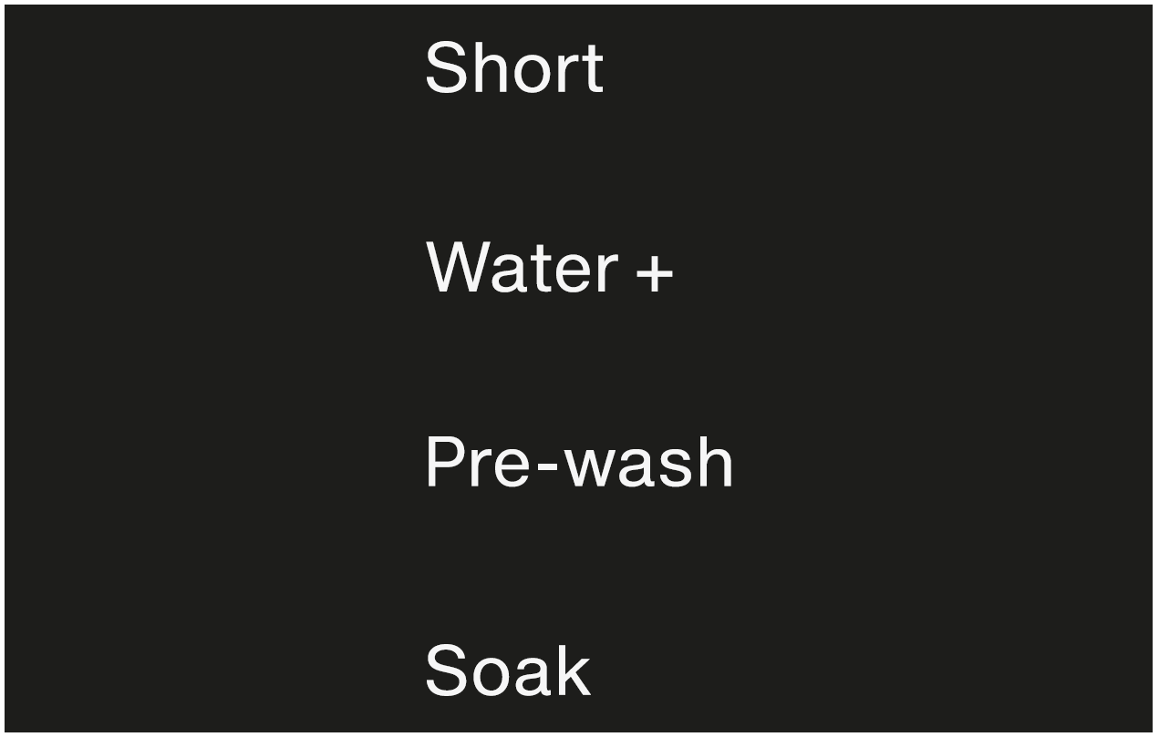
[Extras panel. One column, four options top to bottom: Short, Water +, Pre-wash, Soak.]
- Touch the sensor for the extra you want.
The relevant sensor will light up brightly.
Not all the extra options are suitable for use with every programme.
An extra that is not permitted for the wash programme is not lit dimly and cannot be activated by touch.

Short
For textiles with light soiling with no visible staining.
The wash duration is reduced.

Water +
The water level in the main wash and the rinses will be increased. A second rinse cycle is carried out in the Separate rinse/Starch programme.
You can select other functions for the Water + sensor control. These are described under “Programmable functions”.

Pre-wash
For laundry with large amounts of dirt, e.g. dust and sand.

Soak
For cleaning heavily soiled and stained items with protein stains.
- A duration of between 30 minutes and 2 hours can be programmed in 30 minute increments for the soak process.
- The factory default setting is 30 minutes.
See “Programmable functions – Soak” for instructions on how to programme a different soak period.

The following extras can be selected in addition to the programmes
● = can be selected
= activated automatically
X = cannot be selected
 | Short | Water + | Pre-wash | Soak
ECO 40-60 | ● | ● | ● | ●
Cottons | ● | ● | ● | ●
Minimum iron | ● | ● | ● | ●
Delicates | ● | ● | ● | ●
Shirts | ● | ● | ● | ●
Express 20 |  | X | X | X
Dark garments/Denim | ● | ● | ● | ●
Outerwear | ● | ● | ● | ●
Separate rinse/Starch | X | ● | X | X

Garment care label symbols
Washing
The figure quoted in the bucket is the maximum temperature the garment can be washed at. The number of bars under the symbol indicates the level of agitation permitted.
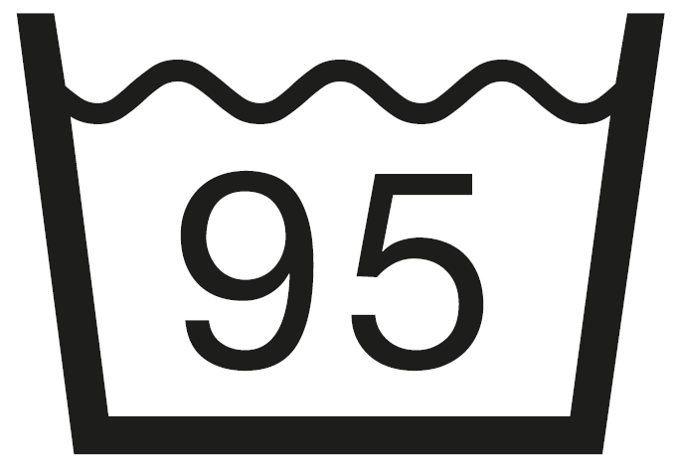 | [Bucket full of water with 95, no bars under the symbol]  No bar under the symbol = normal agitation
[Bucket full of water with 60, one bar under the symbol]
One bar under the symbol = reduced agitation
[Bucket full of water with 30, two bars under the symbol]
Two bars under the symbol = much reduced agitation
[Bucket full of water with hand in water]
Hand wash (if no temperature is specified, use the lowest temperature or cold)
[Bucket full of water with cross over it]
Do not wash

Programme selection examples
Programme | Garment care label symbols
Cottons | [Six buckets full of water with 95, 70, 60, 50, 40 and 30, no bars under the buckets]
Minimum iron | [Five buckets full of water with 95, 60, 50, 40 and 30, one bar under each bucket]
Delicates | [Two buckets full of water with 40 and 30, two bars under each bucket]
Woollens | [Bucket full of water with hand in water]
Express 20 | [Two buckets full of water with 40 and 30, no bars under the buckets]


Drying
The number of dots indicates the drying temperature
[Square icon containing a circle with two dots]
Normal temperature
[Square icon containing a circle with one dot]
Low temperature

[Square icon containing a circle with a cross over it]
Do not tumble dry


Ironing
The number of dots indicates the ironing temperature
[Iron icon with three dots]
Hot iron (max. sole plate temp. approx. 200 °C)
[Iron icon with two dots]
Medium hot iron (max. sole plate temp. approx. 150 °C)
[Iron icon with one dot]
Cool iron (max. sole plate temp. approx. 110 °C).
Do not steam iron garments carrying this symbol as this could cause irreversible damage.
[Iron icon with a cross over it]
Do not iron

Professional cleaning
[Circle icons with a capital F letter in one and a capital P letter in the other]
Dry clean only. The letters indicate the type of cleaning agent required.
[Circle icon with a capital W letter]
Professional Wet Clean only
[Circle icon with a cross through it]
Do not dry clean

Bleaching
[A triangle symbol]
Any oxidising bleaching agent
can be used
[A triangle symbol with a lined fill]
Only use an oxygen based
bleach or a non-chlorine bleach
[A triangle symbol with a cross over it]
Do not bleach

Programme sequence
A = intensive rhythm
B = normal rhythm
C = sensitive rhythm
E = handwash rhythm
= carried out
X = not carried out

 | Main wash |  | Rinses |  | Spinning
 | Water  level | Wash  rhythm | Water  level | Rinses
ECO 40-60 | low | A | medium | 2-52,3
Cottons | low | A | medium | 2-51,2,3
Minimum iron | low | B | high | 2-42,3
Delicates | high | C | high | 2-42,3
Woollens | high | E | high | 2
Shirts | high | C | high | 3-43
Express 20 | low | A | low | 1
Dark garments/ Denim | medium | B | low | 3-52,3
Outerwear | high | C | high | 3-43
Proofing | X | B | medium | 1
Drain/Spin | X | X | X | X
Separate rinse/ Starch | medium | B | high | 0-15
Please see the next page for a description of the symbols.
This washing machine has fully electronic controls with automatic load control. The washing machine takes in the right amount of water required for the programme depending on the amount of laundry and its absorbency rate.
The programme sequences outlined in the chart are based on the basic programme with a full load.

Special features in the programme sequence
Anti-crease: At the end of the programme, the drum continues to turn at intervals for up to 30 minutes to help prevent creasing.
Exception: there is no anti-crease phase in the Woollens programme. The washing machine can be opened at any time.
1) If a temperature of 60 °C or higher is selected, two rinses are carried out. If a temperature of less than 60 °C is selected, three rinses are carried out.
2) An additional rinse is carried out if:
– there is too much foam in the drum
– a spin speed lower than 700 rpm has been selected.
3) An additional rinse is carried out if:
– the Water + extra option has been selected and the options 02 or 03 have been activated in Programmable functions.
5) An additional rinse is carried out if: the Water + extra option has been selected.

Changing the programme sequence

Changing a programme or adding/removing laundry
After the successful start of a programme it is no longer possible to select a different programme.
After the start of a programme it is no longer possible to open the door.
If you would like to change the programme or add/remove laundry, you must cancel the programme.

Cancelling a programme
You can cancel a programme at any time after it has started:
- Touch the Start/Stop sensor.
The water is pumped out, the time display changes to 0:00. As soon as the [padlock] symbol goes out in the control panel, the programme has been cancelled and the door can be opened.

Selecting a different programme after cancelling the programme
- Open the door.
- Close the door.
- Check that there is still detergent in the dispenser drawer. Add more detergent if necessary.
- Turn the programme selector to the programme you want and start it by pressing the Start/Stop sensor.

Removing laundry after cancelling the programme
If you want to remove the laundry when it is dripping wet:
- Open the door.
- Remove the laundry.
If you want to remove the laundry after it has been spun (damp):
- Open the door.
- Close the door.
- Turn the programme selector to Drain/Spin.
Tip: Select an appropriate spin speed.
- Touch the Start/Stop sensor.
The laundry is spun and after spinning, it can be removed, damp.

Interrupting a programme
- Turn the programme selector to the off position [12 o’clock].
The washing machine switches off.
- To continue: turn the programme selector to the position of the wash programme that was started.
Tip: If -0- appears in the time display, the programme selector is in the incorrect position.

Garment care label symbols
Washing
The figure quoted in the bucket is the maximum temperature the garment can be washed at. The number of bars under the symbol indicates the level of agitation permitted.
[Bucket full of water with 95, no bars under the symbol]
No bar under the symbol = normal agitation
[Bucket full of water with 60, one bar under the symbol]
One bar under the symbol = reduced agitation
[Bucket full of water with 30, two bars under the symbol]
Two bars under the symbol = much reduced agitation
[Bucket full of water with hand in water]
Hand wash (if no temperature is specified, use the lowest temperature or cold)
[Bucket full of water with cross over it]
Do not wash

Programme selection examples
Programme | Garment care label symbols
Cottons | [Six buckets full of water with 95, 70, 60, 50, 40 and 30, no bars under the buckets]
Minimum iron | [Five buckets full of water with 95, 60, 50, 40 and 30, one bar under each bucket]
Delicates | [Two buckets full of water with 40 and 30, two bars under each bucket]
Woollens | [Bucket full of water with hand in water]
Express 20 | [Two buckets full of water with 40 and 30, no bars under the buckets]


Drying
The number of dots indicates the drying temperature
[Square icon containing a circle with two dots]
Normal temperature
[Square icon containing a circle with one dot]
Low temperature

[Square icon containing a circle with a cross over it]
Do not tumble dry


Ironing
The number of dots indicates the ironing temperature
[Iron icon with three dots]
Hot iron (max. sole plate temp. approx. 200 °C)
[Iron icon with two dots]
Medium hot iron (max. sole plate temp. approx. 150 °C)
[Iron icon with one dot]
Cool iron (max. sole plate temp. approx. 110 °C).
Do not steam iron garments carrying this symbol as this could cause irreversible damage.
[Iron icon with a cross over it]
Do not iron

Professional cleaning
[Circle icons with a capital F letter in one and a capital P letter in the other]
Dry clean only. The letters indicate the type of cleaning agent required.
[Circle icon with a capital W letter]
Professional Wet Clean only
[Circle icon with a cross through it]
Do not dry clean

Bleaching
[A triangle symbol]
Any oxidising bleaching agent
can be used
[A triangle symbol with a lined fill]
Only use an oxygen based
bleach or a non-chlorine bleach
[A triangle symbol with a cross over it]
Do not bleach

Detergent

The correct detergent
All detergents produced for automatic washing machines are suitable. Follow the manufacturer's instructions and dosage recommendations on the packaging.
For users in Asia: please use a low foaming detergent suitable for use in front-loading machines

The right amount to dispense will depend on the following:
- the soiling level of the load
- the quantity of the laundry
- the water hardness level. Check with your local water supplier if you do not know the hardness level in your area.

Water softeners
A water softener can be used to cut down on the use of detergents in areas with water hardness levels II and III. Dispense according to the amount specified on the packaging. First add detergent and then the water softener.
You can then use the recommended amount of detergent for water hardness level I.

Water hardness levels
Hardness  scale | Hardness level  in mmol/l | German scale  °d
I (soft) | 0 – 1.5 | 0 – 8.4
II (medium) | 1.5 – 2.5 | 8.4 – 14
III (hard) | above 2.5 | above 14

Dispensing aids
Use dispensing aids, (e.g. balls) if these are supplied with the detergent, particularly when using liquid detergent.

Refill packs of detergent
When purchasing detergent buy refill packs wherever possible. This helps reduce the amount of waste packaging.

Fabric conditioner and liquid starch
Fabric conditioner makes garments soft to handle and helps prevent static cling when tumble drying.
Starch stiffens and gives body to items of laundry, e.g. shirts, tablecloths and bed linen.

Adding fabric conditioner or liquid starch separately
Prepare the starch in accordance with the manufacturer's instructions on the packaging.
Tip: When adding fabric softener, activate the Water plus extra.
- Add fabric conditioner to the [flower] compartment or insert the appropriate capsule.
- Add liquid starch to the [flower] compartment and powder or viscous starch to the pre-wash [basin I] compartment.
- Select the Separate rinse/Starch programme.
- Change the spin speed if necessary.
- Activate the Cap [casule] sensor if using a capsule.
- Touch the Start/Stop sensor.

Colour run and dye removers/dyes
Warning: Damage due to colour run/dye removers. Colour run and dye removers can cause corrosion in the washing machine. Do not use colour run or dye removers in this washing machine.
Dyes suitable for use in domestic washing machines can be used. However, please note that the salt used in the dyeing process can cause corrosion to stainless steel components in the machine if you use dye frequently. Always observe the dye manufacturer's instructions carefully.

Recommended Miele detergents
Miele detergents have been specially designed for day-to-day use in Miele washing machines. See “Detergents and care products” for more information about these detergents.
= Recommendation
X = No recommendation
CD = [capsule droplet] Specialist detergents (e.g. WoolCare)
CF = [capsule flower] Fabric care (e.g. fabric conditioner)
CT = [capsule triangle] Additive (e.g. booster)
 | Miele detergents |  | Miele capsules
 | Ultra White | Ultra Color | CD | CF | CT
ECO 40-60 |  |  | X
Cottons |  |  | X
Minimum iron | X |  | X
Delicates | X |  |  |  | ‒
Woollens | X | X |  | X | X
Shirts |  |  | X
Express 20 | X |  | X |  | X
Dark garments/ Denim | X |  |  |  | X
Outerwear | X |  |  | X | X
Proofing | X | X | X |  | X
Separate rinse/ Starch | X / X | X / X | X / X | / X | X / X

Recommended detergents in accordance with Directive (EU) Nr. 1015/2010
The recommendations apply to the temperature ranges given in the Programme chart.
= Recommendation
X = No recommendation
1 = Liquid detergent
2 = Powder detergent
 | Universal | Coloureds | Delicates and woollens | Specialist
 | detergent
ECO 40-60 |  |  | ‒ | ‒
Cottons |  |  | ‒ | ‒
Minimum iron | ‒ |  | ‒ | ‒
Delicates | ‒ | ‒ |  | ‒
Woollens | ‒ | ‒
Shirts |  |  | ‒ | ‒
Express 20 | ‒ | 1 | ‒ | ‒
Dark garments/ Denim | ‒ | 1 | ‒
Outerwear | ‒ | ‒

Cleaning and care

Cleaning the external casing and the control panel
Warning: Risk of electric shock! Mains voltage is present when the washing machine is switched off. Disconnect the machine from the electricity supply before cleaning or maintenance.
Warning: Risk of damage due to ingress of water. The pressure of a water jet can cause water to get into the washing machine, resulting in damage to components. Do not spray the washing machine with a water jet.
- Clean the casing and control panel with a mild cleaning agent or soap and water and dry both with a soft cloth.
- The drum can be cleaned using a suitable stainless steel cleaning agent following the manufacturer's instructions on the packaging.
Warning: Damage caused by cleaning agents. Solvent based cleaning agents, abrasive cleaners, glass cleaners or multi-purpose cleaning agents can cause damage to plastic surfaces and other parts. Do not use any of these cleaning agents.

Cleaning the detergent dispenser drawer
Note: Washing at low temperatures and the use of liquid detergent can lead to a build-up of mould and bacteria in the detergent dispenser drawer.
- For hygiene reasons, clean the entire drawer at regular intervals.

Removing the dispenser drawer
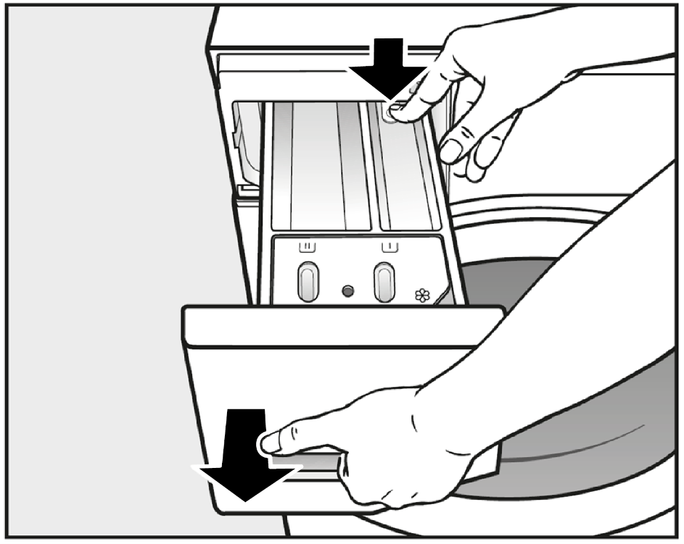
- Pull out the detergent dispenser drawer until a resistance is felt. Press down the release button and at the same time pull the drawer right out of the machine.
- Clean the detergent drawer with warm water.

Cleaning the siphon and the [flower/capsule] compartment channel
Information: Liquid starch results in clogging. If clogged, the siphon in the [flower/capsule] compartment will not work and the compartment can overflow. Clean the siphon particularly thoroughly after using liquid starch a few times.
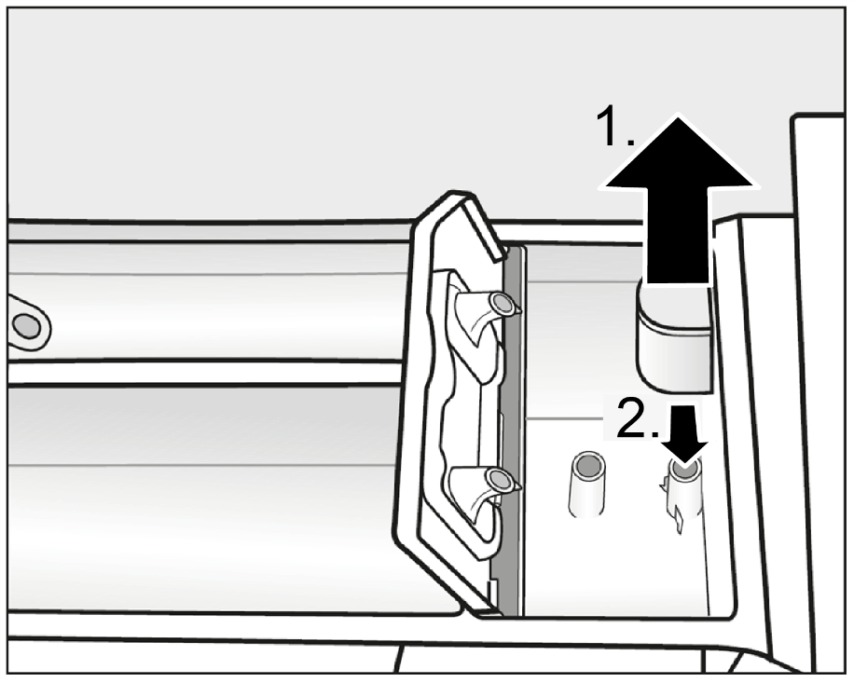
- Remove the siphon from the softener [flower] compartment and clean under warm running water. Clean the siphon tube in the same way.
- Replace the siphon.
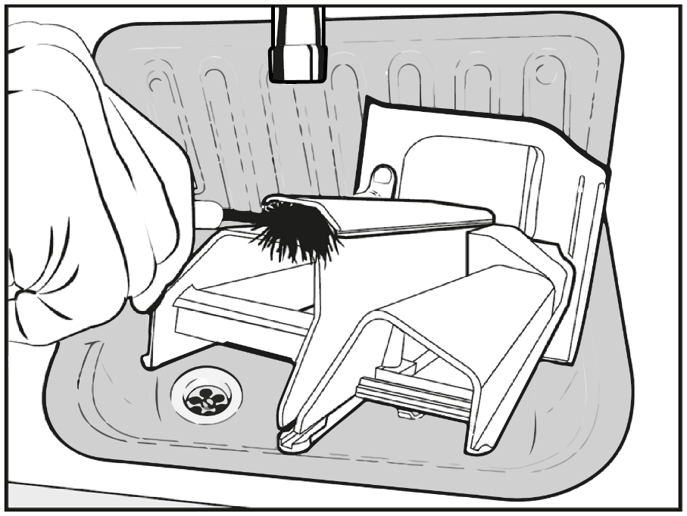
- Clean the fabric conditioner channel using a brush and warm water.

Cleaning the detergent dispenser drawer compartment
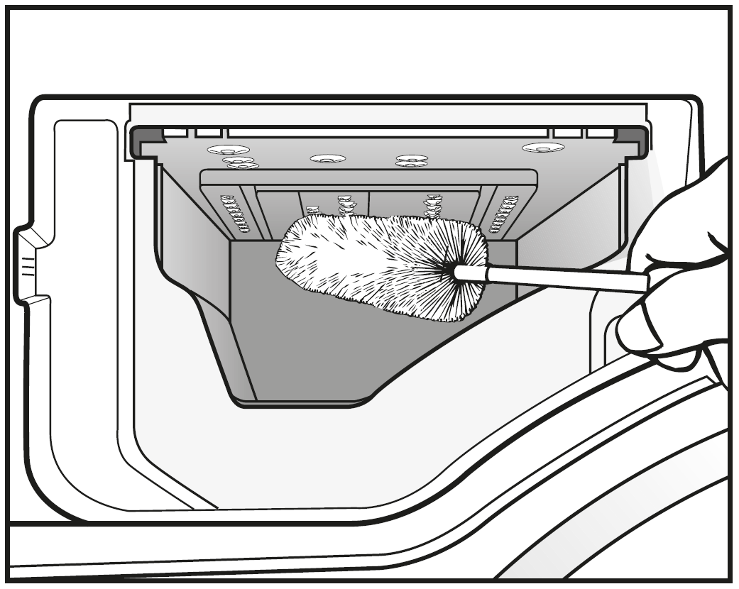
- Use a bottle brush to remove detergent residues and limescale from the jets inside the detergent dispenser drawer compartment.
- Replace the detergent dispenser drawer.
Tip: Leave the detergent dispenser drawer slightly open to allow it to dry.

Hygiene info (Cleaning the drum)
Washing at low temperatures and/or using liquid detergent can cause bacteria and unpleasant odours to build up in the washing machine. Use the Cottons 90 °C programme to clean the washing machine. Clean the drum when the indicator light [plus] comes on at the latest.

Cleaning the water inlet filter
The washing machine has a filter to protect the water inlet valve. The accessible filter in the union at the open end of the inlet hose should be checked every six months or so, or more often if there are frequent interruptions to the water supply.
- First turn off the stopcock.
- Unscrew the inlet hose from the stopcock.
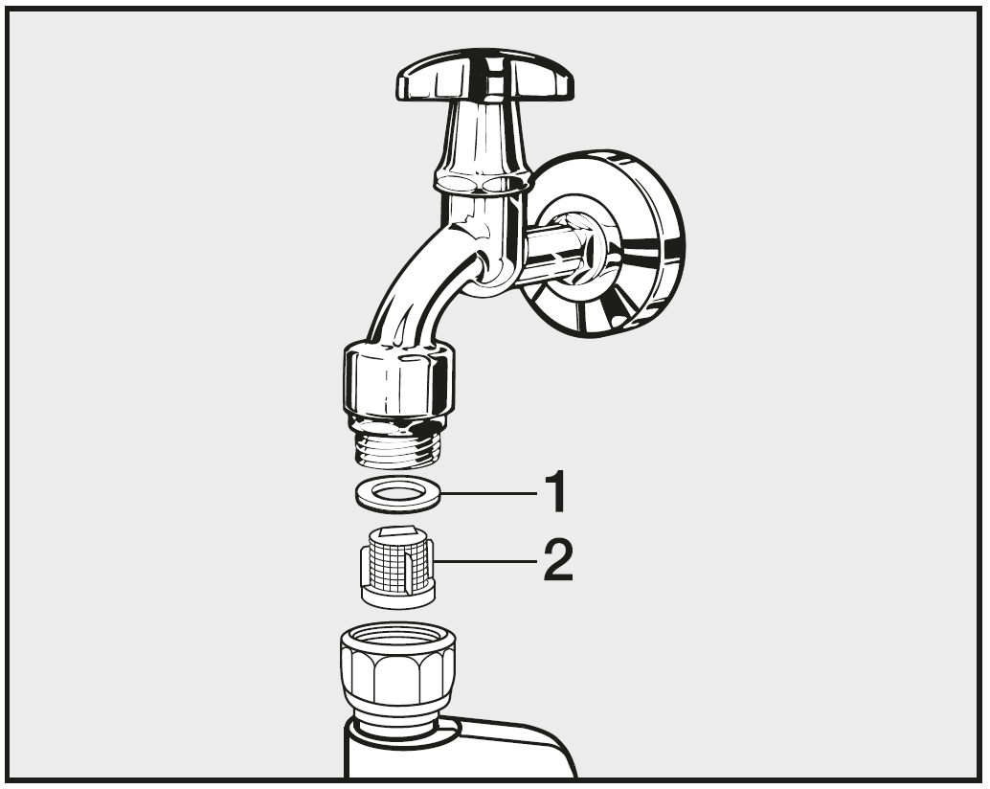
- Remove the rubber seal [1] from the recess.
- Using pointed pliers, take hold of the plastic filter bar [2] and remove it. Clean the plastic filter.
- Put the filter and seal back in the reverse order and reconnect the hose.
Important: Turn on the stopcock and check the connection is watertight. If water drips out, tighten the connection.
Important: The filter must be put back in place after cleaning.

Problem solving guide
Minor faults in the performance of the washing machine, some of which may result from incorrect operation, can be put right without contacting the Service Department.
The following guide may help you to find the reason for a fault, and to correct it.
You should, however, note the following:
Warning: Repair work to electrical appliances should only be carried out by a suitably qualified person in strict accordance with current local and national safety regulations. Repairs and other work by unqualified persons could be dangerous. The manufacturer cannot be held liable for unauthorised work.

The programme does not start
Problem | Cause and remedy
The control panel remains  dark. | There is no power to the machine.  - Check whether the mains plug is plugged in and switched on.  - Check whether the fuse or circuit breaker has tripped.
The washing machine has switched off automatically to save energy.
- Switch the washing machine on again by turning the programme selector.
F and 34 alternately appear in the time display. | The door is not closed properly. The door lock could not engage.  - Close the door again.  - Start the programme again.  If the fault message appears again, contact the Service Department.

The programme is cancelled and a fault indicator light lights up in the control panel
Problem | Cause and remedy
The fault indicator light [tap] lights up, F and 10 appear alternately in the time display and the buzzer sounds. | The water inlet is blocked or restricted.  - Check whether the stopcock is opened properly.  - Check whether the inlet hose is kinked.  - Check whether the water pressure is too low.
The filter in the water inlet is blocked.
- Clean the filter.
The fault indicator light [tap] lights up, F and 11 appear alternately in the time display and the  buzzer sounds. | The water outlet is blocked or restricted.  The drain hose has been fixed too high.  - Clean the drain filter and the drain pump.  - The maximum delivery head is 1 m.
The fault indicator light [tap] lights up, F and 138 appear alternately in the time display and the  buzzer sounds. | The water protection system has reacted.  - Close the stopcock.  - Call the Service Department.
F and XXX appear alternately on the time display and the buzzer sounds. | There is a fault.  - Disconnect the washing machine from the electricity supply. Switch off at the wall and withdraw the plug from the socket, or disconnect the fuse.  - Wait at least 2 minutes before reconnecting the washing machine to the electricity supply.  - Switch the washing machine on again.  - Restart the programme.  If the fault message appears again, contact the Miele Customer Service Department.

During the programme, a symbol appears in the time display
Problem | Cause and remedy
-0- lights up | The programme selector was moved to a different position after the programme had started.   - Turn the programme selector back to the original position.
The programme has been interrupted.
- Open the door.
- Close the door.

At the end of the programme, an indicator light lights up in the control panel
Problem | Cause and remedy
The indicator light [door] lights up. | Excessive foam has built up during washing.  - Use less detergent next time, and follow the manufacturer's recommended dosage amounts on the packaging.
The indicator light [plus] lights up. | When washing, a wash programme using a temperature above 60 °C has not been run for a long time.  - Run the Cottons 90 °C programme using Miele machine cleaner or a universal powder detergent.  This will clean the washing machine and prevent a build-up of bacteria and odours.

General problems with the washing machine
Problem | Cause and remedy
The washing machine smells. | The [plus] indicator light was ignored. A wash programme using a temperature above 60 °C has not been run for a long time.  - In order to prevent bacteria and unpleasant odours building up in the washing machine, run the Cottons 90 °C programme using Miele machine cleaner or a universal powder detergent.
The door and the detergent dispenser drawer were left shut after washing.
- Leave the door and the detergent dispenser drawer slightly open to allow them to dry.
The machine shakes  during the spin cycle. | The machine feet are not level.  - Level the machine and adjust the feet correctly.
The laundry has not  been spun properly and  is still wet. | The machine detected an imbalance during the final spin cycle and reduced the spin speed automatically.  - Include both large and small items in the load as this will give better distribution during spinning.
Strange pump noises  can be heard. | This is not a fault.  These slurping noises occur at the end of the pump sequence as a normal part of operation.
Large amounts of detergent residue remain in the detergent dispenser  drawer. | The water pressure is too low.  - Clean the water inlet filter.  - It may be useful to select the Water + extra option.
Powder detergent used in conjunction with water softeners tends to become sticky.
- In future, add washing powder into the dispenser drawer first, and then add the water softener.
Fabric conditioner is not  completely dispensed  or too much water remains in the [flower] compartment. | The siphon tube is not correctly positioned or is clogged.  - Clean the siphon, see “Cleaning and care – Cleaning the detergent dispenser drawer”.
At the end of the programme there is still liquid in the capsule. | The small pipe in the detergent dispenser drawer onto which the capsule is placed is blocked.  - Clean the small pipe.
This is not a fault.
For technical reasons a small amount of water will remain in the capsule.
There is water next to  the capsule in the fabric  conditioner compartment | The [capsule] sensor control was not activated.  - Make sure that you remember to activate the [capsule] sensor control the next time you insert a capsule.
An empty capsule was not removed at the end of the last wash programme. 
- Remove and dispose of the empty capsule at the end of each programme.
There is a blockage in the small pipe in the detergent drawer onto which the capsule is placed.
- Clean the small pipe.

An unsatisfactory wash result
Problem | Cause and remedy
Liquid detergent does  not give the required  result. | Liquid detergents usually contain no bleaching agents. They do not remove fruit, coffee and tea stains.  - Use a general purpose powder detergent containing a bleaching agent.  - Use the appropriate capsule or add stain removers to the [basin II] compartment.  - Never put stain removers and liquid detergent together in the dispenser drawer.
White residues which  look like powder detergent  are seen on dark  textiles after washing. | The detergent contained compounds (zeolites) to aid water softening which are not soluble in water. These have ended up on the laundry.  - Try and brush off the residues with a soft brush once the laundry is dry.  - Wash dark textiles using a detergent which contains no zeolites. Liquid detergents usually contain no zeolites.  - Use the Dark garments/Denim programme for dark coloured laundry.
White residues which  look like powder detergent  are seen on dark  textiles after washing. | The detergent contained compounds (zeolites) to aid water softening which are not soluble in water. These have ended up on the laundry.  - Try and brush off the residues with a soft brush once the laundry is dry.  - Wash dark textiles using a detergent which contains no zeolites. Liquid detergents usually contain no zeolites.  - Use the Dark garments / Denim programme for dark coloured laundry.

The door will not open
Problem | Cause and remedy
The door cannot be pulled open during a programme. | The door is locked during a programme.  - Touch the Start/Stop sensor to cancel the programme.  The programme is cancelled, the door will unlock and you will be able to pull it open.
There is still water in the drum and the machine is unable to drain.
- Clean the drain filters and the drain pump as described in “Opening the door in the event of a blocked drain outlet and/or power failure”.
After the programme is  cancelled, flashing bars 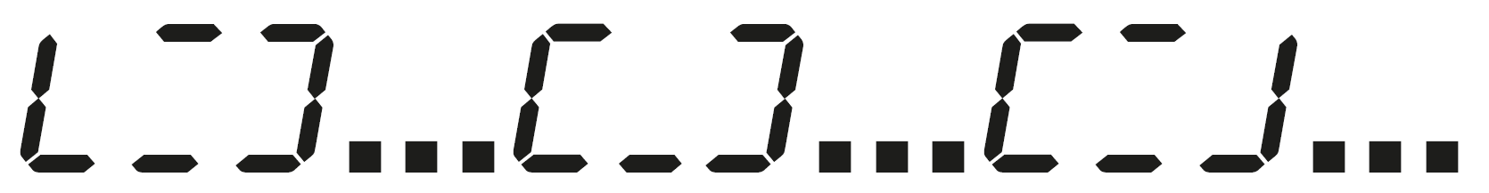 appear in the time display. | For safety reasons the drum door cannot be opened if the suds temperature is higher than 55 °C.  - Wait until the temperature in the drum has decreased and the bars have stopped flashing in the display.
F and 35 alternately appear in the time display. | The door lock has jammed.  - Call the Service Department.

Opening the door in the event of a blocked drain outlet and/or power cut
- Switch off the washing machine.
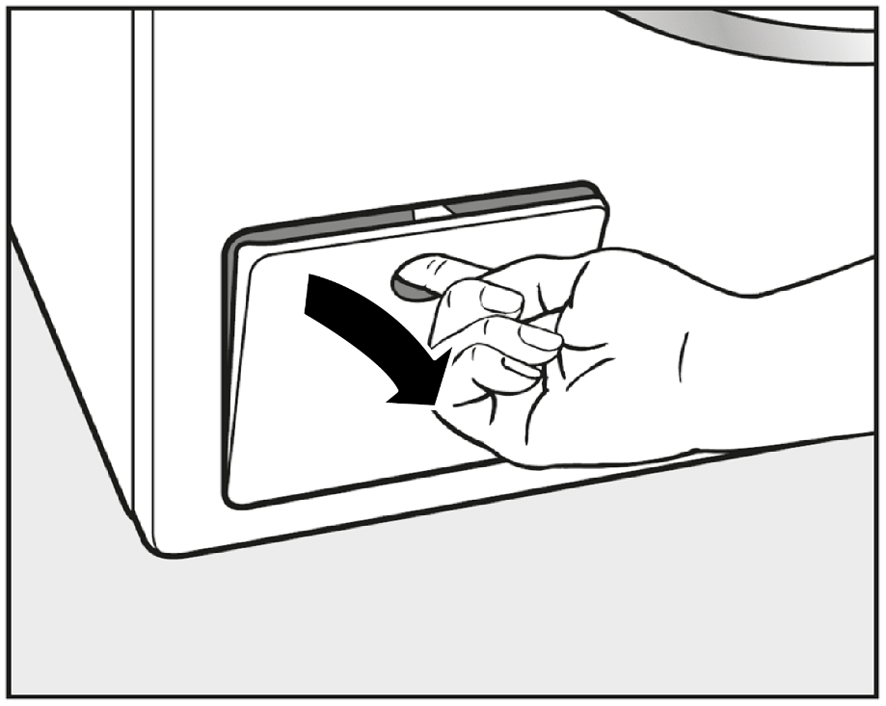
- Open the drain pump access panel.

Blocked drain outlet
If the drain outlet is blocked, there may be a large quantity of water left behind in the washing machine.
Warning: Risk of scalding due to hot suds. Escaping suds will be hot if laundry has been washed at high temperatures! Carefully allow all suds to drain off.

Draining the washing machine
Important: Remove the drain filter, though not completely.
- Place a suitable container under the access panel, e.g. a universal oven tray.
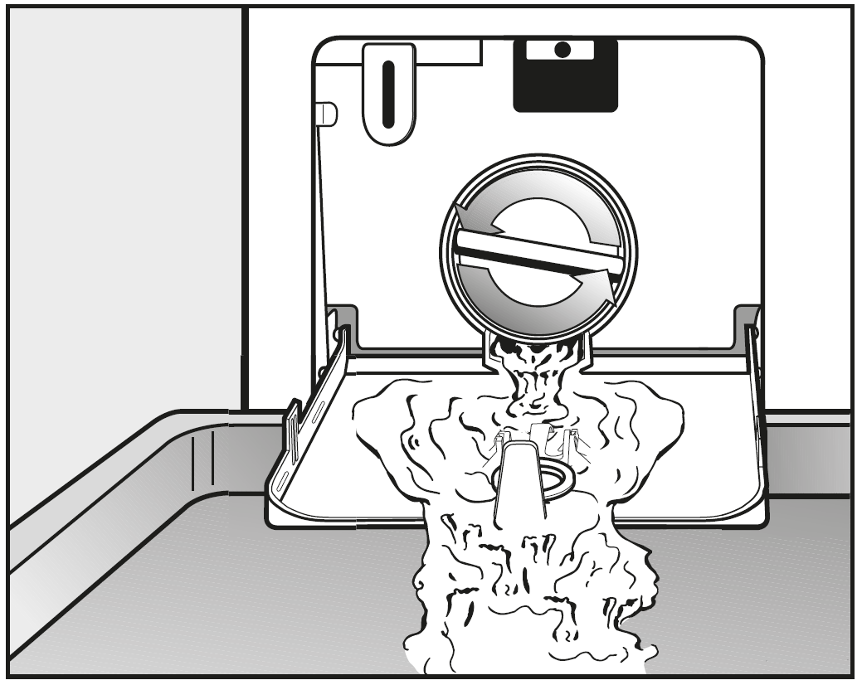
- Slowly unscrew the drain filter to let the water out.
- Tighten the drain filter back up again if you need to interrupt the flow of water.
Once the flow of water ceases:
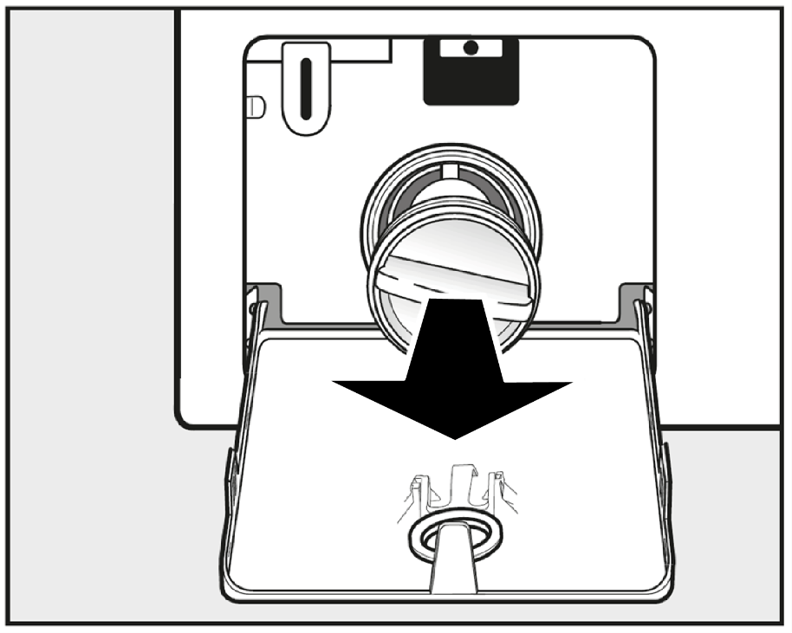
- Remove the drain filter completely.
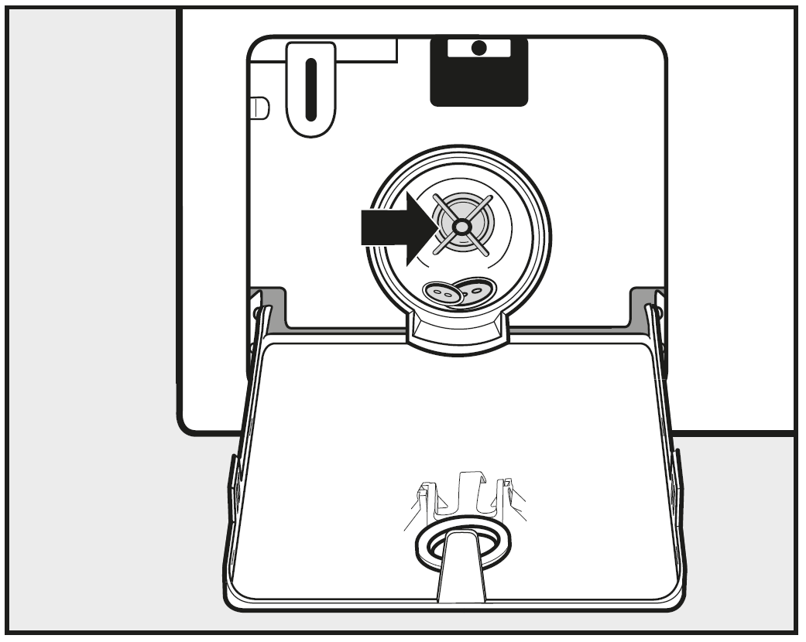
- Clean the drain filter thoroughly.
- Remove any foreign objects (e.g., buttons, coins etc.) and clean the interior.
- Turn the impellers by hand to check that they rotate freely.
- Replace the drain filter correctly and tighten it securely.
- Close the drain pump access panel.
Warning: Risk of water damage. Make sure the drain filter is securely tightened. Otherwise there is a risk of water leakage during use. Replace the drain filter correctly and tighten it securely.

Open the door
Warning: Danger of injury due to rotating drum! Reaching into a moving drum is extremely dangerous. Always make sure that the drum is stationary before reaching in to remove laundry.
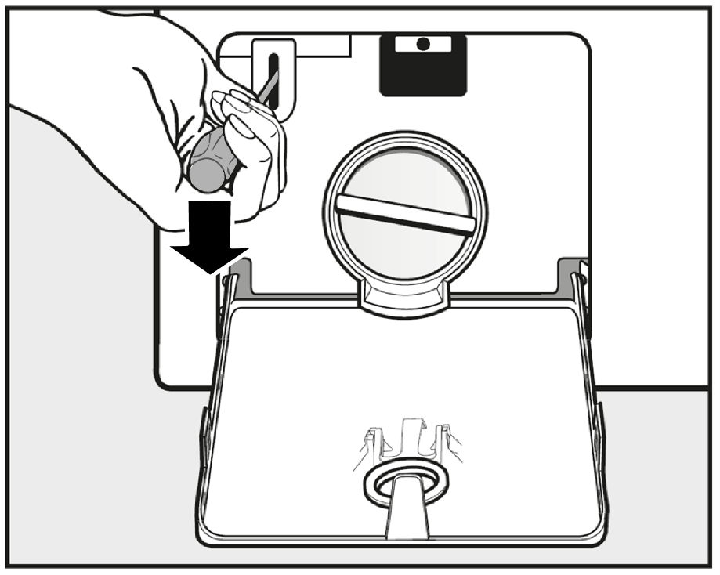
- Use a screwdriver to unlock the door.
- Pull open the door.

After sales service

Repairs
In the event of any faults which you cannot remedy yourself, please contact:
- your Miele Dealer, or
- Miele (Contact details for Miele are given at the end of this booklet).
When contacting your Dealer or Miele, please quote the model and serial number of your machine, both of which are shown on the data plate visible above the porthole glass when the door is open.
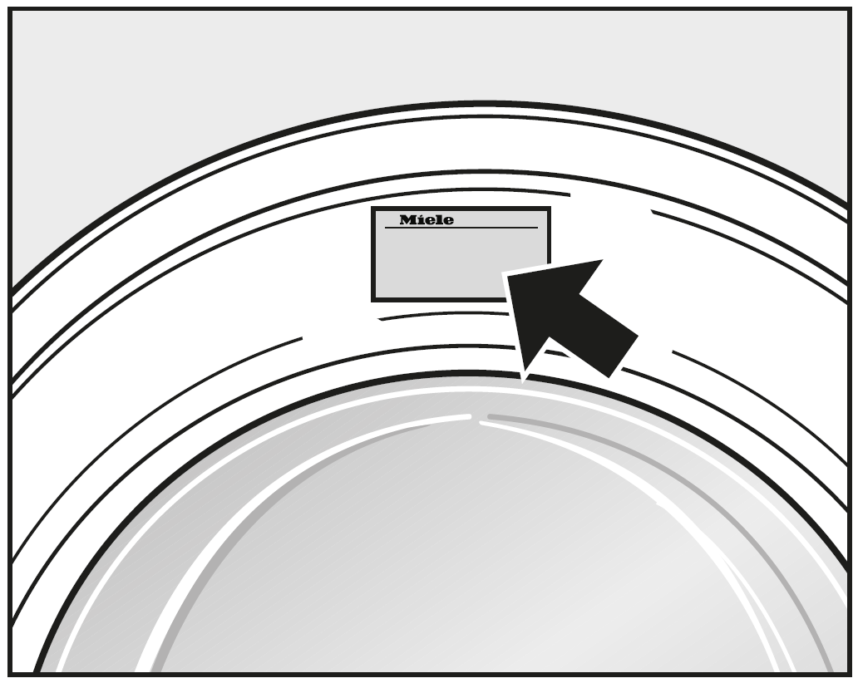
N.B. A call-out charge will be applied for service visits where the problem could have been resolved as described in these instructions.

Warranty: U.K.
In the U.K, the washing machine warranty is valid for 2 years from the date of purchase.
In the U.K. you must activate your cover by calling 0330 160 6640 or registering online at www.miele.co.uk.

Warranty: Other countries
For information on the appliance warranty specific to your country please contact Miele. See end of this booklet for contact details.

Optional accessories
Optional spare parts and accessories for this washing machine are available from your Miele Dealer, the Miele Spare Parts Department or via the internet at www.miele.co.uk.
Please note that telephone calls may be monitored and recorded for training purposes.

Installation

Front view
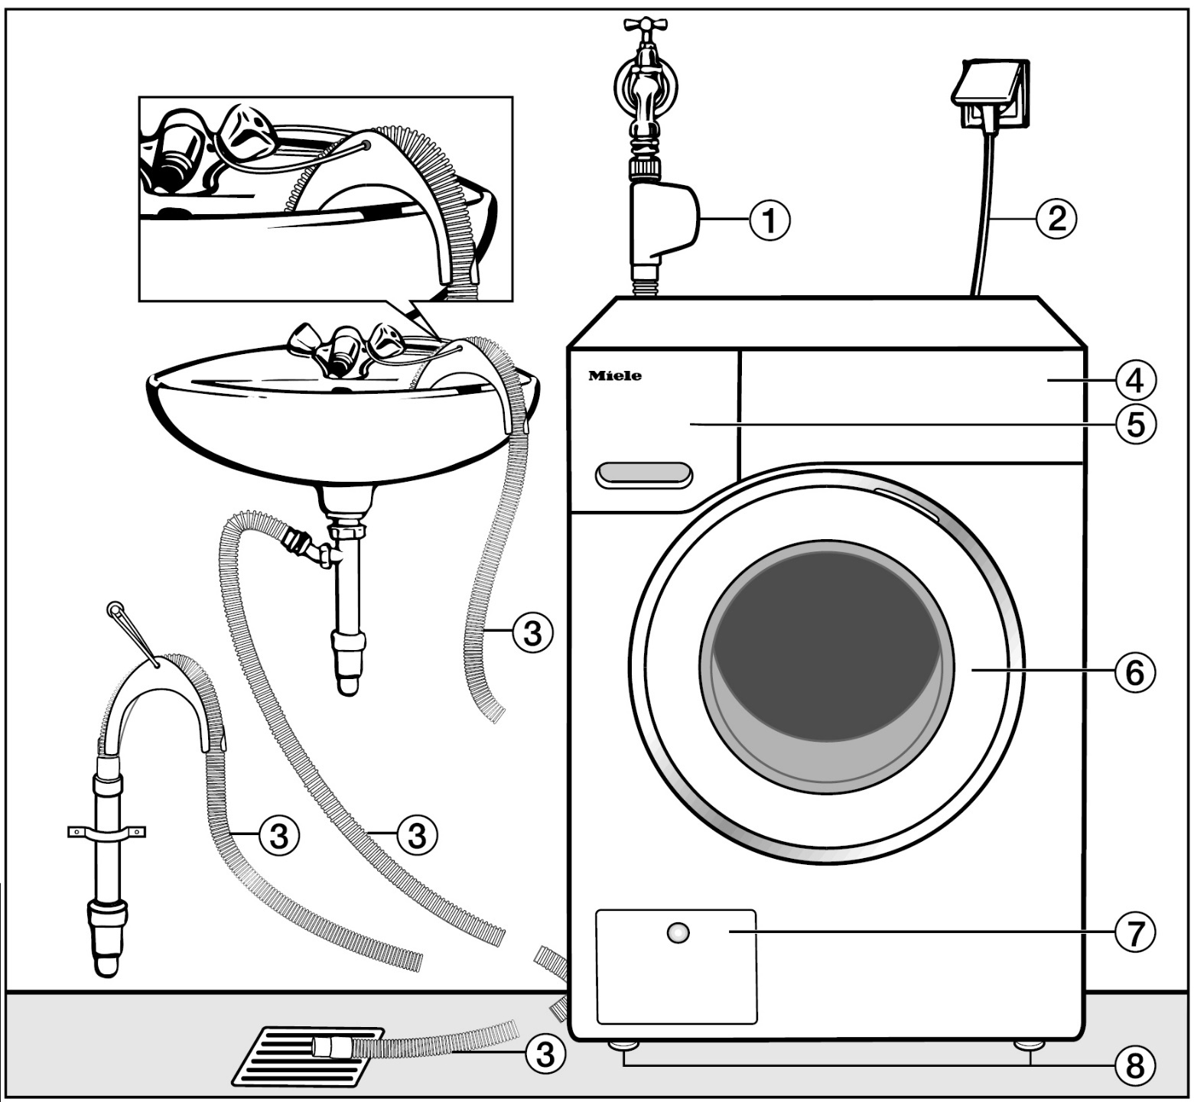
- Inlet hose with Waterproof system
- Mains connection cable
- Flexible drain hose (with detachable swivel elbow)
- Control panel
- Detergent dispenser drawer
- Door
- Access to drain filters, drain pumps and emergency release
- Four height-adjustable feet

Rear view
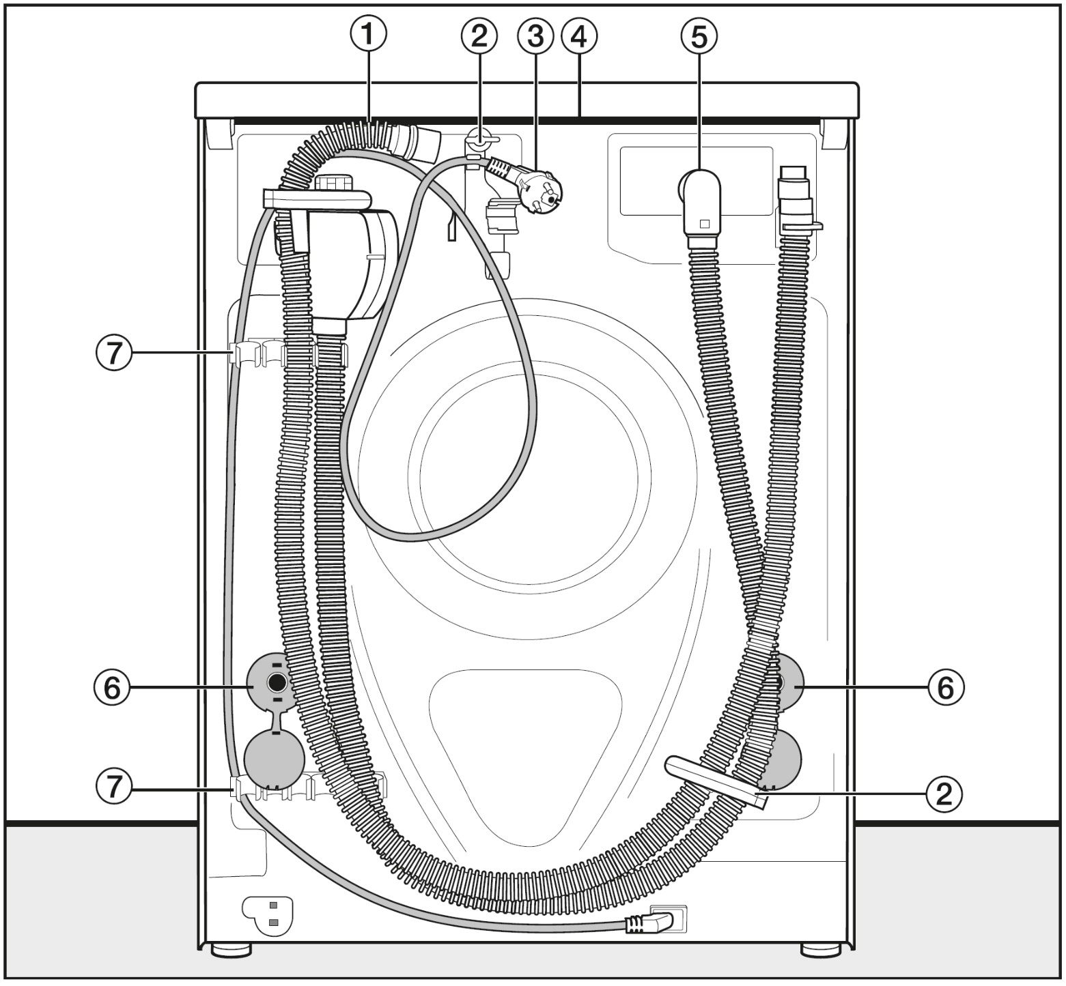
- Drain hose
- Transport clips for inlet and drain hoses and mains connection cable
- Mains connection cable
- Protruding lid for holding when moving the machine
- Inlet hose with Waterproof system
- Safety caps for transit bars
- Transport clips for inlet and drain hoses and for storing transit bars when not in use

Installation surface
A concrete floor is the most suitable installation surface. It is far less prone to vibration during the spin cycle than wooden floorboards or a carpeted surface.
Please note:
- The machine must be level and securely positioned.
- To avoid vibrations during spinning, the machine should not be installed on soft floor coverings.
If installing on a wooden joist floor:
- Install the machine on a plywood base (at least 59 x 52 x 3 cm). The base should span several joists and be bolted to the joists and not only to the floorboards. Check for the presence of pipes and cables first.
Tip: If possible, install the machine in a corner. This is usually the most stable part of the floor.
Warning: Injury can occur if the washing machine has not been adequately secured. During installation, the washing machine must be secured on a plinth to be made available on site (concrete or brick), in order to ensure it cannot fall or slip. Secure the washing machine using a clamp/fastening bracket (MTS floor mounting kit – available from your Miele dealer or Miele spare parts department).

Transporting the washing machine to its installation site
Warning: Danger of injury due to unsecure lid. Make sure the fixings at the back of the lid are secure. Otherwise there is a danger of the lid being pulled off when carrying the machine. Before carrying the machine check that the lid is secure where it protrudes at the back of the machine.
- Carry the washing machine by the front feet and by the lid where it protrudes at the back of the appliance.

Removing the transit bars
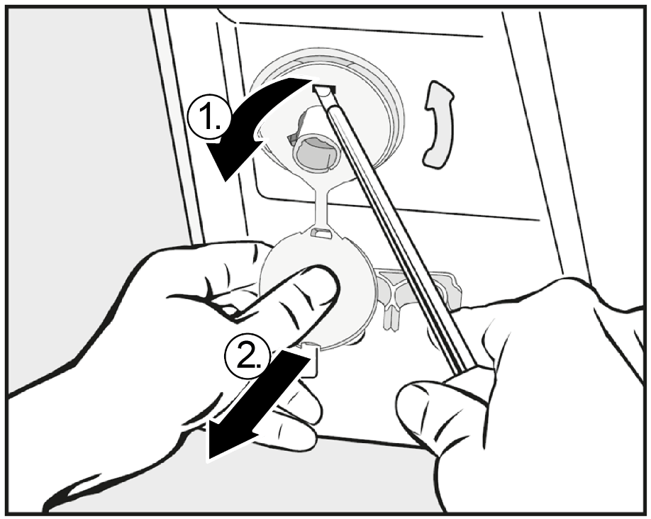
- Remove the left and right covers.
1. Pull off the transit bar covers and
2. then use a screwdriver to release the catches at the top and bottom.
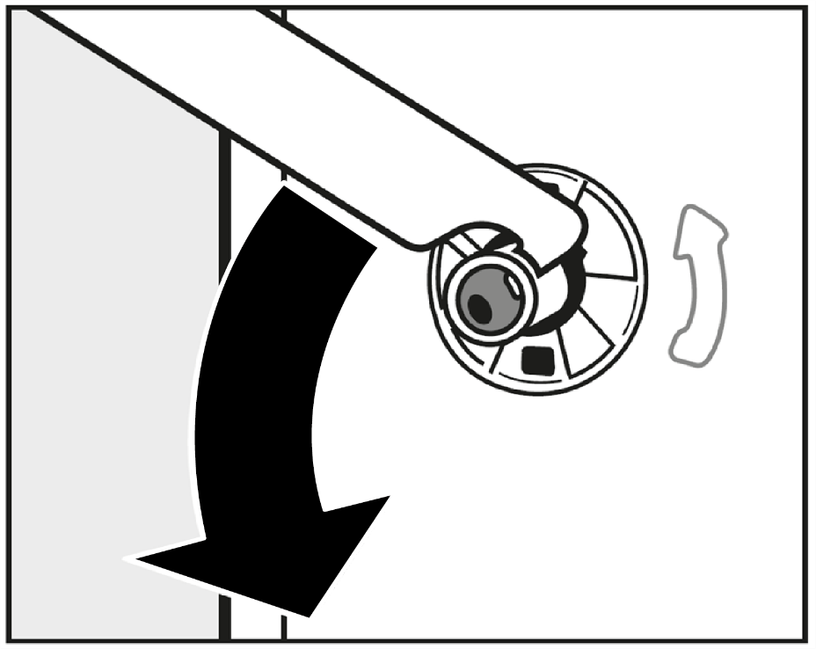
- Using the spanner supplied, turn the left-hand transit bar 90°, then

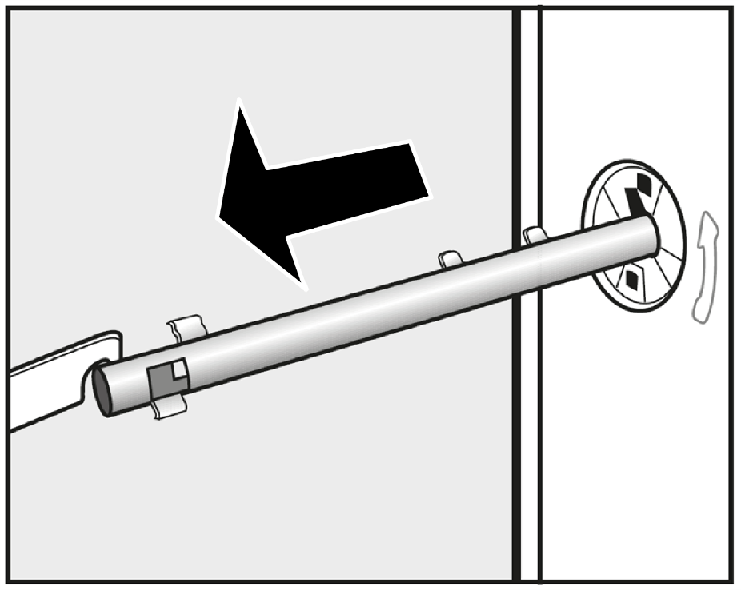
- withdraw the transit bar.
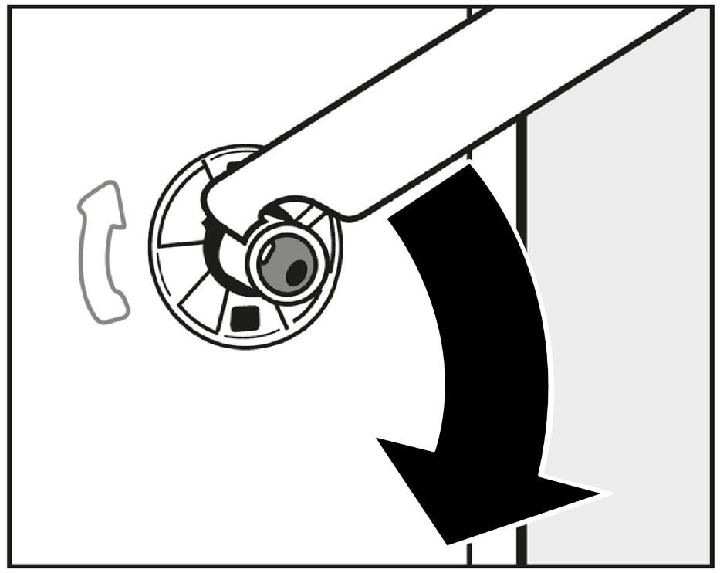
- Turn the right-hand transit bar 90°, then
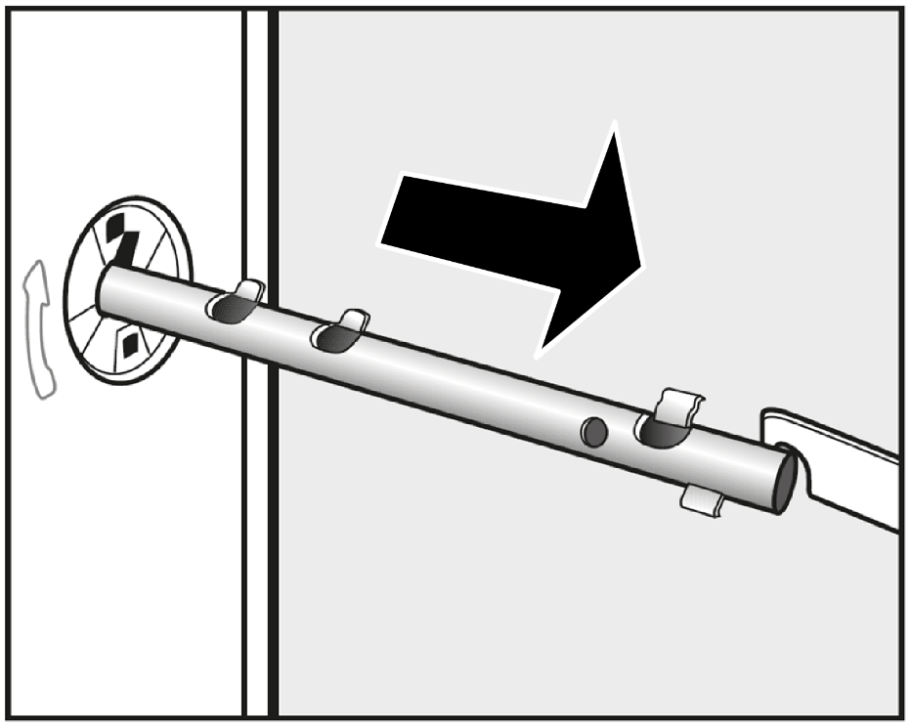
- withdraw the transit bar.
Warning: Risk of injury from sharp edges. There is a risk of injury from reaching into holes that are not covered. Cover the holes for the transit bars after they have been removed.
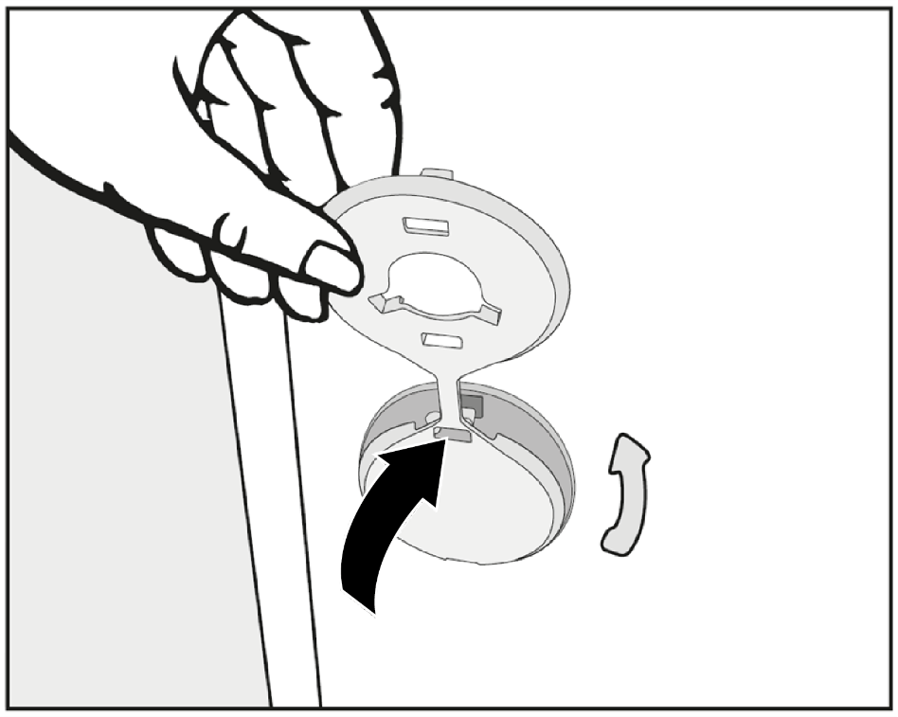
- Fit the stoppers onto the two holes.

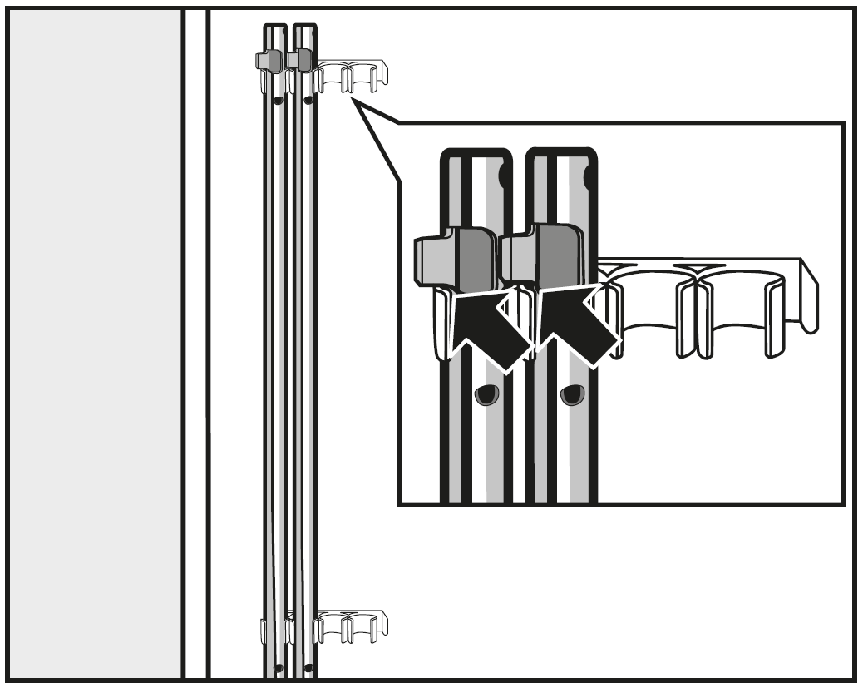
- Secure the transit bars to the back of the washing machine. Make sure that the top catch is located above the holder.
Warning: Risk of damage from incorrect transport. The washing machine may become damaged if moved without the transit bars in place. Keep the transit bars in a safe place. Fit them again if the machine is to be moved (e.g. when moving house).

Re-fitting the transit bars
Re-fitting is carried out by reversing the procedure.

Levelling the machine
The washing machine must stand perfectly level on all four feet to ensure safe and proper operation.
Incorrect installation may increase electricity and water consumption and may cause the machine to move about.

Screwing out and adjusting the feet
The four adjustable screw feet are used for levelling the washing machine. The machine is supplied with all four feet are screwed in.
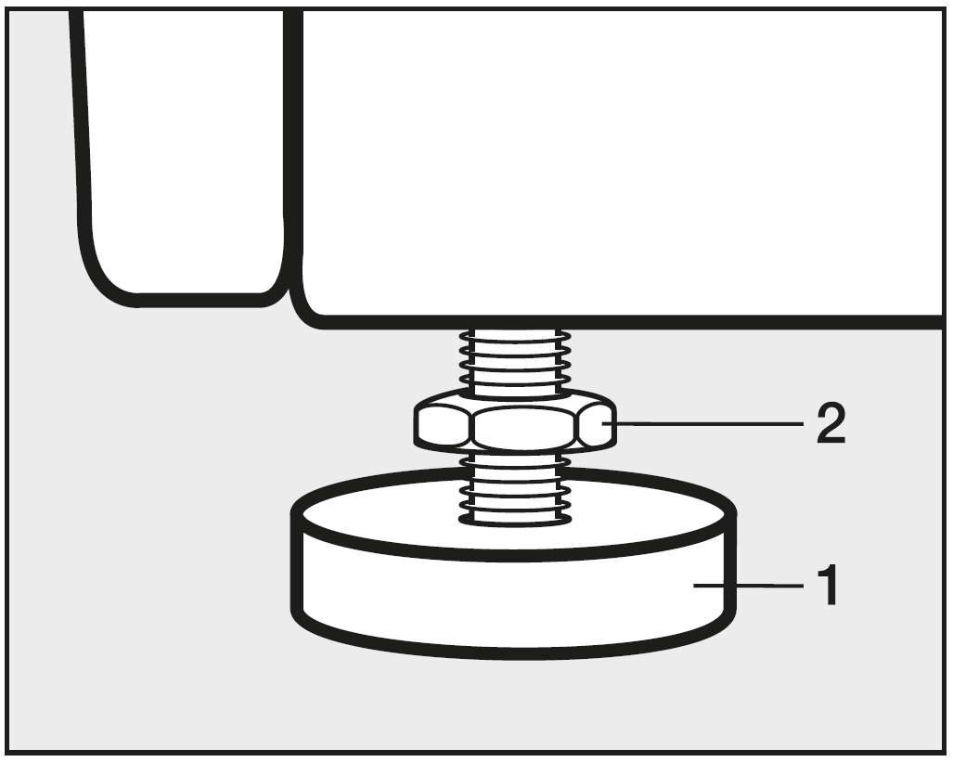
- Using the spanner supplied, turn counter nut [2] in a clockwise direction. Then turn counter nut [2] together with foot [1] to unscrew.
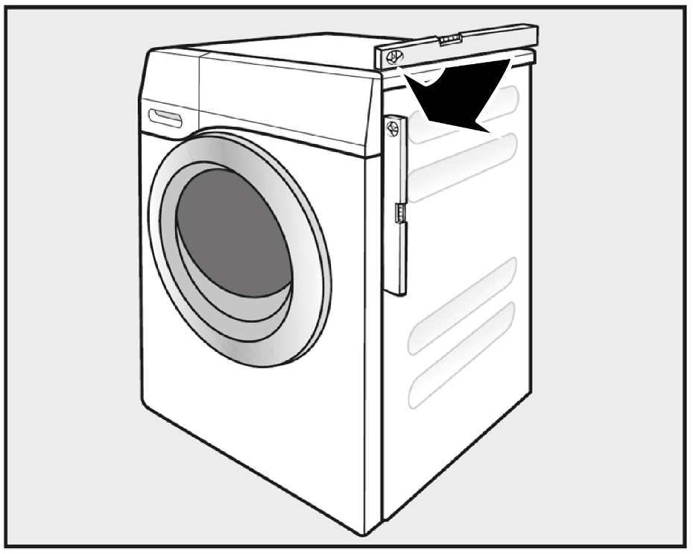
- Use a level to check that the washing machine is standing level.
- Hold foot [1] securely with a pipe wrench. Turn counter nut [2] again using the spanner supplied until it sits firmly up against the housing.
Warning: Risk of damage due to incorrectly aligned washing machine. There is a danger of the washing machine moving about if the feet are not secured. Turn all four counter nuts for the feet until they sit firmly up against the housing. Please also check this for the feet which did not need adjustment.

Installing under a continuous worktop
Warning: Risk of electric shock due to exposed cables. There is a risk of coming into contact with live parts while the lid is removed. Do not remove the washing machine lid.
This washing machine (with lid intact) can be pushed under a countertop if there is space to do so.

Washer-dryer stack
The washing machine can be combined with a Miele tumble dryer in a washerdryer stack. The appropriate “WTV” stacking kit* to match your dryer is required.
All parts marked* are available from your Dealer or Miele.

Please note:
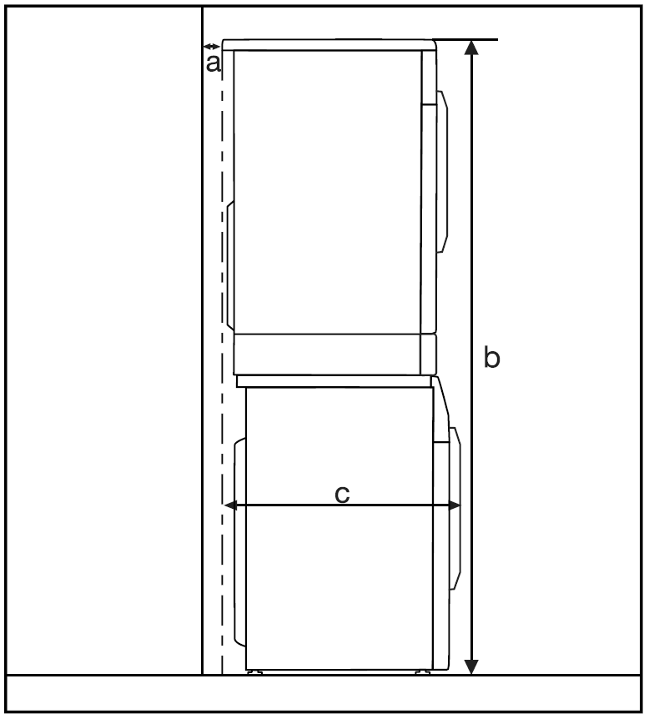
a = at least 2 cm
b = WTV without drawer: 172 cm
WTV with drawer: 181 cm
c = 68 cm

The water protection system
The Miele water protection system protects all parts of the washing machine from water damage.
The system consists of three main components:
- the inlet hose
- the electronic unit and drainage and overflow protection
- the drain hose

The Waterproof System (WPS)
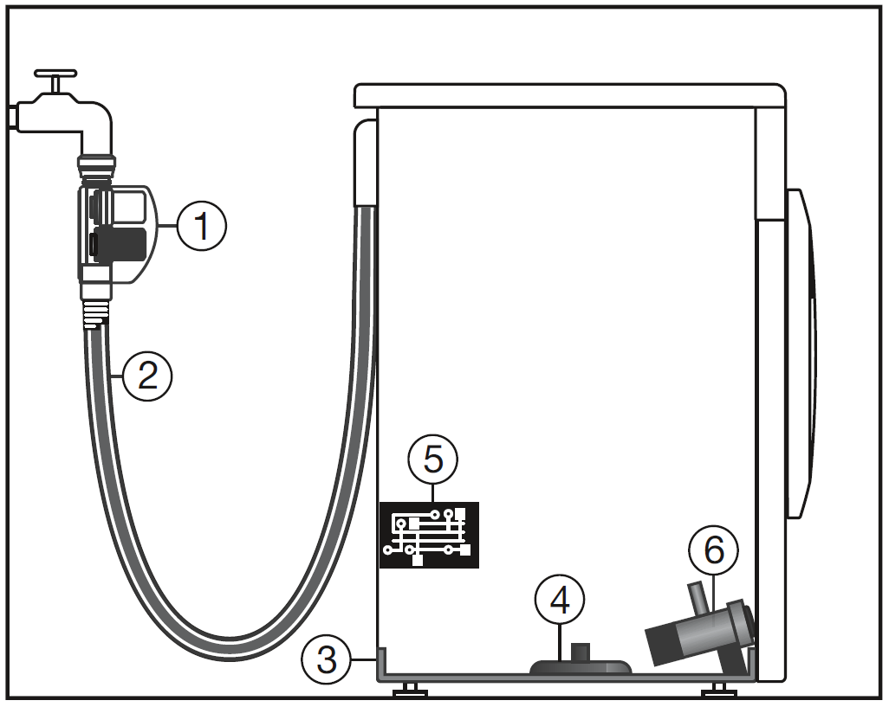
- Two solenoid valves
- Double-skinned inlet hose
- Sump
- Float switch
- Electronic unit
- Drain pump

Inlet hose
- The casing on the inlet hose contains two solenoid valves [1], which cut off the water intake directly at the stopcock. These valves provide two-fold protection. In the event that one of the valves is faulty, the other valve will cut off the water intake.
Blocking the water intake at the stopcock means that the inlet hose is only under pressure whilst water is being taken into the machine. For the remainder of the time, pressure on the inlet hose is negligible.
- Protection against the solenoid valves bursting
The solenoid valves are pressure tested to between 7,000 kPa and 10,000 kPa against bursting.
- The double-skinned inlet hose [2] has a pressure-resistant inner hose and a protective sleeve. Any leaking water is fed into the sump [3] through this protective sleeve. A float switch [4] closes the solenoid valves, preventing any more water flowing into the machine and water in the suds container is pumped away.

The electronic unit [5] and drainage and overflow protection
- Drainage protection
Any leaking water is collected in the sump [3] in the base of the machine. A float switch [4] closes the solenoid valves [1], preventing any more water from flowing into the machine and water in the suds container is pumped away.
- Overflow protection
If the water level exceeds a certain level, the drain pump [6] switches in and pumps the excess water away in a controlled manner.
Should the water level rise repeatedly in an uncontrolled way, the drain pump [6] will switch on continuously, the washing machine will indicate that there is a fault and a tone will sound.

Drain hose
The drain hose is protected by a ventilation system which prevents the washing machine from being emptied completely.

Connection to the water supply
Warning: Health risk and risk of damage due to contaminated incoming water. The quality of the incoming water must correspond to the drinking water specification of the country in which the washing machine is being operated. Always connect the washing machine to the mains water supply.
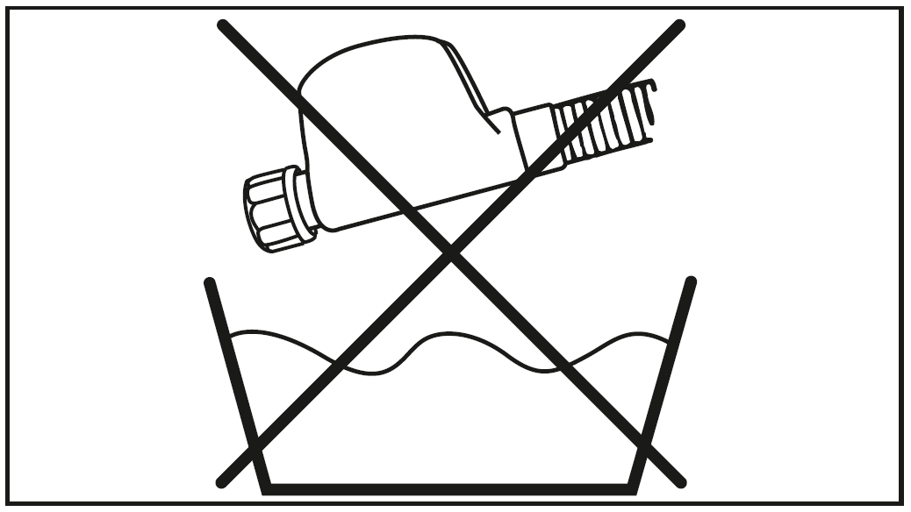
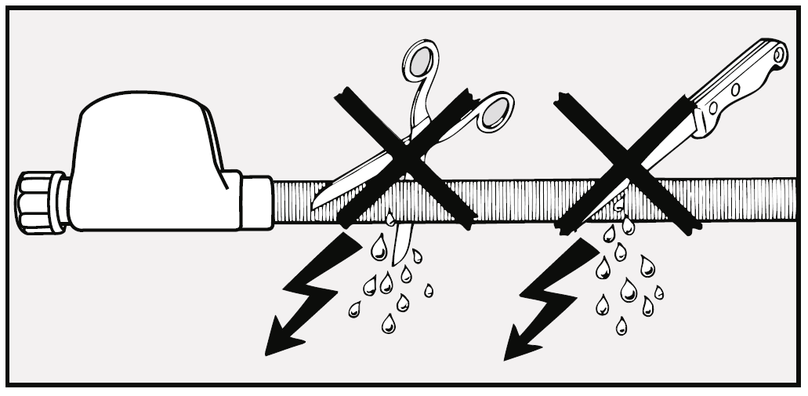
Warning: Risk of electric shock! There are electrical wires in the water inlet hose. The inlet hose must not be connected in an area subject to spray water, e.g. in a bathroom or shower room.
The washing machine should be connected to the mains water supply in accordance with current local and national safety regulations. The German authorities do not require it to have a non-return valve as the washing machine has been designed to comply with DIN regulations.
The water-connection pressure needs to be between 100 kPa and 1000 kPa. If the water-connection pressure exceeds 1000 kPa, a pressure reducing valve must be installed.
A stopcock with a three quarter inch threaded union is required for the connection. If this is not available, only a qualified installer may connect the washing machine to the mains water supply.
Important: The connection point is subject to mains water pressure. Turn on the stopcock slowly and check for leaks. Correct the position of the washer and the threaded union if necessary.
Important: The washing machine is not suitable for connection to a hot water supply. The washing machine must not be connected to a hot water supply.

Maintenance
Only use a Miele Waterproof system hose should you need a replacement.
Warning: Damage caused by dirty water. This washing machine has a filter in the hose connection to the casing to protect the solenoid valve. This filter must not be removed.

Hose extension
A 1.5 metre long (metal) extension hose is available from your Miele dealer or the Miele Spare Parts Department as an optional extra.
This hose is tested to withstand pressures of up to 14,000 kPa and can be used as a flexible extension to the water supply.

Water drainage
The suds are drained through a drain pump with a 1 m delivery head. For the water to drain freely, the hose must be free of kinks.
If required, the hose can be extended to a length of up to 5 m. Accessories are available from Miele or from your Miele dealer.
For a delivery head of more than 1 m (up to a max. of 1.8 m) a replacement drain pump will need to be fitted. Please contact Miele for advice. For a delivery head of 1.8 m the hose can be extended to a length of up to 2.5 m. Accessories are available from Miele or from your Miele dealer.

Drainage options:
- Directed into a sink or basin:
Please note:
- Hook the hose over the edge and secure it.
- If the water is pumped into a washbasin, make sure that it can drain away freely. Otherwise there is a risk of water overflowing or of some of the drained water being sucked back into the machine.
2. Connected securely to a plastic drain pipe with a rubber nipple (there is no need to use a siphon).
3. Connected securely to a floor drain (gully).
4. Connected securely to a washbasin with plastic nipple.

Please note:
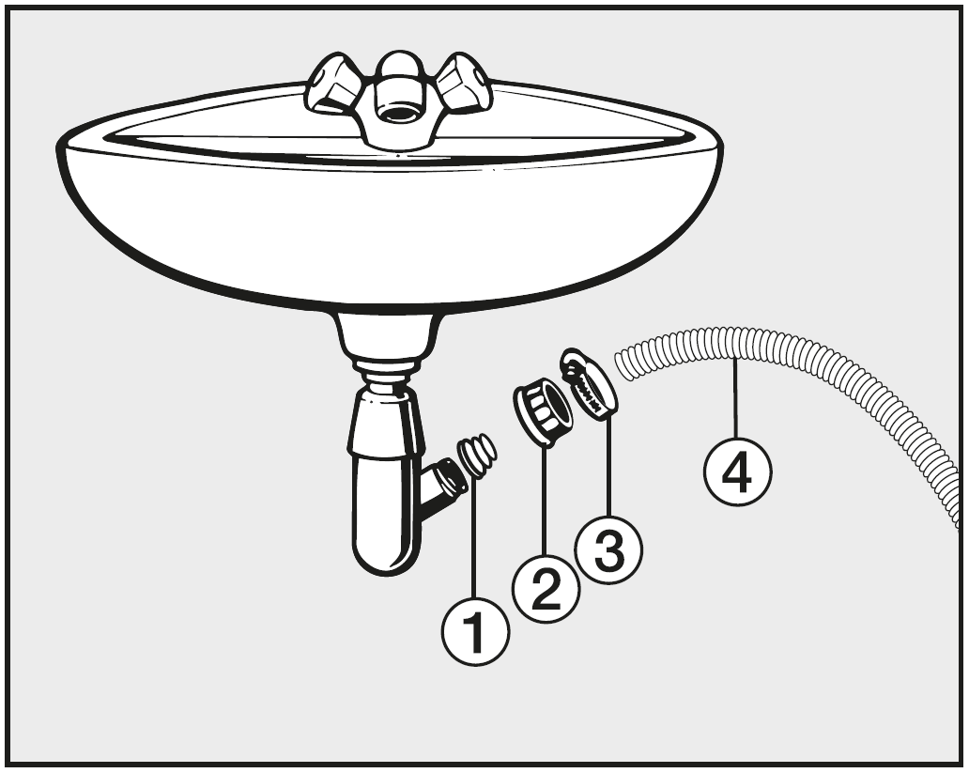
- Adapter
- Spigot nut
- Hose clip
- End of the hose
- Fit adapter [1] to the sink drain outlet using nut [2].
- Attach the end of hose [4] to adapter [1].
- Use a screwdriver to tighten hose clip [3] up close to the nut.

Electrical connection
The washing machine is supplied with an electrical connection cable with moulded plug ready for connection to a switched socket.
The socket must be easily accessible after the washing machine has been installed. If that is not possible, ensure that a suitable means of disconnection is provided on the installation side for each pole.
Warning: Risk of fire from overheating. Connecting the washing machine to a multi-socket plug adapter or to an extension lead can overload the cable. Do not use an extension lead or multi-socket plug adapter.
The electrical system must comply with local and national safety regulations (BS 7671 in the UK). We recommend the use of a suitable RCD.
[RCD type A symbol].
If the connection cable is damaged, it must only be replaced with a specific connection cable of the same type (available from the Miele Customer Service Department). For safety reasons, such replacement may only be carried out by a qualified technician or the Miele Customer Service Department.
The data plate indicates the nominal power consumption and the appropriate fuse rating. Compare the specifications on the data plate with those of the electricity supply and make sure that they match.
If in any doubt, consult a qualified electrician.
Do not connect the washing machine to a stand-alone inverter such as those used with an autonomous energy source, e.g. solar power. When the washing machine is switched on, power surges could result in a safety switch-off. This could damage the electronic module.

Technical data
Height: 850 mm
Width: 596 mm
Depth: 636 mm
Depth with door open: 1054 mm
Height for building under: 850 mm
Width for building under: 600 mm
Weight: Approx. 100 kg
Capacity: 8 kg dry laundry
Voltage: See data plate
Connected load: See data plate
Fuse rating: See data plate
Consumption data: See “Consumption data”
Minimum flow pressure: 100 kPa
Maximum flow pressure: 1000 kPa
Inlet hose length: 1.60 m
Drain hose length: 1.50 m
Mains connection cable length: 2.00 m
Delivery head max.: 1.00 m
Maximum drainage length: 5.00 m
LEDs: Class 1
Test certificates awarded: See data plate

Data sheet household washing machines
In acc. with delegated regulation (EU) No. 1061/2010
MIELE
Model name/identifier | WDD 131 WPS  GuideLine
Rated capacity [1] | 8,0 kg
Energy efficiency class
A+++ (most efficient) to D (least efficient) | A+++
Annual energy consumption (AEc) [2] | 177 kWh/year
Energy consumption of the standard "60°C cotton programme" at full load | 0,90 kWh
Energy consumption of the standard "60°C cotton programme" at partial load | 0,88 kWh
Energy consumption of the standard "40°C cotton programme" at partial load | 0,53 kWh
Weighted power consumption in off-mode (Po) | 0,30 W
Weighted power consumption in the left-on mode (Pl) | 0,30 W
Weighted annual water consumption (AWc) [3] | 10.120 Litres/year
Spin-drying efficiency class
A (most efficient) to G (least efficient) | B
Maximum spin speed [4] | 1.400 rpm
Remaining moisture content [4] | 53 %
Standard programme to which the information in the label and the fiche relates [5] | Cottons 60/40 with  arrow
Programme time of the standard programme
60°C cotton programme (full load) | 179 min
60°C cotton programme (partial load) | 179 min
40°C cotton programme (partial load) | 179 min
Duration of the 'left-on' mode (Tl) [6] | 15 min
Airborne acoustical noise emissions
Washing phase [7] | 50 dB(A) re 1 pW
Spinning phase [7] | 74 dB(A) re 1 pW
Built-in | ‒
This product does not release silver ions during the washing cycle.
- Yes, standard feature
[1] In kg of cotton for the standard "60 °C cotton programme "at full load or the "40 °C cotton programme" at full load, whichever is the lower.
[2] Based on 220 standard washing cycles for cotton programmes at 60 °C and 40 °C at full and partial load, and the consumption of the low-power modes. Actual energy consumption will depend on how the appliance is used.
[3] Based on 220 standard washing cycles for cotton programmes at 60 °C and 40 °C at full and partial load. Actual water consumption will depend on how the appliance is used.
[4] Attained for the standard "60 °C cotton programme" at full load or the standard "40 °C cotton programme" at partial load, whichever is the lower, and remaining moisture content attained for the standard "60 °C cotton programme" at full load or the standard "40 °C cotton programme" at partial load, whichever is the greater.
[5] These programmes are suitable to clean normally soiled cotton laundry and are the most efficient programmes in terms of combined energy and water consumption.
[6] If the household washing machine is equipped with a power management system.
[7] For the standard "60 °C cotton programme" at full load.

Consumption data
°C |  | Load  kg | Energy  kWh | Water  Litres | Duration  H:min | Residual Moisture  %
Cottons | 60°C* | 8.0 | 0.90 | 49 | 2:59 | 53
 | 60°C* | 4.0 | 0.88 | 48 | 2:59 | 53
 | 40°C* | 4.0 | 0.53 | 39 | 2:59 | 53
Cottons | 90 | 8.0 | 2.10 | 49 | 2:29 | 53
 | 60 | 8.0 | 1.35 | 49 | 2:29 | 53
 | 60 | 4.0 | 1.15 | 48 | 2:19 | 53
 | 40 | 8.0 | 0.98 | 54 | 2:39 | 53
 | 20 | 8.0 | 0.35 | 54 | 2:39 | 53
Minimum iron | 30 | 3.5 | 0.45 | 52 | 1:59 | 30
Delicates | 30 | 2.0 | 0.25 | 30 | 1:09 | ‒
Woollens | 30 | 2.0 | 0.23 | 35 | 0:38 | ‒
Express 20 [1] | 40 | 3.5 | 0.34 | 30 | 0:20 | ‒
Shirts | 60 | 2.0 | 0.77 | 40 | 1:31 | ‒
[1] Short extra activated
Important: Consumption data can vary from the nominal values given depending on water pressure, water hardness, water inlet temperature, room temperature, type and volume of load, fluctuations in the electricity supply and any extras selected.

Selecting test programmes
* Test programmes that conform to EN 60456 and the energy label to Directive 1061/2010 can be selected via the ECO 40-60 programme.
- Turn the programme selector to the ECO 40-60 programme.
In the temperature display, temperature 60 is brightly illuminated and 40 is dimly illuminated.
The 60°C Cottons test programme is selected.
- Touch the 40 sensor control.
Temperature 40 is brightly illuminated and 60 is dimly illuminated. The 40°C Cottons test programme is selected.

Programmable functions
Note: The programmable functions are used to alter the machine's electronics to suit changing requirements. Programmable functions can be altered at any time.
The programming is carried out in eight steps (1, 2, 3, … 8) using the sensor controls.

Accessing the programming level
Pre-requisites:
- The washing machine is switched on (the programme selector is pointing to a wash programme).
- The washing machine door is open.
- Touch the Start/Stop sensor and leave your finger on it whilst carrying out steps 2-3.
- Close the washing machine door.
Wait until the Start/Stop sensor lights up constantly ...
- ... and then take your finger off the Start/Stop sensor.
After approx. four seconds, P13 will light up in the time display.

Choosing and selecting a programmable function
Note: The number of the programmable function will appear in the time display as P and a number: e.g. P13.
- Touch the > or < sensor control to scroll to the next or previous programmable function:
Programmable functions
P13 | Sensor tone
P14 | PIN code
P22 | Control field standby status
P24 | Memory
P26 | Longer pre-wash – Cottons
P27 | Soak duration
P28 | Gentle action
P29 | Temperature reduction
P30 | Water plus
P31 | Water plus level
P32 | Maximum rinse level
P33 | Suds cooling
P34 | Anti-crease
P62 | Backlight brightness dimmed
P63 | Welcome tone
- Confirm the selected programmable function by touching the Start/Stop sensor control.

Editing and saving a programmable function
You can either switch a programmable function on or off or select different options.
- Touch the > or < sensor control to switch the programmable function on or off or to select an option:
X = can be selected
O = Factory default setting
Programmable function
 | Available options
 | -00 | -01 | -02 | -03 | -04 | -05 ‒ -07
P13 | X | O | X
P14 | O | X
P22 | X | O
P24 | O | X
P26 | O | X | X | X
P27 |  | O | X | X | X
P28 | O | X
P29 | O | X
P30 |  | O | X | X
P31 |  | O | X | X | X
P32 | O | X
P33 | O | X
P34 | X | O
P62 |  | X | X | O | X | X
P63 | X | O | X
- Confirm the chosen selection with the Start/Stop sensor control.
The number of the programmable function, e.g. P13, will then light up again.

Exit programming level
- Turn the programme selector to the off position [12 o’clock].
The option you have selected is now stored in memory. You can change it again at any time.

P13 Sensor tone
Note: Each touch of a sensor control is confirmed with an audible tone.
Selection
-00 = Sensor tone is switched off
-01 = Sensor tone is set to normal volume (factory default setting)
-02 = Sensor tone is set to loud volume

P14 Lock code
Note: The lock code prevents the washing machine being used without your knowledge.
When the code has been activated, you have to enter a code after switching the washing machine on. Otherwise the washing machine cannot be operated.
Options
-00 = Lock code switched off (factory default setting)
-01 = Lock code is switched on

Using the washing machine with a lock code
The code is 125 and cannot be altered.
- Switch on the washing machine.
_ _ _ appears in the time display and the > and < sensors light up.
- Touch the > sensor.
_ _ 1 appears in the time display.
- Confirm the number with the Start/Stop sensor.
The first number was saved and you can now enter the second number using the > and < sensors.
- Also enter the second and third numbers and confirm the numbers with the Start/Stop sensor.
The lock is released and a wash programme can now be selected and started.

P22 Control panel switch-off status
Note: To save energy the time display and sensors will go out after 10 minutes, and only the Start/Stop sensor will flash slowly.
Options
-00 = Off
The time display and sensors will remain lit up while the washing machine is switched on
-01 = On (factory default setting)
The time display and sensors will switch off after 10 minutes if the programme is started.
However; the time display and sensors will remain lit up for 10 minutes after a delay start time has elapsed, after the end of the programme or at the end of the anti-crease phase.

P24 Memory
Note: The washing machine will save the last settings (temperature, spin speed and some of the extras) selected for a programme after the programme has started.
When this programme is chosen again, these saved settings will appear in the display.
Options
-00 = Memory is switched off (factory default setting)
-01 = Memory is switched on

P26 Longer pre-wash Cottons
Note: If you require a longer pre-wash you can extend the pre-wash time.
Options
-00 = No increase in the pre-wash time (factory default setting)
-01 = + 6 minutes increase in the pre-wash time
-02 = + 9 minutes increase in the pre-wash time
-03 = + 12 minutes increase in the pre-wash time

P27 Soak duration
Note: You can set a duration for the soak process of between 30 minutes and two hours.
You can select the duration in 30 minute increments. When the Soak Extra option is selected the laundry will be soaked for the duration selected.
Options
-01 = 30 minutes soak duration (factory default setting)
-02 = 1 hour soak duration
-03 = 1 hour 30 minutes soak duration
-04 = 2 hours soak duration

P28 Gentle action
Note: Activating gentle action reduces the drum action and is suitable for washing lightly soiled items more gently.
Gentle action can be activated for the Cottons and Minimum iron programmes.
Options
-00 = Gentle action is switched off (factory default setting)
-01 = Gentle action rhythm is switched on

P29 Reduce temperature
Note: The boiling point for water is lower at high altitudes. In order to avoid water boiling, Miele recommend activating the reduce temperature setting at altitudes of more than 2000 m above sea level. The maximum temperature is reduced to 80 °C even when a higher temperature is selected.
Options
-00 = The reduce temperature setting is switched off
(factory default setting)
-01 = The reduce temperature setting is turned on

P30 Water plus
Note: You can determine the amount of water used if the Water plus extra is selected.
Options
-01 = More water is used in the wash and rinse stages
(factory default setting)
-02 = An extra rinse is carried out
-03 = The water level is increased in the wash and rinse stages
and an additional rinse is carried out

P31 Water plus level
Note: There are three different water levels which can be selected by activating the Water plus extra.
Options
-01 = No higher water level (factory default setting)
-02 = Water level increase by 1 level when washing and rinsing
-03 = Water level increase by 2 levels when washing and rinsing
-04 = Water level increase by 3 levels when washing and rinsing

P32 Maximum rinse level
Note: The water level in the rinse cycle can be permanently set to the highest value.
This function is useful for allergy sufferers as it achieves an excellent rinse result. Water consumption will increase.
Options
-00 = Maximum rinse level is switched off (factory default setting)
-01 = Maximum rinse level is switched on

P33 Suds cooling
Note: When this is activated, additional water flows into the drum at the end of the main wash to cool the suds down. Hot suds can damage plastic drainage pipes.
Suds cooling takes place when a temperature of 70 °C or higher is selected for the Cottons programme.
Suds cooling should be activated:
- to prevent the danger of scalding if the drain hose is hooked over the edge of a sink or basin.
- where drainage pipes do not comply with DIN 1986.
Options
-00 = Suds cooling is switched off (factory default setting)
-01 = Suds cooling is switched on

P34 Anti-crease
Note: The anti-crease function helps prevent creasing if laundry is not going to be removed immediately after the end of the programme.
The drum continues to turn at intervals for up to 30 minutes at the end of the programme. The door can be opened at any time.
Options
-00 = The anti-crease function is switched off
-01 = The anti-crease function is switched on (factory default setting)

P62 Backlight brightness dimmed
Note: The brightness of the dimmed sensors in the control panel can be set to one of seven different levels.
The brightness changes as soon as you select a different setting.
Options
-01 (Darkest level) to -07 (Lightest level)
-03 = (Factory default setting)

P63 Welcome tone
Note: The welcome tone sounds whenever the washing machine is switched on.
You can activate or deactivate the welcome tone.
Selection
-00 = Welcome tone is deactivated
-01 = Welcome tone is switched on at normal volume
(factory default setting)
-02 = Welcome tone is switched on at loud volume

Optional accessories
Detergent, fabric care, additives and machine care products are available for this washing machine. All the products have been designed for Miele washing machines.
These and many other useful products can be ordered via the internet at www.miele.co.uk or from Miele (see end of this booklet for contact details).

Detergent

UltraWhite
- Multi-purpose powder detergent
- For white and light-coloured laundry as well as heavily soiled cotton items
- Effective stain removal even at low temperatures

UltraColor
- Liquid detergent for coloured items
- For coloured and dark fabrics
- Protects bright colours from fading
- Effective stain removal even at low temperatures

Wool and delicates detergent
- Liquid detergent for delicates
- Particularly suitable for woollen and silk fabrics
- Cleans at temperatures as low as 20 °C, helps retain the shape of delicate items and protect colours

Specialist detergents
Specialist detergents are available as capsules [droplet] in convenient single dose amounts or in a handy bottle.

Outerwear
- Liquid detergent for outerwear and performance clothing
- Cleans with care and is gentle on colours
- With lanolin to care for and condition membrane fabric

Sport
- Liquid detergent for sportswear and fleece garments
- Neutralises unpleasant odours
- Retains the shape of the items

Down
- Liquid detergent suitable for pillows, sleeping bags, and down-filled items
- Retains the elasticity of down and feather-filled items
- Retains the breathability of downfilled items
- Prevents down filling clumping together

WoolCare
- Liquid detergent for woollens and delicates
- Includes a special wheat protein conditioning formula
- Helps prevent felting
- Gentle on colours
- Only available as capsules [droplet]

SilkCare
- Liquid detergent for silks
- Contains a special silk protein conditioning formula
- Gentle on colours
- Only available as capsules [droplet]

Fabric care
Fabric care is available as capsules [flower] in convenient single dose amounts or in a handy bottle.

Proofing agent
- For proofing microfibre fabrics, e.g. rain coats
- Retains the breathability of fabrics

Fabric conditioner
- Fresh, natural fragrance
- Makes laundry soft to handle

Additive

Booster
- For removing stains
- For white and coloured laundry
- Available as capsules [triangle] in convenient single dose amounts

Machine care

Machine cleaner
- For cleaning the washing machine thoroughly and effectively
- Removes grease, bacteria, and associated unpleasant odours
- Use 1–3 times per year

Descaling agent
- removes heavy limescale deposits
- Mild and gentle with natural citric acid

Water softener tablets
- Reduces the amount of detergent needed for hard water
- Less detergent residue in fabrics
- Less chemicals in waste water due to reduced amount of detergent

United Kingdom:
Miele Co. Ltd.
Fairacres, Marcham Road
Abingdon, Oxon, OX14 1TW
Tel: 0330 160 6600
Internet: www.miele.com
Manufacturer:
Miele & Cie. KG
Carl-Miele-Straße 29
33332 Gütersloh
Germany
WDD 131 WPS GuideLine
(en-GB / M.-Nr. 11 343 530 / 00)

How to contact RNIB
Phone: 0303 123 9999
Email: helpline@rnib.org.uk
Address: RNIB, Midgate House, Midgate, Peterborough PE1 1TN
Online Shop: shop.rnib.org.uk

RNIB terms and conditions of sale
This product has a two-year parts and labour guarantee from the date of purchase. You must activate your cover by calling 0330 160 6640 or registering online at miele.co.uk
If you have any issues with the product and you did not purchase directly from RNIB then please contact your retailer in the first instance.
If you’d like to return the item, please contact RNIB to get a returns authorisation number to help us deal efficiently with your product return.
You can request full terms and conditions from RNIB or view them online.
RNIB Enterprises Limited (with registered number 0887094) is a wholly owned trading subsidiary of the Royal National Institute of Blind People ("RNIB"), a charity registered in England and Wales (226227), Scotland (SC039316) and Isle of Man (1109). RNIB Enterprises Limited covenants all of its taxable profits to RNIB.
Date: June 2020.
© Royal National Institute of Blind People.

