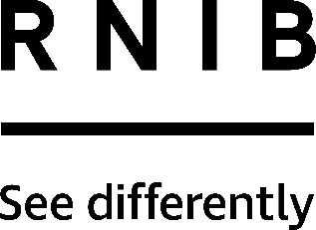

Plate surround (DK195-R and DK195-W)
Thank you for purchasing from RNIB. For hygiene reasons this product is non-returnable unless faulty, or it can be returned within 14 days if unsuitable, in an unopened and as new condition. If, unfortunately the item is unsuitable and it meets the unopened and as new criteria, please contact us within 14 days of receipt to obtain your returns number. For further details and guidance on returning faulty items, please see the Terms and conditions of sale and How to contact RNIB sections of this instruction manual.

Please retain these instructions for future reference. These instructions are also available in other formats.

General description
This plastic plate surround fixes to any round plate with diameter 190 - 250 mm (7.5 to 10 inches) using three hooks; to help keep food on the plate. Simply place the middle clip of the food bumper on the back edge of the plate (furthest from you), and then bend the surround outwards, if needed, to fit the other clips accordingly. This plate surround is both microwave and dishwasher safe.

How to contact RNIB
Phone: 0303 123 9999
Email: shop@rnib.org.uk
Address: RNIB, Northminster House, Northminster, Peterborough PE1 1YN
Online Shop: shop.rnib.org.uk

Email for international customers: exports@rnib.org.uk

Terms and conditions of sale
This product is guaranteed from manufacturing faults for 24 months from the date of purchase. If you have any issues with the product and you did not purchase directly from RNIB then please contact your retailer in the first instance.

For all faulty returns contact RNIB first to get a returns authorisation number to help us deal efficiently with your product return.

You can request full terms and conditions from RNIB or view them online.

RNIB Enterprises Limited (with registered number 0887094) is a wholly owned trading subsidiary of the Royal National Institute of Blind People ("RNIB"), a charity registered in England and Wales (226227), Scotland (SC039316) and Isle of Man (1226). RNIB Enterprises Limited covenants all of its taxable profits to RNIB.

Date: May 2021.

© 2021Royal National Institute of Blind People.

