Anti-spill suction mug (DK201)
Thank you for purchasing from RNIB. For hygiene reasons this product is non-returnable unless faulty, or it can be returned within 14 days if unsuitable, in an unopened and as new condition. If, unfortunately the item is unsuitable and it meets the unopened and as new criteria, please contact us within 14 days of receipt to obtain your returns number. For further details and guidance on returning faulty items, please see the Terms and conditions of sale and How to contact RNIB sections of this instruction manual.

Please retain these instructions for future reference. These instructions are also available in other formats.

General description
This twin wall insulated mug has a suction base, making it difficult to tip over if knocked by accident. Use on all flat and non-porous surfaces, such as desks or tables knowing that the clever grip-pad at the base will help reduce spillage occurrence.

In order to lift the mug, ensure that you lift straight up. If you try to lift at an angle, in trying to stick to the table the mug may jerk away; causing the contents to spill.

Please note: For hygiene reasons this product cannot be returned unless faulty.

Orientation

Base
At the base you will feel a flat surface that may move up as you touch it. This is the suction pad that stops the contents from spilling. Note: The pad at the base moves. This is how it functions.

Top
The product comes with a flat topped lid which is removable for use as needed. Use this to reduce spillage potential when on the move and for security on tables in busy environments.

Special Warnings
- Always lift the mug vertically. Do not excessively pull/knock/draw/hit the product as it may cause damage.
- The mechanism is designed to move slightly to create the vacuum - which gives the mug its stability. To ensure optimum performance and to allow the mechanism to function correctly, when washing do not leave immersed in water and dry standing the right way up.
- Do not use metal cleaner (e.g. steel balls) on the product surface as it may cause damage.
- Do not use bleach, chlorine, abrasive and/or other harsh chemicals to clean this product.
- Wash all parts with warm soapy water before use. Always store with the lid removed for parts to dry completely.
- Keep out of reach of children when filled with hot liquids.
- If filling with boiling liquid, allow it to cool for at least three minutes before placing the lid on.
- Do not use in the microwave, oven or dishwasher.
- Do not place near a direct heat source.

How to contact RNIB
Phone: 0303 123 9999
Email: shop@rnib.org.uk
Address: RNIB, Northminster House, Northminster, Peterborough PE1 1YN
Online Shop: shop.rnib.org.uk
Email for international customers: exports@rnib.org.uk

Terms and conditions of sale
This product is guaranteed from manufacturing faults for 12 months from the date of purchase. If you have any issues with the product and you did not purchase directly from RNIB then please contact your retailer in the first instance.

For all returns and repairs contact RNIB first to get a returns authorisation number to help us deal efficiently with your product return.

You can request full terms and conditions from RNIB or view them online.

RNIB Enterprises Limited (with registered number 0887094) is a wholly owned trading subsidiary of the Royal National Institute of Blind People ("RNIB"), a charity registered in England and Wales (226227), Scotland (SC039316) and Isle of Man (1226). RNIB Enterprises Limited covenants all of its taxable profits to RNIB.

This product is CE marked and fully complies with all applicable EU legislation.

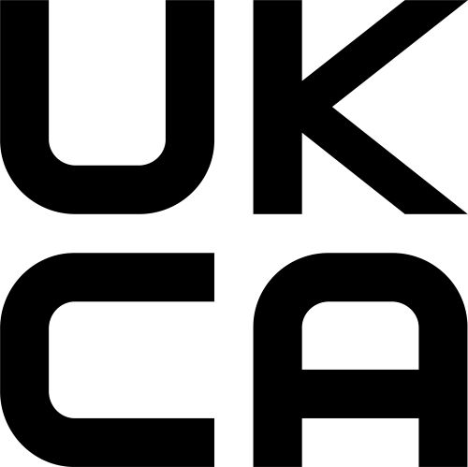

This product is UKCA marked and fully complies with the relevant UK legislation.

Please do not throw items marked with this symbol in your bin. Recycle your electricals and electronic devices free at your local recycling centre. Search for your nearest recycling centre by visiting www.recyclenow.com.

Date: January 2022.

© RNIB

