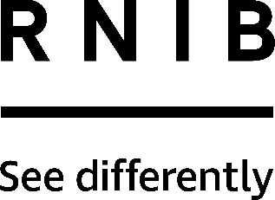

Broad and Fineliner Spectrum Pens (DW52, DW53)
Thank you for purchasing from RNIB. For hygiene reasons this product is non-returnable unless faulty, or it can be returned within 14 days if unsuitable, in an unopened and as new condition. If, unfortunately the item is unsuitable and it meets the unopened and as new criteria, please contact us within 14 days of receipt to obtain your returns number. For further details and guidance on returning faulty items, please see the Terms and conditions of sale and How to contact RNIB sections of this instruction manual.

Please retain these instructions for future reference. These instructions are also available in other formats.

General description
The broad black pens (DW52) have a thick line width of 1.7mm and a round-ended fibre tip that is hardwearing. Please note: These pens may not be suitable in situations where limited space is available, for example, signing cheques.
The fineliners (DW53) have a line width of 0.4mm and contain non-toxic and xylene-free water-based black ink. They are quick-drying and the extra-fine 0.4mm fibre tip is encased in metal for protection.

Pens are supplied in packs of 12.

Using the product
Pen marks from both the broad and fine pens will wash out. If ink gets on clothing, cover the stain in washing up liquid and leave it to soak in. With the washing up liquid still on the stain, wash clothing in the normal manner.

How to contact RNIB
Phone: 0303 123 9999
Email: shop@rnib.org.uk
Address: RNIB, Midgate House, Midgate, Peterborough PE1 1TN
Online Shop: shop.rnib.org.uk

Email for international customers: exports@rnib.org.uk

Terms and conditions of sale
This product is guaranteed from manufacturing faults for 12 months from the date of purchase. If you have any issues with the product and you did not purchase directly from RNIB then please contact your retailer in the first instance.

For all returns and repairs contact RNIB first to get a returns authorisation number to help us deal efficiently with your product return.

You can request full terms and conditions from RNIB or view them online.

RNIB Enterprises Limited (with registered number 0887094) is a wholly owned trading subsidiary of the Royal National Institute of Blind People ("RNIB"), a charity registered in England and Wales (226227), Scotland (SC039316) and Isle of Man (1109). RNIB Enterprises Limited covenants all of its taxable profits to RNIB.

Date: December 2019.

© 2019 Royal National Institute of Blind People.

