Twin Science discovery set handbook (ET45)
Thank you for purchasing from RNIB. In the unlikely event the item is unsuitable, please contact us within 14 days of receipt to obtain your returns number. To ensure your return goes smoothly, the item and all components must be in as new condition and packed in its original, undamaged packaging. For further details and guidance on returning faulty items, please see the Terms and conditions of sale and How to contact RNIB sections of this instruction manual.

Please retain these instructions for future reference. These instructions are also available in other formats.

Contents
A note from the product developer 3
Warnings 4
Keep the booklet and box 4
Magnets 5
Risk of suffocation 5
Power supply 5
Environment and liquids 5
Overheating 5
Damaged modules 5
Battery 6
Cleaning the modules 6
Important notes 6
General definitions 7
Circuit 7
Colour codes 7
Magnet 7
Command flow 7
Modules quick key 8
Module descriptions 9
Battery 9
USB Port / Power (UP) 9
Proximity Sensor (PS) 10
Sound Sensor / Sound Trigger (ST) 11
Light Sensor (LS) 11
Motion Sensor / Motion Trigger (MT) 12
Remote Control (RC) 12
Signal Convertor / Inverter (S) 13
Latch (L) 13
Logic Gate / AND/OR Multi Logic (AO) 14
Connection Cable 16
Splitter 16
Counter (C) 17
Motor (M) 17
Servo Motor (SM) 18
Serial LED / Bargraph (BG) 19
Cable LED (LED) 19
Buzzer (BZ) 20
Additional building block pieces 20
Swivel wheel 21
Quick start 23
How to get started with the Twin Science Kit 23
Designing simple circuits 23
Projects – starter level 26
Horn 26
Book reading lamp 27
Street lamp 27
Cooler fan 29
Morning alarm 29
Hand fan 30
Projects – intermediate level 31
Right answer-matic 31
Applaud and illuminate 32
Parking sensor 33
Secret object alarm 35
Windmill 36
Flashlight 37
Crane 38
Projects – advanced level 39
Electronic candle 39
Confetti rain 41
Mechanical basketball player 42
Guest at the door 43
Card box 45
Keep foods fresh 46
Goal 48
Waving robot 49
Burglar alarm 51
Smart Car 53
Autonomous car 54
Line tracking robot 56
How do you use yours? 57
How to contact RNIB 57
RNIB Children, Young People and Families Team 58
Terms and conditions of sale 58
Why recycle? 59
What is WEEE? 59
How are we helping? 59

A note from the product developer
Young Guru Academy (YGA) is an international non-governmental organisation that was founded in Turkey in 2000. YGA people dream of a better world, design projects, and decide on pioneering advancements in unity. Twin Science Kit is developed as part of “Science Immigration to Antolia” project of YGA with the aim to make kids understand and love the things around them by letting them learn about the world scientifically. We believe that if love was a scientific rule, it would be so much easier for us to see how harmonious the universe is. Science makes it easier for us to learn about life and understand it better, and people can only love what they understand. That is why we want to make science easier to understand for everyone.

Every child is born with a strong drive of curiosity that makes discovery and learning much easier. But with warnings such as “don’t open, you will damage it”, “don’t touch, you will get shocked,” their curiosity turns into fear without even realising. While we were working on this project, we dreamed of nurturing this drive of curiosity in children’s nature instead of hindering it, and showing children how easy and fun science is.

Twin, which aims to make children love science, is composed of well thought do-it-yourself experiments. Twin Science Set explains the underlying operating logic of complicated-looking technological devices using easy to connect electronic blocks and make them easier to understand. Twin Science Set unites imagination with knowledge and helps us achieve our dreams.

“Combine game, entertainment and information with experiment. One who doesn’t experiment is the one who doesn’t know. The real source of science is experiment.” said Einstein.

We believe that seeing it even for just one time is worth reading about it a thousand times, and one experiment is enough to express a thousand words. We want children to grow by experimenting and learning by themselves while also learning about themselves and be hopeful about the future.

As Nobel Prize winner Aziz Sancar, who draws his inspirations from the teachings of Yunus Emre, we want to help each child to write his or her own Yunus Emre legacy in the field of science.

Twin Science Set: free minds; unique experiments; confident individuals.

Warnings

Keep the booklet and box
- Please read the important information and warnings inside the box and the entire booklet carefully. This set contains chemicals and/or pieces that may be harmful if misused.
- Keep the box and the booklet for future reference.

Magnets
- This product contains small magnets.
- Swallowed magnets can be harmful and cause death.
- Seek immediate medical attention if magnets are swallowed or inhaled.

Risk of suffocation
- This kit contains small parts and some modules contain long cords.
- Not suitable for children under three years old to play with or be near.

Power supply
- Do not connect the modules to electric sockets or alternating current supplies.
- Keep the conductive materials away from sockets and circuits.
- Keep the circuit turned off when not in use.

Environment and liquids
- Do not operate the Twin Science Kit in proximity to water or any liquid and prevent any liquid spilling over the modules.
- Do not use during extreme environmental conditions. For example, do not use them in very hot, very cold, very humid, dusty or sandy environments.

Overheating
- Some modules may become hot depending on the area and method of use.
- In case of overheating, inspect the circuit and stop using the overheated parts.

Damaged modules
- Remove any broken or damaged modules from the circuit and stop using them.

Battery
- The battery should be charged only under adult supervision.
- The battery should be detached from the circuit and modules before being charged; do not use the modules while charging the battery.
- Do not expose the battery to direct sunlight or high temperatures such as fire.
- Do not charge the battery in moist or wet environments.
- Do not use the battery near explosive gases or flammable substances.
- Do not burn or ignite the battery.
- Avoid getting the battery in contact with chemicals.
- Abstain from dropping, smashing, hitting or mechanically misusing the battery.
- Do not used damaged or broken batteries.

Cleaning the modules
- Ensure all parts are clean before using the modules.
- Magnets may attract small metallic particles, or debris this makes it hard for other modules to be attached.
- Only clean the modules when they are not in use and always ensure they’re detached from the battery.
- Use a dry or slightly damp cloth.

Important notes
The experiment materials, other than the electronic modules, are not included in this kit. For example, to make the book reading lamp you will need to source white paper, a paper clip (or other wire) and adhesive tape.

The example experiments in this manual include cutting and gluing processes. These tools should be used under adult supervision.

General definitions

Circuit
You can build an electronic circuit by combining Twin modules rapidly with the help of magnets. Twin modules are designed to be compatible with Lego pieces. You may prepare a circuit and connect it to any Lego piece.

Colour codes
Twin modules are defined with four different colours based on their functions.

- Energy/Power group is grey – these are the modules that supply the energy required for the circuit to run.
- Input group is yellow – these are the modules that send signals to the modules.
- Wire group is red – these are the modules that expand the circuit, change its direction, and enable its connection to other modules.
- Output group is blue – these are the modules that send outputs to the outside such as sound, motion and light.

Magnet
The magnets found on both sides of the Twin modules always attach to the right face, making it easier to build a circuit.

Command flow
Power is always the first module to be used. Input modules only trigger the operation of output modules. Thus, input modules should be positioned before the output modules.

Modules quick key

Module | Code
Battery
Buzzer | BZ
Cable LED | LED
Connection Cable
Counter | C
Fan | FAN
Latch | L
Light Sensor | LS
Logic Gate / AND/OR Multi Logic | AO
Motion Sensor / Motion Trigger | MT
Motor | M
Proximity Sensor | PS
Remote Control | RC
Serial LED / Bargraph | BG
Servo Motor | SM
Signal Convertor / Inverter | S
Sound Sensory / Sound Trigger | ST
Splitter
USB Port / Power | UP

Module descriptions

Battery
The Battery module works with five volts (5v) and supplies the power needed by the circuit you have created. Remember, power is essential for the circuit to run, so place the Battery module first when designing the circuit.

Use the USB cable found inside the box to charge the battery. Connect the micro USB end of the cable to the battery, and then charge with any computer or any adapter with one Amp (1A) output.

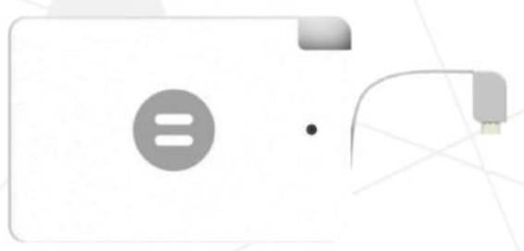

USB Port / Power (UP)
The USB Port connects to the Battery module with a USB cable. It helps you to transmit the power coming from the Battery module to your circuit. Thanks to the switch on the module, you may switch the power on/off. While building your circuit, position the USB Port right after the Battery module.

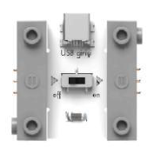

Proximity Sensor (PS)
Senses the proximity of the objects with the help of its infrared emitter and receiver connected with a cable. Sends an analogue signal based on the proximity degree. This analogue signal determines the zero volt to five volts power received by the circuit. Set the sensitivity of the sensor by turning the dial in the plus or minus (+ or −) direction. Mode "a" enables the transmission of more power to the circuit when an object gets closer to the sensor. Mode "b" enables transmission of less power to the circuit when an object gets closer to the sensor. The sensing precision of the Proximity Sensor may decrease in very bright environments. By adding modules such as Serial LED and Buzzer after the Proximity Sensor, you can observe the flow of power easily. The infrared emitter rays hit the object, bounce and return to the infrared receiver. The distance is determined based on the angle of incidence of this returning ray, and a signal is sent in the ratio of the distance.

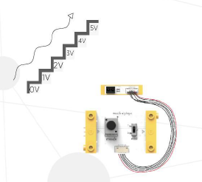

Sound Sensor / Sound Trigger (ST)
Senses the ambient sound volume. Sends a signal to the next module when the ambient sound reaches a specific level. Set the sensitivity of the sensor by turning the dial in the plus or minus (+ or −) direction. Imagine turning on the light by clapping. You may design a circuit that operates with your voice using this module. Sound Sensor transmits the signal for four seconds. Thus, you should wait for four seconds to send a signal again.

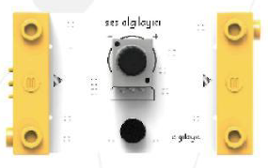

Light Sensor (LS)
Measures the amount of light. In mode “a”, it transmits power to the next module in ratio to darkness of the environment. In mode “b”, it transmits power to the next module in ratio to the brightness amount. Set the sensitivity of the module by turning the dial in the plus or minus (+ or −) direction. Did you ever realise that the street lamps turn on automatically when it’s dark?

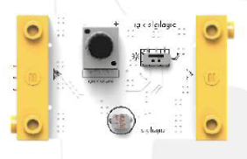

Motion Sensor / Motion Trigger (MT)
Sends a signal to the next module when it detects a movement around. Motion Sensor transmits the signal for six seconds. Any motion sensed in the environment within these six seconds will increase the signal transmission time. The sensing precision of the Motion Sensor may decrease in very bright environments. This is the same technology used for outdoor lighting and automatic doors. In mode "a", it sends a signal when there is motion around. In mode "b", it sends a signal when there is no motion around.

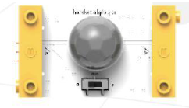

Remote Control (RC)
Senses the signal emitted by the remote control thanks to the built-in infrared sensor and sends a signal to the next module. You may send a signal to the Remote Control module with any remote control that you use at your home (TV, air-conditioner, sound system etc.). Did you know that there are infrared sensors on TVs and that you control your TVs thanks to this module?

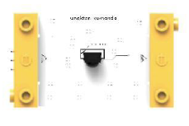

Signal Convertor / Inverter (S)
Receives the signal coming from the circuit and transmits it to the next module. Imagine that you had placed the Cable LED right after the Button and designed a LED that turns on when you press the Button. When you place a Signal Converter between the Button and the Cable LED, the Cable LED turns on when the Button is not pressed and turns off when it is pressed. If you want your circuit elements to work differently than normal, the Signal Converter can help you.

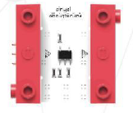

Latch (L)
Ensures the continuity of the transmitted signal if placed after the input parts. Use it after input parts such as Light Sensor, Sound Sensor, Motion Sensor and Button. For example, to make a lamp that constantly emits light until you turn it off, you should place the Latch after the Button module.

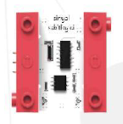

Logic Gate / AND/OR Multi Logic (AO)
AND Gate: When mode 1 and mode 2 switch display the value "a", the circuit is in AND mode. In this mode, it is required for the Logic Gate to receive signals from both connected input parts in order to send a signal to the next module.

OR Gate: When mode 1 switch displays the value "a" and mode 2 switch displays the value "b", the circuit is in OR mode. In this mode, it is required for the Logic Gate to receive signals from any or both connected input parts in order to send a signal to the next module.

XNOR Gate: When mode 1 switch displays the value "b" and mode 2 switch displays the value "a", the circuit is in XNOR mode. In this mode, it is required for the Logic Gate to receive signals from both connected input parts or not to receive signals from any of the parts in order to send a signal to the next module.

XOR Gate: When mode 1 and mode 2 switches display the value "b", the circuit is in XOR mode. In this mode, it is required for the Logic Gate to receive a signal from only one of the connected input parts in order to send a signal to the next module.

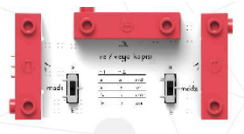

AND Gate input and output table

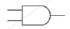

Input 1 | Input 2 | Output
No | No | No
No | Yes | No
Yes | No | No
Yes | Yes | Yes

OR Gate input and output table

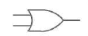

Input 1 | Input 2 | Output
No | No | No
No | Yes | Yes
Yes | No | Yes
Yes | Yes | Yes

XNOR Gate input and output table

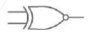

Input 1 | Input 2 | Output
No | No | Yes
No | Yes | No
Yes | No | No
Yes | Yes | Yes

XOR Gate input and output table

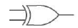

Input 1 | Input 2 | Output
No | No | No
No | Yes | Yes
Yes | No | Yes
Yes | Yes | No

Connection Cable
Enable different setups while building the circuit thanks to the cable in the centre. As a result, you may design your circuit more flexibly.

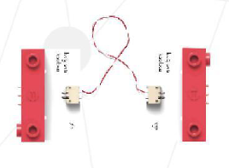

Splitter
Transmits the received signal to two connected modules through cables. So, you should use the Splitter if you want to send the signal coming from the circuit to two different modules. Do you see its similarity to the multiple extension cables?

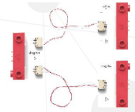

Counter (C)
Helps you read the signal values transmitted from the modules beforehand. You can see the strength of the received signal by switching to mode per cent (%) of "değer". Mode "V" enables you to read the voltage value transmitted from your circuit. By switching it to "sayaç", you may obtain a meter that counts the transmitted signals as increasing values in mode “up triangle” (▲) and decreasing values in mode “down triangle” (▼). You can reset the values using the reset button. You should place the Meter module into your circuit when you want to keep scores or measure values.

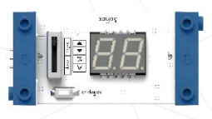

Motor (M)
A mechanical Twin module that converts the electrical power to motion when the signal is received. The metal rod named 'shaft' on the Motor begins rotating when placed accordingly in the circuit. The shaft helps transfer the motion of rotation to other pieces. For example, you may place a wheel at the end of the shaft and observe that it is rotating. You may adjust the direction of rotation with the help of its switch.

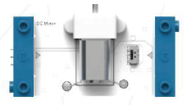

Fan (FAN)
Begins rotating when the signal is received. You can use the Fan module in cooling circuits or in experiments that you want to measure the power of air. Did you know that computers have fans to cool their circuits?

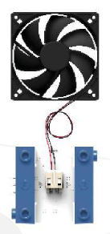

Servo Motor (SM)
Moves forwards and backwards or rotates to a specific direction according to the strength of the signal as a controllable motor. When the switch is in mode "a", the motor rotates at an angle of 90 degrees with a speed that is in proportion to the strength of the signal. And in mode "b", it swings at an angle of 90 degrees with a speed that is in proportion again to the strength of the signal. There are six different Servo Motor caps inside the Twin Discovery Set. Choose the right one for your design and mount it to your Servo Motor using a cross point screwdriver. Did you know that a Servo Motor is used in windscreen wipers?

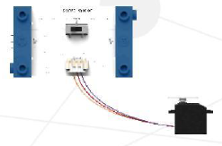

Serial LED / Bargraph (BG)
Helps measure the signal level in your circuit. The five LED units on this module will flash according to the level of the signal. You may use the Serial LED to measure the ambient values such as sound, light, or the proximity to objects.

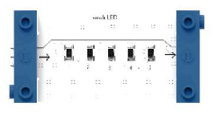

Cable LED (LED)
Observe that the LED flashes at the end of the cable when the signal is received. You may use the green LED for light, and the red LED with frosted glass for warning. Enables flexible design of the illumination feature of the circuit because it is cabled.

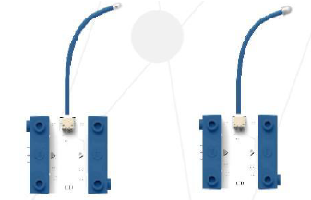

Buzzer (BZ)
Makes sound by vibrating when the signal is received. The vibration amount increases or decreases based on the level of the signal. Do you know that sound is all about vibrations? Have you noticed an alarm clock vibrates while ringing? The Buzzer may help you while designing your alarm or alert circuits.

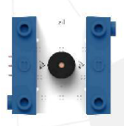

Additional building block pieces
These items are included in a plastic bag and can be found in the bottom of the kit box.
- 16 by 31 base board.
- Two wheels (wheel hub and tyres)
- Four yellow elastic bands.
- One white two by eight rectangular slab with holes.
- Two yellow column pieces.
- Four yellow two by one pieces with a hole in the centre.
- Four grey wheels, with grooves for the elastic bands to rest in.
- Two white two by two flat pieces.
- Eight yellow connector beads.
- One three by one grey bar; two holes on the side, one in the top
- Two blue cogs.
- Six small grey axle rods.
- Two long black axle rods.
- One medium black axle rod.
- Two black capital T shaped pieces with five holes.

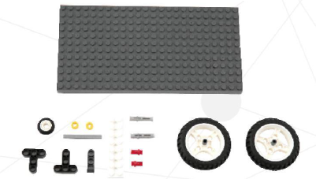

Swivel wheel
This can be made from the above parts and will be required in some of the later experiments.

To build the Swivel Wheel you will need these 11 pieces:
- Two black capital T-shaped pieces
- Two small grey axle rods
- One three by one grey bar; two holes on the side, one in the top
- One medium black axle rod
- One white two by eight flat piece
- One medium red connecting rod
- Two yellow connector beads
- One wheel.

Section one: connect the first four pieces:
- Black capital T > Small grey axle rods in first and second holes on the horizontal bar > attach the grey bar to the rods.

Section two: connect the next three pieces:
- Black capital T > Medium red rod in bottom hole on the vertical bar > attach the rod to the wheel

Connect sections one and two (sandwich the pieces together):
- Connect the two small grey rods on section one, to the first and second holes on the horizontal bar of the Black T in section two.
- Connect the medium red rod through the wheel and into the bottom hole of the vertical bar of Black T in section one.

Section three: connect the next four pieces:
- Long black rod > one yellow connector bead at the bottom of the rod > attach the white two by eight flat piece using the hole in one end, slide it to the bottom of the rod, to rest on the bead > one yellow connector bead on top.

Connect section three to section one and two:
- Connect the bottom of the black rod to the middle grey bar (Black T, Grey bar, Black T), there is a hole in the top for it to slot into.

The Swivel Wheel is complete.

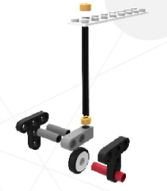

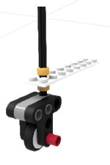

Quick start

How to get started with the Twin Science Kit
The best way to discover Twin is to conduct as many experiments as you can without fear, and to be open to discoveries while conducting these experiments. We always dreamed of the following while we were working on these kits.

- Producing a kit that you will enjoy without fear of damaging or breaking it.
- Helping you discover how easy the main working principles of all those technological tools that we use are.
- Enabling you to design the first versions of the products that you dream and to easily share these with the people around you.

Designing simple circuits
Life without energy is not possible for any human being. Twin parts require energy just like we do. Let’s start with the Battery, this is essential to every circuit as it provides the required energy. Let’s imagine building a lamp.

Connect these three modules:
- Power bank > USB Port (UP) > Cable LED (LED).

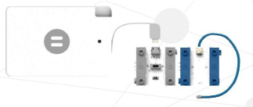

But what would happen if the lamps in your home were always on? So, why are they not on in our houses all the time? Let’s add the Button module in between the USB Port and the Cable LED.

Connect the four modules in this order:
- Power bank > USB Port (UP) > Button (B) > Cable LED (LED).

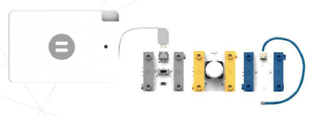

Let’s switch off the light by pressing the Button, acting as a switch for our circuit.

Did you realise that the Cable LED emits light as long as you keep the Button pressed? What do you say about building a lamp circuit that starts emitting light when you press the Button and continues emitting light until you press the Button again? Let’s add the Latch module in between the Button and Cable LED.

Connect the five modules in this order:
- Power bank > USB Port (UP) > Button (B) > Latch (L) > Cable LED (LED).

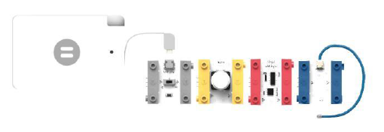

Well, what if you wanted to make a lamp that turns on when you clap instead of pressing the Button? Then the Sound Sensor is just the right module for you. You may make your dream come true by replacing the Button module with the Sound Sensor module.

Connect the five modules in this order:
- Power bank > USB Port (UP) > Sound Sensor (ST) > Latch (L) > Cable LED (LED).

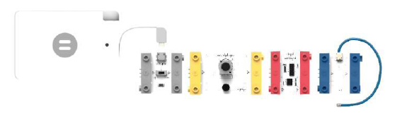

Your lamp now turns on when you clap, and turns off when you clap again, remember to wait at least four seconds between each clap.

Projects – starter level

Horn
In this experiment, we will examine how a car horn works. Let’s build the circuit; the horn will then work when you press the Button.

You may use the same circuit for the doorbell.

Connect the four modules in this order:
- Power bank > USB Port (UP) > Button (B) > Buzzer (BZ)

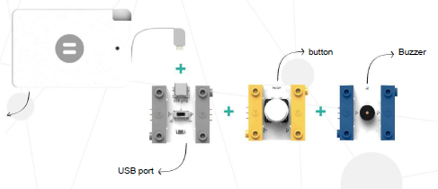

Book reading lamp
In this experiment, we will make a reading lamp that will enable you to read a book in the dark.

Required materials not included in the Twin Kit: white paper, wire (such as a paper clip), adhesive tape.

Let’s build the circuit; the frosted glass Cable LED illuminates a wider area.

Connect the five modules in this order:
- Power bank > USB Port (UP) > Button (B) > Latch (L) > Cable LED (LED)

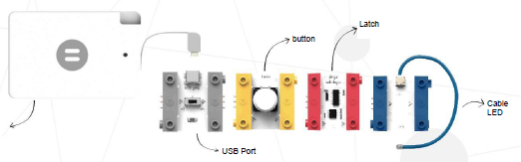

- Roll a square of white paper into a cone shape.
- Place the LED inside the cone and fix it using the adhesive tape.
- Shape the LED by fastening the wire.

Your lamp is ready, now you can start reading. Enjoy!

Street lamp
In this experiment, we will examine the system that enables street lamps to turn on at night (in the dark) and turn off in the morning (in the light).

Required materials not included in the Twin Kit: carboard, scissors.

Let’s build the circuit; ensure that the switch on the Light Sensor is in mode “a” (pushed to the left).

Connect the four modules in this order:
- Power bank > USB Port (UP) > Light Sensor (LS) > Cable LED (LED)

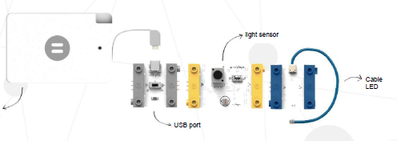

If your building the circuit at night, ensure the room lights are turned off. If building in the day, cover the Light Sensor so it receives no light; you can prevent the inlet of light by covering it with your fingers or palm.

The light will turn on when it is dark and turn off when it is bright again.

If you wish, you can use the cardboard to create a row of houses, with the street lamp outside.

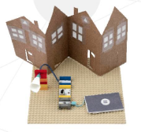

Cooler fan
In this experiment, we will design a fan that will turn on when you press the Button and cool the environment.

Let’s build the circuit.

Connect the five modules in this order:
- Power bank > USB Port (UP) > Button (B) > Latch (L) > Fan (FAN)

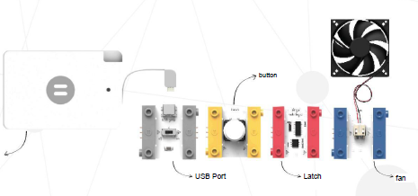

Turn on the power on the USB Port (switch pushed to the right). The Fan will start working when you press the Button. You can turn off the circuit by pressing the Button.

Morning alarm
In this experiment, we will examine how an alarm that wakes us up when the sun rises works.

Let’s build the circuit; ensure the Light Sensor is in mode “b” (pushed to the right).

Connect the four modules in this order:
- Power bank > USB Port (UP) > Light Sensor (LS) > Buzzer (BZ)

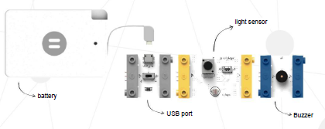

Place the circuit in an area that will receive sunlight in the morning. When the sunlight falls on the Light Sensor, the alarm will begin ringing. Thanks to the alarm, you’ll never be late again!

Hand fan
Are you exhausted from heat? You can cool off by building your own hand fan.

Required materials not included in the Twin Kit: glue, scissors, carboard.

Let’s build the circuit.

Connect the five modules in this order:
- Power bank > USB Port (UP) > Button (B) > Latch (L) > Motor (M)

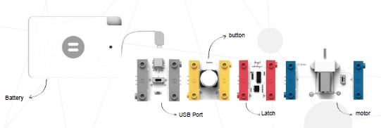

- Cut the cardboard into the shape of a propeller.
- Attach the propeller to the Motor, stabilising it with tape if required.

Your fan will begin working once you press the Button.

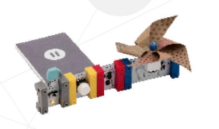

Projects – intermediate level

Right answer-matic
Quiz shows are now much more fun! When you answer the questions correctly, you will see the Serial LED illuminating and hear the Buzzer ringing.

Required materials not included in the Twin Kit: cardboard, box, scissors.

Let’s build the circuit; use the green LED to indicate the correct answer.

Connect the six modules in this order:
- Power bank > USB Port (UP) > Connection Cable > Proximity Sensor (PS) > Latch (L) > Serial LED/Bargraph (BG)

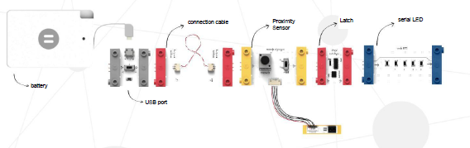

- Cut out a rectangle from the cardboard; this is your answer card.
- Cut two holes in the front of the box, large enough for the answer card to fit through.
- Label the two holes on the box; for example, if the question you’re asking was “How many people took part in the world’s largest marble tournament in September 2010?” – you could make your two answer labels “876” (the correct answer) and “794”.
- Place the circuit inside the box.
- Place the Proximity Sensor in the space behind the right answer.

When someone posts the answer card through the correct answer hole, the card will set off the Proximity Sensor and the Serial LED will light up and the Buzzer will ring.

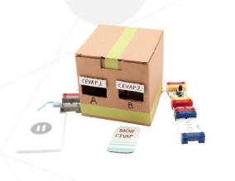

Applaud and illuminate
For this experiment, we’re adding to the simple lamp circuit we made in the section “Designing simple circuits”.

Required materials not included in the Twin Kit: plastic cup, adhesive tape, scissors, cardboard tube (such as a kitchen roll tube).

Hint: instead of a plastic cup, you could use a piece of white paper to create a cone.

Connect the five modules in this order:
- Power bank > USB Port (UP) > Sound Sensor (ST) > Latch (L) > Cable LED (LED).

- Cut a hole in the centre of the cup base.
- Attach the cup to the cardboard tube.
- Feed the Cable LED through the tube and through the hole in the bottom of the cup.

Your lamp now turns on when you clap and turns off when you clap again, remember to wait at least four seconds between each action.

You could also give a voice command such as “Light”.

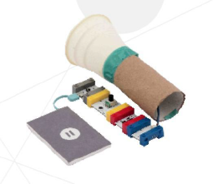

Parking sensor
In this experiment, we will make a parking sensor for a car.

Required materials not included in the Twin Kit: toy car, adhesive tape.
Let’s build the circuit.

Connect the five modules in this order:
- Power bank > USB Port (UP) > Proximity Sensor (PS) > Buzzer (BZ) > Serial LED/Bargraph (BG)

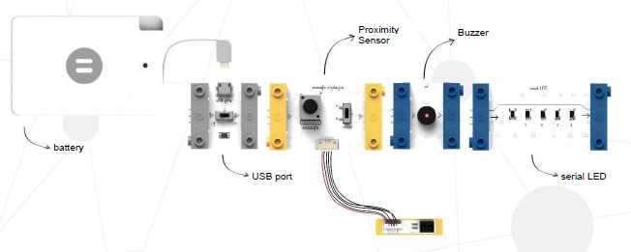

- Attach the parking sensor to the toy car.

Thanks to the parking sensor, you can drive and park the car without hitting any other objects.

The Serial LED will illuminate, and the Buzzer will sound to warn you, based on your proximity degree as you get close to other objects. Drive safely!

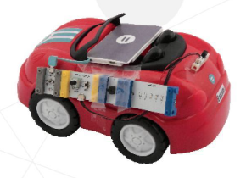

Secret object alarm
Everyone has something special that they want to keep as a secret. This secret alarmed box will protect your special objects.

Required materials not included in the Twin Kit: a box.

Let’s build the circuit.

Connect the five modules in this order:
- Power bank > USB Port (UP) > Motion Sensor (MT) > Connection Cable > Buzzer (BZ)

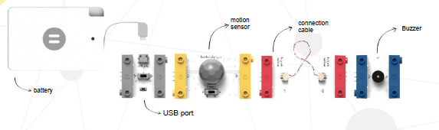

- Place the circuit on the box (or object) that you want to keep a secret.

The Buzzer will ring and warn you when someone gets too close to the box.

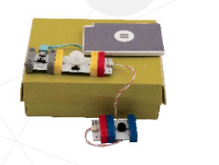

Windmill
In this experiment, we will examine the windmill example together.

Required materials not included in the Twin Kit: glue, scissors, cardboard.

Let’s build the circuit.

Connect the six modules in this order:
- Power bank > USB Port (UP) > Button (B) > Latch (L) > Connection Cable > Motor (M)

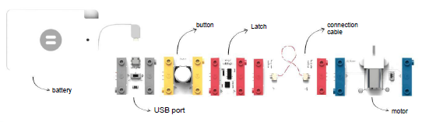

- Design the outer shell of your windmill; use your imagination.
- Build your cardboard windmill.
- Place the circuit under the windmill.
- Fix the windmill’s sails to Motor shaft

You can control the sail rotation by using the Button to switch them on and off.

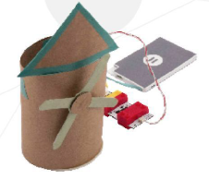

Flashlight
In this experiment, we will make a flashlight (torch).

Required materials not included in the Twin Kit: adhesive tape, scissors, cardboard tube (such as a kitchen roll tube), plastic cup.

Hint: instead of a plastic cup, you could use a piece of white paper to create a cone.

Let’s build the circuit; use the green LED to illuminate further.

Connect the six modules in this order:
- Power bank > USB Port (UP) > Button (B) > Latch (L) > Connection Cable > Cable LED (LED)

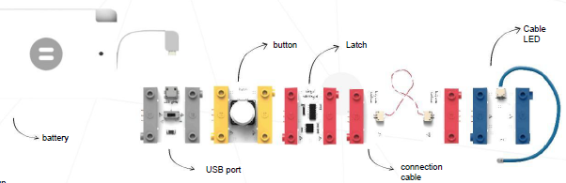

- Cut a hole in the centre of the cup base.
- Attach the cup to the cardboard tube, so the cup sits just inside the tube.
- Feed the Cable LED through the tube and through the hole in the bottom of the cup.
- Attach the circuit modules to the side of the tube, using either the elastic bands or adhesive tape.

Your flashlight is ready to use. Turn it on and off by pressing the Button.

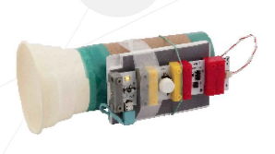

Crane
In this experiment, we will examine a crane (pulley) system.

Required materials not included in the Twin Kit: a box, adhesive tape, rope or string, a small weight.

Let’s build the circuit.

Connect the six modules in this order:
- Power bank > USB Port (UP) > Latch (L) > Connection Cable > Motor (M)

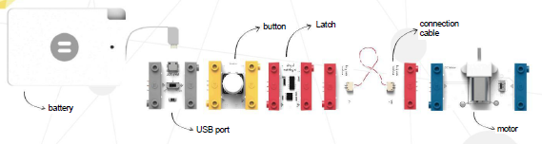

- Fix the Motor to the box using the adhesive tape.
- Tie one end of the rope to the Motor shaft.
- On the bottom end of the rope, tie the small weight.
- Turn on the Power switch.

You can now lift the small weight by pressing the Button.

To lower the small weight, change the direction of the Motor.

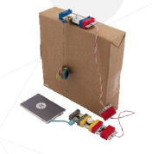

Projects – advanced level

Electronic candle
In this experiment, we’re going to make an LED candle that you can blow out!

Required materials not included in the Twin Kit: cardboard, adhesive tape, scissors.

Hint: cake accessories are optional, such as toy cakes, cupcake cases or even real blueberry muffins to enjoy once the candles are blown out!

Let’s build the circuit.

Connect the eight modules in this order:
- Power bank > USB Port (UP) > Sound Sensor/Trigger (ST) > Signal Converter/Inverter (I) > Cable LED (LED) > Cable LED (LED) > Connection Cable > Serial LED/Bargraph (BG)

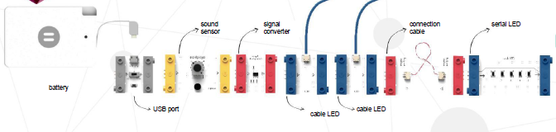

- Cut out a circle from the cardboard (to act as your cake top).
- Make two holes in the cardboard circle, to fit the Cable LEDs through.
- Decorate your cake and light (switch on) the candles.

When you’re ready to blow out the candles, blow or make a noise into Sound Sensor.

Wait four seconds and the candles will light up again, for the next person to blow out and make a wish!

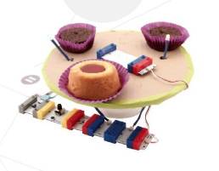

Confetti rain
In this experiment, we will use the Fan and Serial LED to blow confetti,

Required materials not included in the Twin Kit: sheet of A4 paper, adhesive tape, scissors, confetti.

Hint: you can make confetti by cutting up pieces of tissue paper, kitchen towel or a paper napkin.

Let’s build the circuit; ensure the dial on the Sound Sensor is turned right around to the minus position (left).

Connect the eight modules in this order:
- Power bank > USB Port (UP) > Sound Sensor/Trigger (ST) > Fan (F) > Signal Converter/Inverter (I) > Serial LED/Bargraph (BG) > Cable LED (LED > Cable LED (LED)

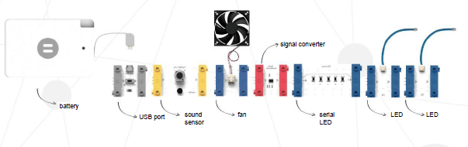

- Make a tube using the A4 paper and adhesive tape.
- Place the paper tube on top of the Fan.
- Place the confetti inside the paper tube.
- Turn on the Power switch.

When you blow hard onto the Sound Sensor, the fan will start working and the blow out confetti rain and the LED lights will turn on too!

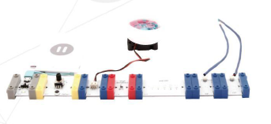

Mechanical basketball player
In this experiment, we will design a mechanical arm that shoots baskets for you.

Required materials not included in the Twin Kit: strong cardboard, plastic cup, adhesive tape, scissors, paper, a bin/basket.

Hint: build the circuit on the base board

Let’s build the circuit; ensure you choose the right cap for the Servo Motor and attach it using a Philips screwdriver.

Connect the five modules in this order:
- Power bank > USB Port (UP) > Button (B) > Connection Cable > Servo Motor (SM)

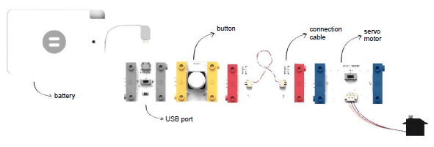

- Cut a rectangle from the carboard; this will be the arm.
- Cut a square from the front of the cup - from the top edge, two thirds down the cup; to create your launch basket.
- Attach the cup to the cardboard arm.
- Tightly attach the cardboard arm to the Servo Motor cap; ensure it does not prevent the Servo Motor rotating.

Your mechanical basketball player is now ready. Place paper balls inside the cup and push the Button for the arm to throw the balls into the basket.

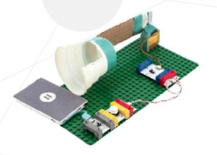

Guest at the door
In this experiment, we will design a circuit that detects how close your guests are to the front door of your house and illuminate the garden path for them.

Required materials not included in the Twin Kit: cardboard, adhesive tape, scissors, glue.

Hint: build the circuit on the base board

Let’s build the circuit.

Connect the seven modules in this order:
- Power bank > USB Port (UP) > Proximity Sensor (PS) > Serial LED/Bargraph (BG) > Connection Cable > Buzzer (BZ) > Cable LED (LED)

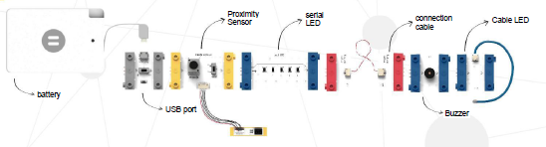

- Design your dream house; use your imagination.
- Build your house out of cardboard.
- Place the Proximity Sensor next to the front door, pointing away from the house and down the path leading up to your house.

Switch the circuit on and off by moving the switch on the USB Port.

With the circuit switched on, the proximity of any guests to your door will cause set off the Buzzer, and the intensity of the Serial LED to increase or decrease. In addition, when your guest gets close to your door the Cable LED will automatically switch on to light their way.

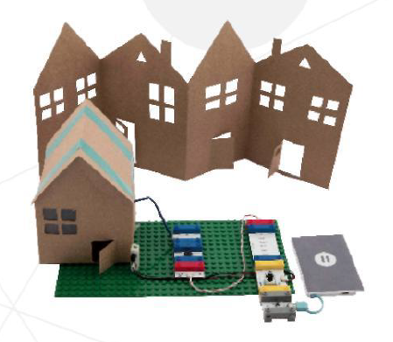

Hint: you can also use this circuit to detect your little brother or sister coming to your bedroom!

Card box
In this experiment, we will design a box that can be opened using a card.

Required materials not included in the kit: cardboard box, scissors, rope or string, different coloured pencils.

Let’s build the circuit:

Connect the seven modules in this order:
- Power bank > USB Port (UP) > Proximity Sensor (PS) > Latch (L) > Connection Cable > Motor (M) > Serial LED/Bargraph (BG).

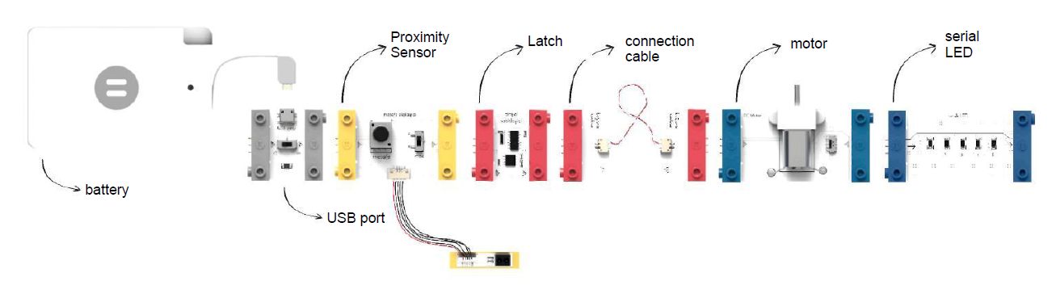
- Remove a strip of cardboard from each of the front of the flaps at the top of the cardboard box. This is to allow the box to open and close without catching.
- On the top face and towards the front of the box, pierce a hole just large enough to pass the string through. Insert the string from the top side of the box and tie a large knot in the section you have just passed through. Pulling on the string should now open the lid of the box.
- Remove the plastic gear on the end of the Motor Shaft and wrap the shaft in double sided tape. Wrap the string around the Motor Shaft.
- Place the following parts of the circuit inside the box; Power bank > USB Port (UP) > Proximity Sensor (PS) > Latch (L) > Connection Cable
- Cut open the edge of the box, but just enough to allow Connection Cable to be passed through.
- Pass the Connection Cable through the side of the box and connect it to the remaining components to complete the circuit. Fix the Motor securely to the surface it is on with tape.
- Cut a slot out of the front of the box, this is where we will insert our card to open the box. Next, cut a card out of cardboard, the card should easily fit into the slot we have just made. Decorate your card in any way you wish.
- Align the sensor on the Proximity Sensor so that it will be covered when your card is inserted.

When you insert your card into the slot, the Motor will turn, and the box will open.
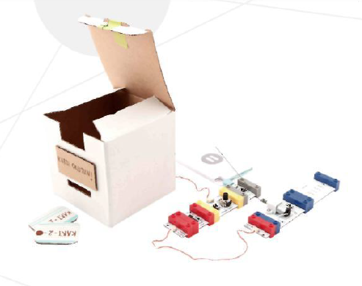

Keep foods fresh
In this experiment, we will build a circuit that prevents food being spoiled.

Let’s build the circuit:

Connect the nine modules in this order:
- Power bank > USB Port (UP) > Button (B) > Latch (L) > Splitter.
- On the left-hand path connect Signal Converter/Inverter (I) > Fan (F).
- On the right-hand path connect Buzzer (BZ) > Cable LED (LED).

Hint: build the circuit on the base board.

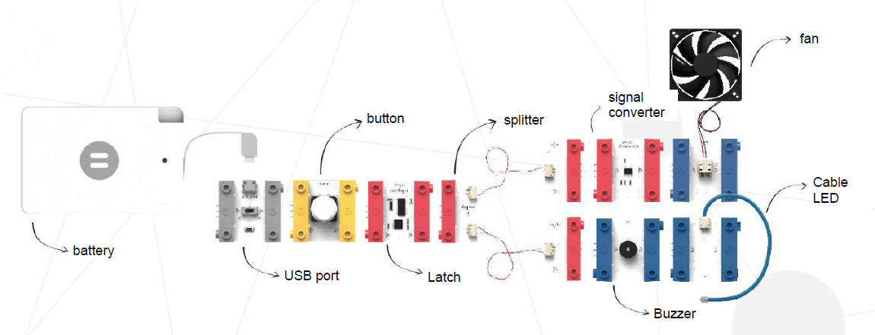

We have now built a circuit which imitates how some refrigerators work. When you open the door of some models of refrigerator, three things occur. The light of the refrigerator turns on, the interior fan stops working and an alarm starts after a while to notify you that the door is kept open for too long. In this circuit, you will observe that the Signal Converter turns on the light, starts the alarm and stops the fan.

Hint: After setting up the system in this way, you can place it inside a covered box and build your own refrigerator. You can activate the circuit of your refrigerator by clicking the Button.

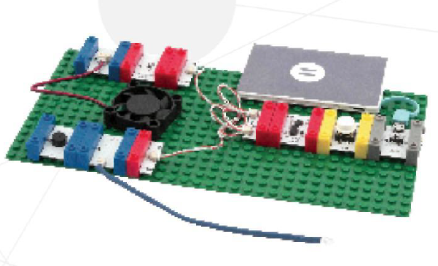

Goal
In this experiment, we will design a circuit that will show us with light and sound when a ball passes between two goalposts.

Let’s build the circuit:

Connect the nine modules in this order:
- Power bank > USB Port (UP) > Splitter
- On the left-hand path connect a Proximity Sensor (PS)
- On the right-hand path connect a Proximity Sensor (PS)
- Attach both Proximity Sensors to a single Logic Gate/ AND/OR Multi Logic (AO)
- To the Logic Gate/ AND/OR Multi Logic (AO) connect the following: Cable LED (LED) > Counter (C) > Buzzer (BZ).

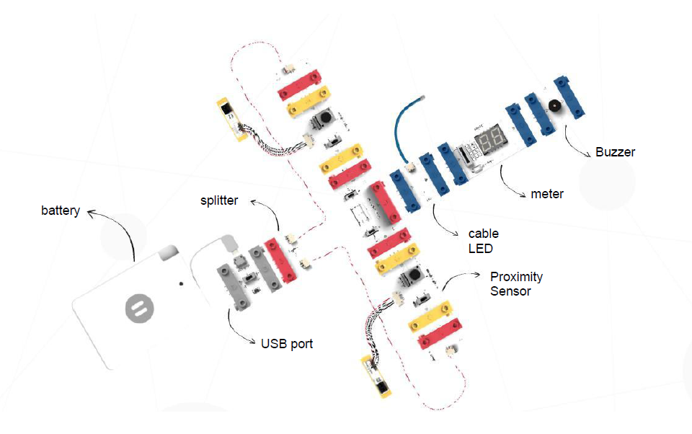

- Ensure the Counter is set to meter or "sayaç" mode.
- On the Logic Gate set the mode 1 switch to value “a”, the mode 2 switch is set to value “b” and the module is set at “OR”.

Hint: You can use and object such as an eraser as a ball.

When the ball passes through the space between the Proximity Sensors, the Cable LED will turn on, the Buzzer will ring, and the Counter will keep count of the score.

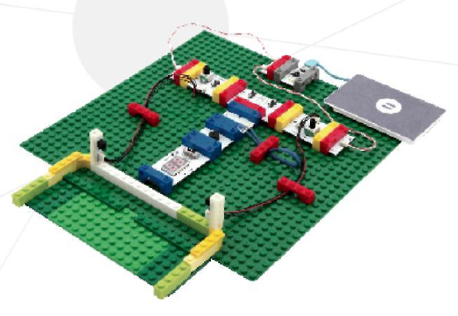

Waving robot
In this experiment, we will build a waving robot.

Required materials not included in the kit: two cardboard boxes (one for the head of the robot and one for the body), a straw, glue, double-sided tape and scissors.

Let’s build the circuit:

Connect the nine modules in this order:
- Power bank > USB Port (UP) > Button (B) > Latch (L) > Splitter
- On the left-hand path connect the following. Serial LED (LED) > Connection Cable > Cable LED (LED).
- On the right-hand path connect A Servo Motor (SM)

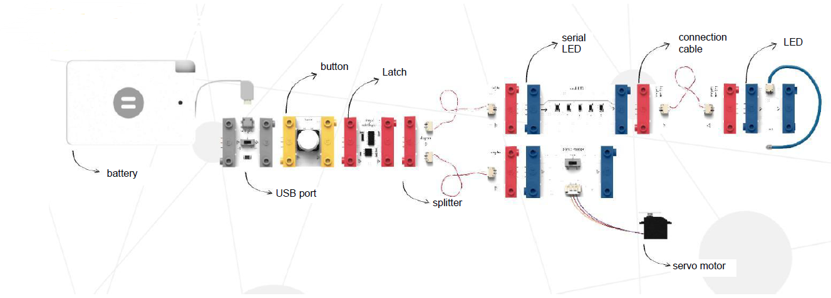

- Glue the two cardboard boxes together to form a basic robot shape.
- Next, cut a strip of carboard long enough to pass through the body of the robot. You will need to leave enough cardboard sticking out from both sides of the body to form the upper arms of the robot.
- Make slits in the body of the robot, pass the arm piece through and glue this section into place.
- Make a hole at one end of the upper arm of the robot, this will form the elbow and should be big enough to pass the straw through.
- Cut out a section of cardboard to form the forearm and hand of the robot, open a hole at the opposite end to the hand. Pass the straw through the hole and fix in place using glue or double-sided tape.
- Pass the straw through the hole in the upper arm of the robot and cut off the excess straw.
- Attach the Serial LED to the chest of the robot, then attach the Servo Motor to the straw on the arm of the robot using double-sided sticky tape.
- Align the Proximity Sensor with the arm of the robot.
- Decorate your robot.
- Switch the circuit on using the USB Port, a green LED light will illuminate to show the circuit has power to it.

Your waving robot is now ready!

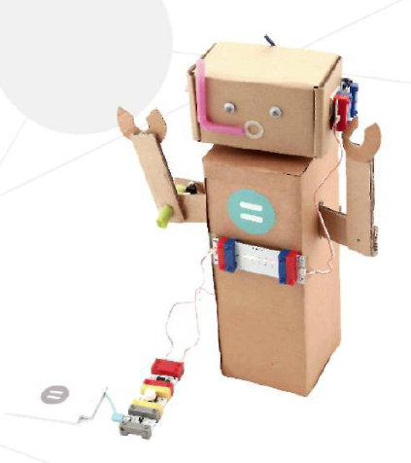

Burglar alarm
In this experiment, we will build an alarm system that senses sound and motion.

Let’s build the circuit:

Connect the eight modules in this order:
- Power bank > USB Port (UP) > Splitter
- On the left-hand path connect a Motion Sensor/ Motion Triger (MT)
- On the right-hand path connect a Sound Sensor/ Sound Trigger (ST)
- Attach the Motion Sensor /Motion Trigger (MT) and the Sound Sensor/ Sound Trigger (ST) to a single Logic Gate/ AND/OR Multi Logic (AO).
- To the Logic Gate/ AND/OR Multi Logic (AO) attach a Buzzer (B), followed by a Cable LED (LED).

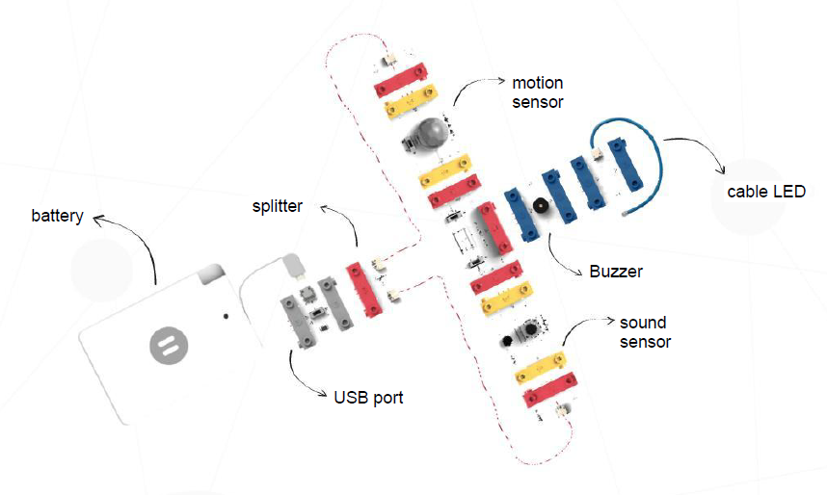

- Ensure that the Logic Gate/ AND/OR Multi Logic (AO) is set to the following. Mode 1 is set to “a”, mode 2 is set to “b” and that mode is set to “OR”.
- Switch the circuit on using the USB Port, a green LED light will illuminate to show the circuit has power to it.

Now, if anyone moves or makes a sound near the circuit, the Buzzer will sound, and the Cable LED will illuminate.

Hint: This is a great circuit to place next to your money box!

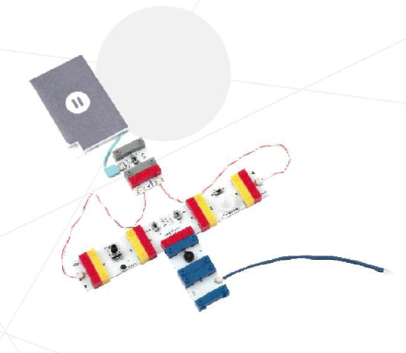

Smart Car
In this experiment, we will build a car that will never hit another object.

Required materials not included in the kit: three wheels, wooden stick, cardboard box, adhesive tape and a straw.

Let’s build the circuit:

Connect the eight modules in this order:
- Power bank > USB Port (UP) > Cable LED (LED) > Splitter
- On the left-hand path connect a Serial LED/ Bargraph (BG)
- On the right-hand path connect a the following: Proximity Sensor (PS) > Connection Cable > Motor (M).

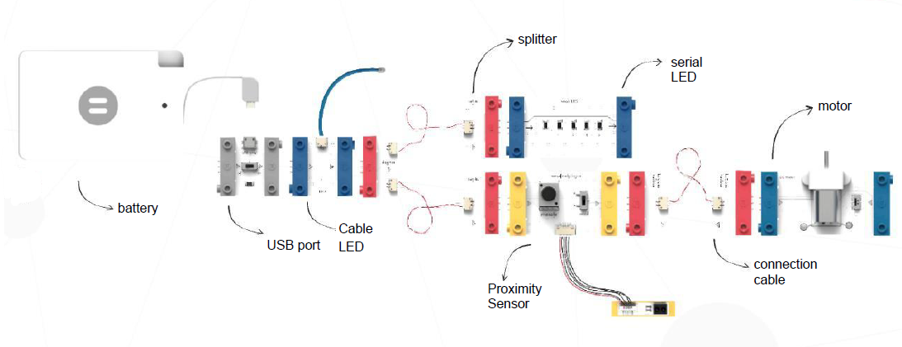

- Attach the straw to the underside and to the rear of the box using tape.
- Pass the wooden stick through the straw and attach a wheel to either side of the stick, use tape to keep the wheels in place.
- Take the circuit and attach it to the top of the cardboard box using tape.
- On the underside of the box, and towards the front, cut a slot big enough to allow the third wheel to run freely.
- Attach the third wheel to the shaft of the Motor, use sticky tape to keep it in place.
- Tape the motor to the cardboard box, ensuring that the wheel is located within the previously cut slot.
- Ensure the Proximity Sensor is located at the front of the car and that it is in mode “a”.
- Our smart car is now ready to go!

Thanks to the Proximity Sensor, the car will stop when it senses an obstacle in front of it.

Hint: With the Serial LED in place, our car is also ready to drive at night!

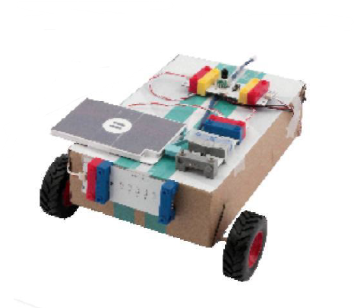

Autonomous car
In this experiment, we will build an autonomous car that changes direction when it faces an obstacle.

- Required materials not included in the kit: tape, two plastic wheels, swivel wheel and a plate (such as a 16 by 31 Lego style base board).

Let’s build the circuit:

Connect the nine modules in this order:
- Power bank > USB Port (UP) > Splitter
- On the left-hand path connect the following: Cable LED (LED) > Proximity Sensor (PS) > Connection Cable > Motor (M)
- On the right-hand path connect the following: Proximity Sensor (PS) > Motor (M).
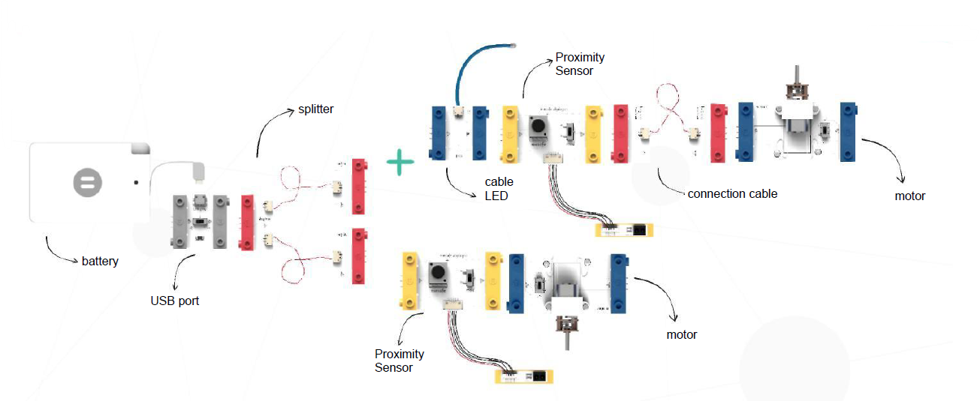

- Attach the circuit to the plate, ensuring that the shafts of the Motors are pointed outwards and are parallel and aligned.
- The Proximity Sensor on the right should send a signal to the Motor on the left, and the Proximity Sensor left should send a signal to the Motor on the right.
- Fasten the Proximity Sensors to the front section of the car and away from each other, this is so the car can sense any obstacle in its driving direction. Set the mode of the Proximity Sensors to “a”.
- Your autonomous car is now ready to test drive!

Prepare a track with obstacles to test your car. Switch the car on using the USB Port, a green light will illuminate when the circuit is powered up.

Hint: If you place a Remote Control module right after the USB Port, you can then use any remote control to start and stop your car!

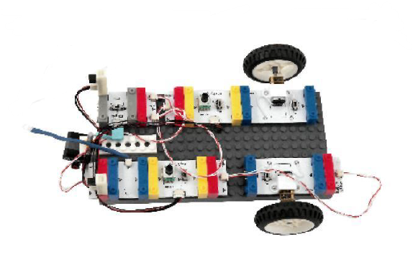

Line tracking robot
In this experiment, we will build a robot that follows a line.

- Required materials not included in the kit: electrical tape, double-sided tape, two plastic wheels, swivel wheel and a plate (such as a 16 by 31 Lego style base board).

Let’s build the circuit:

Connect the twelve modules in this order:
- Power bank > USB Port (UP)
- On the left of the USB Port (UP) add the following: Remote Control (RC) > Button (B)
- On the right of the USB Port (UP) add the following: Serial LED (LED) > Splitter
- On the left-hand path connect the following: Cable LED (LED) > Proximity Sensor (PS) > Connection Cable > Motor (M)
- On the right-hand path connect the following: Proximity Sensor (PS) > Motor (M).

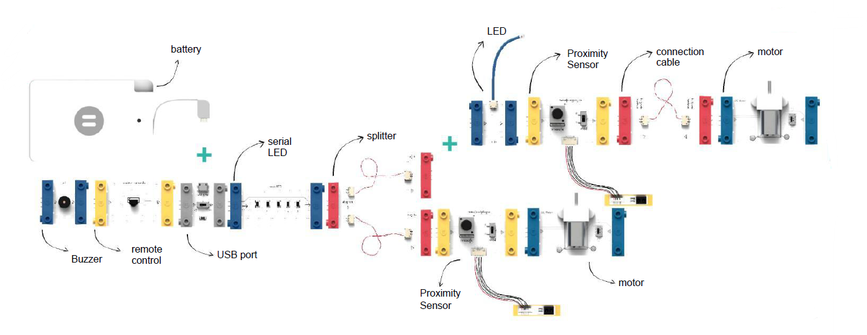

- Attach the Proximity Sensors to the bottom of the plate so they that they can follow the line. The sensors should be placed next to each other in the middle of the plate. Reduce the sensitivity by rotating the dial in “-“ direction. Use double-sided tape to attach the sensors.
- Attach the circuit to the plate, ensuring that the shafts of the Motors are pointed outwards and are parallel and aligned.
- The Proximity Sensor on the right should send a signal to the Motor on the left, and the Proximity Sensor left should send a signal to the Motor on the right.
- Ensue the Proximity Sensor is in mode “a”.

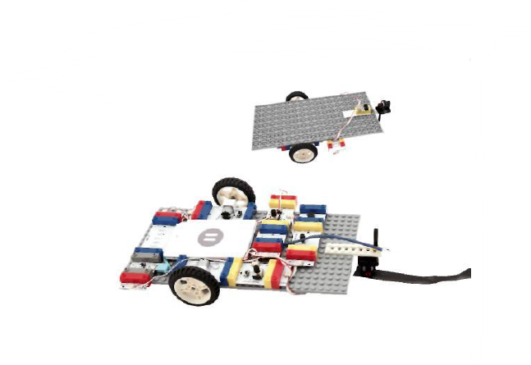

Ensure the sensors are aligned with the black electrical tape before placing the robot on the track.

How do you use yours?
We’d love to hear how you’re using the Twin Science discovery set to support the curriculum and engage your learners. Please share your projects on social media or by contacting our Helpline.

Instagram: @RNIB
Twitter: @RNIB
Facebook: @RNIBUK

How to contact RNIB
Phone: 0303 123 9999
Email: shop@rnib.org.uk
Address: RNIB, Midgate House, Midgate, Peterborough PE1 1TN
Online Shop: shop.rnib.org.uk

Email for UK business customers: kaorders@rnib.org.uk
Email for international business customers: exports@rnib.org.uk

RNIB Children, Young People and Families Team
Educators: rnib.org.uk/educationprofessionals
Parents: www.rnib.org.uk/children
Email: cypf@rnib.org.uk

Terms and conditions of sale
This product is guaranteed from manufacturing faults for 24 months from the date of purchase. If you have any issues with the product and you did not purchase directly from RNIB then please contact your retailer in the first instance.

For all returns and repairs contact RNIB first to get a returns authorisation number to help us deal efficiently with your product return.

You can request full terms and conditions from RNIB or view them online.

RNIB Enterprises Limited (with registered number 0887094) is a wholly owned trading subsidiary of the Royal National Institute of Blind People ("RNIB"), a charity registered in England and Wales (226227), Scotland (SC039316) and Isle of Man (1109). RNIB Enterprises Limited covenants all of its taxable profits to RNIB.

This product is CE marked and fully complies with all applicable EU legislation.

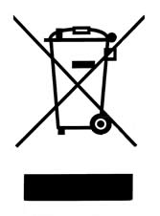

Please do not throw items marked with this symbol in your bin. Recycle your electricals and electronic devices free at your local recycling centre. Search for your nearest recycling centre by visiting recyclenow.com

Why recycle?
Unwanted electrical equipment is the UK’s fastest growing type of waste.

Many electrical items can be repaired or recycled, saving natural resources and the environment. If you do not recycle, electrical equipment will end up in landfill where hazardous substances will leak out and cause soil and water contamination – harming wildlife and human health.

RNIB are proud to support your local authority in providing local recycling facilities for electrical equipment.

To remind you that old electrical equipment can be recycled, it is now marked with the crossed-out wheeled bin symbol. Please do not throw any electrical equipment (including those marked with this symbol) in your bin.

What is WEEE?
The Waste Electrical or Electronic Equipment (WEEE) Directive requires countries to maximise separate collection and environmentally friendly processing of these items.

How are we helping?
In the UK, distributors including retailers must provide a system which allows all customers buying new electrical equipment the opportunity to recycle their old items free of charge. As a responsible retailer, we have met the requirements placed on us by financially supporting the national network of WEEE recycling centres established by local authorities. This is achieved through membership of the national Distributor Take-back scheme (DTS).

Date: June 2019.

© 2019 Royal National Institute of Blind People.

