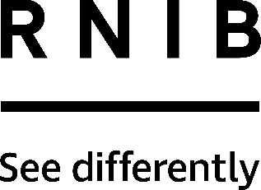

Large Print Bingo Cards (GB60)
Thank you for purchasing from RNIB. In the unlikely event the item is unsuitable, please contact us within 14 days of receipt to obtain your returns number. To ensure your return goes smoothly, the item and all components must be in as new condition and packed in its original, undamaged packaging. For further details and guidance on returning faulty items, please see the Terms and conditions of sale and How to contact RNIB sections of this instruction manual.

General description
These large numbered bingo cards can be used to join in a standard game of bingo. They are most suitable if you want to play one or two cards per game. Each sheet of paper consists of two cards: you can separate them by tearing along the perforation marked by a black dotted line.

These cards look slightly different from normal cards because they have just 15 boxes. However, each box contains a number chosen so that these cards will play just like ordinary cards. For each card, there is the same probability of winning as for a normal card. The numbers are set out with 1- 19 in the first column, 20 - 39 in the second column, 40 - 59 in the third column, 60 - 79 in the fourth column and 80 - 90 in the fifth column.

Each successive pair of cards in the pack will not have any number appearing more than once; this includes each pair on a single sheet. So if you want to play two cards, it is easiest to play with a single sheet. Should you wish to play more than two cards, you may have to mark a particular number called more than once.

Please note: Braille bingo cards are also available from RNIB, product code GB62.

Important: For legal reasons these cards cannot be used in Public Bingo Halls.

How to contact RNIB
Phone: 0303 123 9999
Email: shop@rnib.org.uk
Address: RNIB, Northminster House, Northminster, Peterborough PE1 1YN
Online Shop: shop.rnib.org.uk

Email for international customers: exports@rnib.org.uk

Terms and conditions of sale
This product is guaranteed from manufacturing faults for 12 months from the date of purchase. If you have any issues with the product and you did not purchase directly from RNIB then please contact your retailer in the first instance.

For all returns and repairs contact RNIB first to get a returns authorisation number to help us deal efficiently with your product return.

You can request full terms and conditions from RNIB or view them online.

RNIB Enterprises Limited (with registered number 0887094) is a wholly owned trading subsidiary of the Royal National Institute of Blind People ("RNIB"), a charity registered in England and Wales (226227), Scotland (SC039316) and Isle of Man (1226). RNIB Enterprises Limited covenants all of its taxable profits to RNIB.

Date: August 2023.

© Royal National Institute of Blind People.

