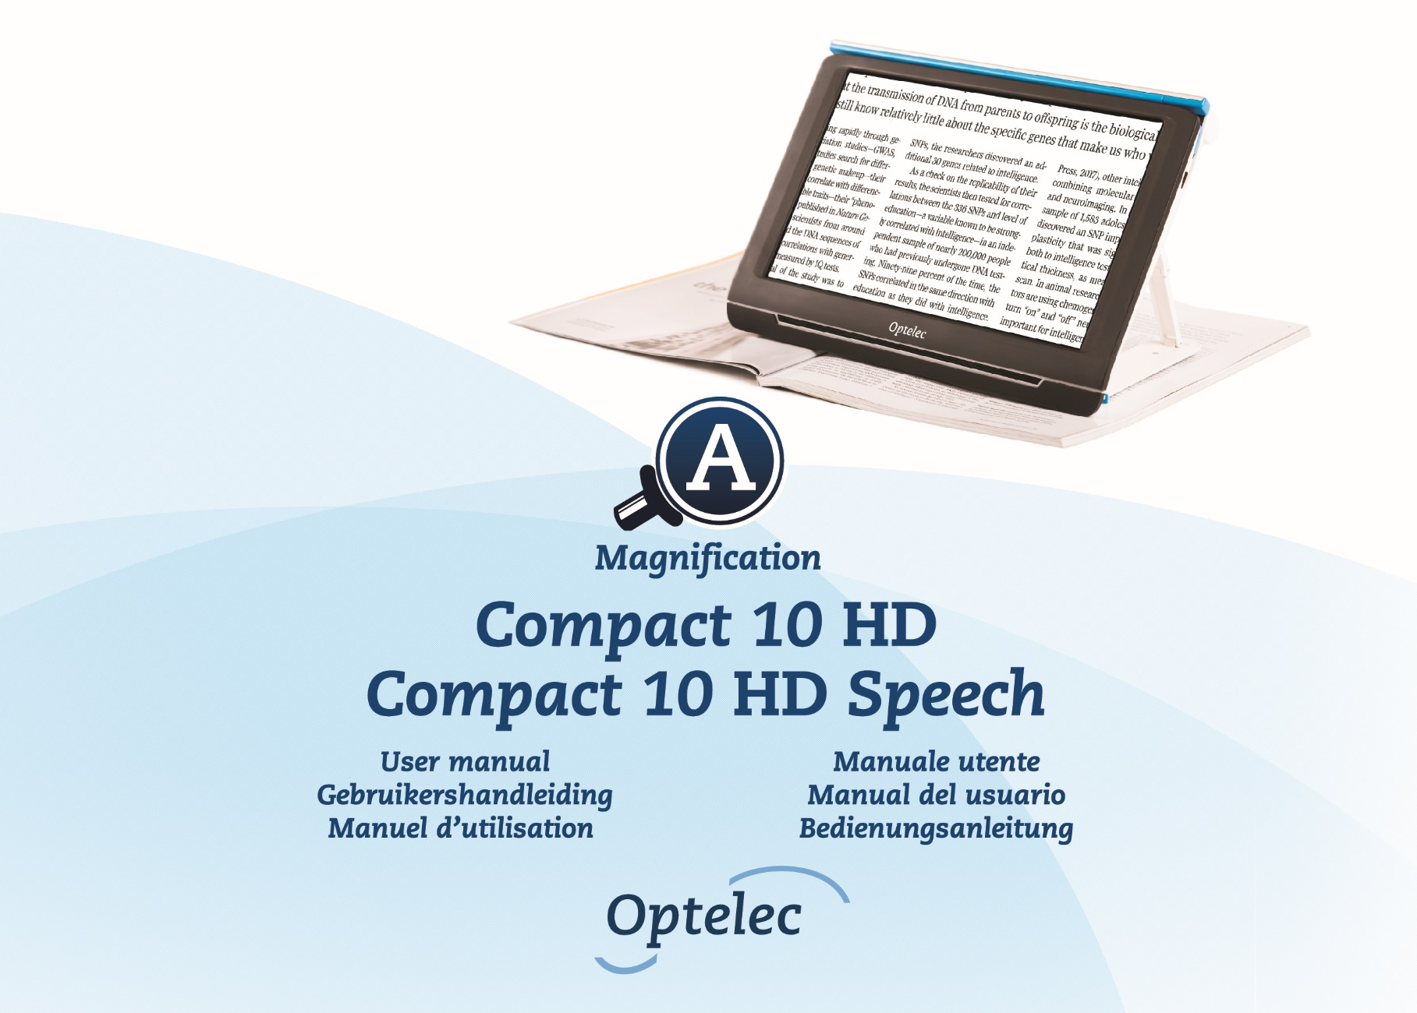

Contents
1. Introduction 15
About this manual 15
What’s in the box? 16
2. Getting started 17
2.1. Charging the battery 18
Battery warning 19
2.2. Power on and off 19
Standby 19
Sleep and resume 20
2.3. Folding and Unfolding the Compact 10 HD 21
2.4. Cleaning the cameras 22
2.5. Buttons and Connections 23
3. Cameras 24
3.1. Magnifier camera 24
3.2. Full Page camera 24
3.3. Overview camera 25
4. Using the Compact 10 HD Speech’s Text-to-Speech & OCR 26
5. Easy and Advanced mode 28
5.1 Features in Easy mode 30
Adjusting the magnification 30
Selecting a viewing mode 30
Taking a snapshot of an image (Compact 10 HD only) 31
Taking a snapshot and use Text-to-Speech (Compact 10 HD Speech only) 31
5.2. Features in Advanced mode 32
Time and date 32
Taking a snapshot of an image (Compact 10 HD Speech) 32
Menu 33
Voice (Compact 10 HD Speech only) 35
Line On/Off 36
Battery status 36
Save 36
Open 37
Adjusting the brightness 38
Settings 39
Color 40
View (Compact 10 HD Speech only) 41
Miracast: connecting wirelessly to a monitor or TV 41
Bluetooth (Compact 10 HD Speech only) 43
Line 44
Buttons 44
Theme 45
Columns (Compact 10 HD Speech only) 45
Lights 45
Sound 45
Standby 46
Language (Compact 10 HD only) 46
Restore 46
6. Transferring documents to PC 47
Appendix A: Technical information 48
Appendix B: Safety and Regulatory Notices 49

Inhoud
1. Inleiding 57
Over deze handleiding 57
Inhoud van de verpakking 58
2. Aan de slag 59
2.1. Opladen van de batterij 60
Batterijwaarschuwing 61
2.2. Aan- en uitzetten 61
Standby 61
Slaapstand en werking hervatten 62
2.3. Het opvouwen en ontvouwen van de Compact 10 HD 63
2.4. Het schoonhouden van de cameralens en de spiegel 64
2.5.Knoppen 65
3. Camera’s 66
3.1. Camera voor Vergroting 66
3.2. Camera voor Volledige pagina 66
3.3. Overzichtscamera 67
4. Tekst-naar-spraak en OCR 68
5. Eenvoudige en geavanceerde weergave 70
5.1. Eenvoudige weergave 72
Vergroting aanpassen 72
Een leesmodus selecteren 72
Een snapshot maken van een afbeelding (Compact 10 HD) 73
Een tekst-naar-spraak snapshot maken (Compact 10 HD Speech) 73
5.2. Geavanceerde weergave 74
Tijd en datum 74
Een snapshot maken van een afbeelding (Compact 10 HD Speech) 74
Het menu 75
Stem 76
Lijn aan/uit 78
Batterijstatus 78
Opslaan 78
Openen 79
Aanpassen van helderheid 80
Instellingen 81
Kleuren 82
Beeld (enkel Compact 10 HD Speech) 83
Miracast: draadloos verbinden met een monitor of tv 83
Bluetooth (enkel Compact 10 HD Speech) 85
Lijn 87
Knoppen 87
Thema 87
Kolommen (enkel Compact 10 HD Speech) 87
Verlichting 88
Geluid 88
Standby 88
Taal (enkel Compact 10 HD) 89
Fabrieksinstellingen herstellen 89
6. Documenten overzetten naar de PC 90
Bijlage A: Technische informatie 91
Bijlage B: Veiligheid en Onderhoud 92

Table des matières
1. Introduction 99
À propos de ce manuel 99
Que contient la boîte? 100
2. Pour débuter 101
2.1. Charger la batterie 102
Avertissement de batterie faible 103
2.2. Mise en marche et Arrêt 104
Mode de veille 104
Mise en veille et redémarrage 104
2.3. Plier et déplier le Compact 10 HD 105
2.4. Nettoyer la fenêtre de la caméra 106
2.5. Les boutons 107
3. Caméras 108
3.1. Caméra de grossissement 108
3.2. Caméra pleine page 108
3.3. Caméra vue d'ensemble 109
4. Utiliser les fonctions texte-à-parole et OCR 110
5. Mode Standard et Mode Avancé 112
5.1. Mode Standard 114
Ajuster le grossissement 114
Choisir un mode de visualisation 114
Prendre une photo (Compact 10 HD) 115
Prendre une photo et utiliser la synthèse vocale (Compact 10 HD Speech) 115
5.2. Mode Avancé 116
Heure et date 116
Prendre une photo (Compact 10 HD Speech) 116
Menu 117
Voix (Compact 10 HD Speech uniquement) 119
Ligne On / Off 120
État de la batterie 120
Sauvegarder 121
Ouvrir 121
Ajuster la luminosité 122
Réglages 123
Couleur 124
Affichage (Compact 10 HD Speech uniquement) 125
Miracast: Connection sans-fil à un moniteur ou à un téléviseur 125
Bluetooth (Compact 10 HD Speech uniquement) 127
Ligne 128
Boutons 129
Thème 129
Colonnes (Compact 10 HD Speech uniquement) 129
Lumières 129
Son 130
Mode veille 130
Langue (Compact 10 HD uniquement) 130
Restaurer 130
6. Transférer des documents vers un PC 131
Annexe A: Informations techniques 132
Annexe B: Sécurité 133

Indice
1. Introduzione 141
Informazioni su questo manuale 141
Contenuto della confezione 142
2. Iniziamo 143
2.1. Ricarica della batteria 144
Avviso sulla batteria 145
2.2. Accensione e spegnimento 146
Standby 146
Stand-by e riattivazione 146
2.3. Aprire e chiudere Compact 10 HD 147
2.4. Pulire la telecamera 148
2.5. Pulsanti 149
3. Telecamere 150
3.1. Telecamera per l'ingrandimento 150
3.2. Telecamera per tutta la pagina 150
3.3. Telecamera panoramica 151
4. Uso delle funzioni Sintesi vocale e OCR di Compact 10 HD Speech 152
5. Modalità Facile e Avanzata 154
5.1. Funzioni in modalità Facile 156
Regolare l'ingrandimento 156
Selezionare una modalità di visualizzazione 156
Acquisire un’immagine (Compact 10 HD) 157
Acquisire un'immagine e fare l'OCR (Compact 10 HD Speech) 157
5.2. Funzioni in modalità Avanzata 158
Data e ora 158
Acquisire un’immagine (Compact 10 HD Speech) 158
Menu 159
Voce (Solo Compact 10 HD Speech) 161
Riga Attivata/Disattivata 162
Stato della batteria 162
Salva 162
Apri 163
Regolare la luminosità 164
Impostazioni 165
Colore 166
Visualizza (Solo Compact 10 HD Speech) 167
Miracast: connessione wireless a un monitor o a una TV 167
Bluetooth (Solo Compact 10 HD Speech) 169
Riga 170
Pulsanti 171
Tema 171
Colonne (Solo Compact 10 HD Speech) 171
Luci 171
Suoni 172
Standby 172
Lingua (Solo Compact 10 HD) 172
Ripristina 172
6. Trasferire documenti sul PC 173
Appendice A: Informazioni tecniche 174
Appendice B: Sicurezza 175

Índice
1. Introducción 183
Acerca de este manual 183
Contenido de la caja? 184
2. Cómo empezar a trabajar 185
2.1. Cargar la batería 186
Aviso de batería 187
2.2. Encender y apagar el equipo 188
Standby 188
Modo suspensión y reactivación 188
2.3. Plegar y desplegar Compact 10 HD 189
2.4. limpiar la ventana de la cámara 190
2.5. Botones y conectores 191
3. Cámaras 192
3.1. Cámara de ampliación 192
3.2. Cámara de página completa 192
3.3. Cámara de vista general 193
4. Utilizar las funciones de texto a voz y OCR de Compact 10 HD Speech 194
5. Los modos Básico y Avanzado 196
5.1 Funciones del modo Básico 198
Ajustar la ampliación 198
Seleccionar un modo de vista 198
Hacer una captura de una imagen (Compact 10 HD) 199
Hacer una captura para reconocimiento y lectura del texto (Compact 10 HD Speech) 199
5.2. Funciones del Modo Avanzado 200
Fecha y hora 200
Hacer una captura de una imagen (Compact 10 HD Speech) 200
Menú 201
Voz (sólo Compact 10 HD Speech) 203
Línea activada/desactivada 204
Estado de la batería 204
Guardar 204
Abrir 205
Ajustar el brillo 206
Configuración 206
Color 207
Vista (sólo Compact 10 HD Speech) 208
Miracast: conexión inalámbrica con un monitor o televisor 208
Bluetooth (sólo Compact 10 HD Speech) 210
línea 212
Botones 212
Tema 212
Columnas (sólo Compact 10 HD Speech) 212
Luces 213
Sonido 213
Standby 213
Idioma (solo Compact 10 HD) 214
Restaurar 214
6. Transferir documentos al PC 215
Apéndice A: Información técnica 216
APÉNDICE B: SEGURIDAD……………………………………………………………………………………………… 217

Inhalt
1. Einführung 224
Über dieses Handbuch 224
Was gehört zum Lieferumfang? 225
2. Erste Schritte 226
2.1. Aufladen des Akkus 227
Akkuwarnung 228
2.2. Ein- und Ausschalten 228
Bereitschaft 228
Schlafmodus und Aufwecken (Standby) 229
2.3. Öffnen und schließen des Compact 10 HD Leseständers 230
2.4. Reinigung der Kameralinsen 231
2.5. Tastenbelegung 232
3. Kameras 233
3.1. Lesekamera 233
3.2. Ganzseitenkamera 233
3.3. Objektkamera 234
4. Mit dem Compact 10 HD Speech Texte erkennen und Vorlesen lassen 235
5. Einfacher und erweiterter Modus 238
5.1. Einfacher Modus 240
Einstellen der Vergrößerung 240
Auswahl des Darstellungsmodus 240
Einen Schnappschuss eines Bildes Machen (Compact 10 HD) 241
Einen Schnapschuss machen und Text anhören (Compact 10 HD Speech) 241
5.2. Erweiterter Modus 242
Zeit und Datum 242
Einen Schnappschuss eines Bildes Machen (Compact 10 HD Speech) 242
Menü 243
Stimmen und Landessprachen (nur Compact 10 HD Speech) 244
Linie Ein/Aus 246
Akku-Status 246
Sichern 247
Öffnen 247
Löschen 248
Die Helligkeit anpassen 249
Einstellungen 250
Farben 251
Darstellung (nur bei Compact 10 HD Speech) 252
Miracast: Drahtlos mit einem Monitor oder Fernseher verbinden 252
Bluetooth (nur bei Compact 10 HD Speech) 254
Linie Ein / Aus 256
Tasten 256
Design 256
Spalten (nur bei Compact 10 HD Speech) 256
Beleuchtung 257
Sound 257
Bereitschaft (Standby) 257
Landessprache (nur bei Compact 10 HD Speech) 258
Wiederherstellen 258
6. Dokumente auf den PC übertragen 259
Anhang A: Technische Informationen 260
Anhang B: Sicherheits- und Pflegehinweise 261

contact 268

Compact 10 HD
Compact 10 HD Speech

User Manual
Version 1.3
© 2019 Optelec, the Netherlands
All rights reserved

Optelec
P.O. Box 399
2990 AJ Barendrecht
The Netherlands

Phone: +31 (0)88 678 34 44
E-mail: info@optelec.nl
Internet: www.optelec.com

1. Introduction
Congratulations on choosing the Compact 10 HD or the Compact 10 HD Speech!

With its large 10” screen, customizable features and intuitive operation, the Compact 10 HD offers all benefits of a desktop video magnifier, but in a much smaller, foldable, and portable design. With the arm unfolded, you can easily look at photos, write your signature, view medicine packaging, and even read round cans without being restricted in your movements. With the Compact 10 HD Speech, the swing-out arm allows you to scan and read full pages of text.

If you have questions or suggestions concerning the use of this product, please contact your distributor or Optelec’s headquarters, using the contact information on the last page of this manual. Your feedback is greatly appreciated. We hope you enjoy working with your Compact 10 HD!

About this manual
At Optelec, we are constantly improving our products and their functionality. Therefore, it is possible that this manual is not the latest version. Please download the most up-to-date manual on www.optelec.com at the Support section.

This manual will familiarize you with the features and basic operation of the Compact 10 HD and the Compact 10 HD Speech. Please read this manual carefully before using your device.
Unless otherwise indicated, all references to the Compact 10 HD will also apply for the Compact 10 HD Speech. Functionality specifically applicable for the Compact 10 HD Speech are marked with the Speech logo.

What’s in the box?
The Compact 10 HD packaging contains the following:

- The Compact 10 HD or the Compact 10 HD Speech video magnifier
- A protective pouch
- A USB power supply with USB-C cable
- 4 country-specific power plugs (EU, US, UK, and AU)
- A screen cleaning cloth
- This user manual

If any of these items are missing from your package, please contact your distributor.

2. Getting started
The Compact 10 HD is placed correctly in front of you when the screen is facing up and towards you, with the Optelec logo below the screen.

2.1. Charging the battery
The Compact 10 HD is delivered with a power supply and four country-specific power plugs in EU, US, UK, and AU types. Slide the appropriate plug for your region onto the power supply until it clicks.

To charge the Compact 10 HD, connect the supplied USB cable to the power supply and the blue USB connector located on the left side of the unit. Plug the other end of the power supply into a power outlet.

Battery full Battery charging Battery almost empty
Charging the Compact 10 HD takes approximately 4 hours. A fully charged Compact 10 HD can operate approximately 3,5 hours, depending on the power settings and usage. For safety reasons, please only use the power supply and USB cable that was delivered with the Compact 10 HD to charge the unit’s battery.

Battery warning
The Compact 10 HD will briefly show an empty battery warning icon to indicate that the battery needs to be charged. When this occurs, make sure to charge your unit. When the battery is empty, the unit will automatically switch off.

If the Compact 10 HD does not switch on, please make sure it is charged.

2.2. Power on and off
To switch on the Compact 10 HD for the first time, the unit needs to be charged. Once charged, hold down the orange On / Off switch. To switch off the Compact 10 HD, press the orange button for three seconds again. When switching on the Compact 10 HD, it will take approximately 20 seconds before an image displays on screen.

Standby
The Compact 10 HD will automatically go into standby mode if no button is pressed or no movement is detected. Pressing the orange on / off button will switch it back on. The standby time can be changed or disabled in the Compact 10 HD menu. Please refer to chapter 5.2 on how to change these settings.

Sleep and resume
When the Compact 10 HD is switched on, a click of the orange On / Off button will place the unit into sleep mode. A click of the orange On / Off button again will resume the Compact 10 HD operation in the mode in which it was put to sleep. When resuming from sleep, the Compact 10 HD will take approximately 1 second before an image displays on screen.

2.3. Folding and Unfolding the Compact 10 HD
When unfolding the Compact 10 HD, the screen will be set at an ergonomic angle for reading, and the magnifier camera will be activated.

To open the Compact 10 HD, follow these steps:
- Place the Compact 10 HD in front of you so that the screen is facing up, and the Optelec logo is below the screen.
- Grab and hold the Compact 10 HD in an upright position. Your fingers hold the feet of the stand while your thumbs hold the side of the Compact 10 HD.
- While supporting the unit by squeezing it with the palms of your hands, curl your ringers underneath the legs and pull them away from the back of the unit. You will feel the legs start to unfold, pull until they are completely straight.

To close the Compact 10 HD, follow these steps:
- Place the Compact 10 HD in front of you so that the screen is facing towards you.
- Hold the Compact 10 HD at the sides and place your fingers on the supports between the feet and the unit.
- Gently press against the hinges of the stand until it starts to fold, then continue folding until the feet are flush with the unit. Tilt the screen down until it clicks in position.

2.4. Cleaning the cameras
For an optimal quality image, it is recommended to ensure that the camera lens and object light window are kept clean. A dirty camera window will result in a fuzzy image and may cause the auto-focus camera to focus incorrectly. To clean the cameras, use the provided cleaning cloth or another soft lens cleaning cloth.

Note: Do not use water or cleaning agents to clean the camera window.

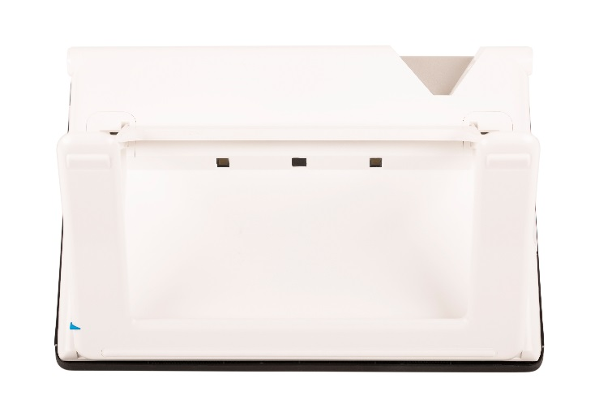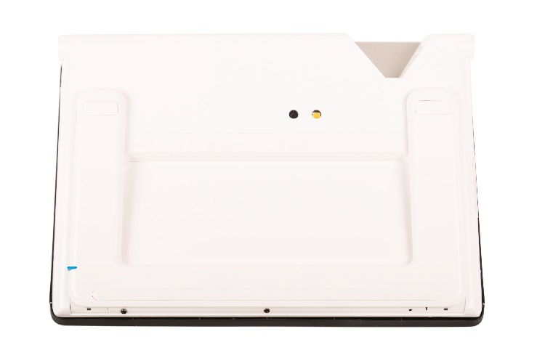

2.5. Buttons and Connections
The Compact 10 HD has the following buttons and connections at the left side of the product:
On / Off button
A short press of the orange On / Off button will place the Compact 10 HD into sleep mode or resume the unit. A 6 second press of this button switches the unit off or back on again.

Audio jack
Use the audio jack to connect a headset to the Compact 10 HD.

USB-C connector
Use the USB-C connector to charge the Compact 10 HD. The supplied USB cable connects to this USB port and power supply. Use only the power supply that comes with the Compact 10 HD to power and charge the unit.

3. Cameras
The Compact 10 HD is equipped with three cameras, each serving a specific task or situation. All cameras can be used in Easy mode and Advanced mode. If the image on screen looks out of focus, tap the screen to re-focus the camera and get a sharp image.

3.1. Magnifier camera
The Magnifier camera is used when the Compact 10 HD is in the open position with the stand unfolded. The Magnifier camera is used for reading on a desk or table. The Compact 10 HD is placed on top of the reading material.

3.2. Full Page camera
The Full Page camera is used when the swing-out camera arm is opened. The Full Page camera can be used to view photos and objects more comfortably, or to write your signature, without being restricted in your movements.

Focus lock
The auto focus can be locked for writing or viewing objects at a fixed distance. Use the pen icon at the top right corner of the screen to lock or unlock the focus.
If you own a Compact 10 HD Speech, the full page camera is also used to scan and read full-page documents. Place the document you want to read below the camera, aligning the bottom left corner of the document with the blue line at the right foot of the Compact 10 HD Speech.

3.3. Overview camera
The Overview camera is used when you power on the Compact 10 HD while the Compact 10 HD stand is closed. To switch from Magnifier camera to Overview camera, close the stand and press the On / Off button. The overview camera is optimized to look at objects at a short distance, such as time tables.

4. Using the Compact 10 HD Speech’s Text-to-Speech & OCR
If you own a Compact 10 HD Speech, you can take a Text-to-Speech snapshot. The Compact 10 HD Speech will extract the text from the image and will read the text aloud.

Activating the speech
To take a Text-to-Speech snapshot and activate the Speech:
- Position the text or part of the text in the camera view and press the Text-to-Speech snapshot button. When taking a Text-to-Speech snapshot of a full page, use the full-page camera and make sure you align the bottom left corner of the document with the blue indicator at the right side of the stand of the Compact 10 HD Speech. For an optimal result, make sure there is enough light in the environment, prevent shadows and limit the text to only the part of the document you would like to read. If the font you are scanning gets too small, the recognition will lose accuracy and might fail.
- A progress bar will be shown. The Compact 10 HD Speech will start reading after the recognition process has been finished.
- Use the Play/Pause button to start or stop reading.
- Tap and hold (long press) on the text to start reading at the word or section you point at.
- Press the “Mode” button to view the captured text in your selected viewing mode and cycle through the selected high contrast colors of this viewing mode. Please refer to chapter 5.2,
View and chapter 5.2 Color for more information.
- If no text is found, a “No text found” message will be shown.

Adjusting the volume and reading speed
To adjust the volume or reading speed, activate the button bar with a single tap. Tap the Audio button to display the “Volume” and “Speed” sliders. The “Volume” and “Speed” sliders are only present in the snapshot view.

Adjusting language and voice
To adjust the language or voice in Easy Mode, press and hold the Audio button to go to the Voice menu. To adjust the language or voice in Advanced Mode, press the “Menu” button and then press the “Voice” menu. Please refer to Chapter 5.2, Voice for more information on how to navigate the “Voice” menu.

Table Mode
The regular reading mode reads columns, ideal for newspapers and magazines. But, you might occasionally want to read a menu, receipt, table or other text that has a table-like layout.
By pressing and holding the Text-to-Speech Snapshot button, the Compact 10 HD Speech will take a snapshot and read all captured text per line from left to right first, and then move on to the next line.
When you exit the Text-to-Speech snapshot and take another snapshot, you will automatically switch back to the regular reading mode.

5. Easy and Advanced mode
To switch between Easy and Advanced mode, press and hold the Mode button and tap Easy or Advanced.

In Easy mode, you have access to the main features:
- Adjusting the magnification
- Selecting a viewing mode
- Taking a snapshot of an image (Compact 10 HD only)
- Taking a snapshot and use Text-to-Speech (Compact 10 HD Speech only)
- Switching between the Magnifier and Overview camera

In Advanced mode, you have the same functions as in Easy mode, plus some additional features:
- Time and date
- Access to the menu with the options to:
  - Save and open snapshots
  - Changing the language and reading voice
  - Changing color modes
  - Enabling the Reading Line
  - Bluetooth audio and Miracast
  - Other advanced settings
  - Taking a snapshot of an image (Compact 10 HD Speech only)
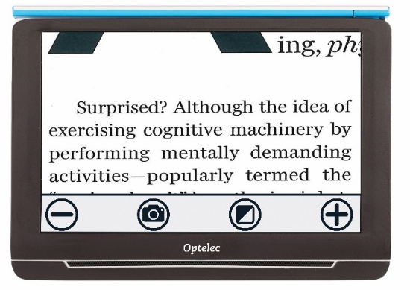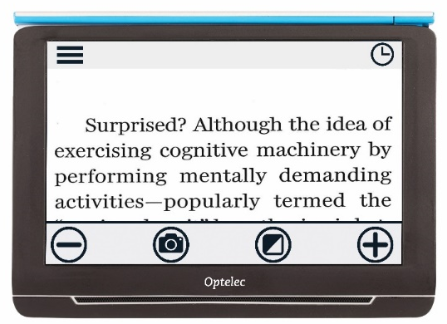
Compact 10 HD Easy Mode Compact 10 HD Advanced Mode

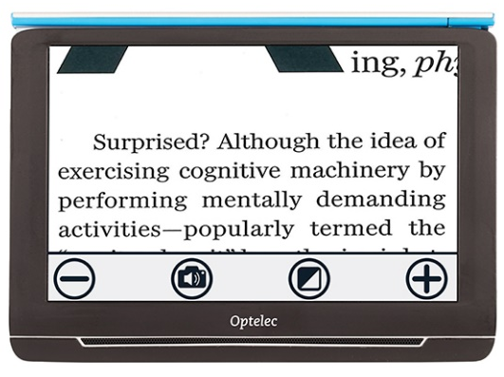 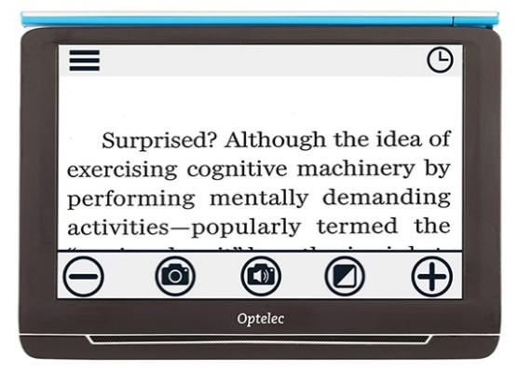
Compact 10 HD Speech Easy Mode Compact 10 HD Speech Advanced Mode

5.1 Features in Easy mode

Adjusting the magnification
To change the magnification, simply tap the screen. The button bar will be shown at the bottom of the screen or at the right side of the screen, depending on the chosen button bar position. The button bar position can be selected in the menu. See chapter 7 for more information on how to change the button bar position. In the button bar tap the + button to increase or the – button to decrease the magnification. Alternatively, use the pinch-to-zoom gesture to change the magnification. Tap the screen to hide the button bar. The button bar will automatically hide when the screen is not touched for 10 seconds.

Selecting a viewing mode
Tapping the Mode button in the middle of the button bar allows you to select one of the following viewing modes:
- Photo mode: Viewing full color texts and photos
- Negative mode: Reading in high contrast, white on black
- Positive mode: Reading in high contrast, black on white
- High contrast color combination 1
- High contrast color combination 2

Taking a snapshot of an image (Compact 10 HD only)
If you own a Compact 10 HD, press the snapshot button to take a snapshot. You can adjust the magnification and viewing mode of the snapshot. Press the X in the top right corner to close the snapshot and return to live video mode.

Taking a snapshot and use Text-to-Speech (Compact 10 HD Speech only)
If you own a Compact 10 HD Speech, press the Text-to-Speech snapshot button to take a snapshot and have it read aloud. Use the Play/Pause button to start or stop reading. You can adjust the magnification and viewing mode, adjust the volume and reading speed and change the voice within the Text-to-Speech snapshot. Press the X in the top right corner to close the Text-to-Speech snapshot and return to live video mode.

Please refer to Chapter 4 for more information on how to use Text-to-Speech.

5.2. Features in Advanced mode

Time and date
To open the clock, tap the screen and tap on the “Clock” icon at the top right corner of the screen.
Use the “Back bar” with the arrow to exit the time and date screen.
To set the time and date, tap the time or date. To change a value, tap on the field you would like to change and tap on the up or down symbol to change the value. Tap on the “Back bar” to exit the set time and date screen.

Taking a snapshot of an image (Compact 10 HD Speech)
If you own a Compact 10 HD Speech and just want to take a snapshot of an image without using Text-to-Speech, press the snapshot button. You can adjust the magnification and viewing mode of the snapshot. Press the X in the top right corner to close the snapshot and return to live video mode.

Menu
Opening and closing the menu

To open the menu, tap on the screen and tap on the “Menu” icon at the left side of the screen. This will open the main menu. To close the menu, tap on the “Back bar”.
Line On/Off

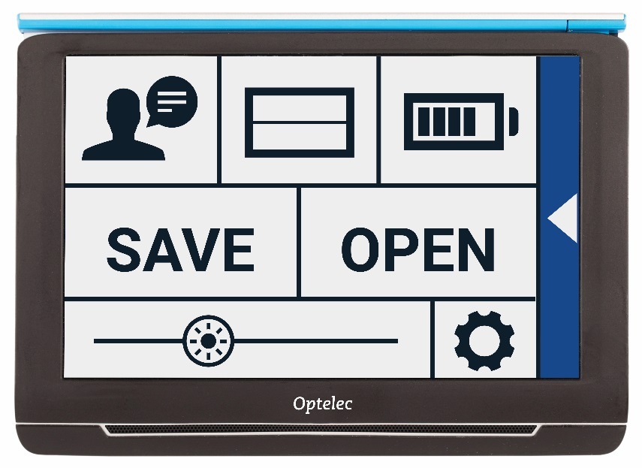
Open
Save
Brightness
Slider
Settings
Voice
Battery
Status
The exact items in the menu will vary, depending on if you own a the Compact 10 HD or 10 HD Speech. To activate a button, tap the button once. Activating a button will open a new menu screen or list. To go back to the main menu, tap on the “Back bar”. To adjust the slider, tap and hold the slider button while moving it to the right or left.

The main menu contains the following options:
- Voice (Compact 10 HD Speech only)
- Line On/Off
- Battery status
- Save
- Open
- Brightness slider
- Settings

Voice (Compact 10 HD Speech only)
To select a voice, language and menu language, or to add or remove a voice or language, open the menu and tap the “Voice” button.

Selecting a voice, language and menu language
This menu item lets you select your reading voice and language. To select another reading voice, tap the voice icon in the top left corner of the main menu to open the list with preselected voices. Each voice represents a language. Tap on a voice to select the voice. If adjusting the reading voice results in a change of language, the menus will automatically change to that language.

Adding or removing a voice or language
To add or remove a voice or language, tap the voice icon in the top left corner of the main menu. In the list with preselected voices, tap on the “Add/Remove” button. To add or remove a reading voice, select the language from the list by tapping on the language. This will display a list with available voices for the selected language. To enable a reading voice, select it from the list by tapping on it. A checkmark in front of the voice name will indicate if it is enabled. When the voice is enabled, it will be available under the “Voice” button in the main menu. By deselecting a voice, the voice will be removed from the available reading voices. The languages of which a reading voice is selected, will appear at the top of the list with languages, and are marked with a checkmark.

Adjusting language and voice in Easy Mode
In Easy mode, you cannot access the Menu. To adjust the language or voice in Easy Mode, press and hold the “Audio” button to go directly to the Voice menu and follow the steps described above.

Line On/Off
The Compact 10 HD can display a reading line to help you position the Compact 10 HD straight on the document. To enable the reading line, tap the “Line” button. Tap this button again to hide the reading line.

Battery status
The battery status is shown in the top right corner of the screen. If you tap the battery icon, a new screen will be opened showing a magnified battery icon and battery status, the “About” button and the “Back arrow” to return to the main menu. The lightning symbol indicates that the battery is charging.

About
Tap on the “About” button in the battery screen to see the application version.

Save
This option is only available in Advanced mode.
To save a snapshot, open the menu and tap the “Save” button.
- Make a snapshot using the snapshot button
- Open the menu
- Press the save button to save the snapshot
If there is no snapshot to save, the “Save“ button will be hidden.

Open
To open a snapshot, open the menu and tap on the “Open” button. A list of thumbnails of the saved snapshots will be shown, showing the most recently saved snapshot first. If there are more snapshots than fit on the screen, swipe up and down to scroll through the list. Tap on the snapshot thumbnail to open it.

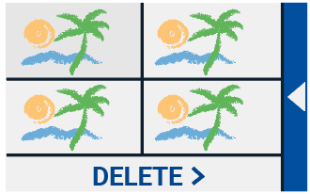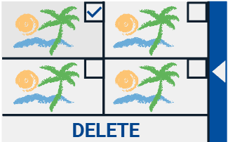
Open to view saved snapshots Delete snapshots

Delete
To delete a snapshot, open the menu and tap on the “Open” button. In the open screen, tap on the “Delete” button. A list of thumbnails of the saved snapshots will be shown, showing the most recently saved snapshot first. Each snapshot has a checkbox at the top right corner. To select a snapshot, tap the checkbox. Tap the “Delete” button to delete the selected snapshots. To delete all snapshots, tap the “Delete” button without selecting a snapshot. You will be prompted to confirm to delete all snapshots. To delete all snapshots, select “Yes”. To cancel deleting all snapshots, select “No”. Both choices will return you to the list of snapshots. Tap the “Back bar” to return to the “Open” screen. Tap the “Back bar” again to return to the main menu.

Adjusting the brightness
Use the slider with the sun icon to increase or decrease the brightness of the screen.

Settings
Tap on the “Settings” button to enter the Settings menu. The “Settings” button is the button with the gear icon at the bottom right. The Settings menu contains the following buttons:
- Color
- View (Compact 10 HD Speech only)
- Miracast
- Bluetooth (Compact 10 HD Speech only)
- Line
- Buttons
- Theme
- Columns (Compact 10 HD Speech only)
- Lights
- Sound
- Standby
- Language (Compact 10 HD only)
- Restore

Color
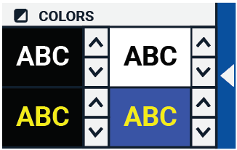
In the settings menu, tap the “Color” button to select the preferred high contrast colors. The Compact 10 HD supports four high contrast modes. For each of these four modes, the foreground and background colors can be selected. Three of the high contrast modes can be disabled. The first high contrast mode on the top left is required.

To change the foreground and background colors, tap the up or down arrow next to the mode you want to change. You will cycle through each of the available modes and can stop on the one you prefer. Select the “X” symbol to disable a high contrast mode. Tap on the “Back bar” to return to the settings menu.

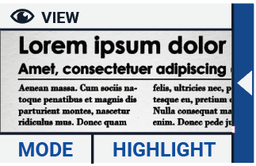
View (Compact 10 HD Speech only)
In the settings menu, tap the “View” button to configure how you want to display captured text when using Text-to-Speech.
To configure how all captured text is shown, press the Mode button to cycle through the different viewing modes: Original, Line and Column.
To configure how the word that is read aloud is shown, press the Highlight button to cycle through the different highlight modes: Rectangle and Underline.
When using Text-to-Speech, tap the Mode button in the button bar to view captured text in the viewing mode you just selected and cycle through your configured high contrast colors.

Miracast: connecting wirelessly to a monitor or TV
Miracast is a standard for a wireless connection to a monitor. It can be described as HDMI over
Wi-Fi", replacing the cable from the Compact 10 HD to the monitor or TV. To be able to use the Miracast function of the Compact 10 HD, your monitor or TV needs to support Miracast. Please refer to your monitor or TV manual and documentation to verify if your device supports the Miracast feature.

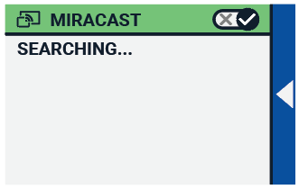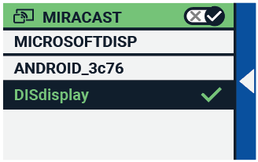

To connect your the Compact 10 HD to a monitor or TV via Miracast, tap the “”Miracast””button and Switch Miracast on. A list with available devices will be displayed. Click on a device to connect. It could take up to a minute to establish the connection. Tap on the device again to disconnect. When a Miracast connection is established, both the audio and video will be streamed to the TV or monitor. To guarantee a good connection, the Compact 10 HD needs to be within one meter or three feet of the monitor or TV. Depending on the connection, a short delay of the video and / or audio could be noticed.

Bluetooth (Compact 10 HD Speech only)
To connect a Bluetooth speaker or headphone, tap the “Bluetooth” button and switch Bluetooth on.

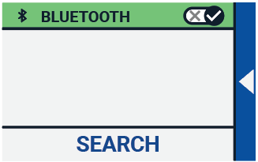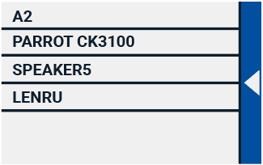

A list with paired devices is being displayed.

If no speaker or headphone is being paired, tap the “Search“ button to search for available devices. Before starting the Bluetooth search, make sure the speaker or headphone is switched on and is set to discoverable. Please refer to the speaker’s or headphone’s manual on how to switch the device to Bluetooth discoverable mode. To pair the speaker or headphone, tap on the device name and if needed enter the pin code. Refer to the speaker’s or headphone’s manual for the pin code of the device.
When the device is paired, to connect the speaker or headphone, tap the device. You will be asked to connect or forget the device. Tap the “Connect” button to make the connection.

To indicate that a device is connected, the connected device will have a checkmark and will be displayed in blue.
To unpair / forget a device, tap the “Forget” button. The device will be removed from the list with paired devices.

Note: Only Bluetooth version 4.0 or higher headsets and speakers are supported.

Line
This menu item enables you to change the reading line position to one of its six positions; horizontal top, horizontal center, horizontal bottom, vertical left, vertical center, vertical right. By default, the reading line is horizontally set to the center of the screen.

Buttons
This menu item enables you to change the button bar position to one of two positions: bottom or side. Depending on your preference, you could change the position of the button bar to the bottom or side of the screen. The default setting is “Bottom”.

Theme
This menu item enables you to select a light or dark theme for the buttons and menus.

Columns (Compact 10 HD Speech only)
This menu item allows you to choose if you want the Compact 10 HD Speech to only read full columns, or incomplete columns as well. By default, Read full columns only is selected. Please note that if you select to read incomplete columns, not all characters and words are fully captured, which may result in incoherent text.

Lights
This menu item allows you to enable or disable the lights in Magnifier mode and in Overview mode. The Magnifier lights are located to the left and right of the magnifier camera. By default, the reading lights are enabled for an optimal image quality.
The Overview light is located next to the overview camera. By default, the overview light is disabled.

Sound
This menu item allows you to change the volume, mute the audio feedback and enable or disable the vibration feedback. By default, sound is enabled and vibration is disabled.

Standby
The standby time sets the time after which the Compact 10 HD goes into standby mode to conserve power. Pressing any button will take the unit out of standby mode. By default, the standby time is set to 5 minutes after no button is pressed or no movement of the Compact 10 HD is detected.

Language (Compact 10 HD only)
This menu item allows you to choose the language of the Compact 10 HD. Tap to select your preferred menu language.

Restore
Tap this menu item if you wish to restore the default settings. You will be prompted if you are sure to restore the defaults. To restore the defaults select “Yes”. To cancel restoring the defaults, select “No”.

6. Transferring documents to PC
To transfer snapshots and documents to a PC, you need a Windows 10 PC and the included USB cable and follow the steps below:

- Switch on the Compact 10 HD and your PC;
- Connect the Compact 10 HD to your Windows 10 PC using the included USB cable. The Compact 10 HD will briefly show the “Connected to PC” icon;
- If you connect the Compact 10 HD for the first time, please wait until Windows has finished setting up the device;
- Depending on your Windows settings, Windows Explorer will open the “CP10” device and show the “Internal Shared Storage”;
- If Windows 10 does not automatically show the Compact 10 HD device, open the Windows Explorer and select the CP10 device;
- Click on the “Internal Shared Storage” and click on the folder “DCIM”;
- The “DCIM” folder contains folders named with the time and date of the taken pictures. Each folder contains the taken picture and if you own a Compact 10 HD Speech, a .txt document with the text found in the picture. In addition, the folder contains 2 system files, a JSON and Processed Picture file.
- Use copy and paste to copy the files to your PC.

Appendix A: Technical information
Magnification Magnifier 2.2 – 22 times
Magnification Overview Approximately 1.8 – 22 times
Magnification Full Page 0.4 – 13 times
Viewing modes Full color photo mode
High contrast, white on black
High contrast, black on white
High contrast color combination 1
High contrast color combination 2
Focus Auto-focus
Screen 10” TFT
Screen resolution 1280 x 800
Dimensions 261 x 189 x 36 mm / 10.28 x 7.44 x 1.42 in
Weight 915 grams / 2.02 lb
Battery Approximately 3.5 hours continuous use
Approximately 4 hours charging time
Li-ion battery Rechargeable, 3.7V, 7600mAh, 28.12Wh
Power supply type (Medical) Adapter Technology Co., LTD. ATM012T-W052VU
Power supply type (Consumer) Shenzhen Fujia Appliance Co., LTD. FJ-SW1260502500UN
Input power rating – Adaptor 100-240V, 50-60Hz, 0.4A
Output power rating – Unit DC5V-2.5A

Appendix B: Safety and Regulatory Notices
Optelec is the manufacturer of the Compact 10 HD and Compact 10 HD Speech.
Please read the instructions carefully before setting up your Compact 10 HD. Keep this user manual for future reference.

Intended Use:
The Compact 10 HD is designed in such a way that it can be used in a hospital environment for general purposes such as reviewing medical records. The Compact 10 HD can not be used for surgical procedures in combination with life supporting systems.

Warning: Critical diagnostic decisions should not be based on images displayed by this device.

- Do not expose the Compact 10 HD to excessive heat or direct sunlight to avoid the risk of fire.
- Do not remove any parts of the Compact 10 HD. Contact an Optelec authorized service organization in your area.
- To avoid risk of electrical damage, keep your Compact 10 HD away from fluids and chemicals.
- Handle the Compact 10 HD with care. Rough handling will damage the internal components.
- Do not use the Compact 10 HD near inadequately shielded medical devices.
- Do not try to open the battery compartment or try to remove the battery.
- Do not touch or look into the LED lights.
- Be careful that your fingers and clothing do not get stuck in moving parts (swing-out arm, stand).
- Contact your dealer to service this equipment if necessary. Do not disassemble your unit as it will void the warranty.
- Always unplug and switch off the unit before cleaning. Use a dry soft cloth to clean the exterior. Do not use cleaning agents or abrasive materials as they will damage your unit.

Use of the Compact 10 HD other than described in this manual will exclude it from warranty conditions.

Any Changes or modifications not expressly approved by the party responsible for compliance could void the user's authority to operate the equipment.

Note: This equipment has been tested and found to comply with the limits for a Class B digital device, pursuant to part 15 of the FCC Rules. These limits are designed to provide reasonable protection against harmful interference in a residential installation. This equipment generates uses and can radiate radio frequency energy and, if not installed and used in accordance with the instructions, may cause harmful interference to radio communications. However, there is no guarantee that interference will not occur in a particular installation. If this equipment does cause harmful interference to radio or television reception, which can be determined by turning the equipment off and on, the user is encouraged to try to correct the interference by one or more of the following measures:
- Reorient or relocate the receiving antenna.
- Increase the separation between the equipment and receiver.
- Connect the equipment into an outlet on a circuit different from that to which the receiver is connected.
- Consult the dealer or an experienced radio/TV technician for help.

FCC RF Radiation Exposure and SAR Statements
The Compact 10 HD and Compact 10 HD Speech have been tested for body-worn Specific Absorption Rate (SAR) compliance. The radio module has been evaluated under FCC Bulletin OET 65C (01-01) and found to be compliant to the requirements as set forth in CFR 47 Sections, 2.1093, and 15.247 (b) (4) addressing RF Exposure from radio frequency devices. This model meets the applicable government requirements for exposure to radio frequency waves. The highest SAR level measured for this device was 0.15 W/kg.

Frequency Range: Wifi: 2412~2472MHz
BT: 2402~2480MHz
Max. Transmit Power: Wifi: 18.0 dBm
BT: 5.0 dBm

Operating conditions
Temperature +10°C to 35°C / 50°F to 95°F
Humidity < 70%, no condensation
Altitudes up to 3000 m (9842 feet)
Pressure 700 – 1060 hPa

Storage & transportation conditions
Temperature +10°C to 40°C / 50°F to 104°F
Humidity < 95%, no condensation
Altitudes up to 12192 m (40000 feet)
Pressure 186 – 1060 hPa

Contacting Product Support
If you have questions about operating, installing or configuring your Compact 10 HD, please contact your Optelec distributor or the Optelec office nearest to you. See the last pages of this manual for a complete list of Optelec addresses.
Warranty Conditions
Optelec warrants the Compact 10 HD, effective from the date of delivery, to be free of any defects in material and workmanship.
The warranty is not transferable and does not apply to groups or multi-users. The Compact 10 HD was designed for the individual purchaser to be used at home, school and work. Optelec reserves the right to repair or replace any purchased Compact 10 HD with a similar or improved product.
In no event shall Optelec or its suppliers be held liable for any indirect or consequential damages. The original user’s remedies are limited to replacement of Compact 10 HD modules. This warranty is valid only when serviced in the country of original purchase, and with intact seals. For additional warranty claims or service during or after warranty period, please contact your Optelec distributor.

Optelec is not responsible for any uses of this device other than those described in this manual.
Accessory: Power (Medical)
Power supply type: Adapter Technology Co., LTD. ATM012T-W052VU
Input power rating – Adaptor: 100-240V, 50-60Hz, 0.32-0.19A
Output power rating – Unit : DC5.1V-2.4A

Accessory: Power (Consumer)
Power supply type: Shenzhen Fujia Appliance Co., LTD. FJ-SW1260502500UN
Input power rating – Adaptor: 100-240V, 50-60Hz, 0.4A
Output power rating – Unit : DC5V-2.5A

Guideline:
- Input rating for Compact 10 HD: 5Vdc. 3A
- Protection against electric shock: Class I
- Protection against harmful ingress of water or particulate matter: IPX0
- The Compact 10 HD is intended to be routinely cleaned and disinfected by the user with a soft cloth after use.
Markings Explanation (on label):

Do not throw this electronic device into the trash when discarding. To minimize pollution and ensure utmost protection of the global environment, please recycle.
This side up.
Fragile.
Keep dry.

.
WEEE Notice
The directive on Waste Electrical and Electronic Equipment (WEEE), which entered into force as European law on February 13, 2003, resulted in a major change in the treatment of electrical equipment at end-of-life.

The purpose of this Directive is, as a first priority, the prevention of WEEE, and in addition, to promote the reuse, recycling and other forms of recovery of such wastes so as to reduce disposal.
The WEEE logo (shown at the left) on the product or its box indicates that this product must not be disposed of or dumped with your other household waste. You are liable to dispose of all your electronic or electrical waste equipment by relocating over to the specified collection point for recycling of such hazardous waste. Isolated collection and proper recovery of your electronic and electrical waste equipment at the time of disposal will help conserve natural resources. Moreover, proper recycling of the electronic and electrical waste equipment will ensure the safety of human health and the environment. For more information about electronic and electrical waste equipment disposal, recovery, and collection points, please contact your local city centre, household waste disposal service, shop from where you purchased the equipment, or manufacturer of the equipment.

WARNING: The use of accessories and cables other than those specified and sold by the manufacturer of the Compact 10 HD, as replacement parts for components, may result in increased emissions or decreased functioning of the Compact 10 HD.

Declaration of Conformity
We declare under our sole responsibility that this product, to which this declaration relates, is in conformity with the council EMC directive 2014/30/EU and the RED directive 2014/53/EU.

RoHS Compliance
This product is in compliance with Directive 2011/65/EU of the European Parliament and of
the Council of 3 January 2013, on the restriction of the use of certain hazardous substances in
electrical and electronic equipment (RoHS-II) and its amendments.

This device bears the CE and FCC approval mark.

This device complies with part 15 of the FCC rules.
Operation is subject to the following two conditions:
(1) This device may not cause harmful interference, and
(2) This device must accept any interference received, including interference that may cause undesired operation.

Caution for battery pack
CAUTION
BATTERY NEEDS TO BE REPLACED BY CERTIFIED SERVICE PERSONNEL.
RISK OF EXPLOSION IF BATTERY IS REPLACED BY AN INCORRECT TYPE.
DISPOSE OF USED BATTERIES ACCORDING TO THE REGULATIONS.

