Emporia Comfort (HM86)
Please retain these instructions for future reference. These instructions are also available in other formats.
Your mobile phone at a glance 4
Symbols on the screen 9
Symbols on the external display 10
1. GETTING STARTED 11
SIM card sizes: Standard, Micro and Nano explained 11
Inserting a SIM card 12
Inserting and charging the battery 13
Turning on the phone 14
Saving energy 14
2. USING THE PHONE 15
Using the menu 15
Dual-function keys 15
3. CALLS 16
Incoming call 16
Ending a call 16
Dialling a number 16
Redialling 16
Hands-free mode 16
4. SMS MESSAGES 17
Menu items: 17
Writing a message 17
Writing using predictive text 17
Writing without predictive text 17
Input method 18
Sending a message 18
Receiving a message 18
5. CAMERA AND PHOTO ALBUM 19
Taking a photo 19
Photo album 19
6. TOOLS 20
Menu items: 20
6.1 Alarm clock 20
6.2 Bluetooth 20
7. CONTACTS 21
Menu items: 21
Saving contacts (name and number) 21
Searching for contacts: 21
Speed dial keys 21
8. SETTINGS 22
8.1 Silent/Sleep mode 22
8.2 Sounds and alerts 22
8.3 Handset volume 22
8.4 Handsfree Volume 22
8.5 Display and Light 23
8.6 Time & Date 23
8.7 Language 23
8.8 Text Size 23
8.9 Predictive Text input 23
8.10 Camera settings 23
8.11 Call waiting 23
8.12 Call forward 23
8.13 Auto Pickup 23
8.14 Suppress number 23
8.15 Help texts 23
8.16 Network selection 24
8.17 Voicemail number 24
8.18 Emergency numbers 24
8.19 Emergency button 24
8.20 Security Settings 24
8.21 Phone book settings 24
8.22 Pin code for settings 24
8.23 Master reset 24
9. EMPORIA EMERGENCY CALL FUNCTION 25
Adding/editing emergency numbers 26
Activating the emergency button 26
10. GUARANTEE AND SERVICE 27
Guarantee 27
Scope of delivery 27
Support 28
Technical data 28
Operating frequency 29
Safety information 29
Intended use 30
Disposal 31
Declaration of conformity (DOC) 32
How to contact RNIB 34
RNIB terms and conditions of sale 34

Your mobile phone at a glance
Open view of phone | 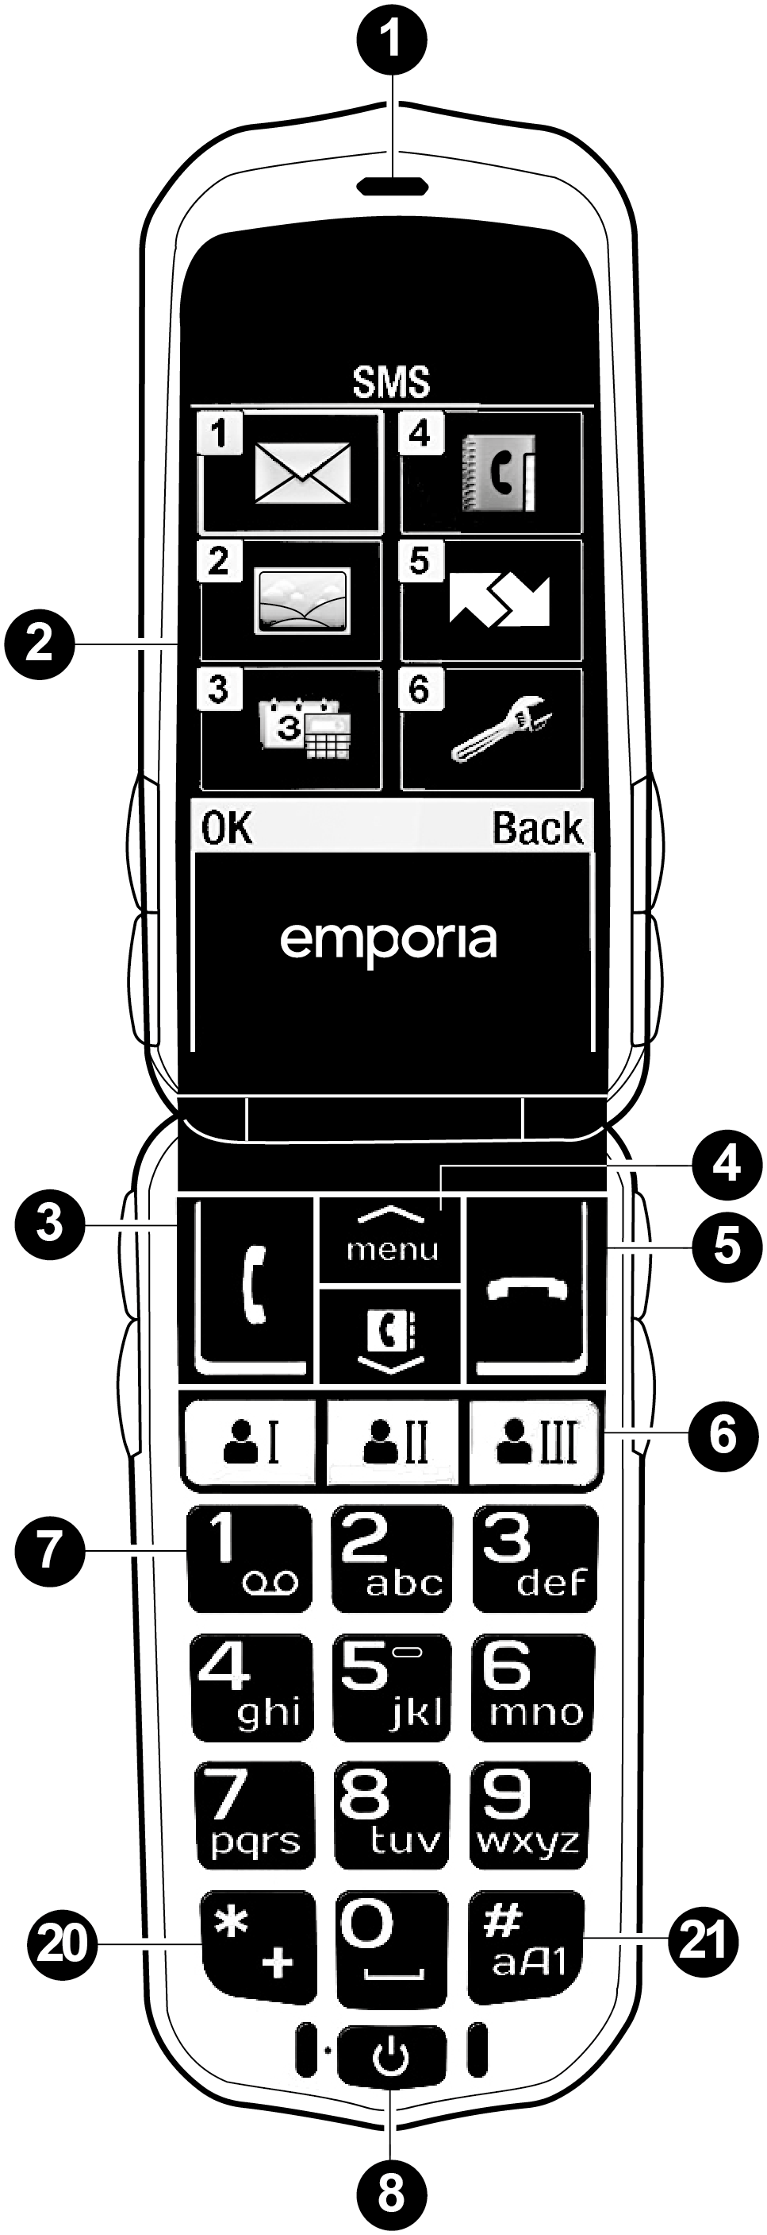
Closed view of phone (front) | 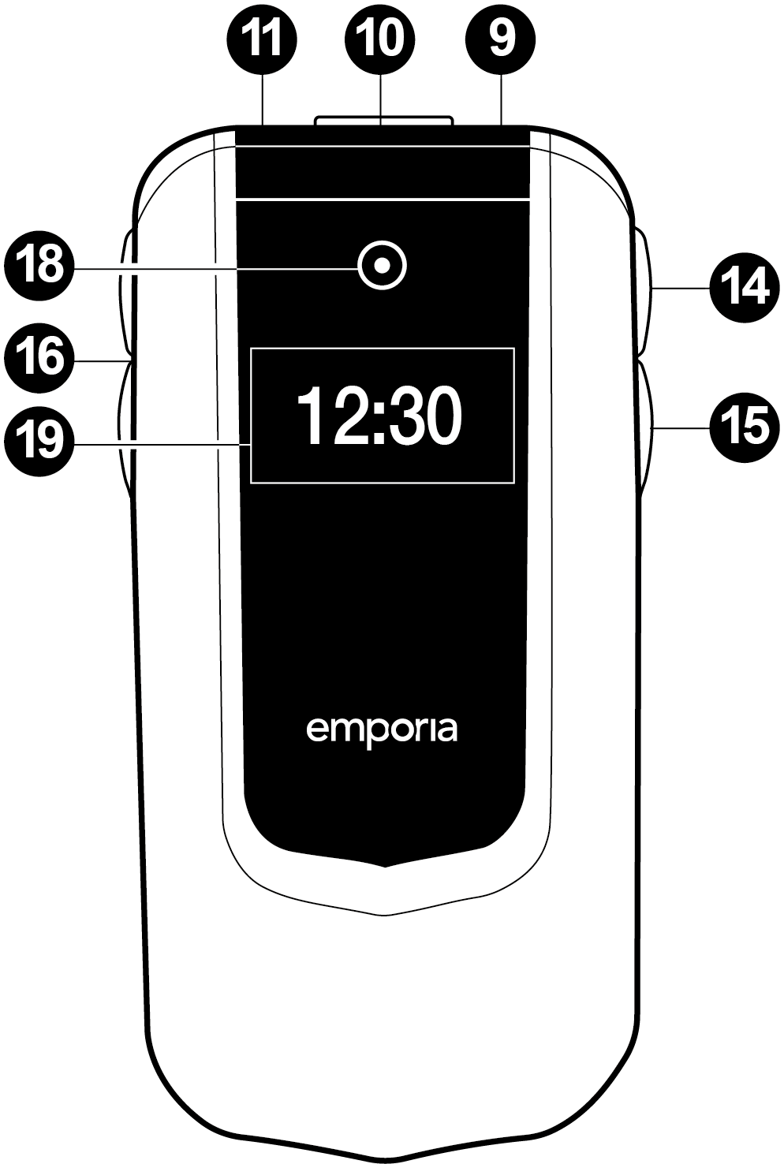
Closed view of phone (rear) | 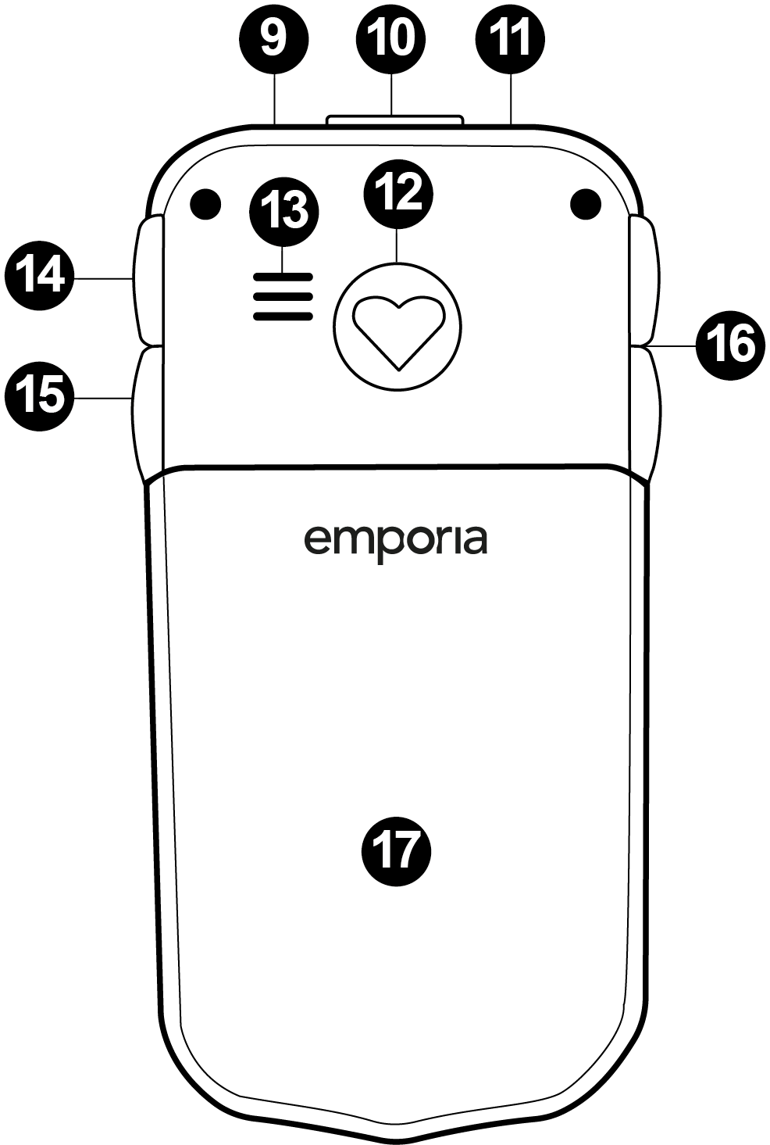

Note: When icons/symbols have been used within the body of the text they have been replaced by wording within square brackets. The following tables show the keys to the diagrams plus the alternative text used for icons/symbols within the body text where applicable:

Diagram Number | Description | Text reference
Open view of phone
1 | Speaker
2 | Display (screen)
3 | 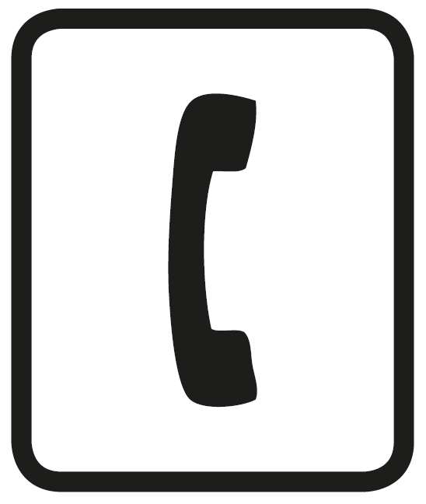 Answer/OK key  - Start 2 Call info | [ok]
4 | menu Arrow keys  - Flick through Contacts and menu  - When the phone is on standby, press menu to call up the menu.  - When the phone is on standby, press to access Contacts. | [menu up]  [menu down]
5 | 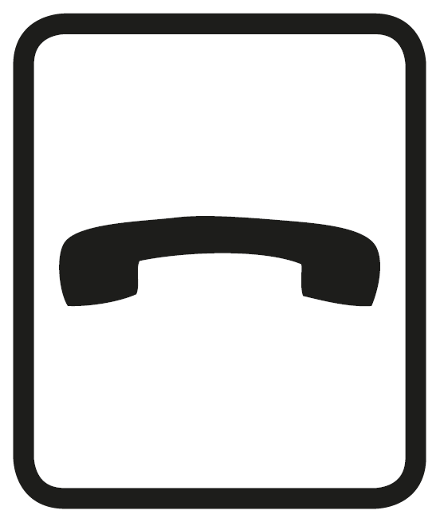 Hang up / Back / Delete key  - When in a call: End  - When in the menu: One step back  - When entering digits or letters: Delete | [back]
6 | Quick dial keys
7 | 1 key (mailbox) | [1]  [0] - [9]
8 | On/Off key | [on/off]
20 | 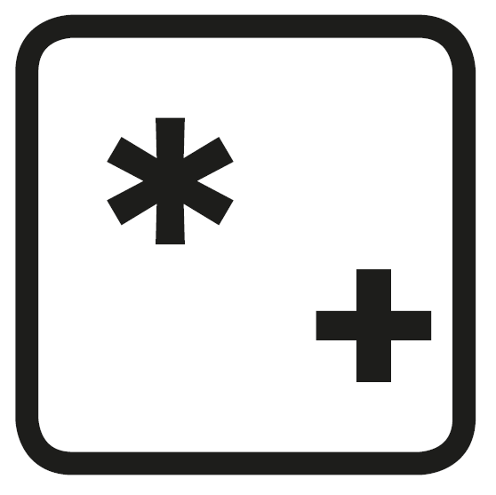 asterisk key | [*]
21 | hash key | [#]
Closed view
9 | Torch
10 | Port for USB charging cable
11 | Headset port
12 | Emergency button
13 | Speaker
14 | Torch button | [torch]
15 | Camera button | [camera]
16 | Handset volume controls  & | [plus]  [minus]
17 | Battery cover
18 | Camera lens
19 | External screen

Symbols on the screen
Symbol | Description | Text reference
 | Network signal strength
 | Roaming (abroad)
 | Battery indicator
 | Missed call
 | Call forwarding
 | New message | [mail]
 | Profile: Silent/Sleep mode
 | Profile: Maximum/Bus mode
 | Profile: Meeting/Theatre mode
 | Alarm clock on
 | Bluetooth activated
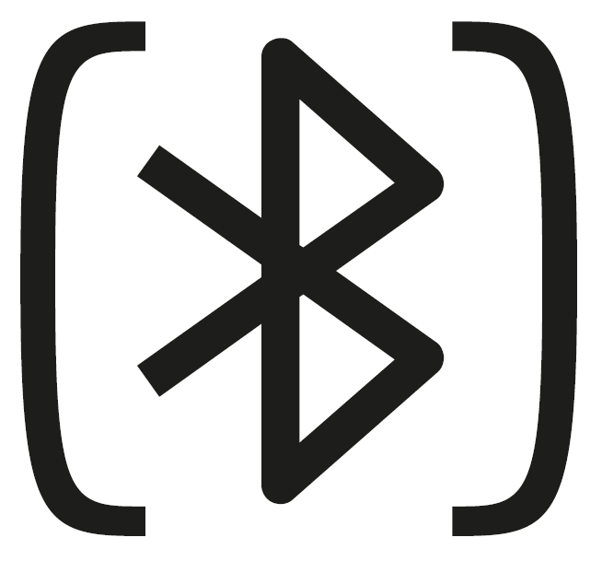 | Bluetooth connected

Symbols on the external display
Symbols are only visible when the phone is closed and disappear when it is opened.

Symbol | Description
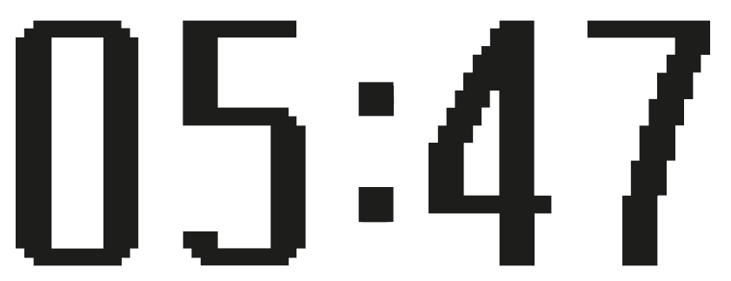 | Time
 | Incoming call
 | Missed call
 | Call forwarding
 | New message
 | Battery low
 | Battery charging
 | Emergency call
 | Alarm clock
 | Sleep

1. GETTING STARTED

SIM card sizes: Standard, Micro and Nano explained
All phones need SIM cards, but they don’t all need SIM cards of the same size. There are three different sizes in use, namely Standard (also known as Mini), Micro and Nano.
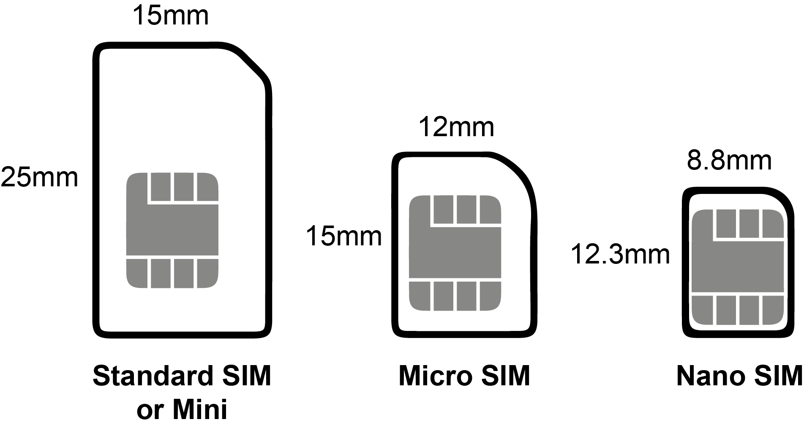

What is a Standard SIM card?
A Standard (or Mini) SIM card is the largest type of SIM card available at 15 x 25mm. You could think of it as a full-size card while the other two are cut down, however, the chip is the same size in all three. This is the important bit that stores your data, so with a Standard SIM card you just have a lot of plastic around it.

What is a Micro SIM card?
A Micro SIM card is one size down from a Standard card. So, it’s a little smaller, at 12 x 15mm. The actual chip is the same size, so it’s just the plastic bit around the chip that’s smaller.

What is a Nano SIM card?
Nano SIM cards are the smallest SIM, at 8.8 x 12.3mm. This has almost no plastic border around the chip.

What can I do if I have the wrong size SIM card?
If you get a new phone that needs a different size SIM card, or you end up with the wrong size for any other reason, your best option is to contact your network and ask them to send a replacement. You’ll usually get three sizes in one, so probably won’t even have to request a specific size.
Alternatively, If your SIM card is too small for your phone, then you could buy an adaptor. These are small pieces of plastic shaped like a Micro or Standard SIM with space for a Micro or Nano SIM inside, so you just stick your SIM card in the adaptor and then put that in your phone.
If your SIM card is too big then you can get SIM card cutting tools which help you cut it down to the right size. However, you risk damaging it by doing this, so we wouldn’t recommend it.

Inserting a SIM card
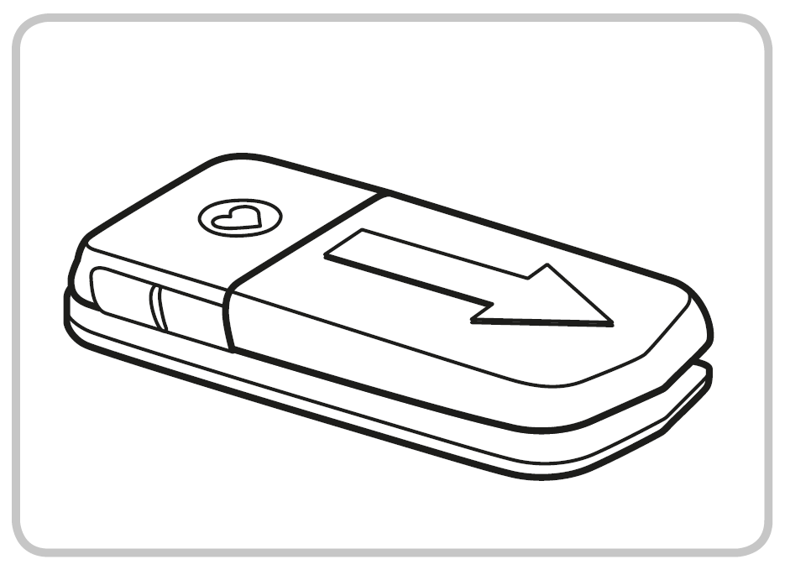
- Remove the battery cover.
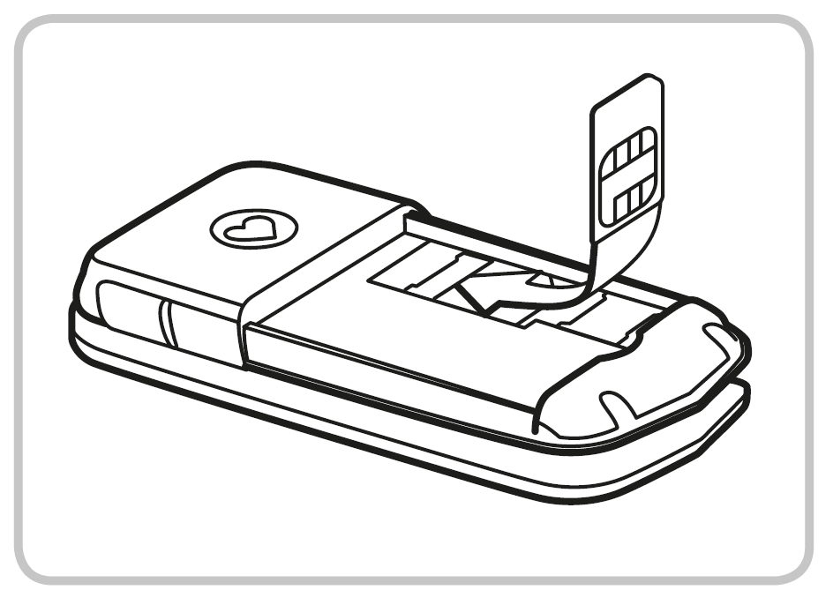
- Slide the SIM card into the SIM card holder with the gold contacts facing down.
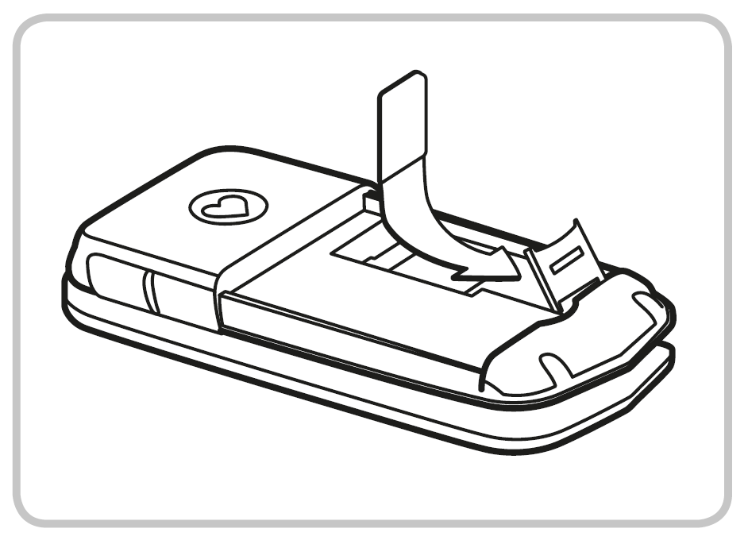
- Slide your data card into the card holder with the gold contacts facing down.

Inserting and charging the battery
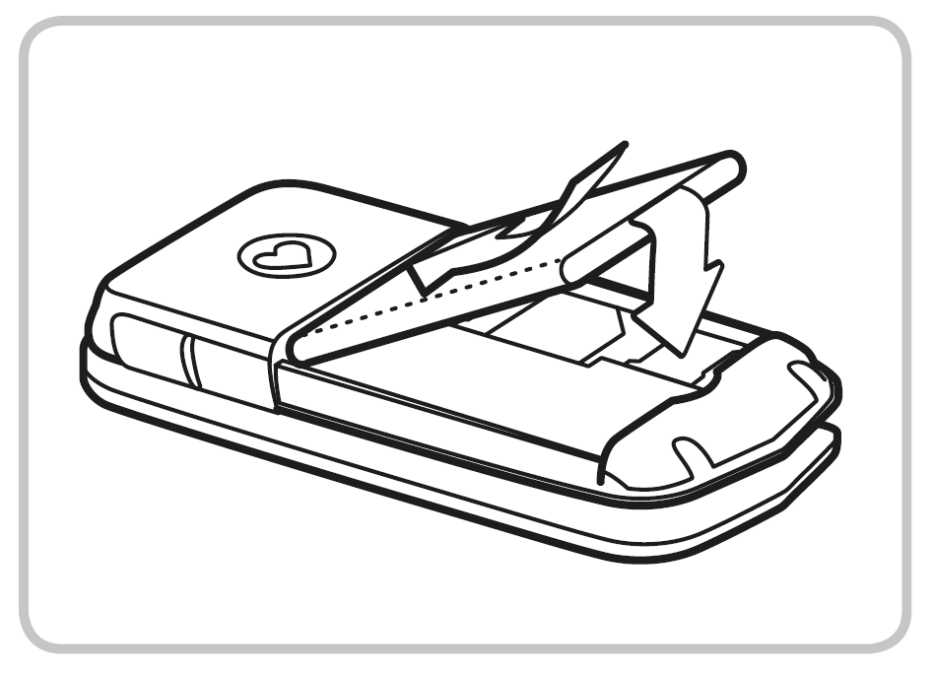
- Insert the battery, making sure that the battery contacts touch the phone's gold contacts.
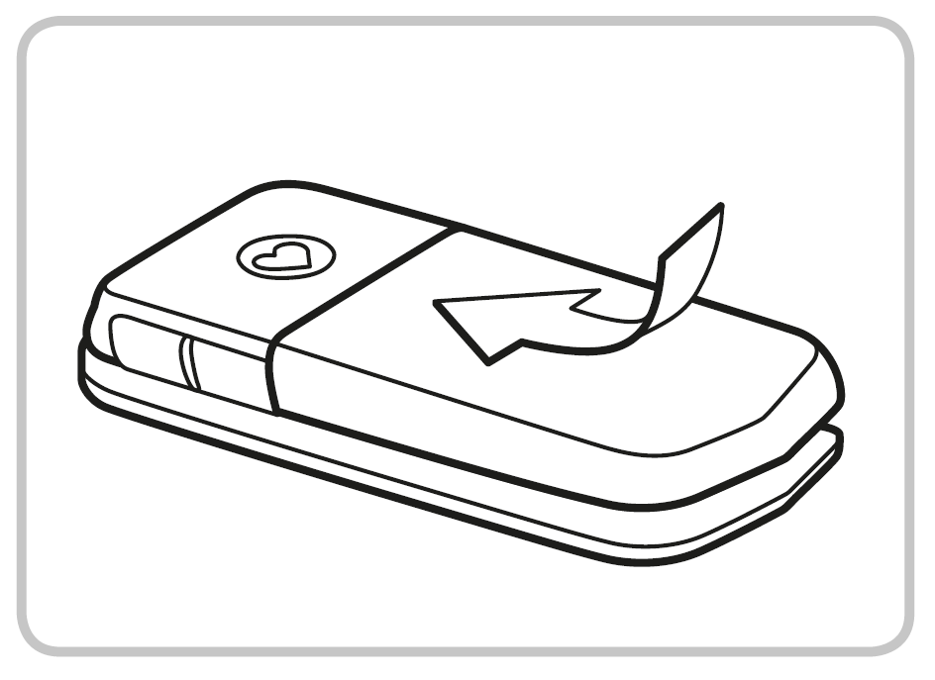
- Slide the battery cover into its position over the battery. You will know it is in the correct position when you hear it click into place.
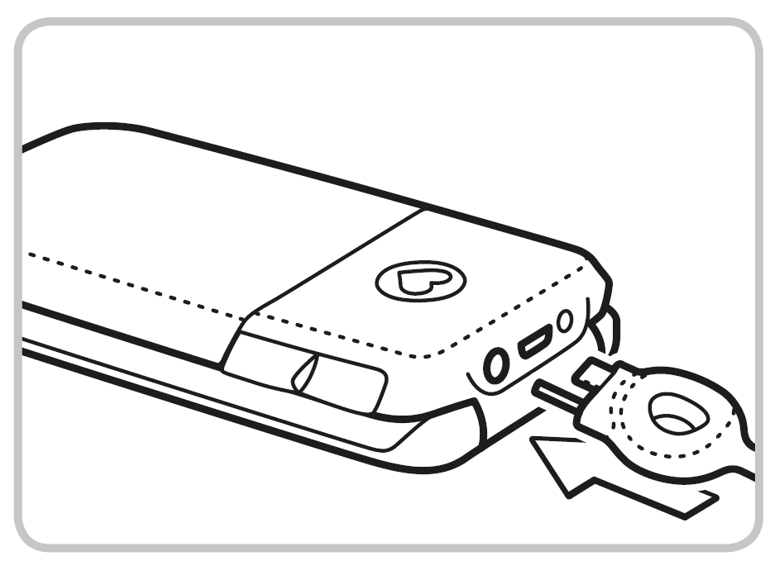
- Plug the charging cable into the USB port on the top of the phone.
Attention: Charge the battery for at least four hours before the first time you use it. Only use batteries and chargers that are permitted for use with this specific model.

Turning on the phone
- Pressing the [on/off] key for at least two seconds switches the phone on.
- To turn the phone off, press the [on/off] key for two seconds again.

Saving energy
If a few seconds pass without the phone receiving any input from you, the screen will go blank to save energy. In the event of an incoming call or you press any key, the screen will automatically light up again.

2. USING THE PHONE
In standby mode the phone is on, but is not running any applications (calls, SMS messages, etc.).

Using the menu
Press [menu up] to open the menu.
- Press [menu up] and/or [menu down] to flick through the menu items.
At the top of the screen, the menu item currently highlighted will be displayed.
- Press [ok] to open a menu item.
- Menu items can be selected directly using the digits assigned to them.
- Options which you can select by pressing [ok] or [back] are displayed at the bottom of the screen.
- To return to standby mode, press [back] several times or close the phone.

Dual-function keys
Some keys have additional functions if they are pressed and held down for a few seconds:
- [1] key: Listen to mailbox
- [*] key: + for country code, e.g. +49 for Germany
- [torch] Torch button: Torch on continuously when the phone is on

3. CALLS

Incoming call
- To answer: Open the phone.
- To reject: Press [back] or close the phone.
- To mute the ringtone temporarily: Press the [minus] button (on the side of the phone).

Ending a call
Press [back] or close the phone.

Dialling a number
Enter the number (incl. area code) you want to dial using the keypad.
- Start the call by pressing [ok].

Redialling
When the phone is on standby, press [ok] to call up your call history.
- Press [menu up] and [menu down] to select a number.
- Start the call by pressing [ok].

Hands-free mode
Press [ok] during a call to open the Options and turn the hands-free function on or off.

4. SMS MESSAGES

Menu items:
Write message, Received, Unsent, Sent, Delete messages, Templates, Blocked numbers for messages, Send contact by SMS, SMS in PhoneBK, Message settings.

Writing a message
[menu up] — Messages — Write message
Enter text using the keypad.

Writing using predictive text
Predictive text has been activated on your phone at the factory.
- Press the number key displaying the letter you require once (e.g. press [4] for i).
- Once you've pressed several keys, words will automatically be suggested.
- One word will be highlighted in white. If this is the word you require, you can insert it simply by pressing [0], which is also used to insert blank spaces.
- If the word you require is not highlighted, you can use the arrow keys, [menu up] and/or [menu down], to move between the suggested words. When the word you require is highlighted, confirm your selection pressing the spacebar key [0].

Writing without predictive text
If you don't want to use predictive text, turn it off by pressing Predictive text input in the Settings menu.
To input text without predictive text, press the respective number key the required number of times for the letter you need. (E.g. 2x [4], 1x [2], 3x [5], 3x [5] and 3x [6] for Hallo)
The symbols available vary according to which language you are using.

Input method
Press [#] to change the input method.
abc — Lower case only
ABC — Upper case only
Abc — Upper and lower case
123 — Digits

Sending a message
Options — Send to — Enter a number or open Contacts by pressing Search.

Receiving a message
Received messages are indicated by an audio signal and the [mail] symbol.
- Press [ok] to open a received message immediately.
- To view your message list, select Messages — Received.

5. CAMERA AND PHOTO ALBUM
Your phone has a camera. You will find photos you have taken in the menu under Photo album.

Taking a photo
In standby mode, enable the camera by pressing [camera].
When the camera is enabled:
- Press [camera] to take a photo.
- Press [menu up] to open Options for the camera.
Available options: Self-timer, Effect, Size, Quality and Night mode.

Photo album
Your photos will be saved in the Photo album menu.
- Press [menu up] and/or [menu down] to flick through the photo album.
- Press [ok] to open Options for the selected picture.
Available options: View, Send, Wallpaper, Contact photo, Rename, Delete, Delete all and Memory.
You can connect your phone to a PC using the USB data cable and transfer your photos.
You can use a data card to increase the storage capacity of your phone. You can purchase these cards from electronics stores.

6. TOOLS

Menu items:
Alarm clock, Birthday reminder, Calendar, Calculator, Camera, Bluetooth.

6.1 Alarm clock
- Setting the time
Enable the alarm clock — Enter the time — Confirm by pressing [ok].
The alarm clock will now go off at the time you have set every day.
- Off: Disable alarm clock
- Switch off the ringing alarm clock by pressing [back].
- Mute the alarm by pressing [ok] or [minus] (it will ring again after five minutes).

6.2 Bluetooth
This function allows you to use Bluetooth-enabled hands-free kits wirelessly.
- Bluetooth on/off
- Connect — Search for new devices
Search for devices you want to connect — Select devices by pressing [ok].
Devices that have been connected before will be recognised and connected automatically.
- Manage devices — Visibility — On
Make your phone visible so that it can connect to a Bluetooth device.

7. CONTACTS

Menu items:
Search name, Add contact, Edit contact, Delete, Send contact by SMS, Copy contact, My number, Speed dial keys, Emergency numbers, Phone book settings and SMS in PhoneBK.

Saving contacts (name and number)
[menu up] — Contacts — Add contact
— Enter name and number
— Contact photo: Select Yes or No
Save each new entry by pressing [ok].
Always save names and numbers with the international dialling code, e.g. save +41 for Switzerland, +43 for Austria and +49 for Germany.

Searching for contacts:
[menu up] — Contacts — Search name
— Press [menu up] and [menu down] to flick through the entries or enter the first few letters of the entry you're looking for using the keypad (and continue flicking with [menu down] if necessary).
— Once you've selected an entry, press [ok] to start a call.

Speed dial keys
You can assign quick dial keys to numbers you call often.
- Saving a quick dial key
— Press one of the quick dial keys
— Enter a name and number or Search for a contact in the phone book.
- Changing or deleting a quick dial key
— Open the menu item Speed dial keys in the Contacts menu.
— Select a quick dial key and change or delete its link to a particular contact.

8. SETTINGS
The settings menu enables you to personalise your phone to suit your requirements. The sub-menus are as listed below.

8.1 Silent/Sleep mode

Visual notifications only (torch LED flashes, notifications on the external display), device vibrates, no ringtone.

8.2 Sounds and alerts
You can personalise the settings for tones, signals and vibration or select a set of predefined settings. Includes Talking Keys (voice announcement).

8.3 Handset volume

8.4 Handsfree Volume

8.5 Display and Light
Adjust the text size, lighting and other features of the display. Display text size can be set at 'small' (17pt) or 'large' (26pt). Please note: these are maximum sizes for each display setting, text size will vary depending on the amount of information being displayed on the screen.
To maximise everything on the display, it is important to choose 'large' in Display set-up when setting up the phone. Please note that menu buttons on the display are 15pt (size cannot be changed).

8.6 Time & Date

8.7 Language

8.8 Text Size

8.9 Predictive Text input

8.10 Camera settings

8.11 Call waiting

8.12 Call forward

8.13 Auto Pickup
Incoming calls are answered immediately when you open the phone. You can change this setting here.

8.14 Suppress number

8.15 Help texts

8.16 Network selection

8.17 Voicemail number
Enter the number for your mailbox.
You will find this number in the documents supplied by your network provider.
Press and hold the [1] key to listen to your messages.

8.18 Emergency numbers

8.19 Emergency button

8.20 Security Settings
- PIN: Request on/off.
- Phone code: on/off, change (factory preset code: 1234)

8.21 Phone book settings

8.22 Pin code for settings

8.23 Master reset
You can restore all the factory settings on your phone (reset code 0000)

9. EMPORIA EMERGENCY CALL FUNCTION
Read the instructions carefully and set the emergency call function according to you needs.
You can save up to five emergency numbers (family members, friends and official institutions).
- In an emergency press and hold the emergency button on the back of the phone. (This works even when the phone is closed.)
- The five preset numbers will be dialled automatically in the order you have saved them in. The phone will go through a list of five numbers a maximum of three times.
- At the same time as each emergency call, a text message (SMS) will be sent to the contact, saying: "You are about to receive an emergency call. An audible warning signal will sound when you answer the call. Please press the 0 key three times to establish the connection."
The contact must press the 0 key three times within 60 seconds, or the call will be disconnected (to prevent your emergency call going through to a contact's mailbox).
- From the moment you make an emergency call, your emporia phone will automatically answer any incoming calls for one hour. To disable this function, press and hold the [back] button for approx. three seconds or turn your device off completely using the [on/off] button and then turn it on again.
- To cancel the emergency call, press and hold [back].
- During the emergency call, a warning tone will sound continuously, to alert anyone nearby and the person being called.
- If you do not have any emergency numbers saved, have no credit on your prepaid phone card or are connected to a foreign network without permission (e.g. roaming is not activated), 112 will be dialled when you press the emergency button.
If you want to add the number of an official institution such as the police or fire brigade as an emergency number, you must check that this is okay with the respective institution beforehand. We do not assume liability for any costs incurred through you calling such an institution by mistake.

Adding/editing emergency numbers
In the Settings menu — Emergency numbers
— Add emergency number
— Select an entry (e.g. EmNo. 1) by pressing [menu up] [menu down]
— Select Ok by pressing [ok]
— Select Private or Help organisation [ok]
— Select a contact

Activating the emergency button
In the Settings menu — Emergency numbers
— Emergency button — On/Off

10. GUARANTEE AND SERVICE
- Manufacturer: emporia telecom GmbH + CoKG, Industriezeile 36, 4020 Linz, Austria
- Importeur: emporia telecom GmbH + CoKG
- Contact: Eveline Pupeter · +43 (0)732 777717 446, www.emporia.eu
- Trade mark: emporia
- Modell: V66 / emporiaCOMFORT

Guarantee
- This guarantee is only valid if the original batteries supplied by emporia have been used.
- Mobile phone: 24 months
- Battery: 6 months

Scope of delivery
- Mobile phone: V66 / emporiaCOMFORT
- Battery: AK-V34; 3.7 V, 1020 mAh, 3.77 Wh
- USB cable
- Charging unit: input: 100-240V AC, 50/60 Hz, 150 mA;
output: DC 5.0 V, 550 mA
- Desktop charger: TL-V66; input: 100-240V AC, 50/60 Hz, 150 mA; output: DC 5.0 V, 550 mA

Support
- Emporia Service Centre
Industriezeile 36, 4020 Linz, Austria.
customercare@emporia.at, www.emporia.eu
Mon.-Thu. 08:30-17:00 · Fri. 08:30-13:00
- Germany: +49 (0) 800 400 4711
- Austria: +43 (0) 732 77 77 17 446
- Switzerland: +41 (0) 8484 50004

Technical data
- Dual-band GSM 900/1800 MHz
- Bluetooth
- Dimensions: 104 x 53 x 18,4 mm
- Weight: 84 g
- Battery: Li-ion 3.7 V/1020 mAh (replaceable)
- Internal antenna: SAR 0.93 W/kg (body), 0.07 W/kg (head)
- Operating Temperature: -10° to 40° C
- Standby time: 280 hrs*
- Talk time: 350 min*
(*Depending on network coverage and activated applications the battery life can be reduced.)
- HAC: T4/M4

Operating frequency
- BT: 2402MHz~2480MHz; transmit power: < 0.0044 W
- E-GSM 900 GPRS 900/EGPRS 900: TX: 880~915MHz;
RX: 925~960 MHz; transmit power: < 2.69 W
- E-GSM 1800 GPRS 1800/EGPRS 1800: TX: 1710~1785 MHz;
RX: 1805~1880 MHz; transmit power: < 1.4125 W

Safety information
- Turn off the phone in hospitals and whenever you are near medical equipment. There should always be a distance of at least 20cm between pacemakers and the phone when it is on.
- Never try to control a vehicle while holding the phone in your hand. Always comply with relevant national laws and traffic regulations.
- Turn off th
- e phone whenever you are travelling in an aeroplane.
- The phone must be switched off whenever it is near a petrol station or other places with explosive substances.
- Never shine the LED torch in the eyes of people or animals! (Protection class 3)
- To prevent hearing impairments, do not use the phone on a high speaker volume for extended periods of time. Do not hold the phone to your ear when the hands-free mode is activated or the emergency button has been pressed.
- Using a headset on a high volume can cause hearing impairments. Check the volume of the headset you are using.
- The phone and the accessories may contain small parts. Keep the phone out of the reach of young children.
- As a precaution, we recommend disconnecting the phone from the charger during thunderstorms.
- The mains adapter serves as a separator between the product and your mains supply. The mains supply must be close to the device and easily accessible.
- This device was tested for typical body-worn operations. To comply with RF exposure requirements, a minimum separation distance of 0 cm must be maintained between the user’s body and the handset, including the antenna. Third-party belt-clips, holsters, and similar accessories used by this device should not contain any metallic components. Body-worn accessories that do not meet these requirements may not comply with RF exposure requirements and should be avoided. Use only the supplied or an approved antenna.
- This device in compliance with the essential requirements and other relevant provisions of Directive 2014/53/EU. All essential radio test suites have been carried out.
- Caution: Risk of explosion if battery is replaced by an incorrect type. Dispose of used batteries according to the instructions.
- The device complies with RF specifications when the device used at 5 cm from your body.

Intended use
- This phone is robust and designed for mobile use. However, it still needs to be protected from moisture (rain, bathroom water, etc.) and heavy impacts.
- For european Network standards only (AT, BE, CZ, DE, DK, ES, FI, FR, GB, HR, HU, IE, IT, NL, NO, PL, PT, SE, SI, SK, SZ, TR).
- Do not leave it where it will be directly exposed to the sun.
- Using the phone for any purpose other than that described above will result in damage to the product. Doing this also entails hazards such as fire, electric shocks, etc. This product must not be changed or modified, and the casing must not be opened.
- The adapter is only suitable for use in conjunction with a standard household mains socket that is connected to your electrical grid and uses 100-240 volts/50/60Hz (10/16A) of alternating voltage.

Disposal
- Disposing of the packaging
The packaging and packaging aids are recyclable and should be made available for reuse.
- Disposing of the battery
Batteries should never be disposed of as domestic refuse! As a consumer you are legally required to return used batteries. They can be handed in at one of your community's local collection points or at specialised stores.
- Disposing of the device  If this product ever wears out, please don't dispose of it as domestic refuse. To ensure you don't cause damage to the environment, take it to a collection station or recycling centre where used devices are processed for recycling in an environmentally friendly manner. | 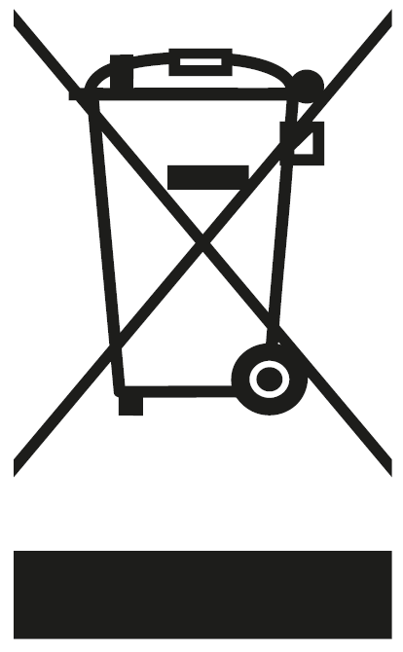

Declaration of conformity (DOC)
Hereby, emporia telecom GmbH + CoKG (Industriezeile 36, 4020 Linz, Austria), declares that the radio equipment type V66 / emporiaCOMFORT is in compliance with the Directive 2014/53/EU.
The full text of the EU declaration of conformity is available at the following internet address: http://www.emporia.eu/doc
Eveline Pupeter
CEO emporia Telecom
15. 02. 2018, Linz/Austria

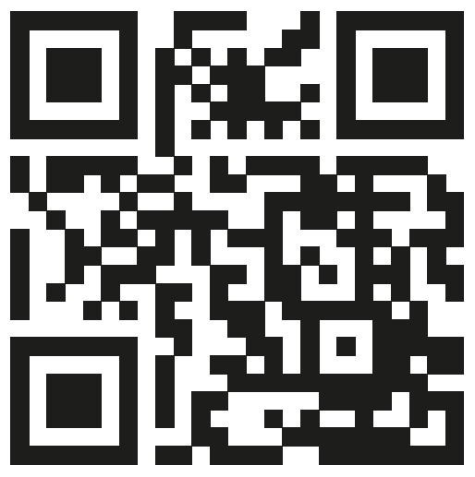
http://www.emporia.eu/doc

DE Druckfehler, Irrtümer und technische Änderungen vorbehalten.
EN Subject to mistakes, printing errors and technical changes.
IT Con riserva di errori di stampa, inesattezze e modifiche tecniche.
FR Toutes erreurs d'impression, erreurs et modifications techniques réservées.
NL Drukfouten, vergissingen en technische wijzigingen voorbehouden.

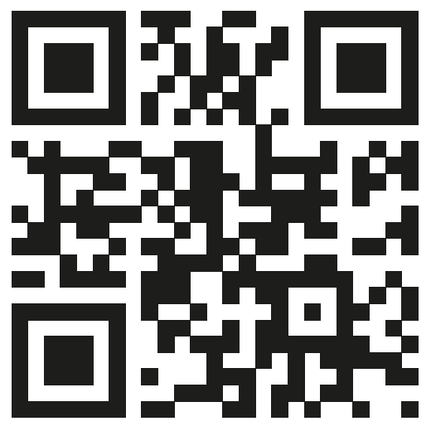

PartNo: V66-GuidBook-V6a_ENG_55432-001_WEB | 201804

How to contact RNIB
Phone: 0303 123 9999
Email: helpline@rnib.org.uk
Address: RNIB, Midgate House, Midgate, Peterborough PE1 1TN
Online Shop: shop.rnib.org.uk

RNIB terms and conditions of sale
If you have any issues with the product and you did not purchase directly from RNIB then please contact your retailer in the first instance.
If you’d like to return the item, please contact RNIB to get a returns authorisation number to help us deal efficiently with your product return.
You can request full terms and conditions from RNIB or view them online.
RNIB Enterprises Limited (with registered number 0887094) is a wholly owned trading subsidiary of the Royal National Institute of Blind People ("RNIB"), a charity registered in England and Wales (226227), Scotland (SC039316) and Isle of Man (1126). RNIB Enterprises Limited covenants all of its taxable profits to RNIB.
Date: October 2020.
© Royal National Institute of Blind People.

