Emporia TALKactive with voice assist (HM87)
Thank you for purchasing from RNIB. In the unlikely event the item is unsuitable, please contact us within 14 days of receipt to obtain your returns number. To ensure your return goes smoothly, the item and all components must be in as new condition and packed in its original, undamaged packaging. For further details and guidance on returning faulty items, please see the Terms and conditions of sale and How to contact RNIB sections of this instruction manual.
Please retain these instructions for future reference. These instructions are also available in other formats.
Contents
1. General description 3
2. Items supplied with the TALKactive mobile phone 4
3. Orientation 5
3.1 The keypad 5
3.2 The display screen 6
3.3 The back of the phone 7
3.4 Left edge 7
3.5 Lower edge 7
4. Your mobile phone at a glance 8
4.1 Open view of phone 8
4.2 Closed view of phone – front 9
4.3 Closed view of phone – rear 9
4.4 Open view of phone written description 10
4.5 Closed view of phone written description 12
4.6 Symbols on the screen 13
4.7 Symbols on the external display panel 14
5. Getting started 15
5.1 Fitting the SIM card and battery 15
5.2 Inserting a SIM card 16
5.3 Inserting and charging the battery 17
5.4 Desk charging 18
5.5 Turning on and off the phone 18
5.6 Saving Energy 20
6. Using the phone 21
6.1 Check your Battery Level 21
6.2 Using the menu 21
7. Calls 22
7.1 Incoming Calls 22
7.2 Ending Calls 22
7.3 Dialling 22
7.4 Redialling 22
7.5 Handsfree Mode 23
7.6 Voicemail 23
8. SMS messages 24
8.1 Menu items 24
8.2 Writing a message 24
8.3 Using the Keypad 24
8.4 Receiving a message 25
9. Camera and photo album 26
9.1 Talk Assist with camera 26
9.2 Taking a photo 26
9.3 Photo album 26
10. Tools 27
10.1 TALK Assist with Tools 27
10.2 Menu items 27
10.3 Alarm clock 27
10.4 Bluetooth 27
11. Contacts 28
11.1 Menu items 28
11.2 Saving contacts (name and number) 28
11.3 Searching for contacts 29
11.4 Speed dial keys 29
12. Settings 30
13. Emporia emergency call function 31
13.1 Adding/editing emergency numbers 32
13.2 Activating the emergency button 33
14. Guarantee and service 33
14.1 Manufacturer details 33
14.2 Scope of delivery 34
14.3 Support 34
14.4 Guarantee 34
14.5 Technical data 34
14.6 Safety information 36
14.7 Intended use 38
15. Disposal 39
15.1 Disposing of the packaging 39
15.2 Disposing of the battery 39
15.3 Disposing of the device 39
15.4 Why recycle? 39
15.5 What is WEEE? 40
15.6 How are RNIB helping? 40
16. Declaration of conformity (DOC) 41
How to contact RNIB 42
RNIB terms and conditions of sale 42

1. General description
TALKactive is an adaptation of Emporia’s T221 ACTIVEglam Clamshell mobile phone. The Talking Features of TALKactive clam are as follows:
- The voice assistant will guide you through the menus and settings as you press the function keys.
- When you receive a message, the voice assistant will read it for you once when opening. All messages are held in the message History and are repeated for you as you scroll through the message history.
- When typing a message, each key will speak the letters as defined by the traditional button layout detailed in section 8. SMS Messages. At any point when writing a message, you can press any of the 3 white buttons ([speed dial I], [camera], [speed dial II]) and the complete message will be read out.
- When someone is calling with an unknown number, the voice assistant will read the number. If the caller is a saved contact in your phone book, the voice assistant will say the name.
- To hear the time and battery status when the phone is closed, press the volume control on the side.

2. Items supplied with the TALKactive mobile phone
- Mobile phone: T221-4G TALKactive clam
- Extra battery cover without an emergency button
- Battery
- Desktop charging stand
- USB cable
- USB charging mains adaptor
- Quick Start Guide for standard ACTIVEglam phone
- Large print User Guide for TALKactive clam

3. Orientation
Out of the box the phone is in the closed position. The phone is hinged dividing the two halves. The lower edge of the phone has curved corners. The top half is the screen and the lower half is the keypad. When closed the clamshell design protects both screen and keypad.

3.1 The keypad
Above the keypad, immediately below the hinge, are four Function Buttons.
On the Left-Hand Side there is a rectangular button with a Green Phone symbol. We refer to this as the [ok] Key. This is used to:
- Start or accept a call
- On standby: access call history
- In the menu: confirm a selection
In the middle there are two Arrow Keys separated by a recessed line. These are used to scroll through Contacts and navigate through the Menu. The Top Key is the [up arrow] and the lower key is the [down arrow].
- Use the [down arrow] to access your CONTACTS and either arrow to scroll through the Menu
- In Standby – press the [up arrow] to access the MENU
On the Right-Hand Side there is a rectangular button with a Red phone symbol. We refer to this as the [back] Key.
This key is used to:
- End a call
- In the Menu – go One Step Back
- When entering digits or letters – Delete
Immediately below the four Function Keys there is a row of three WHITE Rectangular Buttons.
- The LHS button is a SPEED DIAL KEY 1
- The MIDDLE is the Camera Key
- The RHS button is a SPEED DIAL KEY 2
The standard keypad is located below the white buttons.
The On/Off button is located below the keypad on the lower edge of
the phone. A small raised bar on either side of the button will help to locate it.
The Microphone is in the bottom left hand corner.

3.2 The display screen
The large screen is 2.2-inches diagonally. The receiver loudspeaker is at the top of the screen in the middle of the phone.
The Home Screen display has a battery indicator in the top left corner and a signal strength indicator in the top right. Four bars indicate a strong signal. The name of your mobile phone network scrolls across the top centre of the screen.
In the centre of the screen the Time and Date is displayed.
Call History is highlighted in the lower left-hand corner and is accessed via the [ok] button.

3.3 The back of the phone

In the back of the phone there is a loudspeaker for handsfree use and an emergency assistance button. The emergency assistance button can be hidden with the alternative battery cover supplied with the phone. In the bottom left hand corner there is a small opening used when removing the battery cover.

3.4 Left edge
The volume controls are located on the left side of the handset. Press [plus] to increase, [minus] to lower the volume.

3.5 Lower edge
The USB socket is on the lower edge. This device uses a USB-C type charger and is therefore easy to handle as it can be inserted in either direction. This can be used for charging although most people will find it easier to use the desk charging stand. On either side of the USB socket there are two small recesses in the centre of which are metal contacts used to charge the phone in conjunction with the desk charging stand.

4. Your mobile phone at a glance

4.1 Open view of phone
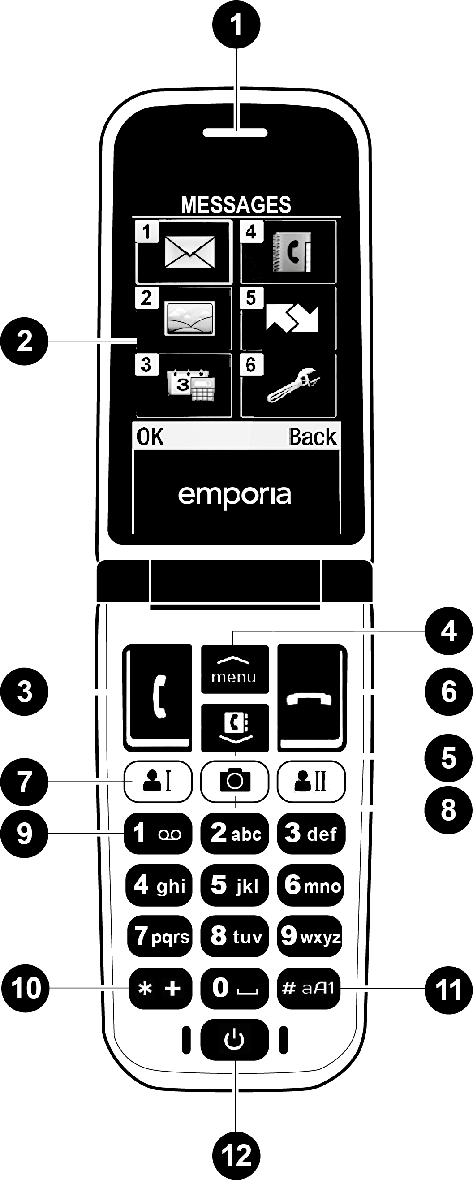

4.2 Closed view of phone – front
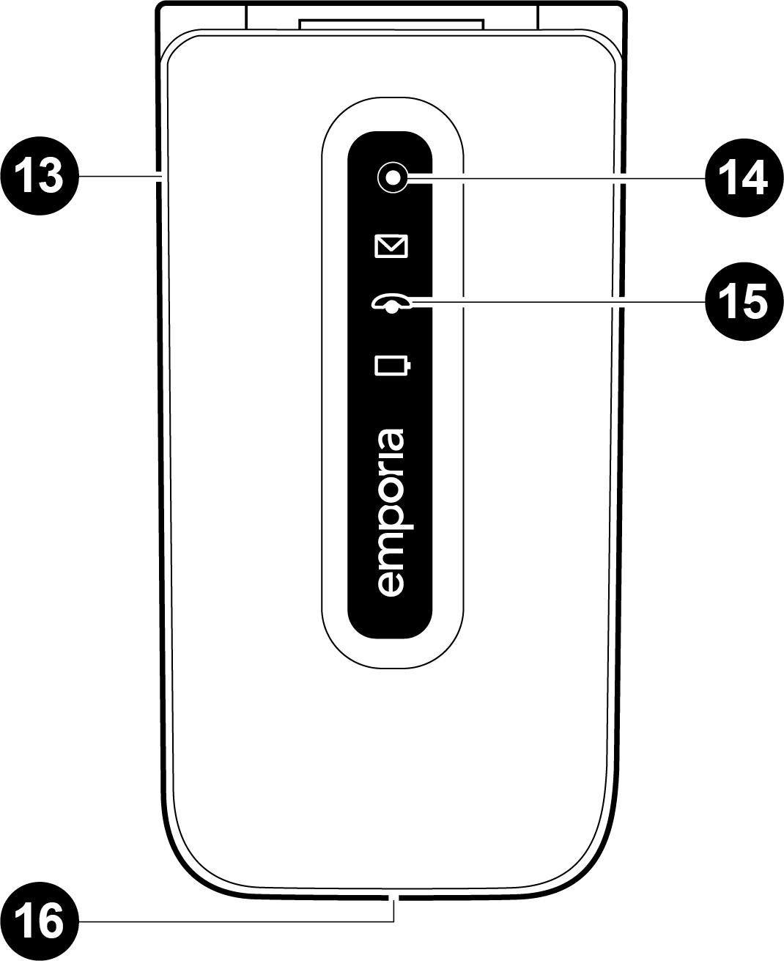

4.3 Closed view of phone – rear
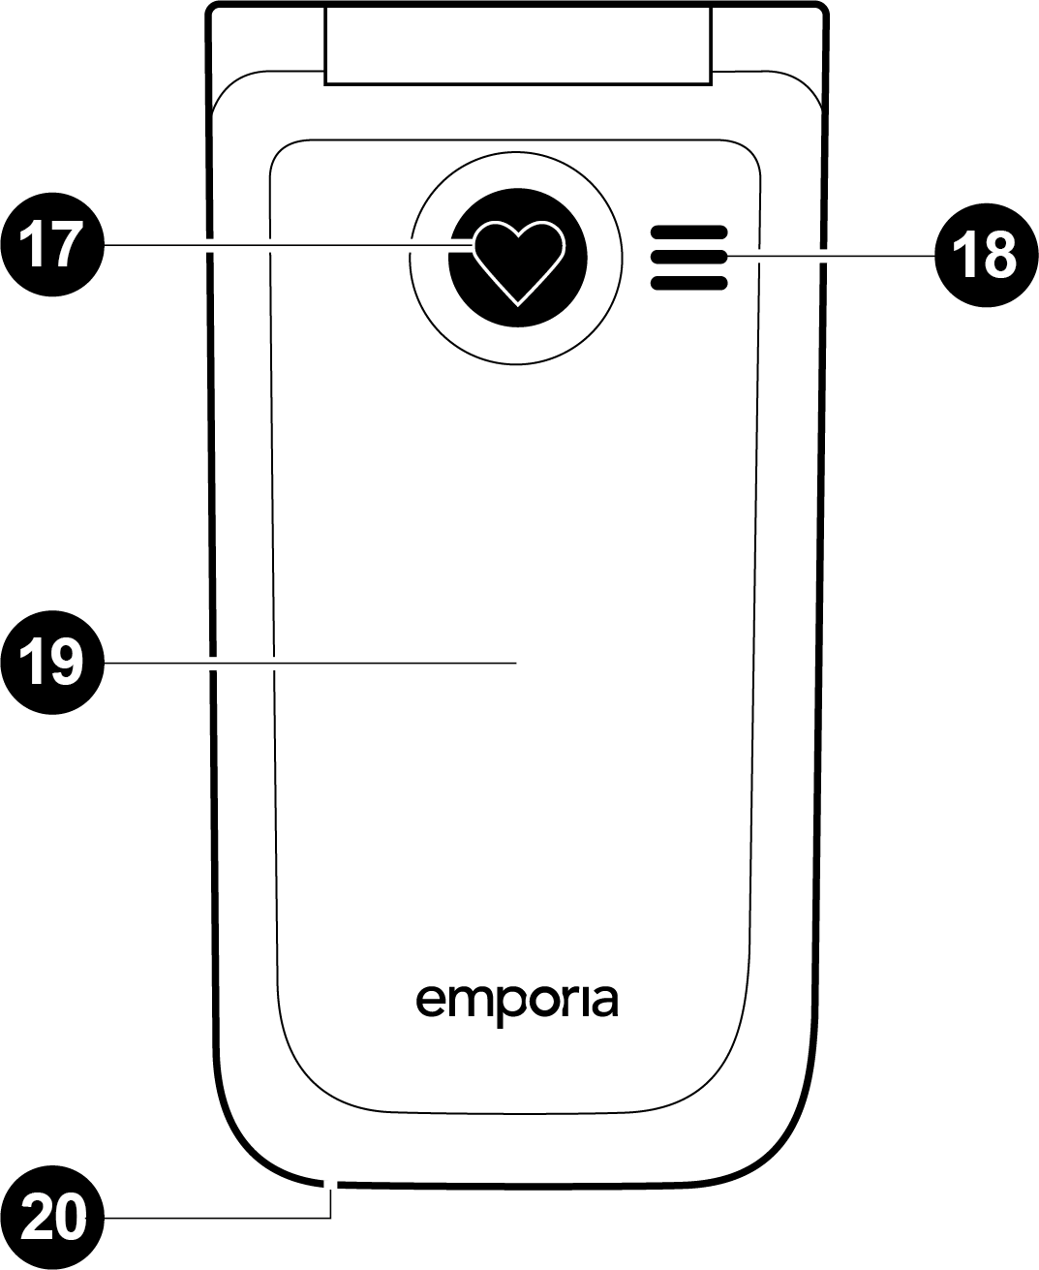
Note: When icons/symbols have been used within the body of the text they have been replaced by wording within square brackets. The following tables show the keys to the diagrams plus the alternative text used for icons/symbols within the body text where applicable:

4.4 Open view of phone written description
Diagram Number | Description | Text reference
1 | Speaker | n/a
2 | Display (screen) | n/a
3 | Answer/OK key  - Start 2 Call info | [ok]
4  5 | menu Arrow keys  - Flick through Contacts and menu  - When the phone is on standby, press [up arrow] to call up the menu.  - When the phone is on standby, press [down arrow] to access Contacts. | [up arrow]  [down arrow]
6 | Hang up / Back / Delete key  - When in a call: End  - When in the menu: One step back  - When entering digits or letters: Delete | [back]
7 |  | [speed dial I]  [speed dial II]
8 | Camera key  - time and battery level | [camera]
9 | 1 key (voicemail) | [1]
10 | asterisk key | [star]
11 | hash key | [hash]
12 | On/Off key | [on/off]

4.5 Closed view of phone written description
Diagram Number | Description | Text reference
13 | Handset volume controls  (on the side of the phone)  and | [plus]  [minus]
14 | Camera lens | n/a
15 | Info LEDs | n/a
16 | Port for USB type C charging cable | n/a
17 | Emergency button (optional) | n/a
18 | External loudspeaker (hands-free) | n/a
19 | Battery cover (two versions:  one with the emergency button  and one without it) | n/a
20 | Opening for removing the battery cover | n/a

4.6 Symbols on the screen
Symbol | Description | Text reference
 | Network signal strength | n/a
 | Roaming (abroad) | n/a
 | Battery indicator | n/a
 | Missed call | n/a
 | Call forwarding | n/a
 | New text message (SMS) | [envelope]
 | Profile: Silent/Sleep mode | n/a
 | Alarm clock on | n/a
 | Bluetooth activated | n/a
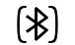 | Bluetooth connected | n/a

4.7 Symbols on the external display panel
Symbol | Description
Message LED
- Flashes when a new message is received
- Stops flashing as soon as the received message has been read

Call LED [icon]
- Flashes when there is a missed call
- Stops flashing as soon as all the calls have been viewed
Battery LED
- Slow flashing: Battery is charging
- On constantly: Battery is fully charged
- Rapid flashing: Battery is out of charge

5. Getting started

5.1 Fitting the SIM card and battery

SIM card sizes: Standard, Micro and Nano explained
All phones need SIM cards, but they don’t all need SIM cards of the same size. There are three different sizes in use, namely Standard (also known as Mini), Micro and Nano.
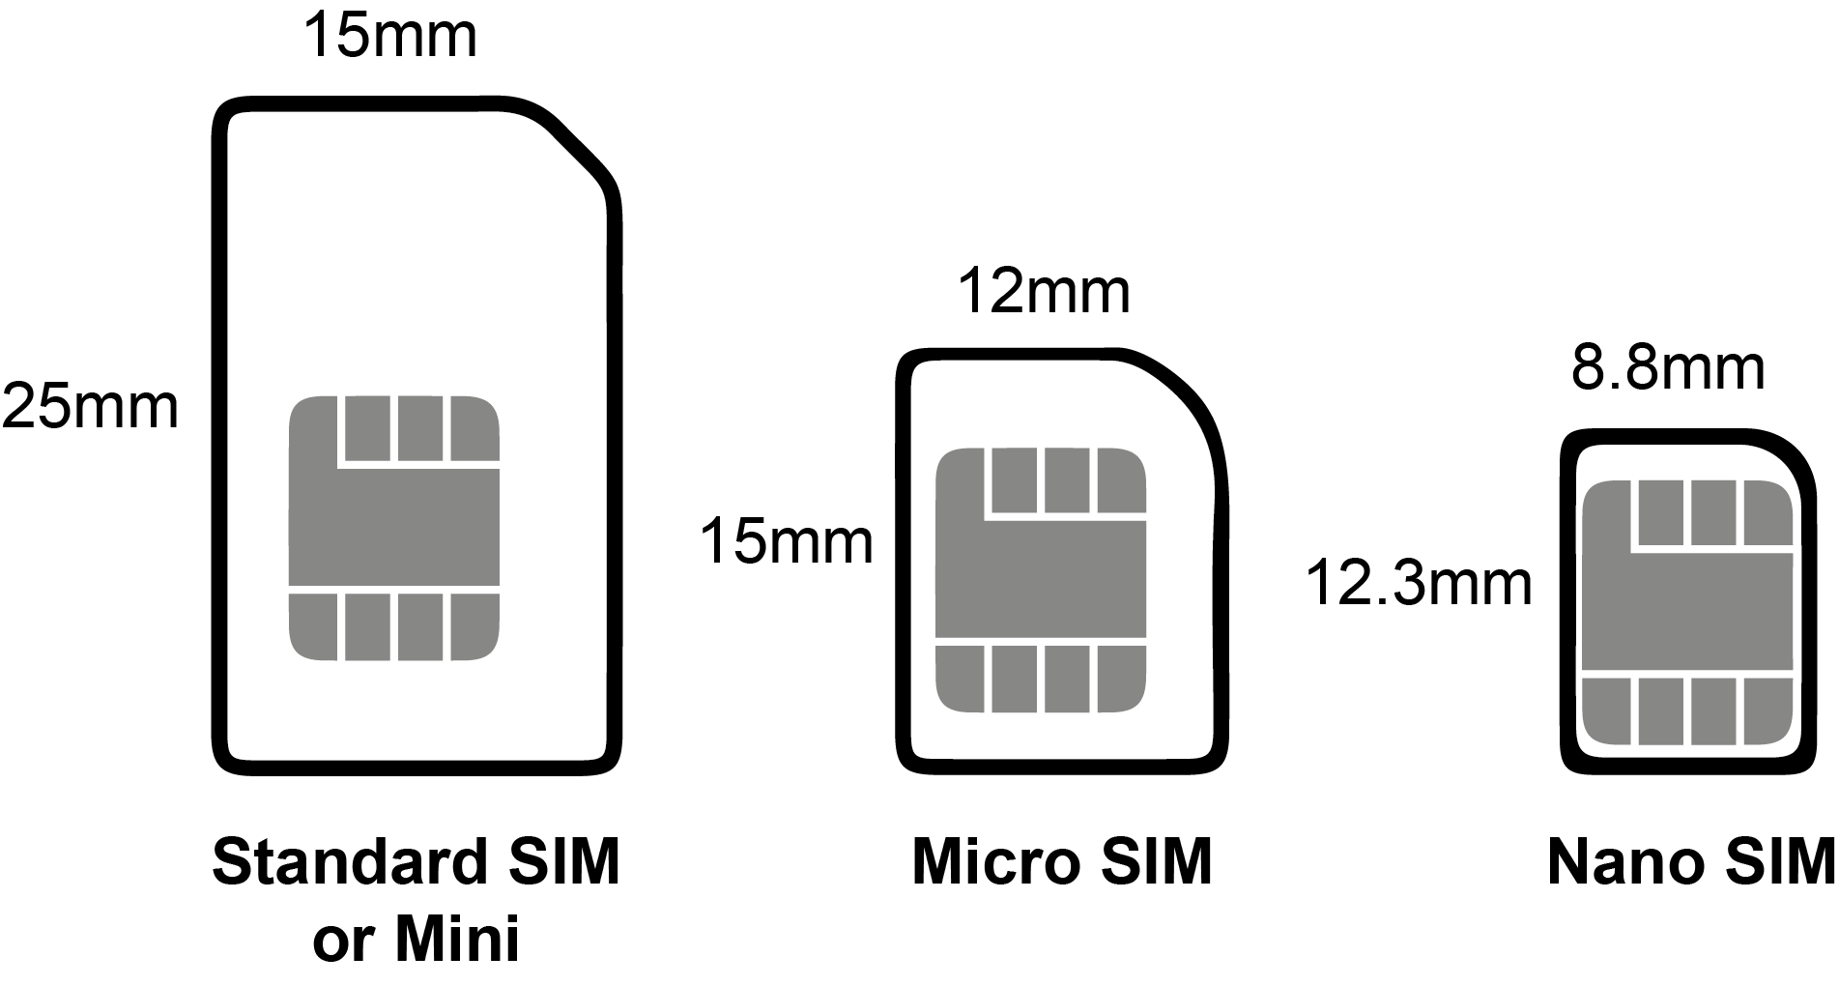

What is a Standard SIM card?
A Standard (or Mini) SIM card is the largest type of SIM card available at 15 x 25mm. You could think of it as a full-size card while the other two are cut down, however, the chip is the same size in all three. This is the important bit that stores your data, so with a Standard SIM card you just have a lot of plastic around it.

What is a Micro SIM card?
A Micro SIM card is one size down from a Standard card. So, it’s a little smaller, at 12 x 15mm. The actual chip is the same size, so it’s just the plastic bit around the chip that’s smaller.

What is a Nano SIM card?
Nano SIM cards are the smallest SIM, at 8.8 x 12.3mm. This has almost no plastic border around the chip. Your TALKactive uses a Nano SIM.

What can I do if I have the wrong size SIM card?
If you get a new phone that needs a different size SIM card, or you end up with the wrong size for any other reason, your best option is to contact your network and ask them to send a replacement. You’ll usually get three sizes in one, so probably won’t even have to request a specific size.
If your SIM card is too big, we recommend that you ask your network for a replacement SIM card, but some people have successfully used special SIM card cutting tools. These will cut a SIM down to the right size but are not recommended as it is quite easy to damage the SIM card and lose all the SIM card contacts and messages, so we wouldn’t recommend it.

5.2 Inserting a SIM card
- Remove the battery cover.
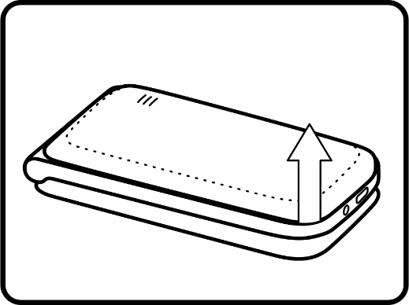
- Slide the SIM card into the SIM card holder with the gold contacts facing down.
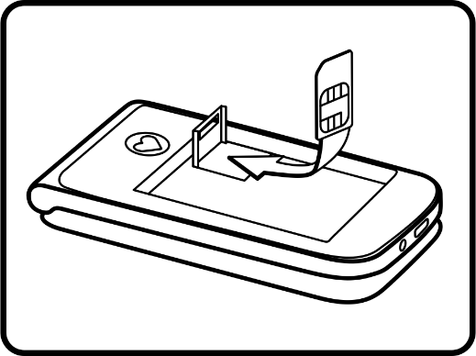

5.3 Inserting and charging the battery
- Insert the battery, making sure that the battery contacts touch the phone's gold contacts.
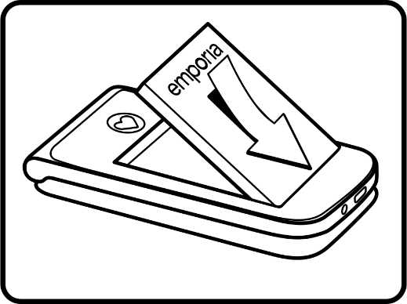
- Slide the battery cover into its position over the battery. You will know it is in the correct position when you hear it click into place.
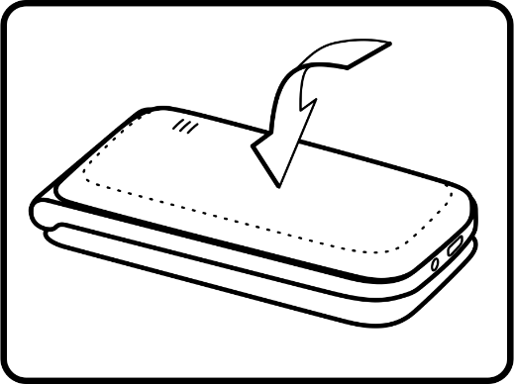
- Plug the charging cable into the USB port on the top of the phone and insert the USB into a mains socket OR set up the Desk Charging Stand.
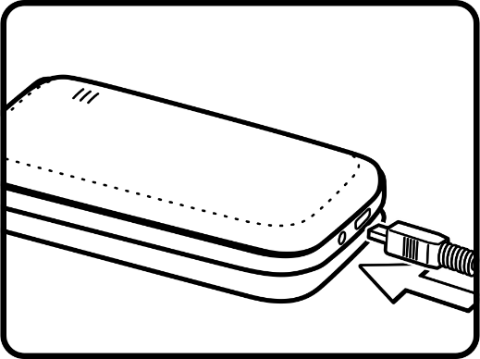
Attention: Charge the battery for at least four hours before the first time you use it. Only use batteries and chargers that are permitted for use with this specific model. We recommend that you remove your phone from any charger when it is charged to ensure the battery performance is optimised, please do not leave your phone charging overnight or all day as this will eventually reduce the battery capacity.

5.4 Desk charging
Using the desk charger is by far the easiest way to charge your phone. Simply take the small plug on the end of the USB charging cable and insert into the USB socket on the back of the desk charging stand. Insert the USB plug into a mains socket and place the phone in the charger.

5.5 Turning on and off the phone
Pressing the [on/off] key for at least two seconds switches the phone on or off. You will feel a short vibration in the phone to confirm that the start-up or shut-down has begun.
When turning the phone on, following the short vibration, A Red Circle appears on the screen and after 15 seconds a start-up tone will play. After a further 10 seconds your phone is ready to use and the Home Screen appears.
When shutting the phone down, following the short vibration, the phone will play the shut-down tone whilst the emporia logo moves across the display. After a few seconds there will be a further vibration and your phone is now switched off.
- Important – Start Up Procedure
When you turn on the phone for the first time, the start up procedure will ask you to:
- Select a Language – it should be set to English by default. Press [ok] to confirm. The language may be changed by pressing the [up arrow] button to highlight the desired language and then press [ok] to confirm.
- Set the time - Enter the time in 24-hour format (HH:MM) and press [ok] to save. If you already have inserted your SIM card the time will automatically be set by the network.
Set the date
- Enter the date in format DD:MM:YY. Again, if you have inserted your SIM card this will already be set by your network. Press [ok] to save.

5.6 Saving Energy
If a few seconds pass without the phone receiving any input from you, the screen will go blank to save energy. In the event of an incoming call or you press any key, the screen will automatically light up again. In standby mode the phone is on, but not running any applications.

6. Using the phone

6.1 Check your Battery Level
In standby mode with the phone closed, press either of the volume keys to hear the time and the battery level. When the phone is open you can hear this information by pressing the camera button. Press [back] to exit camera mode.

6.2 Using the menu
Press [up arrow] to open the main menu.
The following Menu items are spoken in order: Messages, Photo Album, Tools, Contacts, Call History, Settings.
- Press [up arrow] and/or [down arrow] to flick through the menu items. At the top of the screen, the menu item currently highlighted will be displayed and read out.
- Press [ok] to open a menu item.
- Menu items can be selected directly using the numbers assigned to them as follows: Press 1 for Messages, 2 for Photo Album, 3 for Tools, 4 for Contacts, 5 for Call History and 6 for Settings.
- Sub Menus are selected by Pressing [up arrow] and/or [down arrow] to find the Options which you can select by pressing [ok] or [back] to exit, these are displayed at the bottom of the screen. Each sub-menu option is spoken.
- To return to the Home Screen, press [back]. To go to standby, close the phone.

7. Calls

7.1 Incoming Calls
- Incoming call: Open the phone and press [ok]
- To reject a call: Press [back] or close the phone
- To mute the ringtone temporarily press the [minus] on the side of
the phone
NB. You can set the phone to auto answer and auto end calls when opening and closing the phone. To do this please refer to the tools section below.

7.2 Ending Calls
Press [back] or close the phone.
If the screen has gone dark during the call, press [back] twice.

7.3 Dialling
Enter the number you want to dial on the keypad (including the area code) using the keypad. Start the call by pressing [ok].

7.4 Redialling
- When the phone is on standby, press [ok] to show your call history.
- Select a name or number using the [up arrow] and/or [down arrow]
- Start the call by pressing [ok]

7.5 Handsfree Mode
Press [ok] in a call to open the Options Menu and select 2. Speaker. The sound will be played through the external speaker (18).

7.6 Voicemail
To access voicemail, press and hold button 1 on the keypad for
1 second. You phone will call the SIM card’s voicemail number to retrieve your messages. If the voicemail number needs to be changed or added manually, please set this in the menu, Option 6 (settings)
15 (voicemail number) and entering the correct voicemail number (most network SIMs voicemail numbers will be read from the SIM card).

8. SMS messages

8.1 Menu items
Write Message, History, Message Settings

8.2 Writing a message
From the Main Menu, select 1. Messages, then 1. Write Message. Enter text using the Keypad.

8.3 Using the Keypad
Enter text using the keypad. If you enter an incorrect character press the [back] button once to delete a character. Please note that by pressing and holding the [back] button you will delete all text in the message.
Each key has several characters assigned to it which can be selected by pressing the respective key quickly several times.
Press the [hash] key to switch between capitals, lower case and numbers. Unfortunately, this is not read out. NB. when writing a message your phone will automatically capitalise the first word of a sentence.
- Number one has full stop, comma, question mark, exclamation mark, single quote, double quote, colon, semi-colon and the number 1. Press and hold to enter number 1.
- Number two has A, B, C and two.
- Number three has D, E, F and three.
- Number four has G, H, I and four.
- Number five has J, K, L and five.
- Number six has M, N, O and six.
- Number seven has P, Q, R, S and seven.
- Number eight has T, U, V and eight.
- Number nine has W, X, Y, Z and nine.
- Number zero has space and zero.
[star] opens a list of special characters in a grid, use [up arrow] and [down arrow] to scroll through them
[hash] toggles between cases and numbers
- abc – Lower case only
- Abc – Upper and lower case
- ABC – Uppercase only
- 123 – Digits

8.4 Receiving a message
Received messages are indicated by an audio signal and by the [envelope] on the external display.
When the phone is opened the display shows New Message. Press [ok] to view. The sender’s name is read out if it is in your phonebook. If not, the number is read out.
Press [ok] to listen to the message.
Messages are retained until deleted and can be reviewed in History.

9. Camera and photo album

9.1 Talk Assist with camera
Talk Assist is not totally active throughout this application.
As noted earlier in this guide, the White Camera Button is used to check the Time and Battery Level.
When this has been read out, the Camera is enabled.

9.2 Taking a photo
- Press [camera] or [up arrow] to take a photo.
- Press [ok] to view saved photos
- Press [ok] again to open Options for the camera
Available options: 1. View, 2. Send, 3. Wallpaper, 4. Rename,
5. Delete, 6. Delete all

9.3 Photo album
Your photos will be saved in the Photo album.
- Press [up arrow] and/or [down arrow] to flick through the photo album.
- Press [ok] to open Options for the selected picture.
Available options: View, Send, Wallpaper, Rename, Delete,
Delete all

10. Tools

10.1 TALK Assist with Tools
TALK Assist is not totally active throughout this application.

10.2 Menu items
1. Alarm, 2. Birthday Reminder, 3. Calendar, 4. Calculator, 5. Camera, 6. Bluetooth, 7. System update, 8. SIM Tool Kit.

10.3 Alarm clock

Setting the time
- Enable the alarm clock — Enter the time — Confirm by pressing [ok].
- The alarm clock will now go off at the time you have set every day.

Off – disable alarm clock
- Switch off the ringing alarm clock by pressing [back].
- Mute the alarm by pressing [ok] or [minus] (it will ring again after five minutes).

10.4 Bluetooth
This function allows you to use Bluetooth-enabled hands-free kits wirelessly.
- Bluetooth on/off
- Connect — Search for new devices
- Search for devices you want to connect — select devices by pressing [ok].
- Devices that have been connected before will be recognised and connected automatically.
- Manage devices — Visibility — On
- Make your phone visible so that it can connect to a Bluetooth device.

11. Contacts

11.1 Menu Items
Search name, Add contact, Edit contact, Delete, Import/Export, My number, Speed dial keys, Emergency contacts, Contact settings

11.2 Saving contacts (name and number)
[up arrow] — Contacts — Add contact
Enter name and number. Press [ok] to confirm
Important: Always save names and numbers with the international dialling code, e.g. save +44 for UK +41 for Switzerland, +43 for Austria and +49 for Germany.

11.3 Searching for contacts
[up arrow] — Contacts — Search name
— Press [up arrow] and [down arrow] to flick through the entries or enter the first few letters of the entry you're looking for using the keypad (and continue flicking with [down arrow] if necessary).
— Once you've selected an entry, press [ok] to start a call.

11.4 Speed dial keys
You can assign quick dial keys to numbers you call often.

Saving a quick dial key
- Press one of the quick dial keys
- Enter a name and number or Search for a contact in the phone book.

Changing or deleting a quick dial key
- Open the menu item Speed dial keys in the Contacts menu.
- Select a quick dial key and change or delete its link to a particular contact.

12. Settings
The settings menu enables you to personalise your phone to suit your requirements. The sub-menus are as listed below.
- Voice assistant
- Networks settings
- Wi-Fi hotspot
- Silent/Sleep mode
- Sounds and alerts
- Handset volume
- Hands-free volume
- Display and lights
- Time and date
- Language
- Camera settings
- Open to answer calls
- Call waiting
- Call forwarding
- Voicemail number
- Emergency contacts
- Emergency buttons
- Security settings
- Contact settings
- 0000 to enter Settings
- Master reset

13. Emporia emergency call function
If you use the battery cover with the integrated emergency button, you can enable the phone's emergency call function.
Read the instructions carefully and set the emergency call function according to you needs. If you press the emergency call button before setting up the function fully the message Emergency Button is Off, switch it on in Phonebook / Emergency numbers / Emergency button on/off is read out and displayed.
You can save up to five emergency numbers (family members, friends and official institutions).
In an emergency press and hold the emergency button on the back of the phone. (This works even when the phone is closed.)
The five preset numbers will be dialled automatically in the order you have saved them in. If it is not possible to get through to anyone on the first number, the second number will automatically be dialled. If it is not possible to get through to anyone on the second number, the third number will automatically be dialled, and so on. (The phone will go through a list of five numbers a maximum of three times.)
At the same time as each emergency call, a text message (SMS) will be sent to the contact, saying: "You will receive an emergency call with a loud beep signal during the conversation. Press 3x “0” within 1 min, otherwise call will be dropped automatically."

Important
The contact must press the 0 key three times within 60 seconds, or the call will be disconnected (to prevent your emergency call going through to a contact's voicemail).

From the moment you make an emergency call, your emporia phone will automatically answer any incoming calls for one hour. To disable this function, press and hold the [back] button for approx. three seconds or turn your device off completely using the [on/off] button and then turn it on again.
To cancel the emergency call, press and hold [back].
During the emergency call, a warning tone will sound continuously, to alert anyone nearby and the person being called.
If you do not have any emergency numbers saved, have no credit on your prepaid phone card or are connected to a foreign network without permission (e.g. roaming is not activated), 112 (999) will be dialled when you press the emergency button.

Important
If you want to add the number of an official institution such as the police or fire brigade as an emergency number, you must check that this is okay with the respective institution beforehand. We do not assume liability for any costs incurred through you calling such an institution by mistake.

13.1 Adding/editing emergency numbers
In the Settings menu — Emergency numbers
- Add emergency number
- Select an entry (e.g. Em No 1) by pressing [arrow up] [arrow down]
- Press [ok] to confirm
- Select Private or Help organisation [ok] to confirm
- Select a contact [ok] to confirm

13.2 Activating the emergency button
In the Settings menu > Emergency numbers > Emergency button > On/Off

Pre alarm
The pre alarm is a warning tone that sounds for ten seconds and alerts anyone nearby to the emergency call. After this, the emergency call sequence starts. This can be turned on or off in the Settings menu.
- Emergency numbers
- Pre alarm
- On/Off

14. Guarantee and service

14.1 Manufacturer details
- Manufacturer: emporia telecom GmbH + CoKG, Industriezeile 36, 4020 Linz, Austria
- Importer: Emporia UK and Ireland Limited. 1st Floor, Building 2, Croxley Business Park Watford, England.
- Contact: emporiatelecom.co.uk or emporiatelecom.ie
- Trade mark: emporia
- Model: emporiaACTIVEglam, emporiaTALKactive (T221-4G)

14.2 Scope of delivery
- Mobile phone: emporiaTALKglam, emporiaTALKactive (T221-4G)
- Extra battery cover without an emergency button
- Battery: AK-T221-4G
- USB Cable
- Charging unit: RL-V150-USB
- Desktop charger: TL-T221-4G

14.3 Support

Emporia Service Centre
Mon.-Thu. 09:00-16:00 · Fri. 09:00-13:00
service@emporiatelecom.co.uk
UK-Hotline +44.1923.947778
IE-Hotline +353.1.5926339
emporiatelecom.ie/service

14.4 Guarantee
This guarantee is only valid if the original batteries supplied by emporia have been used.
Mobile phone: 12 months
Battery: 6 months

14.5 Technical data
Dimensions: 96.5 × 50.5 × 17.75 mm
Weight: 85g
Battery: Li-ion 3.8 V, 1150 mAh, 4.27 Wh (replaceable)
AC adapter:
Input: 100-240VAC, 50/60Hz, 200mA
Output: DC5.0V, 500mA
Desktop Charger: Input/Output
Standby time: 140 hrs*
Talk time: 320 mins*
(*Depending on network coverage and activated applications the battery life can be reduced).
Internal antenna:
SAR-body: 0.98W/kg
SAR-head: 0.89W/kg
Operating Temperature: -10 to 40 degrees centigrade
Bluetooth: V4
HAC: T4/M4

Operating frequency
BT: 2402 MHz - 2480 MHz Transmitter power: < 0.0018 W
FM: 87.6 MHz - 107.9 MHz
E-GSM 900/GPRS 900/EGPRS 900:
TX: 880 - 915MHz; RX: 925 - 960 MHz;
Transmitter power: < 2.138 W
E-GSM 1800/GPRS 1800/EGPRS 1800:
TX: 1710 - 1785 MHz; RX: 1805 - 1880 MHz;
Transmitter power: < 1.1482 W
WCDMA Band I:
TX:1920 - 1980 MHz; RX: 2110 - 2170 MHz;
Transmitter power: < 0.1811 W
WCDMA Band VIII:
TX: 880 - 915 MHz; RX: 925 - 960 MHz;
Transmitter power: < 0.1652 W
LTE Band I:
TX:1920 - 1980 MHz, RX:2110 - 2170 MHz;
Transmitter power: < 0.1841 W
LTE Band III:
TX:1710 - 1785 MHz, RX:1805 - 1880 MHz;
Transmitter power: < 0.2042 W
LTE Band VII:
TX:2500 - 2570 MHz; RX: 2620 - 2690 MHz;
Transmitter power: < 0.2704 W
LTE Band VIII:
TX: 880 - 915 MHz; RX: 925 - 960 MHz;
Transmitter power: < 0.3516 W
LTE Band XX:
TX: 832 - 862 MHz; RX: 791 - 821 MHz;
Transmitter power: < 0.2618 W

14.6 Safety information
- Turn off your phone in hospitals and whenever you are near medical equipment. There should always be a distance of at least 20 cm between a pacemaker and the phone when it is on.
- Never try to control a vehicle while holding the phone in your hand. Always comply with relevant national laws and traffic regulations.
- Turn off the phone whenever you are travelling in an aeroplane.
- The phone must be switched off whenever it is near a petrol station or other places with explosive substances.
- Never shine the LED torch in the eyes of people or animals! (Protection class 3)
- To prevent hearing impairments, do not use the phone on a high speaker volume for extended periods of time. Do not hold the phone to your ear when hands-free mode is activated or the emergency button has been pressed.
- Using a headset on a high volume can cause hearing impairments. Check the volume of the headset you are using.
- The phone and the accessories may contain small parts. Keep the phone out of the reach of young children.
- As a precaution, we recommend disconnecting the phone from the charger during thunderstorms.
- The mains adapter serves as a separator between the product and your mains supply. The mains supply must be close to the device and easily accessible.
- This device has been tested for typical applications where the device is carried on the body. To meet the RF exposure requirements, the minimum distance between the body, in particular the user’s head, and the handset including the antenna must be 0 cm. Belt clips, holsters and similar accessories from third parties used with this device must not contain metallic components. Accessories carried on the body that do not meet these requirements may not meet the RF exposure requirements and should be avoided. Only use the device’s built-in antenna or an approved antenna.
- This device complies with the essential requirements and other relevant provisions of Directive 2014/53/EU. All the important radio test cases have been written.
- Caution: Risk of explosion if the battery is replaced by the wrong type. Dispose of the used batteries according to the instructions.
- The device complies with RF specifications when the device is 5mm from the body.

14.7 Intended use
This phone is robust and designed for mobile use. However, it still needs to be protected from moisture (rain, bathroom water, etc.) and heavy impacts.
For European Network standards only (AT, BE, CZ, DE, DK, ES, FI, FR, GB, HR, HU, IE, IT, NL, NO, PL, PT, SE, SI, SK, SZ, TR).
Do not leave it where it will be directly exposed to the sun.
Using the phone for any purpose other than that described above will result in damage to the product. Doing this also entails hazards such as fire, electric shocks, etc. This product must not be changed or modified, and the casing must not be opened.
The adapter is only suitable for use in conjunction with a standard household mains socket that is connected to your electrical grid and uses 100-240 volts/50/60Hz (10/16A) of alternating voltage.

15. Disposal

15.1 Disposing of the packaging
The packaging and packaging aids are recyclable and should be made available for reuse.
15.2 Disposing of the battery  Batteries should never be disposed of as domestic refuse! As a consumer you are legally required to return used batteries. They can be handed in at one of your community's local collection points or at specialised stores. | 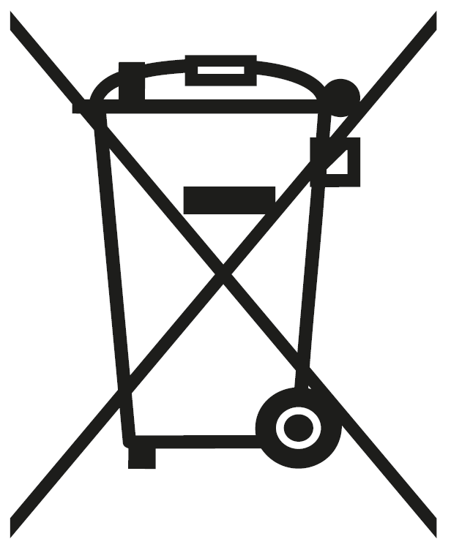
15.3 Disposing of the device  If this product ever wears out, please don't dispose of it as domestic refuse. To ensure you don't cause damage to the environment, take it to a collection station or recycling centre where used devices are processed for recycling in an environmentally friendly manner. | 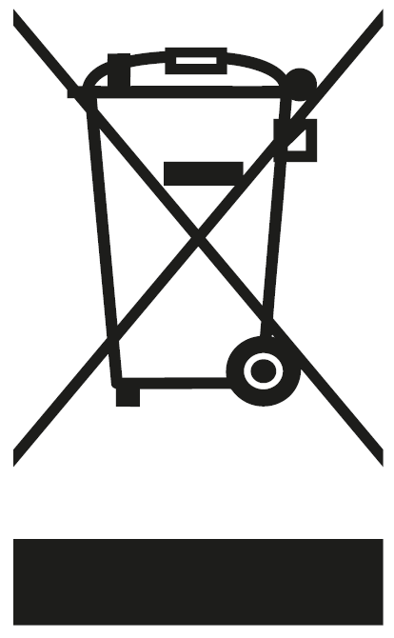
Recycle your electricals and electronic devices free at your local recycling centre. Search for your nearest recycling centre by visiting recyclenow.com

15.4 Why recycle?
Unwanted electrical equipment is the UK’s fastest growing type of waste.
Many electrical items can be repaired or recycled, saving natural resources and the environment. If you do not recycle, electrical equipment will end up in landfill where hazardous substances will leak out and cause soil and water contamination – harming wildlife and human health.
RNIB are proud to support your local authority in providing local recycling facilities for electrical equipment.
To remind you that old electrical equipment can be recycled, it is now marked with the crossed-out wheeled bin symbol. Please do not throw any electrical equipment (including those marked with this symbol) in your bin.

15.5 What is WEEE?
The Waste Electrical or Electronic Equipment (WEEE) Directive requires countries to maximise separate collection and environmentally friendly processing of these items.

15.6 How are RNIB helping?
In the UK, distributors including retailers must provide a system which allows all customers buying new electrical equipment the opportunity to recycle their old items free of charge. As a responsible retailer, we have met the requirements placed on us by financially supporting the national network of WEEE recycling centres established by local authorities. This is achieved through membership of the national Distributor Take-back scheme (DTS).

16. Declaration of conformity (DOC)
emporia telecom GmbH + CoKG (Industriezeile 36, 4020 Linz, Austria), hereby declares that the emporiaACTIVEglam, emporiaTALKactiv (T221-4G) telecommunication or radio device complies with Directive 2014/53/EU.
The full text of the EU declaration of conformity can be viewed on this web page: emporia.eu/doc
Eveline Pupeter
CEO emporia Telecom
31. 05. 2020, Linz/Austria

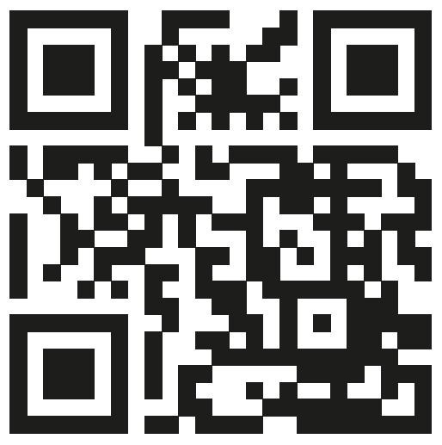
emporia.eu/doc

How to contact RNIB
Phone: 0303 123 9999
Email: helpline@rnib.org.uk
Address: RNIB, Midgate House, Midgate, Peterborough PE1 1TN
Online Shop: shop.rnib.org.uk

RNIB terms and conditions of sale
If you have any issues with the product and you did not purchase directly from RNIB then please contact your retailer in the first instance.
If you’d like to return the item, please contact RNIB to get a returns authorisation number to help us deal efficiently with your product return.
You can request full terms and conditions from RNIB or view them online.
RNIB Enterprises Limited (with registered number 0887094) is a wholly owned trading subsidiary of the Royal National Institute of Blind People ("RNIB"), a charity registered in England and Wales (226227), Scotland (SC039316) and Isle of Man (1226). RNIB Enterprises Limited covenants all of its taxable profits to RNIB.
Date: February 2021
© Royal National Institute of Blind People.

