Emporia V27 Simplicity (HM91)
Thank you for purchasing from RNIB. In the unlikely event the item is unsuitable, please contact us within 14 days of receipt to obtain your returns number. To ensure your return goes smoothly, the item and all components must be in as new condition and packed in its original, undamaged packaging. For further details and guidance on returning faulty items, please see the Terms and conditions of sale and how to contact RNIB sections of this instruction manual.

Please retain these instructions for future reference. These instructions are also available in other formats.

Table of Contents
General description 3
Orientation 3
Left edge 6
Right edge 6
Top edge 6
Front 7
Row one 7
Row two 7
Row three 7
Row four 7
Row five 7
Row six 7
Bottom edge 8
Back 8
Getting started 8
SIM card sizes: Standard, Micro and Nano explained 8
Standard SIM card 8
Micro SIM card 8
Nano SIM card 9
What to do if you have the wrong SIM card 9
Inserting a SIM card 9
Inserting and changing the battery 9
Turning the phone on 10
Saving energy 10
Using the product 10
The home screen 10
Initial start-up procedure 10
Using the menu 11
Dual function keys 11
Calls 11
Incoming calls 11
Making a call 11
SMS messaging 12
Writing an SMS 12
Sending a message 13
Reading a message 13
Radio 13
Searching for a station 13
Adjusting the volume 13
Station list 13
Manual input 13
Auto search 14
Tools 14
Alarm 14
Bluetooth 14
Contacts 14
Searching for a contact in your phonebook 15
Adding a contact 15
Saving a speed dial contact 15
Changing or deleting a speed dial contact 15
SMS in contacts 15
Settings 16
• Silent or sleep mode 16
Sounds and alerts 16
Accessibility settings 16
Additional settings 17
Emporia emergency call function 18
Making an emergency call 18
Disabling auto answer function 18
Cancelling an emergency call 18
Adding or editing emergency numbers 19
Activating the emergency button 19
Pre alarm 19
Guarantee and service 19
In the box 20
Customer support 20
Guarantee 20
Technical Specification 20
Frequencies 21
Safety information 21
Intended use 22
Disposal 23
Disposal of the packaging 23
Disposal of the battery 23
Disposal of the device 23
How to contact RNIB 23
Terms and conditions of sale 23
Why recycle? 24
What is WEEE? 25
How are we helping? 25

General description
The Emporia Simplicity V27 is a 2G bar style mobile phone with accessible features. These include an easy to see keypad and emergency call function.

Orientation
Below is an image of the front of the phone, labelled with numbers to their corresponding symbols.
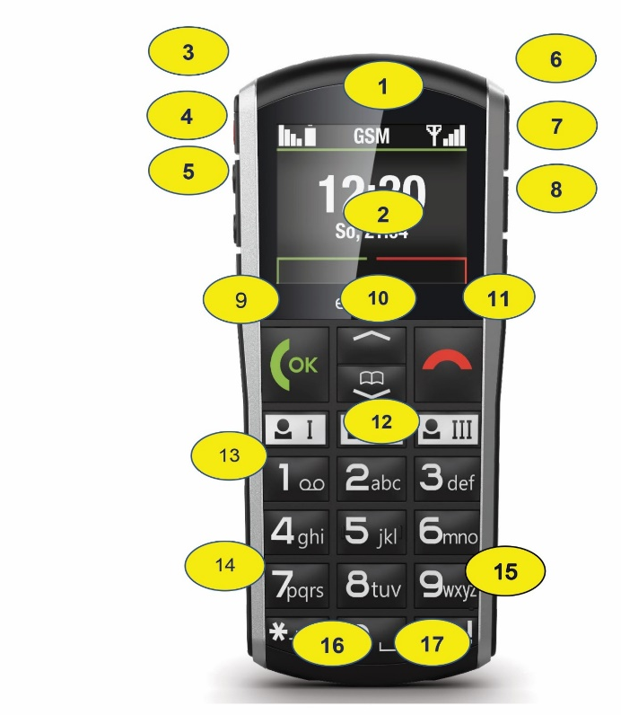
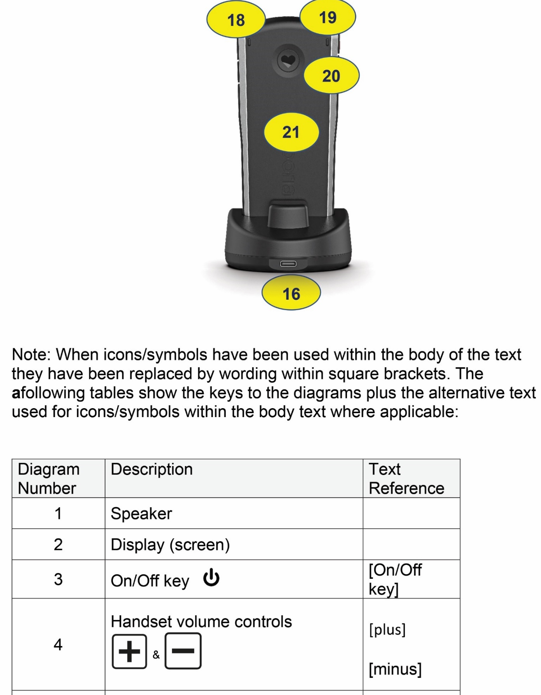

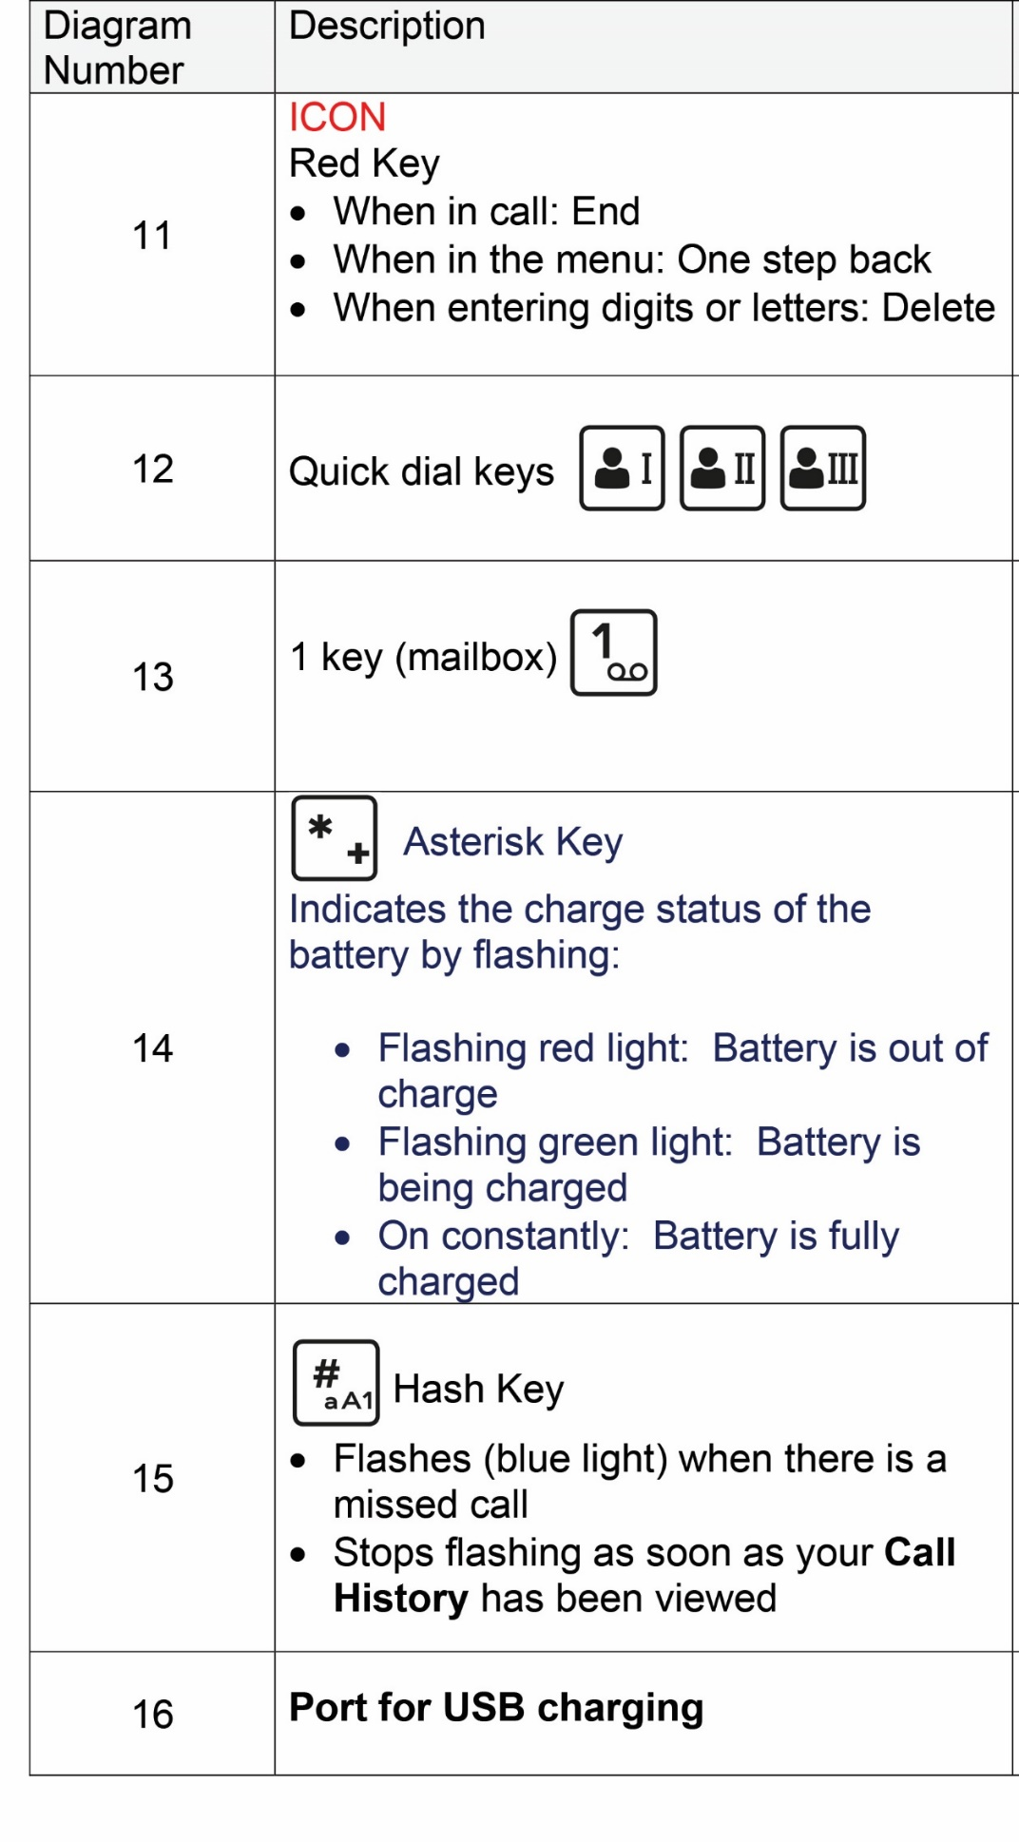

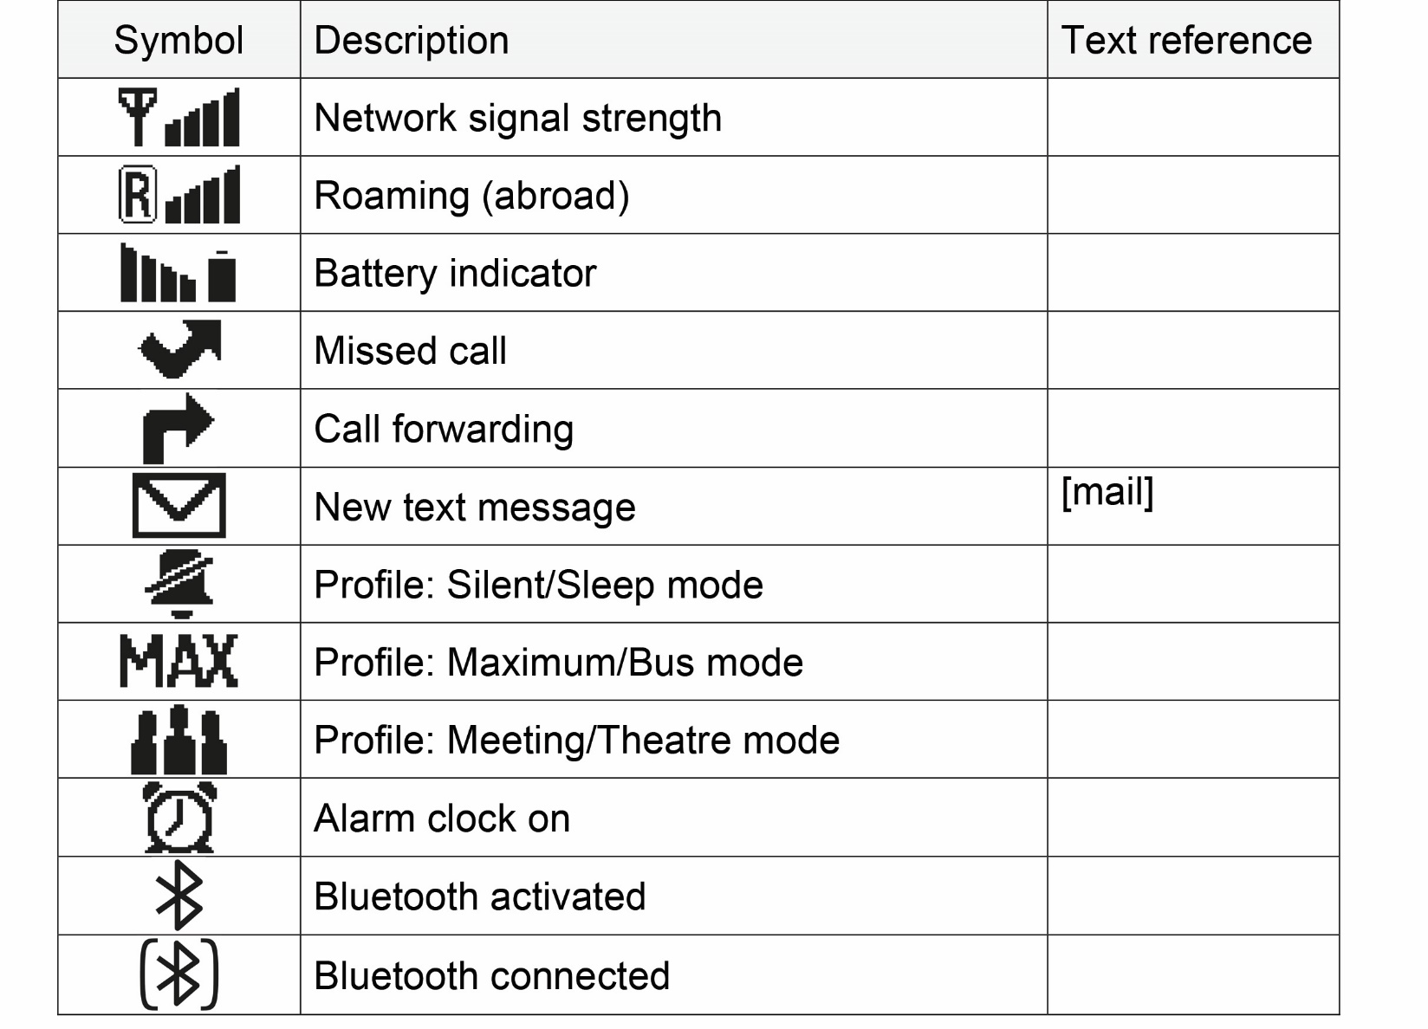

Left edge
On the left edge, there are four buttons. The top (first) button is the rectangular power button to turn the phone on/off. The second and third buttons are round and raised and control the volume. The second button raises the volume, and the third button lowers the volume. The fourth button is the keypad lock.

Right edge
On the right edge, there are three buttons. The top (first) button is the Torch on/off key. The second button is the Menu and the third is the Alarm Clock key.

Top edge
On the top edge, you will find the Torch LED and the Opening for removing the battery cover.

Front
At the top of the screen, you will find the phone’s speaker.

Below the screen, you will find the number keypad which is made up of six rows of three buttons.
Starting at the top and moving from left to right they are:

Row one
- A green OK key. Used to start or accept a call, or to confirm the selection of an option within a menu.
- Up and down arrow keys. When the phone is in standby, the up arrow, when pressed can be used to access favourites, whilst the down arrow can be used to access contacts.
- A red decline key. This button can be used to end calls. When pressed within a menu, it will take you one step back. It can also be used to delete letters whilst typing.

Row two
- Here you will find three quick dial keys.

Row three
- number one
- number two (also A, B and C)
- number three (also D, E, and F).

Row four
- number four (also G, H, and I)
- number five (also J, K, and L)
- number six (also M, N and O).

Row five
- number seven (also P, Q, R and S)
- number eight (also T, U and V)
- number nine (also W, X, Y and Z).

Row six
- Asterisk button. This is the left button in the bottom row of the keypad. It will indicate the status of the phone’s battery by flashing.
- Zero button – This is the middle button in the bottom row of the keypad.
- Hash button. The hash button is the right button in the bottom row of the keypad.

Bottom edge
From left to right, the buttons are as follows:
- USB charging port
- Headphone port

Back
The rear features of the phone from left to right are as follows:
- The opening for removing the battery cover
- The LED torch (flashlight)

On the back of the phone, you will find a heart shaped emergency call button. This is set into a circular recess which sits approximately 2.5 cm from the top of the phone.

Getting started

SIM card sizes: Standard, Micro and Nano explained
All phones need SIM cards, but they don’t all need SIM cards of the same size. There are three different sizes in use, namely Standard (also known as Mini), Micro and Nano.

Standard SIM card
A Standard (or Mini) SIM card is the largest type of SIM card available at 15 x 25mm. You could think of it as a full-size card, while the other two types are cut down. However, the chip is the same size in all three. This is the important bit that stores your data, so with a Standard SIM card you just have a lot of plastic surrounding it.

Micro SIM card
A Micro SIM card is one size down from a Standard card. So, it’s a little smaller, at 12 x 15mm. The actual chip is the same size, so it’s just the plastic bit around the chip that’s smaller.

Nano SIM card
Nano SIM cards are the smallest SIM, at 8.8 x 12.3mm. This has almost no plastic border around the chip.

What to do if you have the wrong SIM card
If you get a new phone that needs a different size SIM card, or you end up with the wrong size for any other reason, your best option is to contact your network and ask them to send a replacement. You’ll usually get three sizes in one, so probably won’t even have to request a specific size.

Alternatively, if your SIM card is too small for your phone, then you could buy an adaptor. These are small pieces of plastic shaped like a Micro or Standard SIM with space for a Micro or Nano SIM inside, so you just stick your SIM card in the adaptor and then put that in your phone.

Please note
We would not recommend you cutting your SIM card to size, as this could risk causing damage to the chip inside.

Inserting a SIM card
To insert your SIM card, remove the battery cover using the opening in the top left-hand corner of the phone. Then slide the SIM card into the SIM card holder with the gold contacts facing down. This is shown in the image below.
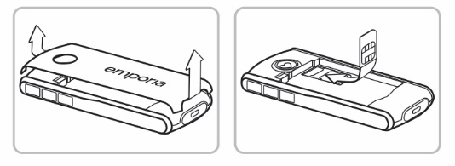

Inserting and changing the battery
Insert the battery, making sure that the battery contacts touch the phone's gold contacts. Then place the battery cover over the battery and click it firmly into place down both sides. You can then plug the charging cable into the USB port on the bottom of the phone and the power plug into a mains outlet. This process is shown in the image below.

To remove the battery, feel for the slit located at the bottom of the battery and use this to lift the battery out.

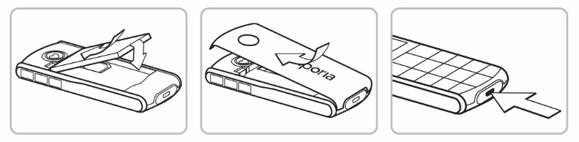
Please note
Charge the battery for at least four hours before the first time you use it. Only use batteries and chargers that are permitted for use with this specific model.

Turning the phone on
Pressing the on/off button located on the left of the phone for at least two seconds switches the phone on.

To turn the phone off, press the on/off button for two seconds again.

Saving energy
If a few seconds pass without the phone receiving any input from you, the screen will go blank to save energy. In the event of an incoming call or you press any key, the screen will automatically light up again. If the keypad is set to lock automatically, the phone will only respond if the green OK button or the keypad lock on the left side of the phone is pressed.

Using the product

The home screen
If your phone is on but not using a function, it will display the home screen. You can return to the home screen any time by pressing the red key several times.

Initial start-up procedure
When you turn on the phone for the first time, you will be prompted to select the Language. The phone should initially be set to English. Press the OK button to confirm this.

You will be promoted to set the Time and the Date. Do this using the keypad to enter the correct time and press OK to confirm.

You will then be prompted to select a Font size. Select Large or Small. Press OK to confirm.

Using the menu
Press the menu key on the left side of the phone to open the menu. The menu is a list of the phone’s various functions.

Use the up and down arrow keys to scroll through the menu. Press OK to open a menu item.

At the top of the screen, the menu item currently highlighted will be displayed. The items available in the menu are:
- Messages
- Settings
- Call History
- Contacts
- Tools
- FM Radio

Dual function keys
Some keys have additional functions if they are pressed and held down for a few seconds:
- Number one key lets you listen to mailbox
- Asterisk / star key: when pressed enters a country code when dialling for example +44 for the United Kingdom.
- Torch button: Torch on continuously when the phone is on

Calls

Incoming calls
To answer an incoming call, press OK.

To reject an incoming call, press the red key.

To mute the ringtone temporarily, press the volume down button on the side of the phone.

To end a call, press the red button.

Making a call
Enter the number, including the area code you want to dial using the keypad. Then start the call by pressing OK.

When the phone is on standby, press OK to call up your call history. Then you can press the up and down arrows to select a number. Start the call by pressing OK.

To initiate handsfree during a call, press the OK button to open the options menu. Then select handsfree by pressing OK. This will be the first option in the list.

SMS messaging
When sending SMS messages, you will have the following menu options available:
- Write message
- Received
- Unsent
- Sent
- Delete messages
- Templates
- Blocked numbers for messages
- Send contact by SMS
- SMS in Contacts
- SMS settings

Writing an SMS
To write a text message, press the menu button followed by OK to select Messages. Then press OK to select write message. You can then enter text using the keypad.

To input text, press the respective number key the required number of times for the letter you need. The symbols available vary according to which language you are using.

Press the hash key to change the input method:
- abc for lower case only.
- ABC for upper case only.
- Abc for upper and lower case.
- 123 for digits.
- Use the figure 1 key to access common punctuation marks.

Sending a message
When you have completed the message, open Options and select Send. Select a Contact from the phonebook, type in a Phone Number using the keypad or select a number from your Recent calls list.

Reading a message
When you receive a new message, an envelope will appear on the home screen.

Press the OK button to read the message immediately. You can find the text message again later in by selecting Menu, Messages, Received.

Radio
Menu options for the radio are as follows:
- Channel list
- Manual input
- Auto search
- Loudspeaker
- Information
- Exit

Searching for a station
You can set the station using the up and down arrow keys.

Adjusting the volume
You can adjust the volume of the radio using the plus and minus keys on the side of the phone. You cannot change the volume if you are in an Options menu item. In this case, close the Options menu first.

Station list
This list shows all station lists already saved.

Manual input
If you know the frequency of the station you want, you can enter it here directly. Press the hash key for the decimal point.

Auto search
This function searches for all detectable stations and saves them in the station list together with their frequencies.

Tools

Alarm
To set an alarm, open the Set time menu option. You can then enter your desired Alarm time and then Save it. The alarm is now activated and will go off at the time you have set every day. When the alarm is ringing, you can press the red key to turn it off or the green key to activate the snooze function.

Select the Off menu option to deactivate the alarm permanently.

Please note
If the phone is turned off, the alarm is turned off as well. The alarm will therefore not go off when the phone is off.

Bluetooth
Turn the Bluetooth function On. Then select the Connect menu option and turn on Search for new devices. A list of available devices will be displayed. Select the device you want to pair the phone with from the list. Then follow the phones instructions to pair the devices. Devices that have been connected before will be recognised and connected automatically.

Contacts
Menu items for contacts are as follows:
- Search name
- Add contact
- Edit contact
- Delete
- Send contact via SMS
- Copy contact
- My number
- Speed dial keys
- Emergency numbers
- Phone book settings
- SMS in Phone Book.

Searching for a contact in your phonebook
When on the home screen, press the phone book key or open Menu, Contacts, Search name. Then use the arrow keys to scroll through the entries or use the keypad to type the first letter of the contact you are looking for.

Adding a contact
Open Menu, Contacts, Add contact. Enter the person's name and the phone number and then Save them.

Please note
Always save names and numbers with the international dialling code, for example, plus 41 for Switzerland, plus 43 for Austria and plus 49 for Germany.

Saving a speed dial contact
You can assign speed-dial keys to numbers you call often. Press one of the speed-dial keys. Then enter a Name and Number or Search for a contact in the phone book. You will be asked if you want to assign a contact to the speed-dial key. Press OK to confirm. Press OK again to search your contacts using the arrow keys. Press OK to select your chosen contact and press OK to confirm.

Changing or deleting a speed dial contact
Open Menu, Contacts, Speed-dial keys. Then select a speed-dial key from the list. You can then edit or delete its link to a particular contact.

SMS in contacts
You can have phone book entries sent to you by text message that will automatically be added to your phone book. The phone number will automatically be stored in your contacts when you receive an SMS with the following content: hashtag Name, hashtag Number hashtag. For example, #Martin#+436641234567#

Open Menu, Contacts, SMS's in Contacts. Then select On or Only from Contacts.

Settings
The settings menu enables you to personalise your phone to suit your requirements. The sub-menus are as listed below.

Silent or sleep mode

Sounds and alerts
- Ringtone
- Alarm melody
- Ringer volume
- Silent/Sleep mode - Visual notifications only. Torch LED flashes and notifications appear on the screen. No ringtone and no vibration function
- Meeting and Theatre mode: Visual notifications only. Torch LED flashes and notifications appear on the screen. No ringtone and no vibration function.
- Maximum and Bus mode: Keytones, SMS tone and vibration function activated, ringtone is set on maximum.
- Increasing Ring
- Vibration for call
- Vibration for alarm clock
- Key tones
- Message Tone
- Vibra for messages
- Handset Volume
- Handsfree Volume
- Confirmation Tone
- Emergency Tone
- Display and Light

Accessibility settings
Adjust the text size, brightness, and other features of the display. Display text size can be set at small (17pt) or 'large (26pt).

Please note
These are maximum sizes for each display setting, text size will vary depending on the amount of information being displayed on the screen. To maximise everything on the display, it is important to choose large in Display set-up when setting up the phone. Please note that menu buttons on the display are 15pt, and the size of these cannot be changed.

Additional settings
- Time and date
- Language
- Text Size
- Call waiting
- Call forward
- Suppress number
- Help Texts

- Auto keypad lock: You can protect your phone against accidental pressing of keys with the keypad lock.
- Manual keypad lock: Open the Settings menu and then Auto keypad lock. Now select whether the keypad should be locked automatically after 15 sec, 30sec, 1 minute or 5 minutes inactivity or whether this function should be switched off.
- Unlocking the keypad lock Press the keypad lock key for 2 seconds. Keypad unlocked will appear on the screen. If the keypad lock is active, the phone will only respond if the green button or the key is pressed. If any other key is pressed, the screen will remain dark to save energy.

- Network Selection
- Favourite Key: You can assign a function you intend to use frequently to the up Arrow key. If you press up Arrow when the phone is on standby, the assigned function will start immediately. A phone number cannot be assigned to the favourite key. The speed-dial keys must be used for this.
- Voicemail number: Enter the number for your voicemail. You will find this number in the documents supplied by your network provider. Press and hold the one button to listen to your voicemail.
- Language
- Emergency numbers
- Emergency button
- Security Settings
- PIN: Request on/off
- Phone code: on/off, change (factory pre-set code: 1234)
- Phone book settings
- Pin code for settings Activate this safety mode to prevent changes being made to settings unintentionally.
- Master reset You can restore all the factory settings on your phone (reset code 1234

Emporia emergency call function
Read these instructions carefully and set the emergency call function according to your needs. You can save up to five emergency numbers of your family members, friends, and official institutions.

Making an emergency call
In an emergency press and hold the heart shaped emergency button on the back of the phone. The five pre-set numbers will be dialled automatically in the order you have saved them in. The phone will go through a list of five numbers a maximum of three times.

Please note
The phone is supplied with a second cover without the emergency call button as the use of this is optional.

At the same time as each emergency call, a text message (SMS) will be sent to the contact, saying: "You are about to receive an emergency call. An audible warning signal will sound when you answer the call. Please press the 0 key three times to establish the connection."

The contact must press the 0 key three times within 60 seconds, or the call will be disconnected, to prevent your emergency call going through to a contact's mailbox.

Disabling auto answer function
From the moment you make an emergency call, your Emporia phone will automatically answer any incoming calls for one hour. To disable this function, press and hold the back button for approx. three seconds or turn your device off completely using the on/off button and then turn it on again.

Cancelling an emergency call
To cancel the emergency call, press and hold the back button. New para

During the emergency call, a warning tone will sound continuously, to alert anyone nearby and the person being called.

If you do not have any emergency numbers saved, have no credit on your prepaid phone card or are connected to a foreign network without permission, when roaming is not activated, 112 will be dialled when you press the emergency button.

If you want to add the number of an official institution such as the police or fire brigade as an emergency number, you must check that this is okay with the respective institution beforehand.

Please note
We do not assume liability for any costs incurred through you calling such an institution by mistake.

Adding or editing emergency numbers
In the Settings menu, find Emergency number, then Add emergency number. Select an entry by pressing up Arrow down Arrow. Then press OK.

Activating the emergency button
Activating the emergency button In the Settings menu can be actioned by pressing the following buttons in this order:
- Emergency numbers
- Emergency button
- On/Off

Pre alarm
The pre alarm is a warning tone that sounds for ten seconds and alerts anyone nearby to the emergency call. After this the emergency call sequence starts. Activating the Pre-Alarm in the Settings menu can be done by pressing Emergency contacts, Pre-alarm, On/Off.

Guarantee and service
- Manufacturer: Emporia telecom GmbH + CoKG, Industriezeile 36, 4020 Linz, Austria
- Importer: Emporia UK and Ireland Ltd., Park Road, Cardinal Point, Rickmansworth, Herts. WD3 1RE, UK
- Contact: www.emporiatelecom.co.uk or www.emporiatelecom.ie
- Brand name: Emporia
- Model: Emporia SIMPLICITY (V27)

In the box
- Emporia Simplicity V27 mobile phone
- Extra battery cover without an emergency button.
- AK-V27 battery
- USB cable
- RL-USBC-500Ma-UK AC adaptor
- TL-V27 charging cradle

Customer support
- Emporia Service Centre is open Monday to Thursday, 09:00AM to 6:00PM, and Fridays 09:00AM to 1:00PM
- Email: service@emporiatelecom.co.uk
- UK Hotline: +44 1923 947778
- Web: www.emporiatelecom.co.uk
- IE Hotline: +353 1 5926339
- Web: www.emporiatelecom.co.ie/service

Guarantee
This guarantee is only valid if the original batteries supplied by Emporia have been used.

- Mobile phone: 12 months
- Battery: 6 months

Technical Specification
- Dimensions: 125.3 × 57.6 × 12.6 mm
- Weight: 90 g
- Battery: Li-ion 3.7 V, 1200 mAh, 4.44 Wh (replaceable)
- AC adapter: input: 100 - 240V AC, 50/60 Hz, 0.15 A; output: DC 5.0 V,0.5
- Table charging unit: input/output
- Standby time: 360 h*
- Talk time: 360 min* (*The battery life can be reduced depending on network coverage and active applications).
- Internal antenna: SAR body: 0.99 W/kg
- SAR head: 0.75 W/kg
- SAR-limbs: 0.88 W/kg
- Operating temperature range: -10°– +40° C
- Hearing Aid Compatible M4/T4
- Bluetooth V 3.0

Frequencies
- BT: 2402 MHz - 2480 MHz. Transmitter power: < 0.0028 W
- FM: 87.6 MHz - 107.9 MHz
- E-GSM 900/GPRS 900/EGPRS 900. TX: 880 - 915MHz; RX: 925 - 960 MHz
- Transmitter power: < 1.6218 W
- E-GSM 1800/GPRS 1800/EGPRS. 1800: TX: 1710 - 1785 MHz. RX: 1805 - 1880 MHz
- Transmitter power: < 0.875 W

Safety information
- Turn off the phone in hospitals and whenever you are near medical equipment.
- There should always be a distance of at least 20cm between pacemakers and the phone when it is on.
- Never try to control a vehicle while holding the phone in your hand. Always comply with relevant national laws and traffic regulations.
- Turn off the phone whenever you are travelling in an aeroplane.
- The phone must be switched off whenever it is near a petrol station or other places with explosive substances.
- Never shine the LED torch in the eyes of people or animals.
- To prevent hearing impairments, do not use the phone on a high speaker volume for extended periods of time. Do not hold the phone to your ear when the hands-free mode is activated, or the emergency button has been pressed.
- Using a headset on a high volume can cause hearing impairments. Check the volume of the headset you are using.
- The phone and the accessories may contain small parts. Keep the phone out of the reach of young children.
- As a precaution, we recommend disconnecting the phone from the charger during thunderstorms.
- The mains adapter serves as a separator between the product and your mains supply. The mains supply must be close to the device and easily accessible.

This device was tested for typical applications where the device is carried on the body. To meet the RF exposure requirements, the minimum distance between the body, in particular the user’s head, and the handset, including the antenna must be 0 cm. Belt-clips, holsters, and similar accessories from third parties used by this device must not contain any metallic components. Accessories carried on the body that do not meet these requirements may not meet the RF exposure requirements and should be avoided. Use only the device’s built-in antenna or an approved antenna.

This device in compliance with the essential requirements and other relevant provisions of Directive 2014/53/EU. All the important radio test cases have been written.

Please note
Risk of explosion if battery is replaced by an incorrect type. Dispose of the used batteries according to the instructions. The device complies with RF specifications when the device used at 5 cm from your body.

Intended use
This phone is robust and designed for mobile use. However, it still needs to be protected from moisture (rain, bathroom water) and heavy impacts.

It is only designed for European Network standards: (AT, BE, CZ, DE, DK, ES, FI, FR, GB, HR, HU, IE, IT, NL, NO, PL, PT, SE, SI, SK, SZ, TR).

Do not leave it where it will be directly exposed to the sun.

Using the phone for any purpose other than that described above will result in damage to the product. Doing this also entails hazards such as fire, electric shocks, etc. This product must not be changed or modified, and the casing must not be opened.

The adapter is only suitable for use in conjunction with a standard household mains socket that is connected to your electrical grid and uses 100-240 volts/50/60Hz (10/16A) of alternating voltage.

Disposal

Disposal of the packaging
The packaging and packaging aids are recyclable and should be recycled.

Disposal of the battery
Batteries should never be disposed of as domestic refuse! As a consumer you are legally required to return used batteries. They can be handed in at one of your community's local collection points or at specialised stores.

Disposal of the device
If this product ever wears out, please don't dispose of it as domestic refuse. To ensure you don't cause damage to the environment, take it to a collection station or recycling centre where used devices are processed for recycling in an environmentally friendly manner.

How to contact RNIB
Phone: 0303 123 9999
Email: shop@rnib.org.uk
Address: RNIB, Northminster House, Northminster, Peterborough PE1 1YN
Online Shop: shop.rnib.org.uk
Email for international customers: exports@rnib.org.uk

RNIB Technology Team:
Telephone 0207 391 2280
Email tfl@rnib.org.uk

Terms and conditions of sale
This phone is guaranteed from manufacturing faults for 12 months from the date of purchase. The battery is guaranteed for 6 months. If you have any issues with the product and you did not purchase directly from RNIB then please contact your retailer in the first instance.

For all returns and repairs contact RNIB first to get a returns authorisation number to help us deal efficiently with your product return.

You can request full terms and conditions from RNIB or view them online.

RNIB Enterprises Limited (with registered number 0887094) is a wholly owned trading subsidiary of the Royal National Institute of Blind People ("RNIB"), a charity registered in England and Wales (226227), Scotland (SC039316) and Isle of Man (1226). RNIB Enterprises Limited covenants all its taxable profits to RNIB.

This product is CE marked and fully complies with all applicable EU legislation.

This product is UKCA marked and fully complies with the relevant UK legislation.

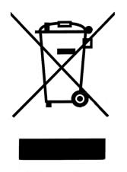

Please do not throw items marked with this symbol in your bin. Recycle your electricals and electronic devices free at your local recycling centre. Search for your nearest recycling centre by visiting www.recyclenow.com.

Why recycle?
Unwanted electrical equipment is the UK’s fastest growing type of waste.

Many electrical items can be repaired or recycled, saving natural resources and the environment. If you do not recycle, electrical equipment will end up in landfill where hazardous substances will leak out and cause soil and water contamination – harming wildlife and human health.

RNIB are proud to support your local authority in providing local recycling facilities for electrical equipment.

To remind you that old electrical equipment can be recycled, it is now marked with the crossed-out wheeled bin symbol. Please do not throw any electrical equipment (including those marked with this symbol) in your bin.

What is WEEE?
The Waste Electrical or Electronic Equipment (WEEE) Directive requires countries to maximise separate collection and environmentally friendly processing of these items.

How are we helping?
In the UK, distributors including retailers must provide a system which allows all customers buying new electrical equipment the opportunity to recycle their old items free of charge. As a responsible retailer, we have met the requirements placed on us by financially supporting the national network of WEEE recycling centres established by local authorities. This is achieved through membership of the national Distributor Take-back scheme (DTS).

Date: June 2022

© RNIB

