OrCam Read (HT387)
Thank you for purchasing from RNIB. In the unlikely event the item is unsuitable, please contact us within 14 days of receipt to obtain your returns number. To ensure your return goes smoothly, the item and all components must be in as new condition and packed in its original, undamaged packaging. For further details and guidance on returning faulty items, please see the Terms and conditions of sale and How to contact RNIB sections of this instruction manual.

Please retain these instructions for future reference. These instructions are adapted from the manufacturer’s user guide and is also available in other formats.

Contents
General description 2
What’s in the box 2
Hardware orientation 2
Getting started 4
Charging your OrCam Read 4
Turn on your OrCam Read device. 4
Turn off your OrCam Read device. 4
Enter Suspend mode 5
Exit Suspend mode. 5
Automatic Suspend and Power Off 5
Reading with OrCam 5
Reading with Trigger Button 5
Reading Navigation 6
Laser Pointer Modes 6
Settings and Connectivity 6
Menu Settings configuration 6
Settings Menu layout 7
Connecting to Wi-Fi 7
Connecting to Bluetooth Audio Device 7
Volume Setting 8
Smart reading commands 8
Voice commands 8
Tips 10
OrCam customer support 11
RNIB Technology Support 11
How to contact RNIB 11
Terms and conditions of sale 11
Why recycle? 12
What is WEEE? 13
How are we helping? 13

General description
OrCam Read is a highly sophisticated lightweight smart camera. Using AI technology, it instantly reads any printed or digital text from books, newspapers, smartphone screens, computers, and more. It is intuitively operated, with just the press of a button. Either listen via the mini speaker on the device or through headphones (wired or Bluetooth). OrCam Read is the most efficient smart pen on the market, with Speed Reading and the only one with Full Page Capture. It is designed for all ages and does not require an internet connection.

What’s in the box
- OrCam Read
- Charger
- Cleaning cloth
- Neck lanyard

Hardware orientation

Front
Short flat side. Houses the camera and lasers.

Back
Short round ended side. Houses the audio outlet (AUX).

Top
Long side with tactile buttons. From front to back (flat to rounded ends); round Trigger button, plus and minus volume buttons, four power indicator LED lights, rectangular power button, charging outlet (USB C) and at the very end an eyelet loop to thread the lanyard through.

Bottom
Long flat side.

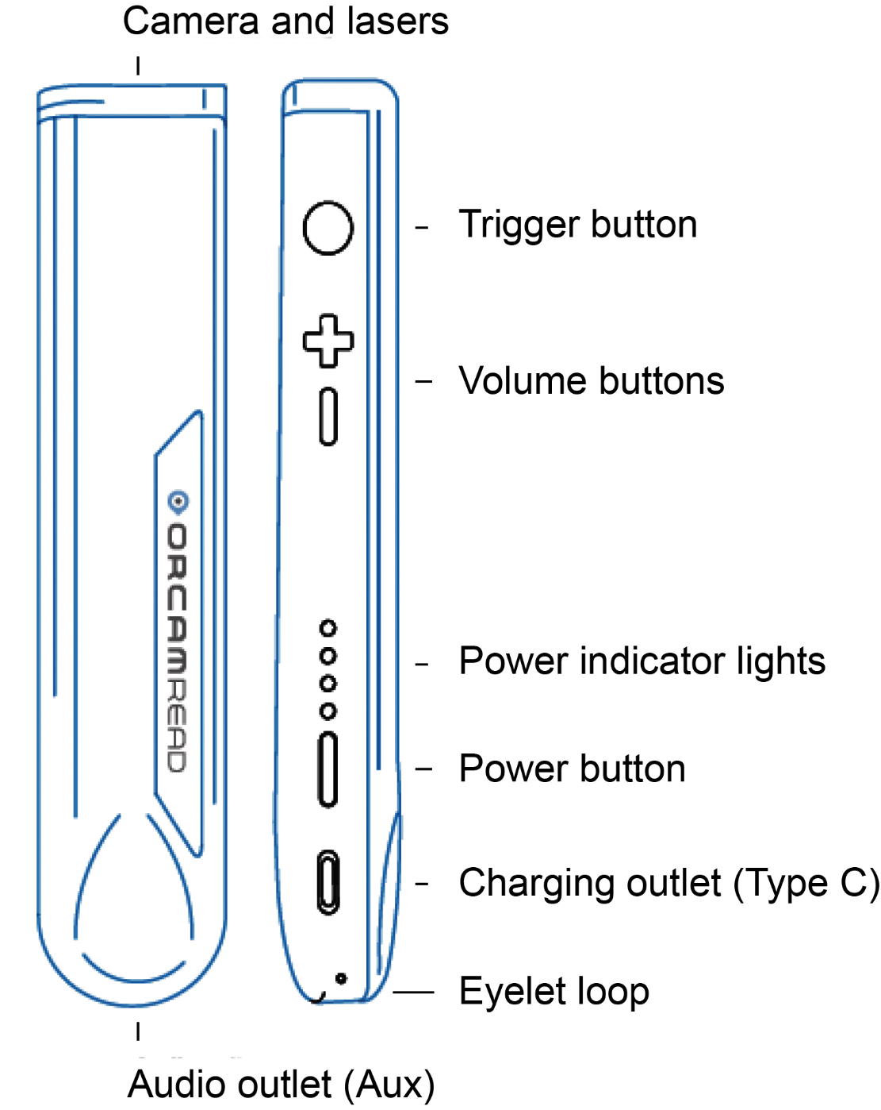

Getting started

Charging your OrCam Read
- Attach the OrCam charger cable to the type-C outlet on the side of the OrCam Read.
- Plug the charger into an electrical socket.

For the initial charge, be sure to charge to maximum capacity - leave plugged in for at least three hours.

The OrCam Read fully charges in 90 to 120 minutes.

OrCam recommends using only the original OrCam
charger provided.

Turn on your OrCam Read device.
- Press the power button on the side of the OrCam Read for about two seconds.
- The laser-light box will start blinking red.
- After about one minute you will hear, “OrCam Read is ready. Battery is [x] per cent charged.”

Note. If you did not hear the phrase, “OrCam Read is ready”, or you are not sure that the OrCam Read is on, touch the trigger button. If the device is on, you will hear a response.

Turn off your OrCam Read device.
- Press the power button once. You will hear, “Suspending. Press again to shut down.”
- Press the power button again. You will hear, “Shutting down, please wait.”
- Just before the unit shuts down, you will hear, “Power off. Bye bye.”

Note. When you turn the OrCam Read on or off, it is recommended to listen to the system messages.

Enter Suspend mode
Press the Power button once. You will hear, “Suspending. Press again to shut down”, and then “Suspending” as the device enters Suspend Mode.

Exit Suspend mode.
- Press the trigger button twice or press the power button.
- You will hear, “Waking up. Battery is [x] per cent charged.”

Automatic Suspend and Power Off
- The OrCam Read automatically enters suspend mode after three minutes of inactivity. This timeframe can be adjusted in the setup menu.
- The OrCam Read powers itself off after three hours in suspend mode.

Note. When left dormant for the set “automatic suspend time”, suspend mode automatically begins and a small beep is played (no “suspending” announcement will be heard), and will wake up when touched, accompanied by a small beep (and not announce, “waking up”).

Reading with OrCam

Reading with Trigger Button
- Hold the OrCam Read steady, directly facing the text at about six to 14 inches (15 to 35 cm) away from the text.
- Press the trigger button, which will activate the laser indicator and a square frame will be projected on the text.
- Adjust the laser square frame to capture the desired text.
- Continue to press down and after two seconds the camera shutter will sound as OrCam Read takes a picture of the text.
- OrCam Read will make several beeps as it processes the text. It will then begin reading.

Note. If your finger is released before two seconds transpire, the camera will not be activated.

Reading Navigation
- To pause reading, press the trigger button twice.
- To resume reading, press the trigger button twice.
- To skip forward, press on the plus (+) button (same button as raising volume).
- To skip back, press on the minus (-) button (same button as lowering volume).
- To stop reading, press the trigger button.
- When OrCam Read completes reading, it will make a chime sound.

Laser Pointer Modes
You can switch the laser pointer mode by pressing the trigger button twice.

There are two Laser Pointer Modes.

- Border: for reading framed text.

- Mouse: to start reading at a specific location.

Note: The OrCam Read captures the selected text within two seconds of holding the trigger button.

Settings and Connectivity

Menu Settings configuration
To customize your OrCam Read's settings via the audio settings menu:
- Hold the power button.
- Press + or - volume button.
- Release the power button.
- The device will announce: “Main Menu, reading rate menu, press button to select or use volume buttons for other settings”.

You can now configure your device settings by simply using the volume plus or minus (+ or -) buttons and the trigger button.

To exit the menu, press the trigger button twice.

Settings Menu layout
- Reading Speed
- Volume
- Reading Settings
- Connectivity Settings
- General Settings
- Exit

Connecting to Wi-Fi
Prior to connecting to Wi-Fi, make sure to connect your OrCam Read to the charger.

- On your computer or smartphone, go to OrCam.com/WiFiSet
- Follow the instructions on the screen to connect to your Wi-Fi network.
- A QR code will then appear on the screen.
- Point the OrCam Read device at the QR code on the screen.
- OrCam Read will chime and make several beeps as it scans the QR code and connects to the Wi-Fi network. It will notify when connected.
- Once you have connected your Wi-Fi network, OrCam Read will automatically check and install software updates every time you connect to the charger in your Wi-Fi network.

Connecting to Bluetooth Audio Device
- Use Bluetooth to connect your OrCam Read to an external speaker or headphones.
- On the speaker or the headphones, press the Bluetooth pairing button. You may then hear pairing-beeping sounds from the Bluetooth audio device.
- On your OrCam Read: Enter the settings menu. Select Connectivity Settings menu, then select Bluetooth settings.
- Choose “Press the trigger button to connect to a Bluetooth audio device or use volume buttons for other settings.” OrCam Read will list available Bluetooth audio devices.
- Press the trigger button to select the device to which you want to connect.
- OrCam will connect to the selected speaker or headphone. You may hear “connected” from the Bluetooth audio device.

Volume Setting
- To increase the volume, press the plus (+) volume button.
- To decrease the volume, press the minus (-) volume button.

Note: OrCam has 10 volume levels. OrCam Read will announce when the maximum or minimum level is reached.

Smart reading commands

Voice commands

Smart Reading
This command starts the OrCam Read smart reading feature.

Help
This command will have the OrCam Read tell you all the available
commands.

Read everything
This command will have the OrCam Read announce everything within its field of view.

Start from “X” / Jump to “X”
Both commands will have the OrCam Read find the first instance of the word you spoke and start reading from the beginning of the sentence.

Read the dates
This command will have the OrCam Read announce every date found in the text.

Read the phone numbers
This command will have the OrCam Read announce every phone number found in the text.

Read the amounts
This command will have the OrCam Read announce every currency
amount found in the text. The current supported currencies are:
$ Dollar currencies (including USD)
£ British Pound
€ Euro
¥ Japanese yen

Previous
This command will have the OrCam Read announce the previous instance.

Next
This command will have the OrCam Read announce the next instance.

Repeat
This command will have the OrCam Read repeat the last
sentence.

Read the headlines
This command will have the OrCam Read find all headlines in the text and read them one after the other.

Read article number X (X can be numbers 1 to 10)
After reading the headline, speaking this command will have the
OrCam Read announce whichever article number you requested.

Read the first article/second article (up to tenth article)
Same as “Read article number X”.

Read the article about “X”
This command will have the OrCam Read find and read the article
that contains the word you say. Note: “X” is a placeholder for the
word you are searching.

Restart
Should the Smart Reading feature not be functioning properly, you
can say this command to restart the mode instead of exiting and
re-entering.

Volume Up
OrCam Read will raise the device’s volume.

Volume Down
OrCam Read will lower the device’s volume.

Reading Speed Up
OrCam Read will now speak and read faster.

Reading Speed Down
OrCam Read will now speak and read slower.

Exit
This command will exit the OrCam Read’s Smart Reading feature.

Tips
- For optimal text reading, ensure that the camera lens is directly facing the text, and the lens is clean. The camera can only read text in its field of view.
- Make sure you do not move text you would like OrCam Read to read while the device is capturing the text.
- For optimal use of the automatic page recognition feature, make sure at least three edges of the page are in the camera’s field of view.
- If you are having trouble keeping the text steady, a book stand is recommended.

OrCam customer support
For more tips, advice, and troubleshooting, contact OrCam’s customer support.

Email: Support@Orcam.com
Phone: 0800 358 5823

RNIB Technology Support
For information or advice on technology that will be suitable for your needs, please contact our team on 0303 123 9999 and speak to one of our advisors within the Sight Loss Advice Service.

How to contact RNIB
Phone: 0303 123 9999
Email: shop@rnib.org.uk
Address: RNIB, Northminster House, Northminster, PE1 1YN
Online Shop: shop.rnib.org.uk

Email for international customers: exports@rnib.org.uk

Terms and conditions of sale
This product is guaranteed from manufacturing faults for 24 months from the date of purchase. If you have any issues with the product and you did not purchase directly from RNIB then please contact your retailer in the first instance.

For all returns and repairs contact RNIB first to get a returns authorisation number to help us deal efficiently with your product return.

You can request full terms and conditions from RNIB or view them online.

RNIB Enterprises Limited (with registered number 0887094) is a wholly owned trading subsidiary of the Royal National Institute of Blind People ("RNIB"), a charity registered in England and Wales (226227), Scotland (SC039316) and Isle of Man (1226). RNIB Enterprises Limited covenants all of its taxable profits to RNIB.

This product is CE marked and fully complies with all applicable EU legislation.

Please do not throw items marked with this symbol in your bin. Recycle your electricals and electronic devices free at your local recycling centre. Search for your nearest recycling centre by visiting www.recyclenow.com.

Why recycle?
Unwanted electrical equipment is the UK’s fastest growing type of waste.

Many electrical items can be repaired or recycled, saving natural resources and the environment. If you do not recycle, electrical equipment will end up in landfill where hazardous substances will leak out and cause soil and water contamination – harming wildlife and human health.

RNIB are proud to support your local authority in providing local recycling facilities for electrical equipment.

To remind you that old electrical equipment can be recycled, it is now marked with the crossed-out wheeled bin symbol. Please do not throw any electrical equipment (including those marked with this symbol) in your bin.

What is WEEE?
The Waste Electrical or Electronic Equipment (WEEE) Directive requires countries to maximise separate collection and environmentally friendly processing of these items.

How are we helping?
In the UK, distributors including retailers must provide a system which allows all customers buying new electrical equipment the opportunity to recycle their old items free of charge. As a responsible retailer, we have met the requirements placed on us by financially supporting the national network of WEEE recycling centres established by local authorities. This is achieved through membership of the national Distributor Take-back scheme (DTS).

RNIB creation date: May 2021.
OrCam creation date: Software Version 9.1-EN, November 2019

© 2021

