TactPlus.™

Tactile graphic printer

User manual

Index
Introduction 3
Chap. 1. Outline of TactPlus. 5
1. Name and function of each item 5
2. Rear View 6
3. Accessories 6
4. Power/Message Lamp 6
5. Voice Guidance 7
6. Dedicated Paper 7
Chap. 2. Installation 7
1. Space for installation 7
2. Operating conditions 7
3. Note 8
Chap. 3. How to connect 8
1. Caution (Installation) 8
2. Inserting the Power cord 9
3. Connection with USB cable and PC 9
Chap. 4. USB Printer Driver Installation 10
1. Related Software 10
2. Installation procedure for Printer Driver with USB 10
3. Installation Printer Driver with USB 11
4. Uninstallation of Printer Driver 12
5. Delete setup application 13
Chap. 5. How to connect with Wired LAN/Wi-Fi 13
1. How to connect with Wired LAN 13
2. How to connect with Wi-Fi 15
3. Add Wi-Fi mode 17
Chap. 6. Add the second printer 17
1. Add the second printer 17
Chap. 7. Set Dedicated Swell paper 18
1. Set Swell (dedicated) paper 18
Chap. 8. How to Print 19
Chap. 9. Printer driver Specification 20
How to open Properties 21
Chap. 10. Voice Guidance and Message on display 21
Chap. 11. Power/Message Lamp 24
Chap. 12. FAQ 26
1. Printer is not turned on 26
2. Printer is working, but Print preparation is not
completed 26
3. Printer is ready, but print won't start after sending data 26
4. Printer is working, but paper is not foamed 26
5. Paper is foamed, but too low/tall/rough 27
6. Would like to adjust volume of Voice Guidance 27
7. Paper is jammed 27
8. Paper is not fed properly 27
9. Other troubles 28
Chap. 13. Product Specification 28
Chap. 14. Registered Trade mark & Description 30
Chap. 15. Service support/Purchase of dedicated paper/ Manufacture 30
Chap. 16. Operation Manual Revision history 30

Introduction
Thank you for buying our TactPlus. printer.

This printer can produce both braille and tactile image at the same time unless this is something the customer has to do, eliminate it.

Name of "TactPlus" is overseas edition of EasyTactix made by SINKA Corporation. Read carefully this manual before using this product.

Quick start guide meaning of symbols
Please understand the meaning of symbols before you read this manual.

[Image: prohibited]
Prohibited operation

[Image: caution]
Hazardous situation

Reprinting of part or the whole of the contents of this document is strictly forbidden.

The contents of this book are subject to change without notice in matters of improved function.

Interroll does not accept any liability for malfunctions or defects due to nonobservance of this manual.

Trademark
All named products and descriptions are trademarks and/or registered trademarks of the respective manufacturers and are accepted as protected.

Microsoft, Windows, Aero, Windows Live, Access, Excel, Excel, Excel logo, Office logo, OneNote, Outlook, PowerPoint, Windows Media, Windows logo, and Windows Start are registered trademark by Microsoft USA or related company.

TactPlus.™ is registered trademark of Kanematsu Corporation and is accepted as protected.

Contact and Inquiry
Kanematsu Corporation
1-2-1, Shibaura, Minatoku, Tokyo, Japan

North & South America Tel: +1 732 271 7561

Europe (incl. Middle East, Africa) Tel: +49 211 3689 234

South East Asia (incl. India, Oceania) Tel: +66 2 632 8077

Other Region Tel: +81 3 5440 8468

Chap. 1. Outline of TactPlus.

1. Name and function of each item
[Image: Diagram of the TactPlus. printer, labelled with the features listed below]

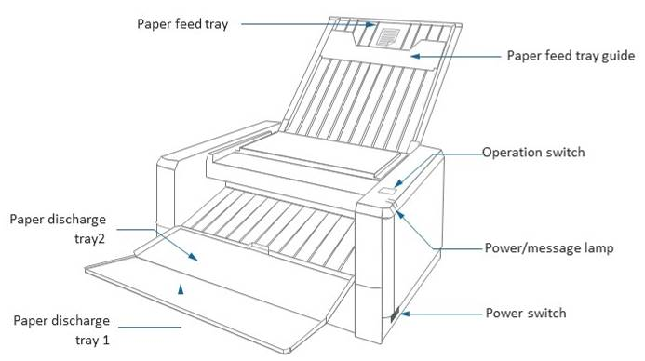

Power switch [located on the bottom right-hand side of the printer unit, close to the front edge]. When the power is turning on, switch is placed on rear side. When the power is turning off, switch is placed on front side.

Operation switch [located on top of the printer unit to the front right-hand side].

Power/message lamp [LED lights in front of the operation switch]. Display the machine status with two LED lamps.

Paper feed tray [located on top of the printer, extends to support the paper as it is loaded into the printer]. Paper feed tray for printing.

Paper feed tray guide [a slide on the extended paper feed tray to hold the paper in place]. Hold a sheet before printing.

Paper discharge tray 1/2 [a fold-out tray located at the front of the printer]. Receive the sheet after printing.

2. Rear View
[Image: Diagram of the rear of the TactPlus. printer, labelled with the features listed below]

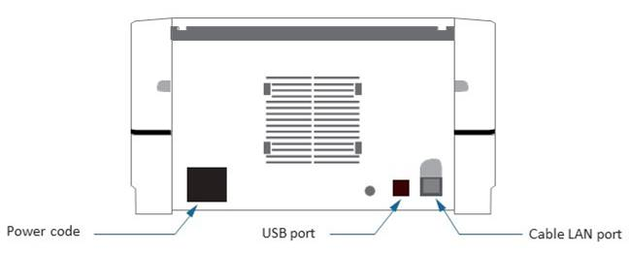

Power cord [large socket located at the bottom left-hand side of the printer unit (when viewed from behind)]. Connect the power cord and cable.

Cable LAN port [located at the bottom right-hand side of the printer unit]. Port for connecting PC and Cable LAN.

USB port [located to the left of the Cable LAN port]. Port for connecting PC and printer.

3. Accessories
(Please first check the box contents.)

- CD-ROM (USB printer driver/Add-in software for Microsoft WORD® & Excel®/operation manual)
- Quick start guide

4. Power/Message Lamp
This machine displays status with two lamp colors.

For details, see the P24. "Power/Message Lamp Description".

5. Voice Guidance
Audio guide is built-in this machine.

For details about sound guidance, see the P.21 "Audio guide".

6. Dedicated Paper
[Image: caution]
Use the genuine three-dimension sheet only, because other sheets may cause trouble.

Chap. 2. Installation

1. Space for installation
[Image: caution]
Install this machine in the location which satisfies the following conditions:
- Area with no direct sunlight and not dusty.
- Area of low humidity and not exposed to the spilled liquid such as water, oil and chemicals.
- Area distant from any magnetism or radio wave generating equipment such as TV and wireless system.
- Level, solid and stable area.
- The gap of 10 centimeter or more shall be set around the machine.

2. Operating conditions
Operating Temperature: 10-30°C

Operating Humidity: 35-70% RH (no condensation)

3. Note
[Image: caution]
Carry carefully so as not to cause falling or hurting. The body weight is 4.9kg.

Carry roughly or shaking will be the cause of trouble.

[Image: Removing the power cable]
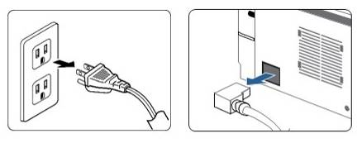
Turn off, plug out the power cable and take off cable before carrying.

Do not pull the cable harder but pull the power plug when you pull the cable.

Chap. 3. How to connect

1. Caution (Installation)
[Image: caution]

All the connection has to be done after verifying that the power switch is turned OFF.

2. Inserting the Power cord
[Image: Connecting the power cord]
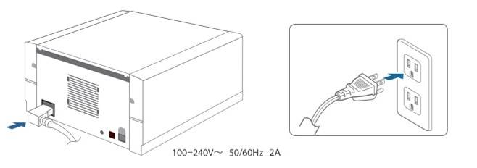
Verify that the power switch is turned off then insert the power cord to the power outlet [the power socket is located to the rear of the printer unit towards the bottom left-hand side].

100-240V

50/60Hz

2A

3. Connection with USB cable and PC
[Image: Diagram of the rear of the printer unit, showing the location of the USB port]
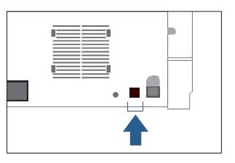
Verify that the power switch is turned off then insert the USB cable which is connected PC to USB port [the USB port is located to the rear of the printer unit at the bottom right-hand side (it is the left-hand port of the two ports found there)].

Refer to P15 "How to connect with Wi-Fi", P13 "How to connect with Wired LAN" regarding other connection.

[Image: caution]
Turn off the power switch before any connecting.

Connect before turning on.

Chap. 4. USB Printer Driver Installation

1. Related Software
The procedure to install add-in braille translation software, see "installation manual of add-in software".

2. Installation procedure for Printer Driver with USB
To print with this machine, the USB driver and the application software for USB driver shall be installed.

Note: in the case of printing braille, see "Installation manual of add-in software".

Supported OS: Windows® 7/8.1/10 (32/64 bit)

(1) Power on your personal computer and then insert the attached CD-ROM.

(2) Run one of the following files included in the CD-ROM depending on your PC specifications:
1. In the case of 64-bit PC: ETXDRV64.msi
2. In the case of 32-bit PC: ETXDRV.msi

(3) Click "Next".

(4) Review the license agreement and, if you agree, check the "I accept the terms of the license agreement" then select "Next" to continue.

(5) Confirm the folder to be installed then click "Next".

(6) The PC is ready for installation. Check the "installation" button then install the software according to the guidance on the screen.

(7) The setup wizard has been completed. Click the "Finish" button to quit.

Follow below procedure for connecting printer with USB cable.

See operation manual for installing driver when you use Wi-fi or LAN cable.

3. Installation Printer Driver with USB
(1) Click "EasyTactix Setup" from Start menu.

(2) Click "Printer setting". [The dialogue box shows two options buttons. The "printer setting" button is on the left.]

(3) Click "OK".

(4) Close all the software, then click "reboot". [The dialogue box shows two options buttons. The "reboot" button is on the left.]

(5) After rebooting, this window [Printer installation/
uninstallation] automatically appears, click "printer setting". [The dialogue box shows two options buttons. The "printer setting" button is on the left.]

(6) Click "OK".

(7) Connect machine and USB cable then turn on the power.

[Image: caution]
Turn off the power when you pull the cable.

(8) Click "OK" for installing Printer.

(9) Click "Install". [The dialogue box shows two options buttons. The "Install" button is on the left.]

(10) [A window containing the text "Printer installation was successful" appears.] Click "OK".

(11) Click "close".

When you cannot success to install driver, follow the step next page.

4. Uninstallation of Printer Driver
To uninstall Driver, "Delete the driver" and "Delete setup application" are needed.

Delete the driver (Windows 10)
(1) From the start menu, click "EasyTactix Uninstaller" in folder.

(2) Click "uninstall". [A dialogue box with two options buttons appears. The uninstall button is on the right.]

(3) [A window titled "ETXSetup" appears] Click "OK"

(4) [A second window, titled "ETX80Setup" appears] Click "OK"

(5) To finish the uninstallation, reboot Windows and follow the step "Delete application" in the next page.

5. Delete setup application

For Windows 10
(1) From the start menu, click "setting" and activate app. Then, click "system".

(2) From the "Apps & features", select EasyTactix.

(3) After opening dialog, click "Uninstall" [the right-hand button in the window].

(4) [A dialogue box appears containing the text "This app and its related info will be uninstalled."] Click "Uninstall".

(5) Once progress bar is closed, uninstallation is finished.

For Windows 7
(1) Open Control panel, and click "Program & features".

(2) Right click on "EasyTactix" from "Apps and features" then choose "Uninstall".

(3) [A dialogue box appears containing the text "Are you sure you want to uninstall EasyTactix?".] Click "Yes" [the left-hand of the two button options].

(4) Once progress bar is closed, uninstallation is finished.

Chap. 5. How to connect with Wired LAN/Wi-Fi

1. How to connect with Wired LAN
For connecting with USB cable, follow the step "ch3. How to connect".

[Image: caution]

Limitation of interface
Please connect with one interface from Wired LAN/Wi-Fi/USB interface. The printer is not supported multi interface connection.

Preparation

Install application of USB printer driver (P.10) with USB mode beforehand.

And connect between printer and USB cable.

(1) Open EasyTactix folder, and click "EasyTactix Navigator".

(2) Select "Wired LAN" from the menu.

Using DHCP (Dynamic Host Configuration Protocol)
(3) Select "Use DHC" in "3. IP address acquisition method" field. Then click "8. Connection (Printer IP setting)".

After few seconds, the answer will be returned that connection was successful or not. If failed, contact to network administrator.

Using IP address
(4) Select "Manually set static IP address" in "3. IP address acquisition method" field.

Then type static IP address, net mask, gateway, DNS etc. Once everything is finished, click "8. Connection (Printer IP setting)".

After few seconds, the answer will be returned that connection was successful or not. If failed, contact to network administrator.

(5) Follow the step "3. Add Wi-Fi mode " for both connections.

2. How to connect with Wi-Fi
For connecting with USB cable, follow the step "ch3. How to connect".

[Image: caution]

Limitation of interface
Please connect with one interface from Wired LAN/Wi-Fi/USB interface. The printer is not supported multi interface connection.

Note for Wi-Fi connection
Normally printer will automatically connect through Wi-Fi but when Wi-Fi is not connected because of radio wave state, (blue light is not lit) turn off/on the printer and check Wi-Fi is working properly (blue light will be lit).

Preparation

Install application of USB printer driver (P.10) with USB mode beforehand.

And connect between printer and USB cable.

(1) Open EasyTactix folder, and click "EasyTactix Navigator".

(2) Select "Wi-Fi " from the menu.

(3) In the "HOST", connectable Wi-Fi host will be displayed. If it is not appeared after a while, confirm the connection with printer and click "search".

Select Wi-Fi (Using DHCP <Dynamic Host Configuraton Protocol>)
(4) When using static IP address, follow the step (8). Select SSID of Wi-Fi router which you want to use.

SSID is written on router itself or manual of router or contact network administrator.

(5) Put "Security Key" which is written on router or manual, or ask network administrator. The way to get IP address is to select "Use DHCP". After choosing, click "8. Connection (Printer IP setting)".

(6) After few seconds, the answer will be returned that connection was successful or not. If it failed, check the security key and try again. If it still fail, contact to network administrator.

(7) If it successed, the value of printer when setting the driver will be displayed in the field of "statistic IP address". Port name will be set automatically. When you want to change IP address you can also use this field.

If you want to add PC connecting with printer, follow the step "D. Add second Printer".

Select Wi-Fi (Using static IP address)
(4) Select SSID of Wi-Fi router which you want to use.

SSID is written on router itself or manual of router or contact network administrator.

(5) Put "Security Key" which is written on router or manual, or ask network administrator. The way to get IP address is to select "Manually set static IP address". After choosing, click "8. Connection (Printer IP setting)".

(6) After few seconds, the answer will be returned that connection was successful or not. If failed, check the security key you typed, and try again.

If still failed, contact network administrator.

Then follow the step "3. Add Wi-Fi mode".

3. Add Wi-Fi mode
(1) Click "Add printer".

(2) When finishing job, click "close".

(3) Open "devices and printers" from control panel and check "EasyTactix (network)" is added.

If you use Windows 10, you can also find from setting. Click "devices" and printer and scanner will be displayed.

Chap. 6. Add the second printer

1. Add the second printer
Preparation

Install application of USB printer driver (P.10) with USB mode beforehand. Ask network administrator about IP address and keep it.

(1) Open EasyTactix folder, and click "EasyTactix Navigator"

(2) Check "Administrator function".

(3) Put IP address of connecting printer which keeped in a memo.

(4) Put "Port name" in the field. Ex: designate same IP address of printer.

(5) Follow the step "3. Add Wi-Fi mode" (P17).

Chap. 7. Set Dedicated Swell paper

1. Set Swell (dedicated) paper
(1) Open top cover and exit tray. [Lift and extend the paper feed tray and fold open the paper discharge trays.]

[Image: Opening out the paper feed and paper discharge trays]
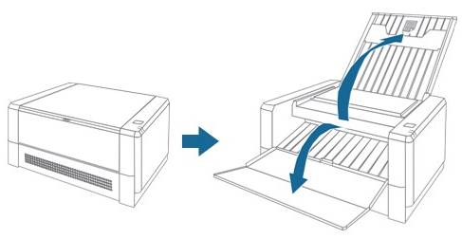

(2) Set the paper to the Paper feed tray as the light gray color will be upper side. [The light gray colour is the front side of the paper and is smoother to the touch than the reverse side.]

[Image: caution]
Smooth texture side will be upper side when you touched the surface.

Note: Please set paper one by one.

When closing Paper feed tray, move back Paper feed tray guide to original position.

[Image: Using the paper feed tray guide]
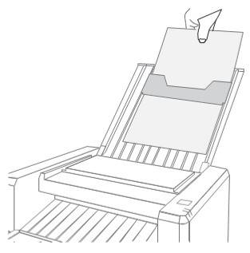

Note: Please use only dedicated swell paper for TactPlus. If other paper is used, it might cause of the problem.

Chap. 8. How to Print

1. Printing

1. Start the printing
Ex: Word Printing

(1) Select "EasyTactix" from Print menu.

Note: The property setting both when printing "only braille" and "braille & graphic".

You can refer to "ch 9. Printer driver specification" (P20).

(2) Click "Print".

2. Finish the printing
[Image: caution]
Note: Do not pull out paper when printing, it might cause out of order.

Chap. 9. Printer driver Specification
When you would like to open printer driver Properties, in the software which you use, select "Print menu" and then "EasyTactix" as printer from the menu. And After clicking the "Preferences ...", you can find properties.

To open screen below from start menu, follow the step "How to open properties".

(1) Click "Preferences ...". You can choose orientation and print order.

(2) The screen when you click "Advanced ..."
1. You can choose "copy count". If you already chose copy count in software, you do not need to choose here.
2. Using "Voice Guidance", you can choose volume OFF (silent)/Small/Middle/Big. Regarding how to set up, follow the step PO.
3. Using "Document Option", you can choose print mode from "Braille/Braille-Graphic/Other"
Braille ... For print data composed of only braille.
Braille-Graphic ... For print data composed of Braille and Graphic.
Other ... not used at the moment.
4. Print speed can be changed from 0 (slow) - 6 (fast).
When lowered speed, foaming will be higher.
When higher speed, foaming will be lower.
Recommended speed is 3 (standard).

Using "Other Temperature setting" you can change temperature. However, it is not normally used.

How to open Properties (Windows 10)
Follow the step below for opening Printer Properties.

(1) Click "Settings" [from your PC's Start menu].

(2) Click "Devices".

(3) Click "Printers & Scanners".

(4) Select "EasyTactix" and click "Manage".

(5) Click "Printer Properties".

(6) Click "Preferences ...". Then move to point (1) in P20. Follow the step from page above.

Chap. 10. Voice Guidance and Message on display
This printer has "Sound Guidance function" and "Message on Display function".

Regarding sound volume adjustment, follow the step (5) in Ch. 9. Printer Driver Specification.

See the list of "Sound Guidance" and "Message on Display". And follow "Counter measure" when problem happened.

[In the original print, there is a further column, labelled "Message on display". There are, however, no entries under this column heading and it has not been included here.]

Sound Guidance | Status | Counter measure
Power switch turned on. | Turning on
Ready to print. | Ready for printing
Now printing. | Printing
Finished printing. | Printing is finished
Paper empty. Set paper and press the operation button. | Paper is not set | Set dedicated paper in the paper feeder.
Paper has not reached the transport section. Long press the operation button, Paper will be forced out to the output tray. | Paper jam | Push operation button for a while and start ejection.
Paper is not properly transported. Long Press the operation button, Paper will be forced out to output tray. | Paper was fed as the paper is tilt | Push operation button for a while and start ejection.
Papers overlapping. Long Press the operation button, Paper will be forced out to the output tray. | Double feeded | Push operation button for a while and start ejection.
Paper jammed. Long Press the operation button, Paper will be forced out to the output tray. | Paper jam | Push operation button for a while and start ejection.
Paper Force to output tray has started. | Eject paper forcibly
Paper Force to output tray has completed | Finish paper ejection
Paper remains in the transport section. Turn off the power and remove the paper in the input and output tray. | Paper jam | If paper is not ejected after pushing button, follow below step. (a) If you can grab paper from ejection side, pull it out slowly not to tear. (b) If you still cannot pull out, call the service center.
Ready to resume printing. Set paper and press operation panel. | Printer is recovered and can print again | Set the paper and push the operation button.
You have attained your maximum printing count. Please contact your vendor | Roller has problem | Call the service center.
Thermal head failed. Please contact your vendor | Print head has problem | Call the service center.
Paper feed motor failed. Please contact your vendor | PM motor has problem | Call the service center.
Preparing to print. Please hold | Preparing for printing
 | Status which TPH excessed proper value. Once TPH cool down, automatically recover original status.
System will now update the firmware. Do not turn off the system during the update, as it may cause the system to fail | Firmware auto updating | Wait for a moment without turning off until you hear the sound "version up is finished".
Firmware update complete. System will automatically restart. | Firmware updating is done | Turn off the printer.
 | Fun has problem | Call the service center.
 | Operation panel has problem | Call the service center.

Chap. 11. Power/Message Lamp
Two LED lamps which installed right side show Printer Status.

[Image: Diagram showing the LED lamps which are located to the front right-hand side of the printer unit]
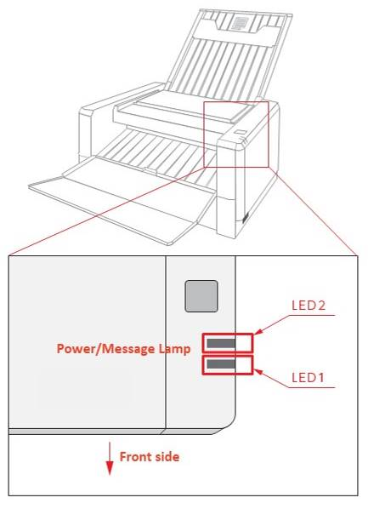

Regarding detailed status by each color, see below list.

LED1 | LED2 | [Status]
Green/Blinking | – | Prepare for Printing or Printing
Green/Light | – | Printer is ready
 | Blue/Blinking | Connecting Wired LAN/Wi-Fi
 | Blue/Light | Stand by Wired LAN/Wi-Fi
Red/Blinking | Red/Blinking | Recoverable error
Red/Light | – | Not recoverable error

Chap. 12. FAQ

1. Printer is not turned on
Check power cable is connected with printer and outlet properly.

If cable is connected properly but it is not turned on, call the service center.

2. Printer is working, but Print preparation is not completed
When printer shows message from "Voice Guidance or Message on screen", or "Power/Message Lamp" is shown, follow the step ch 10.

If problem still cannot be solved, call the service center.

3. Printer is ready, but print won't start after sending data
(1) Check Printer "EasyTactix" is selected before printing.

(2) See LED lamps (Power/Message Lamp) status have no problem.

(3) If printer driver is not installed properly, uninstall the driver and install again.

(4) If there is no solution from (1) to (3), or not be solved, contact the service center.

4. Printer is working, but paper is not foamed
(1) Check using dedicated paper. Do not use other paper.

(2) Follow the step Ch. 9 "Printer Driver Specification".

(3) Check the setting and if still cannot be solved, contact the service center.

5. Paper is foamed, but too low/tall/rough
(1) Check using dedicated paper. Do not use other paper.

(2) Follow the step Ch. 9 "Printer Driver Specification".

(3) Check the setting and if still cannot be solved, contact the service center.

6. Would like to adjust volume of Voice Guidance
Refer to Ch. 9 "Printer Driver Specification".

You can set OFF (silent)/Small/Middle/Big.

When you still cannot adjust the volume, contact the service center.

7. Paper is jammed
(1) Press operation button for more than three seconds and check paper is fed out.

(2) If paper is remain in the printer and cannot take it out, contact the service center.

8. Paper is not fed properly
(1) Check the paper is set only one to supplying tray without tilting.

(2) Check the paper is dedicated paper. You cannot use other paper.

(3) If "Voice Guidance", "message on screen" or Power/message Lamp are shown abnormality, follow the step Ch. 10.
(4) If there is no solution above, call the service center.

9. Other troubles
(1) When connecting multi option components, you may feel electricity sometimes.

In such case, ground from printer or optional components or PC etc. When using this printer, do not use conversion plug and recommend to use three necked plug (with ground terminal).

(2) In FAQ, Ch. 10, or Power/Message Lamp,if there is no solution or do not know the countermeasure or trouble cannot be solved, call the service center.

Chap. 13. Product Specification

Product specification

Printing method | Thermal Printing with 300 dpi
Print speed | 100-150 seconds (in printing Braille 22 lines)
Thermal Print Head | 300 DPI
Supply & Exit Tray | 1 paper each
Interface | USB 2.0/Wi-fi (Wireless LAN)/  100Base-T/TX (Wired LAN)
Electric characteristics | AC100-240V 50/60/220W (IN PRINTING)
Supporting OS | Windows 7/8.1/10 (32/64bit)
Supporting Driver | Dedicated Driver
Voice Guidance | O
Size (W×D×H: mm) | (unused) 316×286×164  (used) 316×637×340
Weight (kg) | 4.9
Temperature (°C) | 10-30
Operational humidity (%RH) | 35-70 (Non-condensing)
Emission value | under 50db
Warranty | 1 year
Media | Dedicated Paper (A4 size: 8.27″ × 11.69″)

Safety regulation cULuS/CE/FCC
This equipment must be earthed. The power plug must be connected to a properly wired earth ground socket outlet. An improperly wired socket outlet could place hazardous voltages on accessible metal parts.

Note: This equipment has been tested and found to comply with the limits for a Class A digital device, pursuant to part 15 of the FCC Rules. These limits are designed to provide reasonable protection against harmful interference when the equipment is operated in a commercial environment. This equipment generates, uses, and can radiate radiointerference to radio communications. Operation of this equipment in a residential area is likely to cause harmful interference in which case the user will be required to correct the interference at his own expense.

This device contains license-exempt transmitter(s)/receiver(s) that comply with Innovation, Science and Economic Development Canada' s license-exempt RSS(s). Operation is subject to the following two conditions;

1. This device may not cause interference.

2. This device must accept any interference, including interference that may cause undesired operation of the device

This equipment complies with IC RSS-102 radiation exposure limits set forth for an uncontrolled environment.
This equipment should be installed and operated with minimum distance 20 cm between the radiator & your body.

Chap. 14. Registered Trade mark & Description
All named products and descriptions in this manual are trademarks and/or registered trademarks of the respective manufacturers and are accepted as protected.

Microsoft, Windows Aero, Windows Live, Access, Word, Excel, Word logo, Excel logo, Office logo, OneNote, Outlook PowerPoint, WindowsMedia, Windows logo, Windows start logo are the registered trademark of the Microsoft Corporation in US or related company.

TactPlus. is the registered trademark of the Kanematsu corporation.

Chap. 15. Service support/Purchase of dedicated paper/Manufacture

Service support/Purchase of dedicated paper
If the product should break or malfunction, please contact the retail shop where you purchased the product.

Inquiry
Manufacturer: SINKA Corporation

The selling agency: Kanematsu Corporation

https://www.tactplusprinter.com/

Chap. 16. Operation Manual Revision history
Revision: 1.0

Date: 08/2018
Revised Page: ALL

Revised content: New release

