'Small item finder' sock and elastic band (SD03)
Thank you for purchasing from RNIB. In the unlikely event the item is unsuitable, please contact us within 14 days of receipt to obtain your returns number. To ensure your return goes smoothly, the item and all components must be in as new condition and packed in its original, undamaged packaging. For further details and guidance on returning faulty items, please see the Terms and conditions of sale and how to contact RNIB sections of this instruction manual. Please retain these instructions for future reference. These instructions are also available in other formats.

General description
This 'Small Item Finder' consists of a brightly coloured cotton sock and an elastic band. When secured over the end of a vacuum cleaner nozzle it can be used to find small items on the floor, with the vacuum suction pulling the item up and the sock trapping it safely.

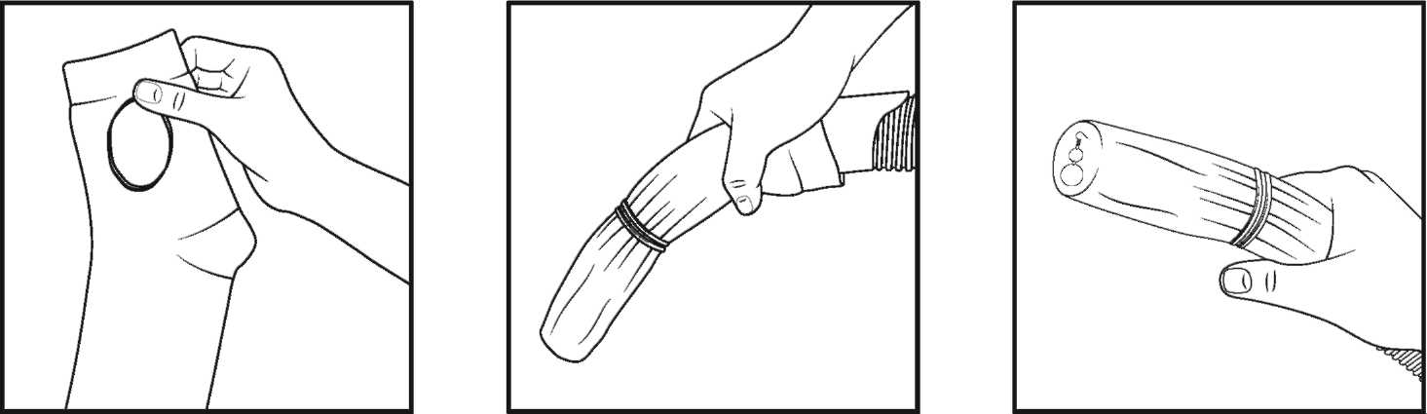

Using the product
Gently slide the sock over the nozzle of your vacuum and secure in place with the elastic band. Turn the vacuum on and aim nozzle in the general direction of the area you wish to scan. After a minute or so, bring the nozzle towards you and feel the top. If your item has been found, remove it before turning the hoover off. If not continue to search the floor.

Special warnings
- Never use for longer than a minute at a time to prevent overheating.

How to contact RNIB
Phone: 0303 123 9999
Email: shop@rnib.org.uk
Address: RNIB, Midgate House, Midgate, Peterborough PE1 1TN
Online Shop: shop.rnib.org.uk

Email for international customers: exports@rnib.org.uk

Terms and conditions of sale
This product is guaranteed from manufacturing faults for 24 months from the date of purchase. If you have any issues with the product and you did not purchase directly from RNIB then please contact your retailer in the first instance.

For all returns and repairs contact RNIB first to get a returns authorisation number to help us deal efficiently with your product return.

You can request full terms and conditions from RNIB or view them online.

RNIB Enterprises Limited (with registered number 0887094) is a wholly owned trading subsidiary of the Royal National Institute of Blind People ("RNIB"), a charity registered in England and Wales (226227), Scotland (SC039316) and Isle of Man (1109). RNIB Enterprises Limited covenants all of its taxable profits to RNIB.

Date: December 2019.

© 2019 Royal National Institute of Blind People.

